NYCCT MAT 2572 Halleck Fall 2016 Practice exam 4

You may submit a formula sheet (1 sheet, 2 pages, hand-written), worth up to 5% extra.

In addition to a written test, you are expected to submit an Excel file with all your Excel work.

**Problems similar to 5 of the following will appear on the exam. Each problem will be worth 20%.**

1. A previous sample of fish in Lake Michigan indicated that the mean polychlorinated biphenyl (PCB) concentration per fish was 11.2 parts per million with a standard deviation of 2.1 parts per million. The concentrations in a new random sample of 25 fish can be found in the Excel file.

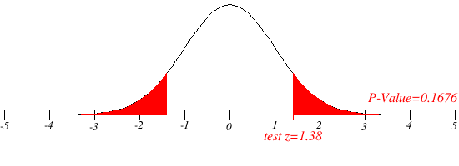Has the mean PCB concentration remained unchanged? Assume that the population standard deviation remains the same. Don’t forget to make a histogram to verify that the data are from a normal distribution.

NOTE: this is a 2-tailed test.

H0: µ=11.2

H1: µ≠11.2

α=5% (default)

10.4 10.8 11.2 11.6 12.0 Xbar

Since the p-value is NOT below the significance level, we do NOT reject H0.

See Excel file on step-by-step guide on how to make histogram.

1. Same data from problem 1 to find a 95th confidence interval for the standard deviation and use it to test the claim that the standard deviation did indeed remain the same.

NOTE: this is a 2-tailed test. H0: std dev is 2.1 ppm H1: std dev ≠ 2.1 ppm

95%

Peak at 22=24-2

12 39

1.85 3.29

Since 2.1 is within the 95th conf interval [1.85, 3.29], we do not reject H0

1. To be able to use the z-test in problem 1, we need to know that the distribution from which the sample came is normal. Why? Test the hypothesis that the population distribution is indeed normal.

H0: pollution concentration is normally distributed

H1: pollution concentration is NOT normally distributed for α=5% (default)

The p-value is 25% which is NOT below α, hence we do NOT reject H0. In another words, we can continue to assume that the underlying population distribution is normal. It should be noted that we had already kind of done this when we created the histogram in problem 1. However, this time we have done it more formally. A reminder that if the sample size is more than 30, then we do not in general have to worry about whether the population distribution is normal, because the sample mean distribution will be (close enough to) normal regardless.

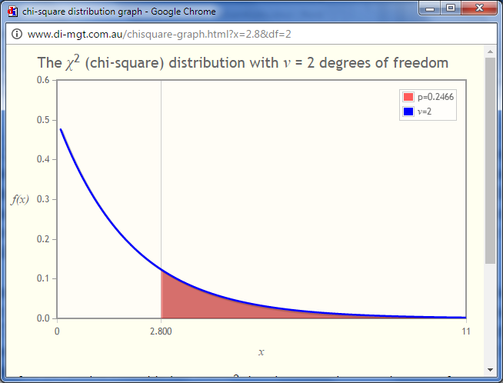

Note how graph looks like exponential decay.

1. A farmer claims to be able to produce larger tomatoes. To test this claim, a tomato variety that has a mean diameter size of 8.2 centimeters with a standard deviation of 2.4 centimeters is used. A sample size of 36 tomatoes will be used to test claim. If the actual mean is 9.1 centimeters, calculate the power of the test to show that the mean size is indeed larger. Assume that the population standard deviation remains the same.

NOTE: this is a 1-tailed test.

Basic strategy is to find the critical value in the hypothesized sample mean distribution and then find the probability of being more than that in the actual sample mean distribution. This will give us the power = 1 - β. All the calculations are in the excel file. The power is 67%. In other words, approximately 67% of the time, the farmer’s tomatoes will said to grow bigger tomatoes.

Blue area above is 5%. Blue and red area above is 67%. Line is at x=8.9.

1. A cat food manufacturer claims that its dry food contains at most 11% moisture on average. The FDA samples 100 bags and measures the moisture content. The raw data can be found in the Excel file. Can the FDA say that the cat food contains too much moisture?

NOTE: this is a 1-tailed test.

H0: µ=11

H1: µ>11

P-value is 10%. For α=5% (default), we do NOT reject H0. In other words, we accept that the moisture levels are within the guidelines.

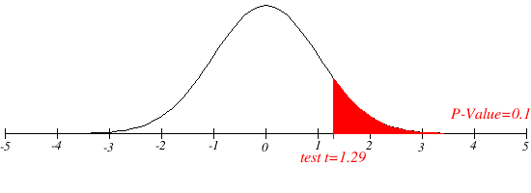

10.92 10.96 11.00 11.04 11.08

1. Middle school students from around the New York State were asked whether good grades, athletic ability, or popularity was most important to them. 50 students each from rural, suburban and urban areas were chosen. Does where a student lives affect their values?

NOTE: this is a 1-tailed test.

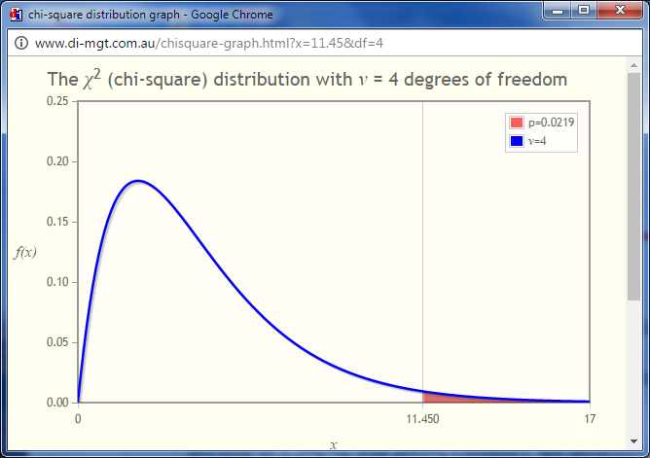

Peak is at x=dof-2=4-2=2

p-value is 2.2% %. For α=5% (default), we do reject H0. In other words, we can say that where a student lives (rural, suburban, urban) does affect their values.