NYCCT MAT2572 Halleck fall 2017 Practice exam 2 solutions

1. Based on recent experience, 10-year-old passenger cars going through a motor vehicle inspection station have an 80% chance of passing the emissions test. Suppose that a municipality owns 200 such cars.
   1. Find the RV for the number of cars that do **not** pass by using the binomial distribution.

Chance that k cars do **not** pass is

* 1. Using your work from part a and the definition of expectation, find an expression for the expectation of the number of repairs needed.
 $$E\left[X\right]=\sum_{k=0}^{n}{k}p\left(k\right)=\sum_{k=0}^{n}{k}\left({n \atop k}\right){p^{k}q}^{n-k}=\sum_{k=0}^{200}{k}\left({200 \atop k}\right){{0.2}^{k}0.8}^{200-k}$$

 2. Find the expectation for the ith car **not** to pass $E\left(X_{i}\right)$ by finding the RV that represents the ith car Xi (0 for pass, 1 for not pass) and using the definition of expectation.

|  |  |  |
| --- | --- | --- |
| **xi** | **0** | **1** |
| P(xi) | .8 | .2 |

* 1. Find the expectation for # cars that are **not** expected to pass by using your answer to c. and $E\left(\sum{X_{i}}\right)=\sum{E\left(X_{i}\right)}=.2+.2+⋯+.2=200*0.2=40$
  2. If the average cost for a repair is $300, about how much can the municipality expect to spend this year on emission repairs for these 200 cars?

$$E\left[\$300*X\right]=\$300E\left[X\right]=\$300*40=\$12,000$$

1. Let.
   1. Find *a* so that fY (y) is a PDF.

 so a=1/9

* 1. Graph fY (y) from 0 ≤ y ≤ 3 (plot every 0.5).

mean=1.75 median=1.79

* 1. Find and graph FY (y), the corresponding CDF, from 0 ≤ y ≤ 3 (plot every 0.5).



 median=1.79

* 1. Find. Graph the inequality on your plot from part b) and shade the area representing the probability. 
  2. Find the expectation and label on your plot from part b)



* 1. Find the median and label on both graphs (the first with a vertical line and the second with a horizontal line and a vertical line).

To find the median, set FY (y)=1/2 and solve for y: 

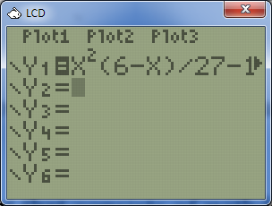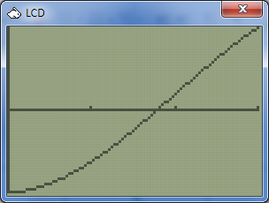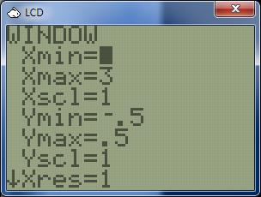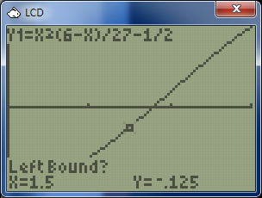

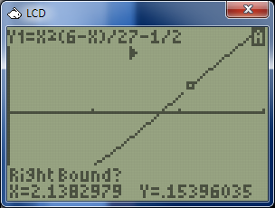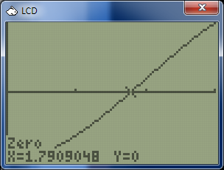Hence the median≈1.79

* 1. Compare relative positions of the median and the expectation. Explain how comparison relates to any skewing. **The mean is to the left of the median, therefore the skewing is to the left.**

1. (40 pts) Consider an experiment that consists of withdrawing a ball from the box, NOT replacing it, and withdrawing a second ball. There are 2 red and 4 green balls in the box. An outcome will be a coordinate of 2 colors, say (r,r), which can be shortened to rr.
   1. What is the sample space of this experiment? Is this a random variable? Why or why not?

No, outcomes are not numbers.

* 1. To get a random variable W, we count the number of red balls selected. Find the possible outcomes and express their probabilities as quotients of binomial coefficients. Write W as a table with row 1 as the outcomes and row 2 the corresponding probabilities.



* 1. Evaluate the binomial coefficients, leaving as fractions. Write W as a matrix with row 1 as the outcomes and row 2 the corresponding probabilities. Rewrite table representing W.



* 1. Use the 2 row table of c to find the expectation μ=E(W).

Expectation is dot product of the 2 rows above thought of as vectors: 0*6/15+1*8/15+2*1/15=10/15=2/3

* 1. Find the 2 row table for W2 and use it find μ2=E(W2).

 μ2=E(W2)=8/15+4/15=12/15=4/5

* 1. Use the results from d and e to find V(W). V(W) = μ2 − μ2 = 4/5 − (2/3)2 = 36/45 – 20/45= 16/45
  2. If X is an RV indicating whether the first ball is red or not (1, 0 respectively) and Y is whether the second ball is red or not (1, 0 respectively). Find E(X) and E(Y) and show that their sum corresponds to your answer in d.

X:  & Y:  so E(X)=E(Y)=1/3 and so E(X+Y)= E(X)+E(Y)=1/3+1/3=2/3

* 1. Find V(X) and V(Y) for X and Y described in f. and show that their sum DOES NOT correspond to your answer in d. Why not? Try to reason why it is more or less.

V(X)=V(Y)=E(X2)-E(X)2=1/3-(1/3)2=(3-1)/9=2/9

Note that 16/45=V(X+Y)≠V(X) +V(Y) = 2/9 + 2/9=4/9=20/45

X and Y are dependent so V(X+Y)=V(X)+V(Y) does not hold. Basically, the variability in the result gets reduced because of the dependence.