Kiki Olanipekun

https://www.prisonpolicy.org/articles/notequal.html

The graphs on this site basically represent a breakdown of the statistics and provide you with a clear view and understanding that incarceration is not an equal opportunity punishment. It also illustrates that the young, the male, and the Blacks and Latino’s are disproportionately incarcerated

By Race and Ethnicity

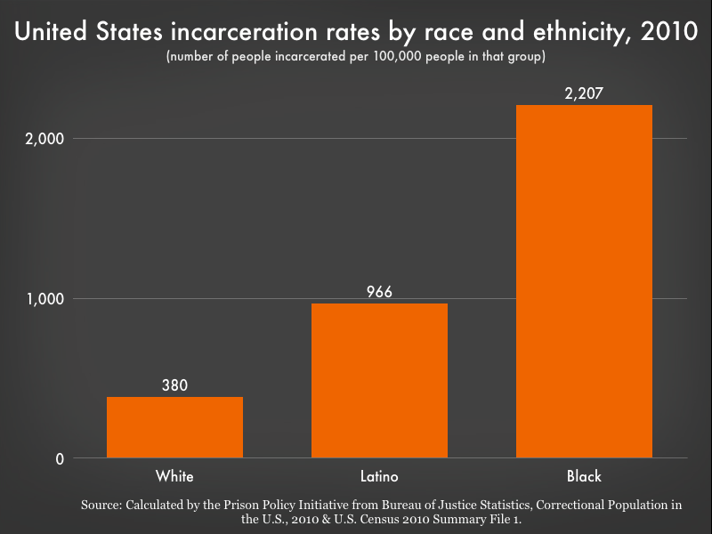

By Sex
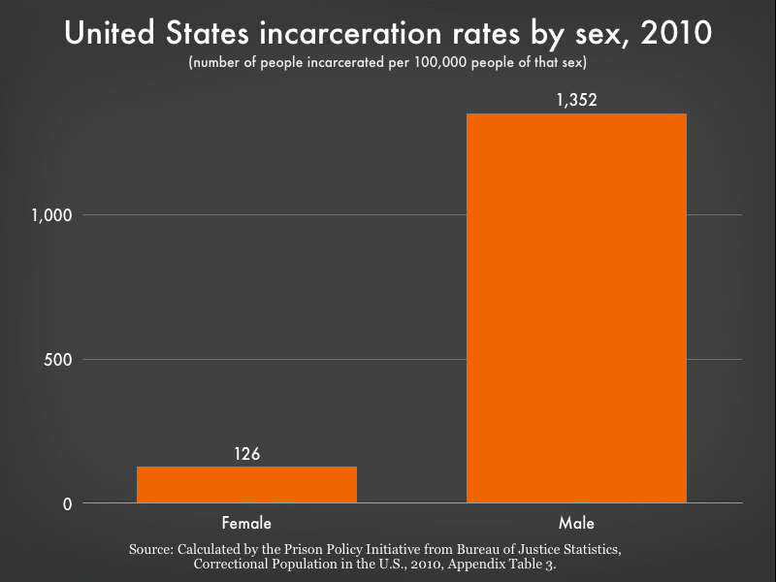
By Race and Gender
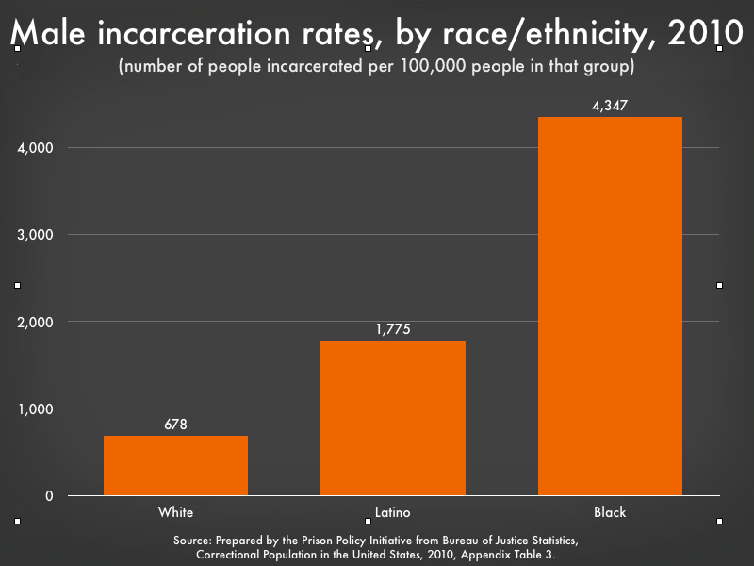

By Age
