https://www.twipemobile.com/reuters-digital-news-report-2018-graphs-need-see/
This article is about how more people are beginning to pay directly for their online news as well as how people are more likely to donate to newspapers, as well as how more people are considering donating to newspaper organizations in the future. This point is then backed up by explaining that there is a decreased reliance on social media for news consumption, proving that people might not be believing or relying on social medias news as much as they used to.
Original graph:
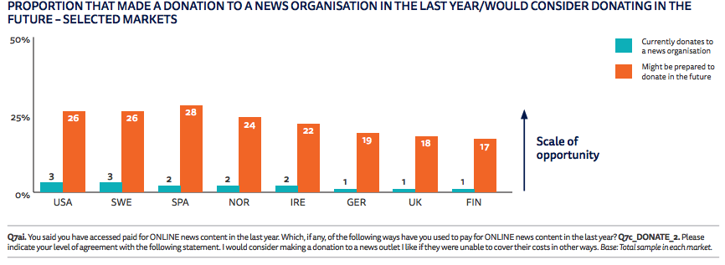
This graph specifically was used in this article to describe the percentage of people who made donations to news organizations in 2018 and the amount of people who would consider making a donation to a news organization in the future.
Reproduction of the graph: