Original Article : https://www.channel4.com/news/factcheck/climate-change-in-ten-graphs
Climate change in ten graphs
by Martin Williams published on june 1st, 2017
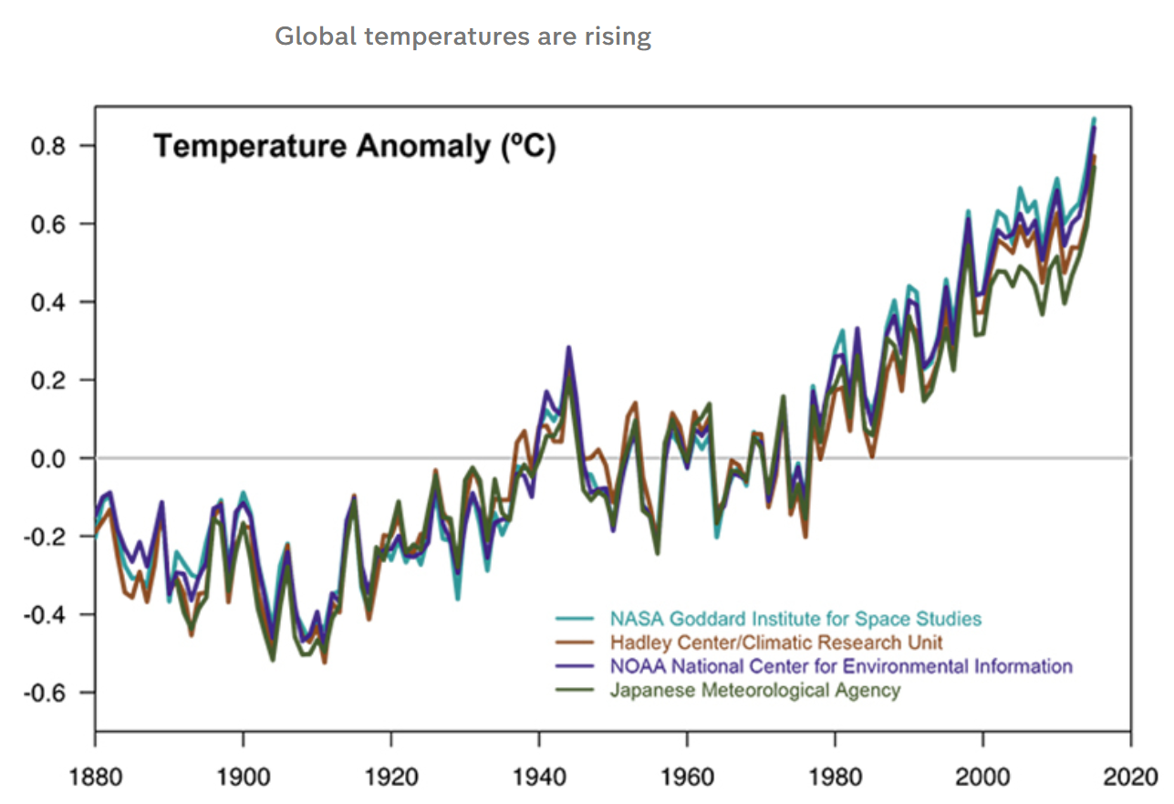
This graph shows changes in global temperatures since 1880s. 4 Different research centers show a similar result with their collected data which indicates global temperatures are rising.
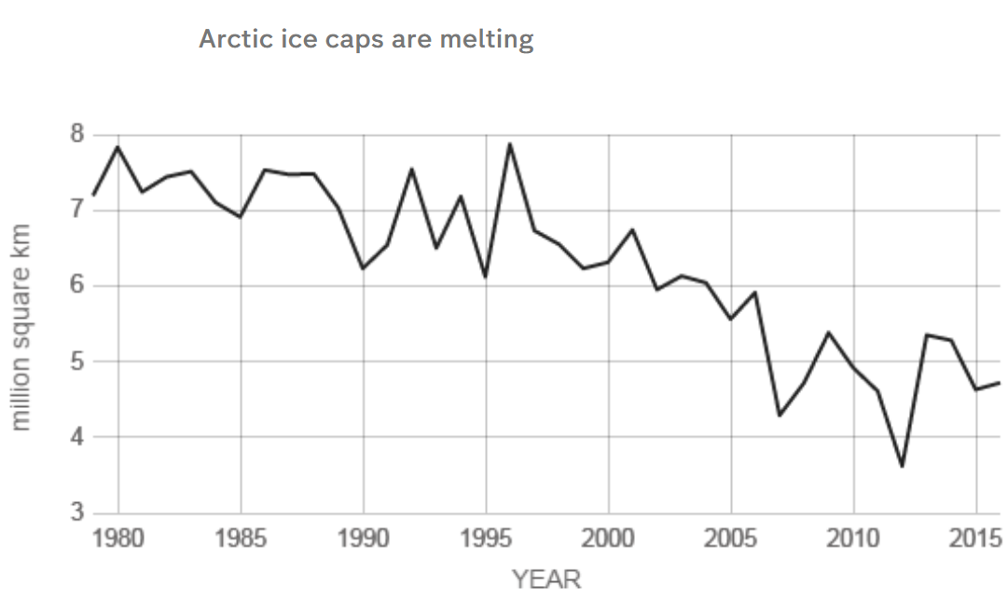
Due to global temperature rising, arctic ice is starting to melt. Since, 1980s total mass of artic (measured in million square km) ice caps are decreasing over years and it’s shown by this graph.
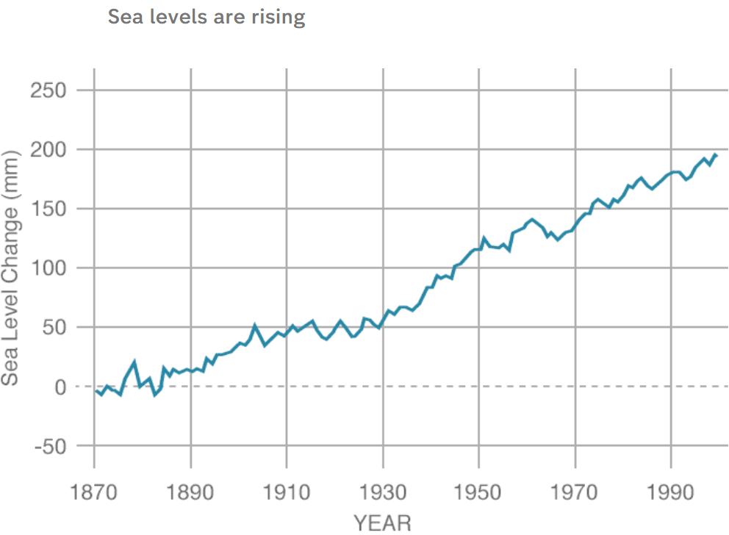
This next graph shows the direct result of artic ice cap melting. This graph shows the sea level change in millimeters over the years. Since ice caps turned into water, increasing the volume of water results in increase in sea level. This is shown through this graph. Since 1870, sea levels been increasing over every decades which shows these 3 graphs have direct relationship with each other. These three graphs tell me that increasing in global temperature causes melting of artic ice caps and ultimately results in increased sea level.
Replication of last graph using
year : 1870 1890 1910 1930 1950 1970 1990
change: 0 15 47 55 125 135 175

