Assignment #2: Graph Analysis

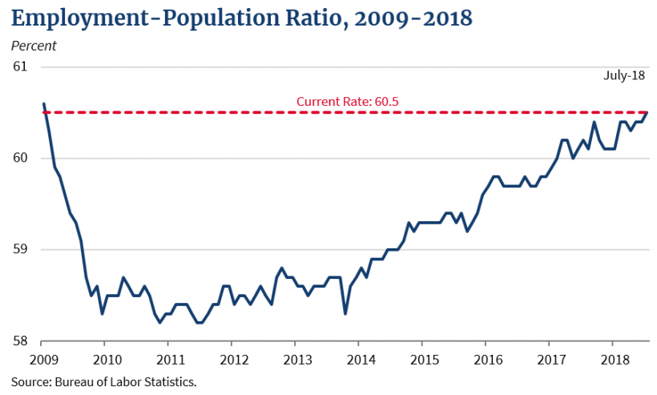
In this article, “Longest Consecutive Positive Monthly Job Growth in United State History,” Nelson D. Schwartz and Ben Casselman state that the United States economy continuous to growth with 3.9 million jobs created since President Donald Trump was elected in November 2016. The Bureau of Labor Statistics report that the average job growth per month is 215.000 for 2018, which is greater than the average monthly gain in 2016 (195K) and 2017 (182K). This graph shows that job growth has been strong across the board during the first 18 months of his administration, and in July the manufacturing and professional & business services industries experienced average monthly gains. Goods-producing industries (constriction, manufacturing, mining, and logging) have added more than 900.000 jobs. The employment-population ratio rose by 0.1 percentage point in July to 60.5 percent. This marks its highest point since January 2009. The employment-population ratio has increased by 0.6 percentage point in January 2017, which demonstrates that economy is growing from 2009 to 2018, more workers are finding jobs and unemployment declined in America.

Reference:
https://www.whitehouse.gov/articles/longest-consecutive-positive-monthly-job-growth-u-s-history/?utm_source=twitter&utm_medium=social&utm_campaign=wh

