Nadia Gordon
Stat Post

You can’t deny global warming after seeing this graph
By Ezra Klein
July 9, 2013
https://www.washingtonpost.com/news/wonk/wp/2013/07/09/you-cant-deny-global-warming-after-seeing-this-graph/?utm_term=.7c8c5c6c4db8

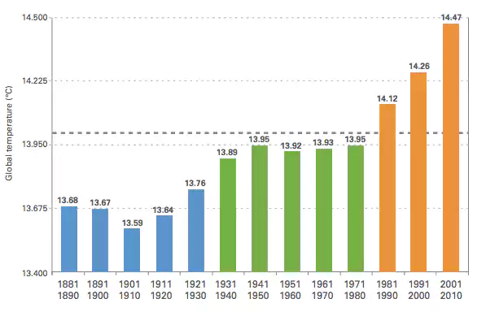
Scientist began to recognize that the Earth was starting to heat up in 1998. Every year follow the temperature continue to increase at a rapid rate. The graph looks at the climate change every decade instead of every year, because the trait would be balanced by the years to come. The graph proof in fact that Earth is getting hotter.
