Truman Nguyen
Statistics with Probability

Article: https://www.usatoday.com/story/tech/news/2017/06/28/iphones-smartphone-revolution-4-graphs/103216746/

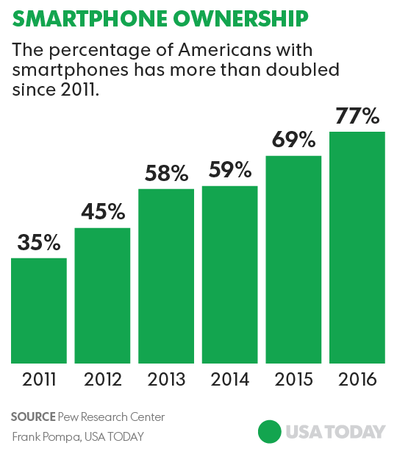
The article is talking about how the evolution of the Iphone on how it is able to run the same software as a computer and how useful it is to be able to carry a mini computer in your pockets. After the years that the Iphone has still continues to produce new and better versions of itself. This graph below explain the increase ownership of the smartphone from 2011 to 2016. Ownership has more than doubled since 2011 due to the increasing reliance on technology and more competitor in the smartphone market. Which mean cheaper smartphones available to the public market.
Also the amount of time spent on smartphone has risen during the years. This is mainly due to the addition of “App” to the smartphone. These app allow us to be able to communicate with each other, access social media, entertainment, and also being able the web browser. Because of this, it increased our dependency of smartphones.
