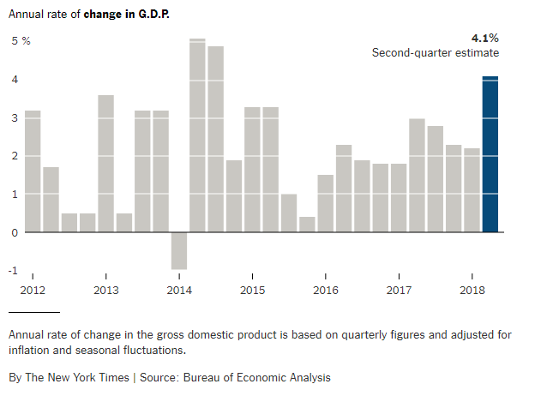
In this article “Economy Hits a High Note, and Trump Takes a Bow”, by Ben Casselman, published in July 27, 2018 , from the New York time, shows a histogram about the annual rate of change in the GDP for different years in the USA. This graph illustrates the percent change og the GDP from 2012 to 2018.

