NYCCT MAT1372 Halleck Fall 2015 Practice exam 3 solns
- You must use a graphing calculator for part I (problems 1 and 2) and Excel for part II (problems 3 and 4).
- You may submit a formula sheet (1 sheet, 2 pages, hand-written), worth up to 5% extra.
- (25 pts) The playing time for high school basketball player is a continuous random variable Y defined by a density function which is 0 except between 30 and 60 minutes, where it has the form of an isosceles triangle.
  - Draw a graph of the density function and find the height of the triangle
A= ½ bh = ½ (30)(h)=1 so h=1/15

  - Shade and label the appropriate region of the graph for P(35<Y<45) and guess the probability by looking at the shaded graph. Looking at the shaded area, it is going to be a bit less than .5, perhaps .45.
  - Find the probability. Does your answer more or less match what you guessed?
Using the formula for trapezoid ½(b₁+b₂)h=½(1/45+1/15)10=5*(4/45)=20/45=.44. This is close to what I guessed.
- (25 pts) A recent poll (Tuesday 11/24/15):
http://www.quinnipiac.edu/news-and-events/quinnipiac-university-poll/iowa/release-detail?ReleaseID=2305
has Trump leading the Iowa Caucus polls 25% to Rubio’s 23%. However, the lead is within the claimed margin of error of ± 4%. Focus just on Trump’s numbers.
  - Find the standard deviation for whether one voter is a supporter of Trump or not.
This is a binomial distribution (coin flipping) with just one trial (flip).
σ= √(pq)= √(.25*.75q)=.43
  - Given that the sample size was 600, find the standard error (the standard deviation for the sample mean). Std err=σ/√n=.43/√600=.0177 Draw the appropriate normal curve and label the horizontal axis with both Xbar and Z labels.
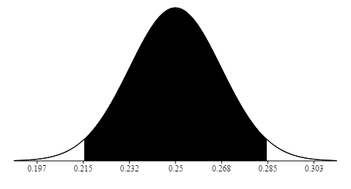

  - The margin of error is approximately ± twice the standard error. Find it. Is it roughly what the polltakers claim? Margin of error = ±2(.0177)= ±3.5% which if we round up is the 4% provided by the polltakers.
  - By what factor will the sample size need to be increased (assuming that results will stay the same) for us to conclude that Trump is definitely leading. The difference between the candidates is 2%. To definitively say that Trump is in the lead, we need to halve the margin of error which corresponds to halving the standard error. To halve the standard error, we need to increase the sampling by a factor of 4.

- (25 pts) A previous sample of fish in Lake Michigan indicated that the mean polychlorinated biphenyl (PCB) concentration per fish was 11.2 parts per million with a standard deviation of 2 parts per million. Suppose a new random sample of 10 fish has the following concentrations:
11.5, 12.0, 11.6, 11.8, 10.4, 10.8, 12.2, 11.9, 12.4, 12.6
Assume that the standard deviation has remained equal to 2 parts per million, and test the hypothesis that the mean PCB concentration has also remained unchanged at 11.2 parts per million. Use the 5 percent level of significance. NOTE: this is a 2-tailed test.
H₀ = 11.2, H₁ ≠ 11.2 Sample mean is 11.72. Std err=σ/√n=2/√10=.632
So the z value for the sample mean is z=(11.72-11.2)/.632=.822
and the pvalue=2*(1-norm.s.dist(.822,true))=.411~41%
This is way above 5%, so we do not reject H₀. We do not have enough evidence to say that the concentration has changed.
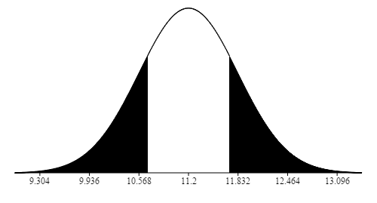
- (25 pts) A farmer claims to be able to produce larger tomatoes. To test this claim, a tomato variety that has a mean diameter size of 8.2 centimeters with a standard deviation of 2.4 centimeters is used. If a sample of 36 tomatoes yielded a sample mean of 9.1 centimeters, does this prove that the mean size is indeed larger? Assume that the population standard deviation remains equal to 2.4, and use the 5 percent level of significance. NOTE: this is a 1-tailed test.
H₀ = 8.2, H₁ >8.2 Sample mean is 9.1. Std err=σ/√n=2.4/√36=.4
So the z value for the sample mean is z=(9.1-8.2)/.4=.9/.4=9/4=2.25
and the pvalue=1-norm.s.dist(2.25,true)=.0122~1.2%
This is below 5%, so we do reject H₀. We do have enough evidence to say that the farmer is producing larger tomatoes.
