NYCCT MAT1372 Halleck Fall 2015 Practice exam 2 solutions
- You must use a graphing calculator.
- At the end of class, be sure to turn in your formula sheet (1 sheet, 2 pages, hand-written), worth 10%.
- (10 pts) The formula =$B$2*A2 is located in cell B1.
    - If this was copied and pasted into cell D3, what would the resulting formula be? =$B$2*C4
    - What would this new formula evaluate to? 3*4=12
 | A | B | C | D
1 | 2 | =$B$2*A2 | 4 | 5
2 | 3 | 3 | 8 | 6
3 | 5 | 4 | 3 | ?????????
4 | 4 | 3 | 4 | 9

- (20 pts) A 5 digit PIN number can begin with any digit (except zero) and the remaining digits have no restriction.
  - If repeated digits are allowed, find the probability of the PIN code beginning with a 7 and ending with an 8. The middle 3 digits have no restriction so 10^3/(9*10^4)=1/90

  - If repeated digits are not allowed, find the probability of the PIN code is odd.
Let O be the event “pin is odd” and NR the event “there are no repeats” then this is a conditional probability P(O|NR). For the numerator (the intersection), do the last and first digits to get 5 and 8 respectively, then the middle 3 are 8,7 and 6. Denominator (which is NR) is done similarly: just do the digits this time from left to right in order. P(O|NR)=5*8*7*6*8/(9*9*8*7*6)=5*8/9^2=40/81, just a hair less than ½

  - Find the probability that the PIN code is odd if repeated digits are allowed.
This is just P(O). Numerator is 9*10^4. Denominator is 9*10^3*5. (In both cases, you can just work left to right.) Hence P(O)= 9*10^3*5/(9*10^4)=1/2

  - Are the events PIN is odd and PIN has no repeated digits independent?
There 2 equivalent formulations to determine independence between events A and B
        - P(A)*P(B)=P(A ∩ B) (theorem)
        - P(A)=P(A|B) (definition)
In this case, we use (ii) (the definition). We note that ½=P(O)≠ P(O|NR)=40/81.
Hence, O and NR are NOT independent, i.e., they are dependent
(the occurrence of one affects the chances of the other).

- (20 pts) Consider an experiment that consists of withdrawing a ball from the box, NOT replacing it, and withdrawing a second ball. There are 1 red, and 4 green ball in the box.
  - What is the sample space of this experiment? Is this a random variable? Why or why not?
S=No, experiment is not an RV, since outcomes are not numbers.

  - Suppose that the experiment is carried further by counting the number of red balls selected? Why is this a random variable? Now the experiment is an RV, since the outcomes are numbers.

  - For the experiment described in b, find the outcomes and express their probabilities as quotients of binomial coefficients.
As quotients of BC’s: Evaluating:

  - Evaluate the binomial coefficients, leaving as fractions and find the expectation.
Expectation is the sum of each outcome times its probability: 0*3/5+1*2/5=2/5
(use the middle row and the bottom row in the table on the right above).

  - Find the variance for the random variable of c and d.
From the table on the right above, we see that X and X² are identical so V(X)=E(X²)-E(X)²=2/5-(2/5)²=(10-4)/25=6/25.
(For E(X²), use the top row and the bottom row in the table on the right above)

  - If X is RV indicating whether the first ball is red or not (1, 0 respectively) and Y is whether the second ball is red or not (1, 0 respectively). Find E(X) and E(Y) and show that their sum corresponds to your answer in d.
X: & Y: so E(X)=E(Y)=1/5 and so E(X+Y)= E(X)+E(Y)=1/5+1/5=2/5

  - Find V(X) and V(Y) for X and Y described in f. and show that their sum DOES NOT correspond to your answer in d. Why not? Try to reason why it is more or less.
From the above tables we see that V(X)=V(Y)=E(X²)-E(X)²=1/5-(1/5)²=(5-1)/25=4/25
However, note that 6/25=V(X+Y)≠V(X) +V(Y) = 4/25 + 4/25=8/25
X and Y are dependent so V(X+Y)=V(X)+V(Y) does not hold. Basically, the variability in the result gets reduced because of the dependence.

- (20 pts) Records show that deaths occur at the rate of 0.1 per day among patients residing in a large nursing home.
  - Provide 2 reasons why deaths are NOT Poisson distributed.
      - The death of one resident may emotionally upset his or her friends in the home, who may as a result die at an increased rate.
      - Seasonally because of cold-weather related illnesses like the flu, which can often be deadly for elderly people, the average death rate over the year will vary.

  - Assuming that they are Poisson distributed, find the chance that 2 or more patients will die in one week.
λ=7(0.1)=0.7
P(X≥2)=1-((P(X=0)+P(X=1))=1-e^{-λ}(1/0!+ λ/1!)=1-1.7 e^{-0.7}≈15.6%

- (20 pts) A random sample of 747 obituaries published recently in Salt Lake City newspapers revealed that 344 (or 46%) of the residents died in the three-month period following their birthdays. Assess the statistical significance of that finding by approximating the probability that 46% or more would die in that particular interval if deaths occurred randomly throughout the year. Solve the problem using the binomial distribution.
  - Find the expectation.
μ=np=747(.25)=186.75

  - Find the variance.
σ= √(npq)= √(747*0.25*0.75)=11.835

  - Draw the normal distribution graph using the information from a and b. (Normal distribution approximates the shape of the binomial distribution.) and shade the portions which corresponds to the question.

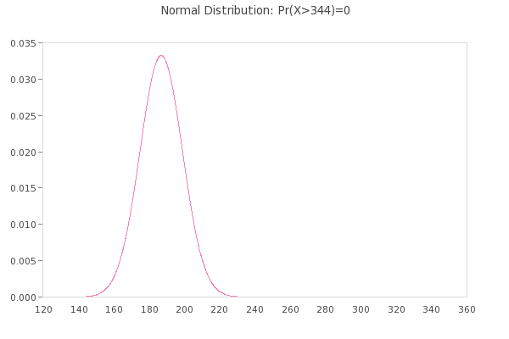
Note that the probability is 0.

Nothing to shade as the height of the curve is undetectable beyond 3 standard deviations. If number of deaths within 3 months were 200, then the shaded graph would look like:

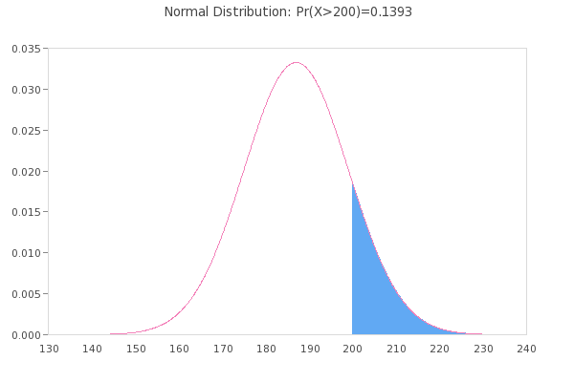

Note that probability represented by the area under is curve is around 14%.
  - Solve the problem using a graphing calculator. Be sure to describe the syntax of any functions you use and your selection for any inputs.
Type 1− and then press successively the 2nd and vars key:
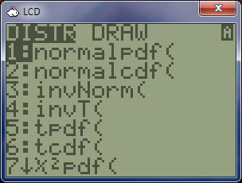
In succession, press the ALPHA and APPS keys or scroll up or down to get to
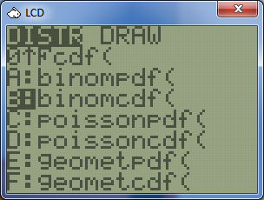
Press enter and you will be prompted for the inputs. Note, in older models, you will have to type the inputs directly into the function (you will not be told what the syntax is).
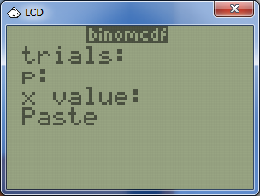

Type in 747, down arrow, .25, down arrow, 343, down arrow.
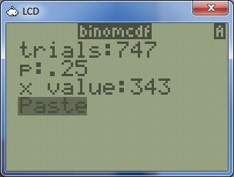
Press enter and your screen should look like
Press enter again.
The syntax for binomcdf is n,p,k Hence the probability is 0. Our conclusion is that the cluster of deaths in the 3 months after their birthdays could not have happened due to randomness. Elderly people have a higher probability of death in the first few months after a birthday. Now this could be due to a higher will to live right BEFORE their birthdays. Perhaps they are getting close to death, but they muster up additional strength to make it to their birthdays. However, they then die soon afterwards. It would be interesting to do a study of the data to see if this is true. There should be corresponding DECREASE in the death rate in those 3 prior months.

