MAT 1372-6556 Statistics with Probability Practice Exam 1 Fall 2013

Closed book and notes. No use of computers, laptops, tablets or other handhelds. A calculator is ok.

1. The formula **=B$2*$A1** is located in cell **B1**.

a) What does cell B1 evaluate to? **3*2=6**

b) If this was copied and pasted into cell D3, what would the resulting formula be?= **D$2*$A3**

c) What would the cell D3 evaluate to? **6*5=30**

|  |  |  |  |  |
| --- | --- | --- | --- | --- |
|  | **A** | **B** | **C** | **D** |
| **1** | 2 | **=B$2*$A1** | 4 | 5 |
| **2** | 3 | 3 | 8 | 6 |
| **3** | 5 | 4 | 3 | ????????? |
| **4** | 4 | 3 | 4 | 9 |

1. The following are the weights of chickens that have been put out for sale in a supermarket. Make a stem and leaf plot using every .05 for the stem (3.7(5), 3.8,3.8(5),3.9,3.9(5), 4.0,4.0(5) 4.1, 4.1(5)). What can you say about the distribution? Is it evenly distributed? Bell-shaped? Symmetric? Find the median and mode. The mean turns out to be 3.97. Does this indicate that right or left skewing? Why? **This graph roughly bell-shaped and symmetric.**

3.75 3.88 3.94 3.96 4.02 4.09 **The mode and median are 3.96.**

3.82 3.92 3.94 3.98 4.03 4.10 **A mean of 3.97 indicates**

3.84 3.93 3.96 3.99 4.06 4.12 **skewing to right since the mean**

3.86 3.93 3.96 4.02 4.06 4.17 **is slightly more sensitive to**

**skewing than the median.**

1. A histogram uses bins, each of which represents a(n) **interval**  of data. If our data go from a low of 21 to a

high of 48 and we want 7 bins, then the width of each bin is _**(48-21+1)/7=4**_(show your calculation.)

For 10 bins, the width is **(48-21+1)/10=2.8~3**. For 5 bins, the width is**(48-21+1)/5=5.6~6**. Given our love for 5’s &

10’s, what would most likely be our choice for bin width? Why? **5; from last calcs, we see 3 ≤ binwidth ≤ 6**.

For this last choice, if using Excel, the first and last #’s for setting up the bins would be ___**25**___ and ___**50**____

or if using a stem and leaf plot, the stems would be **2,2,3,3,4,4**.

1. A box contains six balls—one red, and five blue. Consider an experiment that consists of withdrawing a ball from the box, replacing it, and withdrawing a second ball. Draw a tree diagram. Be sure to include labels and probabilities and use to make a table with outcomes and probabilities. **Express all probabilities as fractions in lowest terms.**





* 1. What is the sample space of this experiment? **{rr,rb,br,bb}**
  2. As a set, what is the event A: the first ball drawn is red? What is its probability? **A={rr,rb}; P(A)=1/6**
  3. As a set, what is the event B: the same color ball is drawn twice? What is its probability?

**B={rr,bb}; P(B)=1/36+25/36=26/36=13/18**

* 1. Find A or B and its probability. Draw a Venn diagram with outcomes. Shade appropriately.

**A or B={rr,rb,bb}; P(A or B)=13/18+5/36=31/36 (or 1−5/36) (pictured in yellow below to left)**



* 1. Find A and (not B) and its probability. Draw a Venn diagram with outcomes. Shade appropriately.

**A and (not B)={rb}; P(A and (not B))=5/36 (pictured in red above on right)**

1. Repeat Prob. 5 when the second ball is drawn without replacement of the first ball.





* 1. What is the sample space of this experiment? **{rb,br,bb}**
  2. As a set, what is the event A: the first ball drawn is red? What is its probability? **A={rb}; P(A)=1/6**
  3. As a set, what is the event B: the same color ball is drawn twice? What is its probability?

**B={bb}; P(B)=20/30=2/3**

* 1. Find A or B and its probability. Draw a Venn diagram with outcomes. Shade appropriately.

**A or B={rb,bb}; P(A or B)=1/6+2/3=5/6 (or 1−1/6) (pictured in yellow below to left)**



* 1. Find A and (not B) and its probability. Draw a Venn diagram with outcomes. Shade appropriately.

**A and (not B)={rb}; P(A and (not B))=1/6 (pictured in red above on right)**

1. Of the families in a certain community, all have a parent or grandparent, 93 percent have at least one parent, and 18 percent have at least one grandparent.
   1. If a family is chosen at random, what is the probability it has both a parent and a grandparent? Draw a Venn diagram with probabilities. Shade appropriately. **(pictured in red below to left)**



If the community consists of 1000 families, how many of them have only a grandparent? Draw a Venn diagram with frequencies. Shade appropriately. **(pictured in yellow above on right)**

1. It is estimated that 20 percent of all adolescents in the United States are obese, 1 percent of all adolescents suffer from diabetes type II, and 0.8 percent of all adolescents both are obese and suffer from diabetes. 

Determine the conditional probability that a randomly chosen adolescent

* 1. suffers from diabetes given that he or she is obese; **P(diabetes|obese)=.8%/20%=4%**
  2. is obese given that she or he suffers from diabetes. **P(obese|diabetes)=.8%/1%=80%**

1. The adults in an apartment building consist of 12 men and 15 women. A committee is formed of 6 randomly selected adult residents.

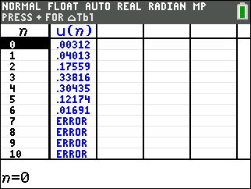 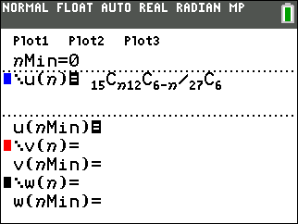

What is the probability that it will consist of

|  |  |
| --- | --- |
| * 1. 4 women and 2 men?   **=30.4%** | * 1. 5 women and 1 men?   **=12.2%** |
| * 1. 6 women?   **=1.7%** | * 1. At least 4 women? **At least 4 women means 4, 5 or 6 women so sum the answers to parts a-c: 30.4%+12.2% +1.7%=44.3%** |
| * 1. Use complement to find at least 3 men. | **At least 3 men means at most 3 women, the complement of which is at least 4 women, so is 1 − answer to part d or 1-42.3%=55.7%** |

**For some reason, I was not able to program v as the cumulative function desired. However, I did get it as a shifted function:**

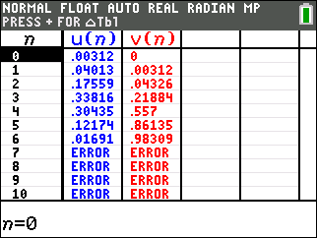 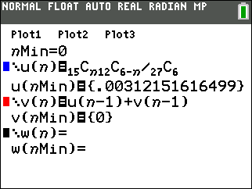

**Note in particular the 55.7% for 3 or less women chosen (n is the number of women chosen).**

1. A license plate from Vermont has 3 letters and 4 digits.
   1. How many different license plates can be made?

**263*104**

* 1. If the letters must be distinct and the first digit cannot be a zero, how many plates can be made?

**26*25*24*9*103**

* 1. If exactly 2 letters must be the same and the last digit must be odd, how many plates can be made?



1. **pick the letter which is repeated**
2. **pick the remaining letter**
3. **place the letters which are repeated**
4. **pick the first 4 numbers**
5. **pick the last number**