New York City College of Technology MAT1372 Practice_Exam II, Halleck, Fall 2013

Show all work and answers in blue book. You may use scientific or graphing calculator. Pts for problems sum to 90. For remaining 10 pts, submit handwritten 2-sided **quality** formula sheet of all the material needed for the exam. When finished, make sure name is on everything which you submit; **without folding,** insert formula sheet, exam sheet and graph paper into blue book.

1. (10 pts) A random variable has the following probability distribution:

X -2 -1 1 2

P(X) 0.3 0.2 0.3 ?

Find and **interpret** a) the probability when X=2 b) the mean and c) the standard deviation**.**

2. (10 pts) If a bent coin with probability of a head .3 is tossed 5 times, use the binomial distribution formula to find an expression for and then evaluate **by hand** the probability of getting

a) exactly 0 heads b) exactly 1 head c) at least 2 heads [use results from parts a) and b)].

d) Write down excel command that you could use to answer c) directly without using answers from a) and b).

3. **(**10 pts) An insurance company estimates that 5% of all its customer’s insurance claims are fraudulent. The company received 57,000 claims last year. Let  be random variable which is 1 if *i*th complaint is fraudulent and 0 otherwise. Let *X* be the random variable which counts the number of fraudulent claims last year.

a) Find the expectation for  and *X* and interpret.

b) Find the standard deviation for  and *X* and interpret.

4. (10 pts) A pair of dice is rolled 1000 times. Let be the random variable which consists of 1 if the sum of roll *i* is 10 and 0 otherwise. Let *X* be the random variable which counts the number of 10’s in the 1000 rolls.

a) Find the expectation for  and *X* and interpret.

b) Find the standard deviation for  and *X* and interpret.

5. (20 pts) The following data represent number of days absent (X) and final average (Y) in a statistics course.

a) Use the graph paper to draw a scatter plot. Make sure that you utilize most of the half-sheet. Draw in what you think is the trend line. b) Find and interpret the coefficient of correlation. c) Find and interpret the square of the coefficient of correlation. d) Find the equation of the regression line and plot on your scatter plot.

e) Interpret the slope & y-intercept. f) If Carol has 5 absences, what final grade can she expect?

 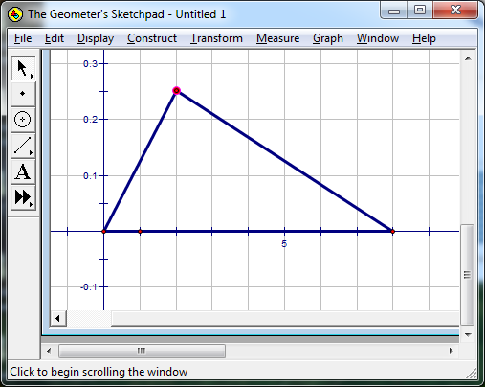

6. (10 pts) If the a probability distribution is in the form of a right triangle with peak at 2 and x-intercept 8, find

a) height of the triangle. b) P(x<2) c) P(4<x<6)

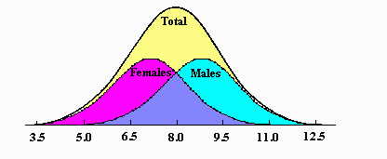7. (20 pts) Men shoe sizes in one ethnic population are normally distributed with mean 9 and standard deviation 1.5. **For each part, draw a picture with the normal distribution with both X and Z labels.**

1. Find P( X < 10.5)
2. Find P( X > 12)
3. Write the Excel command to find P( |X−9| >2)
4. Using normsinv, write the Excel command to find the value of x above which 17% of men have higher shoe sizes.