Zevanya
Carrie Hall
English 1101
April 4, 2019
Too Cool for School
“ Hey! Can I copy your homework? I was really busy yesterday.”
Busy? But your Snapchat story says you were at the karaoke.
“ Why is our math teacher mad all the time? Does she know we all have a life?”
Why? Probably because 95 percent of the class never submits the homework.
“ I can’t believe I failed!”
Why is it hard to believe you failed when you put zero effort into studying and cheated off someone else?
Must be nice living under a three-story house with three maids and not worry about anything because mommy’s credit card got you covered. Honestly, why are you even in school? Why are you guys so proud of wearing branded clothing from head to toe when your parents were the ones who paid for it anyways. Instead of wasting time on trivial things like “should I buy Coach or Gucci”, start thinking about your future. Stop being spoiled teens that take education for granted because there are thousands of kids in Indonesia that are willing to die for one.
Before I moved to New York, I attended an international school in Indonesia. My school adopted Singapore’s education system and we also followed the Cambridge examinations curriculum. In this system, we were taught solely based on textbooks and worksheets. I don’t entirely agree with this method of teaching as it creates a closed discussion on other possible answers and theories. Nevertheless, the school was still known to excel students in academics and human skills. We were taught advanced mathematics, chemistry, biology, and physics during the eighth grade. Later on, during the ninth grade, we were split into two majors: business and science.
I admit that the school gave us a very narrow choice but regardless of which major we chose, all of us entered college with our own desired majors instead of just “business and science.” In fact, I was able to use my knowledge from my science classes into my hospitality courses. I was able to ace my college math class and understand some food science theories thanks to my biology class. My friend, Yolanda, experienced the same thing when she drifted to interior design in college. She was able to understand certain interior design concepts that were related to physics. Sometimes I look back and think to myself “what if our school had already planned everything? What if they knew that these two majors would be beneficial in any field the students go to?”
I can’t say this is or will be the same case for every student that goes to my school because it depends entirely on the student. I’ve had numerous classmates that couldn’t care less if they had to repeat the same grade because well, their parents could afford it. Seeing them waste not only their parents’ money but also their hard work really bothered me. Earning money isn’t easy regardless if your family owns their own company or manages their own business. It still takes hard work and dedication to keep the business alive. On the other hand, I can’t entirely blame the kids because their parents were the ones who raised them to become spoiled. They’ve always given their kids the easy way out and never taught them how harsh and competitive the real world is.

In Indonesia, numerous children around the age of five to thirteen are unable to receive an education. They had no choice but to help their parents earn money by selling water, tissues, and cigarettes. Also, you would find numerous kids on the streets in Jakarta playing the role as an unofficial parking ranger. Keep in mind that the government does not pay these kids, they receive their income from small tips from people riding cars, motorcycles or trucks. Around four years ago my mother's company held a volunteer work trip. My mother asked around ten kids what their future goals were and every one of them replied the same, they all wanted to go to school, wear uniforms and learn something. In the article “Children at Work” by Sharon Bessel, a 14-year-old girl said, “my parents are dead, I have to support myself, how can I go to school when I must work?” This proves how even if these kids wanted to go to school they simply can’t. The article also mentioned that “factory children, usually girls aged between twelve and fourteen years, routinely work eight to fourteen hours a day, six days a week.” In other words, these children have no choice but to give up being a kid and start living as an adult. Do you guys know what it’s like? Of course not. The only struggle I’ve seen you guys had was choosing between iPhone X and iPhone 8.
It broke my heart to hear that these kids only wanted something so simple but was something most of us took for granted. Gatto states that “your children should have a more meaningful life, and they can.”(5) I am aware that not all schools are like my school and private schools are indeed not on the affordable side but I was able to have a more meaningful life because I actually learned. Not only did my school help students excel in academics, but they also promoted fund-raising events to help the less fortunate. We would visit orphanages and hold talent shows where the students themselves would put on small shows like singing or acting. We would also come to school earlier to make packaged meals for the kids and staff. It was also the school’s idea to chip in a few extra changes from our pocket money to donate for families living in the villages that needed assistance for giving their children a chance of receiving a proper education.
My classmates that were “too cool for school” never really participated in these events so they weren’t able to visually see what the less fortunate were going through. The teachers thought holding activities and events like this would open the students’ minds and for those who actually did participate, it built a whole new perspective for us. I matured sooner than most people my age, learned to appreciate more for what I have than what I don’t and applied what I learned in high school into college and the real world. I’m not asking you to change the world or donate all of your parents’ income to these kids but small things really do make a change. We live in a world where one way or another we depend on each other. We millennials blame Gen Y for passing down the chaos that we have to fix yet we’re doing the same to the generation after us. I’m not filthy rich but my school showed me how sharing my knowledge and wisdom helped these kids. It gave them hope.
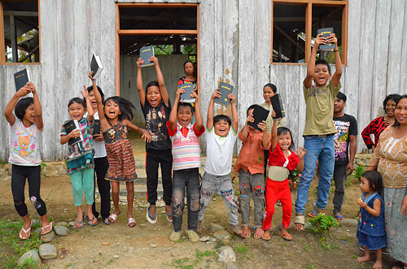

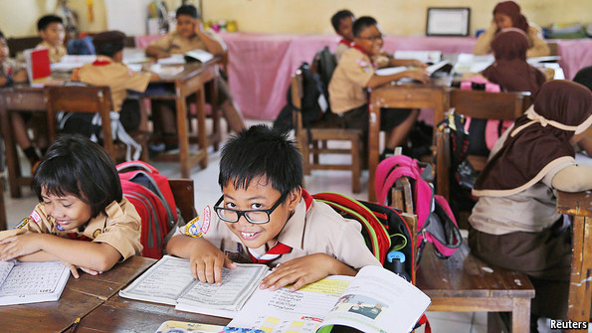

Works Cited
Gatto, John Taylor “Against School”
Bessel, Sharron. “Children at Work.” Inside Indonesia, www.insideindonesia.org/children-at-work.

