Jane Lee, Gabriel Tossas, Sherri Nguyen, Rita Peni

May 11, 2017

International Retailing – Dr. Tung

**Section 1 – Finland’s Country Analysis**

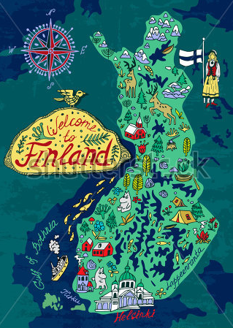 The geography of Finland is mostly flat land and more than 70% of it being covered in a thick forest. There are about four and a half million people living in urban areas however, the population of Finland is about five and a half million people. The *Better Life Index* of 2016 indicates that “…the average household net adjusted disposable income per capita is USD $28,238 a year”. In the article *Finns Save without a Plan* by Uutiset ja Lehdistotiedotteet (2011), it writes that “…half of Finns save on a regular basis but without a plan… The age group of 26-39 has the largest proportion of regular savings whereas the age group of 40-53 has more non-savers”. This makes Finland ranked at 12/38 in the Organization for Economic Cooperation and Development. Finland is one of the top 10 countries that travel in the world and this is because Finnish people have high incomes and relatively low unemployment rate. In the past, the highest unemployment rate was 19.90%. Now, Finland’s unemployment rate is at 9.2% (Finland Unemployment Rate, 2017) which is half of what was the highest and they have been improving over the years. Finland was part of Sweden until they joined the Russian empire making them rely on the Russian economy. Today in 2017, Finland’s purchasing power is $225 billion USD (Finland GDP, 2017). Looking back from ten years ago, Finland has improved from $209.512 to $225 billion. In other words, Finnish people travel domestically because they find it more valuable to their money.

The airport jacket is a great product for travelers to just have the jacket and not carry a bag but also serve a purpose. Finnish people would not mind spending around 200-275 EURO for the airport jacket because they understand the investment of this product, know it will last for a long time and it is not just a trendy product. Katie Lepi (2014) writes in the article *The Top 10 (And Counting) Education Systems in the World*, “…Finland – well known for its excellence in education…” ergo, this means that Finnish people are educated and have the means, culture and knowledge to want to travel.

Finland has a parliament political system. This means that they run on a Democratic Party system and citizens vote for the individuals they want to be represented by. Jarmo Laine (2015), the senior science council at the Academy of Finland states in *Parliamentarism in Finland,* “Parliament has three main functions through which it represents the people and makes basic decisions on Finnish policy. It passes laws, it debates and approves the national budget and it supervises the way the country is governed”. The President of Finland also suggests their choice for who should be chosen as Prime Minister. The Prime Minister’s job in Finland is to refine existing laws and make them better to serve the people better but also create new laws and pass them through the President and Parliament. The company decided to import the jacket to Finland because they have the luxury of traveling a lot. Finnish people often travel to domestic land than international land. Andrea Magrath (2014) from DailyMailUK writes in her article *The World’s Most Well-Travelled Nations Revealed,* “The average Finnish person takes 7.5 trips a year” therefore, 5.8 out of 7.5 trips are domestic trips and 1.7 trips are international trips. This jacket can be used in all travel journeys because of the length adjustment feature.

**Section 2 – Triple Bottom Line Strategy**

The triple bottom line theory is “…an accounting framework that incorporates three dimensions of performance: social, environmental and financial” (Slaper & Hall, 2011). This theory is used to measure the success of a business and help businesses be more socially aware, help the environment but also make profits with their business. Sustainability is the key to the triple bottom line framework. Carolina Miranda of Cultivating Capital states that a business model will not survive if its sights are set only on financial profit.

H&M is a fashion company that promotes sustainability even though they fall under the fast fashion umbrella and produce large quantities of clothing. In 2013, H&M introduced a program where if consumers donated and recycled textiles and clothing, they would receive a 15% off coupon. In *Is H&M Misleading Customers with all its talk of Sustainability,* by BAIN, “Bloomberg said it’s a smart marketing strategy for the businesses to encourage consumers to consume fewer landfills.” Since raw materials are getting scarcer and scarcer every day, the recycling and reusing of material is integral. Fast fashion enables consumers to purchase goods at a lower price, however, this does damage to the ecosystem and consumers do not know that. This enables consumers to throw away unwanted products instead of recycling them. Waste management in the textile industry makes sure reusable textiles do not go to waste. The economic health and price of natural fossil fuels is rising. Knowing that, Luz Claudio (2007) states “fast fashion leaves a pollution footprint, with each step of the clothing life cycle generating potential environmental and occupational hazards. For example, polyester, the most widely used manufactured fiber, is made from petroleum”. With such a scarce and expensive resource being used to create a product to just be tossed away is unethical. On top of wasting this resource, the carbon emissions and gargantuan amounts of energy needed to make this man-made material is harming the surrounding ecosystem. This disrupts rivers, lakes, forests and other natural habitats and the animals that inhibit that place.

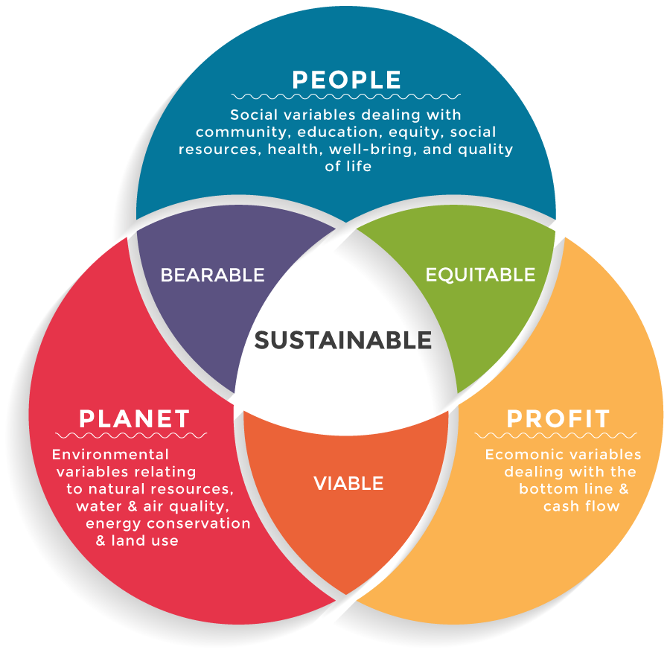 Several practices such as fair trade can help a business be more socially responsible. Many times, farmers can destroy the land and surrounding ecosystem because of toxic chemicals that are used in their farm land. Fair trading ensures that “…fair prices for farmers, better labor standards, or maybe even safe working conditions” (Fair Trade USA, 2015). Therefore, people who work in factories in places such as Bangladesh who have a fair trade agreement with the manufacturer have better working conditions and get paid a fair and livable wage to survive. One company that has provided fair trade is FOSSIL, the watch company. Teaming up with ME to WE, the company provides these female artisans with financial literacy and leadership training tools which help her and her family break the cycle of poverty. The company wants to follow their footsteps in making the lives of people who are not in well-developed countries make their way there. Helping the people who work for you in not only a responsibility, but it is morally right. Fair trading also helps farmers of all kind, coffee, bananas, chocolate or cotton, gain a larger fraction of the final good being sold. Aditi Fruitwala states in her article *The Case of Organic Cotton*, “Organic cotton is grown without chemical fertilizers, defoliants, pesticides, or herbicides, and from untreated, non genetically-modified seed”. When a consumer buys a fair traded product, they support a healthy lifestyle for themselves and the farmers from around the world. Another company like Patagonia pays premium for every fair trade item and whatever is paid extra, goes directly to the worker without management. Patagonia adopted the fair trade practice in 2014 and gives consumer awareness that the company is doing a good deed and giving back to the community. The Wrights will pay a fair and livable wage to the people who live in third world countries and protect our farmers who provide the material for us.

Protecting organic cotton farmers is crucial in a socially responsible retailer like ours. We want to implement the protection of our farmers who provide our materials. We will pay them a fair price for the cotton they produce for us and make sure they are in safe working conditions. Thomas Schueneman (2014) from Triple Pundit writes that “Cotton accounts for 40% of global textile production, supporting the livelihoods of nearly 300 million people or nearly 7% of all labor in the developing world.” People depend on this product but no one really knows what happens to cotton farmers who are surrounded by all of the chemicals that are needed to produce it. Textiles production pollutes about 200 tons of water because of the harmful chemicals used. This is what is so important to The Wrights, we need to make sure our products are made with care and not damaging the surrounding environment. Doing this, we will make a better name for ourselves. The Organic Cotton Organization (2017) explains perfectly in their article *Risk of Cotton Farming* what happens when a highly intensive pesticide crop is grown and farmers cannot protect themselves, “Conventional cotton production has a series of social and economic risks, especially for small farmers in developing countries. Many small farmers in the South fall ill or die due to a lack of adequate equipment and knowledge about how to handle pesticides properly.” Cotton is still very much a cash crop however; it can still threat the security of small farmers in constantly changing weather climates.

The investment of clean and renewable energy is another good way to be a socially responsible retailer. This can mean the small things like recycling or LED lights or the larger things like solar energy. The prestigious LEED award is “…the nation's top rating system for design, construction and operation of high performance green buildings, homes and neighborhoods” (“Striking Gold: Conrad New York Awarded Prestigious LEED® Gold for New Construction Certification,” 2013). Understanding this concept tells you that the Conrad Building in the Lower Manhattan Battery Park City, is a completely green and certified gold building. This building is so energy efficient that it creates more green energy than it actually needs to process and function throughout the day all while catering to guests in its hotel and restaurant. Not only can retailers be socially responsible by taking care of others but they can start that with the building they occupy. Stella McCartney, a British fashion designer, is one of the first luxury designers who incorporate animal cruelty in her designs. Not only is she protecting animals, but her store layout is powered by renewable energy. Showrooms and stores feature solar panels, FSC woods and the LED lights converse to 75% of the energy.

One of the leading sportswear apparel and footwear companies is Puma. Puma is one of the first companies to publish a full Environmental Profit and Loss Account in 2011. The Profit and Loss Account states the operations and cost from the Puma supply chains. The Profit and Loss Account also helps the company have better control in their supply chain and they know exactly what is happening in their company. The analysis show 85% of Puma’s impact came from raw materials. Puma identified the problem and now is being responsible with suppliers to reduce cutting machines, incorporating new sewing technology and investing in new advances in technology. In the article *Puma to Release CSR Report on Economic and Environmental Impact on Ecosystems* by Ian Andrew (2011), he states “Another strategy Puma stays in the game of being sustainable is reusing 100% recycled polyester fibers and recovers manufacturing scrap waste.” If The Wrights incorporate this, we can cut down on costs while making profit. Puma not only incorporates the triple bottom line theory, they show how a business can create long term results within the company. By creating these justifications, The Wrights can be socially responsible by:

* Paying farmers a fair and livable wage,
* Protecting cotton farmers,
* Always trying to improve on technology to refine our business,
* Recyclable fashion,
* Renewable, green and clean energy.

**Section 3 – Business Concept**

Now more than any time of history, it’s easy to travel around the world. Finland is number one on the list of the people who travel the most in the world. Finnish people are most likely to travel 7-8 times a year. About 5 out 7 times, their trips are domestic while the others are international. We are a packing solution to frequent travelers, selling an airport jacket renamed to “The Wrights”. The Wrights is a wearable suitcase outerwear with no more worrying about extra baggage fees. Providing certified high quality materials. No animal cruelty in the making.

**Mission Statement:** Is to create a product that would suit and help our customer while also helping the world environmentally and socially.

**Vision Statement:** Creating quality goods that out last trends and provided long lasting qualities. Strategies include reusable sources, less water usage and fair trade.

**Strategies:** Through selling quality and substance over fast production and looking over the minute details we excel in.

**Location:** Capital of Finland, Helsinki. Most tourist and foot traffic in Finland.

**Price points:** 190 euros (Spring) & 290 euros (Winter)

**Retail Format:** As an upcoming brand, our preliminary budget is $300k and the floor plan is going to be about 1,500 square ft. (Small Boutique). We are an independent retailer who specialized in outerwear tech.

The budget consist of covering the

* Average wages to be pay out to workers
* Manufacturing / producing
* Displays
* Retail rent
* Fair trade
* Best quality materials for our product
* Online website
* Transportation / Shipping

**Individual responsibility:**

Gabriel Tossas: Logistics and quality control / Ecommerce: responsible for all online activities, advertising decision, distribution / transportation cost, and ensure production standard

Rita Peni**:** Labor and store management: supervising staff, managing budget, maintaining statistical and financial records, cleaning & preparing workplace, loading / delivery products

Jane Lee:Designs & Visual coordinator: Sketch designs, select materials, promotion displays, floor layout and implement merchandising strategy.

Sherri Nguyen: Loss and Prevention / Visuals: Ensure workplace safety, coming up of ways to prevent loss from merchandise. Creating eye-catching visual displays that lead customers through the store.

**E-Commerce:** Being that the main store is in Helsinki Finland, we offer an online website to all consumers to purchase within or outside the country.

**Main Competitors:**

* The North Face
* Canada Goose
* LUTHA
* Columbia

**Materials:** We want to follow by the Finnish culture of being sustainable having reusable fabrics and obtaining local sources. For our winter season, jackets is made from 100% wool but we do not promote animal cruelty so we decided for the sheep /lamb to be shaved not killed.

**Product Description:**

* 14 deep pockets
* Fully adjustable zipper (length purposes)
* Include portable bag options: tote, duffle or backpack
* Spring Colors: pastel pink, neutral, white, lavender, mint green
* Winter Colors: emerald green, tan, burgundy red
* All season colors: Black, navy blue, heather grey, olive green
* Holds up to 33 pounds = 15 kilos
* Allows a laptop, tablet, 5 t-shirts, a pair of jean, 2 pairs of shoes, 1 jumper (sweater) and a SLR camera
* Sizes: XS – XXXXL (Both genders)

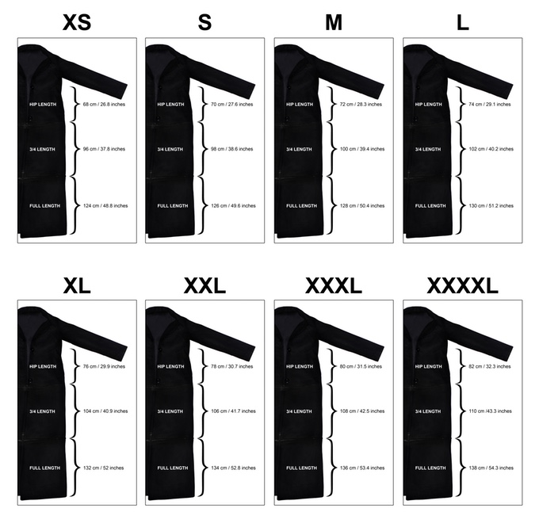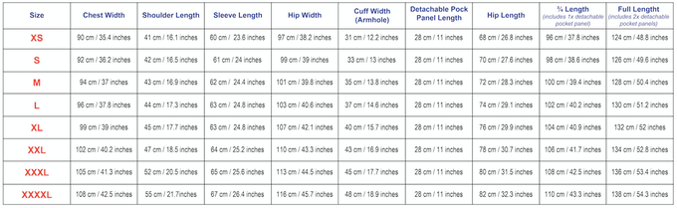**Measurement for Women:**

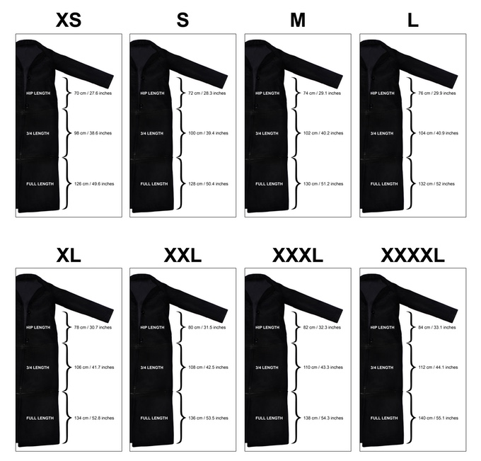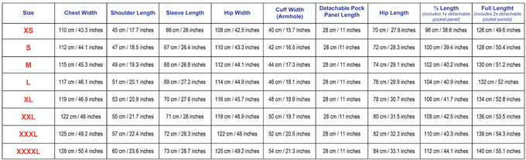Measurement for Men:

**Section 4 – Industry Segment and Market Analysis**

The outerwear industry aka the apparel industry includes apparel, accessories, and footwear. It is a huge market, totaling to be a multibillion dollar industry. The most profitable in the industry is the women’s clothing, equaling to about 53% of total revenue (Euromonitor, 2017). Apparel is a very seasonal business, and is its most profitable during the holidays. The market is made of well-branded retailers who make up a chunk of the apparel market. The rest is made of boutiques, and small businesses. Larger stores like the well-branded retailers make the most profit, because the product is offered at a retail price, and pertains to a larger target market. Finland’s largest market segment is the “clothing” market; its volume is to be at about $868 million US dollars (Euromonitor, 2017).

E-commerce is set to continue to increase by the looks of its popularity now (Fashion and Apparel, 2017). The markets demand is for e-commerce to take over. The colder weather that takes place is also a demand for better, and warmer outerwear; making our jacket a perfect fit for our target. The apparel industry in Finland seeks media visibility, to turn their media into profits. Finnish fashion also seeks investors to turn their projects into fashion icons, and legendary trends. The business trends we see are increasingly strengthened by online sales. In brick and motor stores, mobile payment options are becoming important to younger shoppers (Retail Industry Analysis, 2017). Smaller retail stores are shying away from deep inventories, going narrower with specialty items; because online market offers more (Retail Industry Analysis,2017). The best customer service experience that is noticed is also known as the “frictionless shopping experience”, where you order online to pick up in store making it an east payment option (Retail Industry Analysis,2017).

**Legal Considerations – (Trade Agreement, export policies and tariffs on products) –**Finland has several trade agreements that they have signed off on. With these trade agreements, they help protect some of Finland's own inventions and exports. These agreements can also be able to help foster a stronger economic system. By being members ofthesevarious trade agreements, Finland is able to keep the growth of its own economy and importing goods at a strong level.The policies of Finland’s trade agreement vary from date they are signed to their purpose. WIPO is an agreement that is from the United Nations and its purpose is to have a strong and effective plan on a countries intellectual property (Trade Policy, 2016). This agreement protects and allows Finland’s tech in all fields to be protected. UNECE is a trade agreement by the United Nations that was created in 1947(Trade Policy, 2016). This was to help a countries economy. Its bandwidth includes discussions in economic, technological and societal fields.WTO trade agreement is the thirdtrade policy Finland signed. This helps to create binding agreements between the members that create standards for international trade agreements. The policy also enforces the standards and rules of the trades created by members. There are currently 162 members of the WTO agreement (Trade Policy, 2016).

**Finland market segment structure –**

Finland is a country that is constantly improving. Finland has many shopping malls and smaller shops (Lang LaSalle, 2013). In Helsinki, many shopping malls fall under the category of hypermarket because it is an all in one stop district (Lang LaSalle, 2013). Finnish people get the full satisfaction of all their shopping needs from grocery to department stores and even making a quick stop at a café / restaurant (Lang LaSalle, 2013). Most stores in Finland open from Monday to Friday 9-5 just like anywhere in the world. The only difference is on Saturday; shops are open 9-2 or are extended until 4pm at most (Who Sells What? Finnish Retailers, 2017). Most shops are closed on Sundays unless they are a larger corporation (Who Sells What? Finnish Retailers, 2017). Depending on the seasons, for example the summer, stores are open seven days a week and extended hours happen due to more markets offered in the summer (Who Sells What? Finnish Retailers, 2017). Besides shopping malls, Finnish people support local designers and these people comprise of the market of smaller shops. Looking in depth with Helsinki, they are still growing and do not have many large global retailers like New York (Helsinki Shopping Districts, 2016). A major retailer in Finland includes Ikea, Starbucks, Zara, McDonald and H&M; most of the other retailers are all Finnish brands (Helsinki Shopping Districts, 2016). The major retailers are either found in hypermarket malls or in the district of Helsinki where they 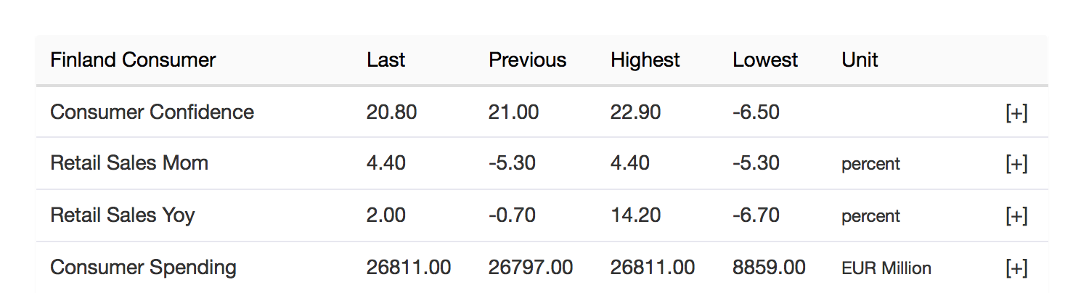have a store itself. Consumer Confidence is high in Finland, meaning people are positive about the economic health. Look below for statistic number.

Retrieved from: http://www.tradingeconomics.com/finland/retail-sales-yoy

Although Finland has many products to offer in shopping district, Finland tends to do better with e-commerce due to the fact there’s more variety in discount companies that are competing with regular department store and grocery (Trade Economics, 2017).

The major brands, and manufactures and designers within the segment are very popular. The top three are Christian Dior, Nike, Zara; and are established as the most profitable names in apparel and fashion (McGrath, 2016). “Companies in this industry manufacture garments made from purchased fabric, and from fabric they produce themselves. These companies include Hanesbrands, PVH, Ralph Lauren, and VF Corporation, along with Michael Kors, and Prada (McGrath, 2016). The top six designers in the industry are, Coco Chanel, Donna Karan, Giorgio Armani, Calvin Klein, Donatella Versace, Ralph Lauren (McGrath, 2016).

**Section 5 – Competitive Analysis**

**The North Face**

The North Face Inc. is an American outdoor product company that specializes in outerwear, fleece, coats, shirts, footwear and athletic equipment (The North Face Our Story, 2017). The Wrights see North Face Inc. as a competitor in manufacturing outerwear and selling outdoor products because they’re well known. In Finland, most people are well connected to nature and like to be outdoors so it gives North Face Inc. a chance to compete with our company. North Face Inc. has been in the industry since 1968 and is known for making durable jackets for anyone who likes to travel or do outdoor activities (The North Face Our Story, 2017). Some of North Face strengths are offering their products to men, women, and children. This means that they cover more area because they appeal to both genders and people of all ages. The brand is partnered up with “Clothes the loops”, a program where consumers are encouraged to bring unwanted clothes and footwear of any brand names. It can be brought in any type of condition to one of North Face Inc. stores and consumers will receive a $10 reward toward their next purchase of $100 and more (The North Face Responsibility, 2017). Since North Face Inc. is part of the recycling program, The Wrights wants to incorporate a recycling concept to our brand and give our customers 15% off toward their next purchase with no minimum amount. North Face has the upper hand when their products are being sold at department stores, chain store, the internet and social media (The North Face Our Story, 2017). Being that the company been around for more than 5 decades, that doesn’t limited their opportunities to expand and grow. All of the North Face products have a lifetime warranty (Brandao, 2015). One of North Face weakness is pricing because some of their jackets are put at a very high price due to the name recognition and the quality focusing on new sustainability (Patterson, 2011). A minor weakness of North Face products are mainly target for cold weather season (winter season only) while The Wrights are making a traveler jacket for fall and spring season (Patterson, 2011). Taking a look from our competitors, we give our customers the options of changing lengths of the jacket so they don’t have to stick to one style. Some of North Face opportunities can be incorporating more innovated technologies into their products (Brandao, 2015). With it being an American brand, it can expand internationally to attract more customers all over the world. One of the major threats North Face needs to find a solution for is knock off versions of their jackets, many people cannot afford the real one (Brandao, 2015). In conclusion, The Wrights don’t want to have limited opportunities. Finland is the main location for this traveler jacket and we will the product online and promote it on social media to spread the word. A recycling program will be incorporate in stores to be more efficient. Our jacket will also have a lifetime guarantee so our consumers know they are getting a great product.

**Columbia**

Columbia sportswear and outerwear is one of The Wrights’ competitors, and has seniority being that the brand has existed since 1938. Columbia is a brand that carries outerwear but the parent company is their Columbia Sportswear (Zigu,2017). The brand, sold in Finland which makes it one of our competitors, targets a similar consumer such as ours, being the “…urban upper and upper middle class men and women; with the age group, more in the young range” (Zigu,2017). The strengths this outerwear and sportswear brand has been mainly the legacy the brand holds for over 7 decades. “The brands unique digital marketing for every sport outfit has been a success, along with its presence in more than 72 countries through over 13,000 retailers” (Zigu,2017). One of the brands weaknesses that can help our brand along with the fact that Columbia has not advertised as much as compared to other global retailers in the outerwear field; is that they also are “…not well known as its competitors in other parts of the world” (Zigu,2017). This plays as advantage to us to build our brand image in Finland. Columbia’s social responsibility program has “… standards of manufacturing practice, or what they call SMP, this means their products are manufactured at independent factories around the world” (Columbia, 2017). As a company who cares for values, and ethics, Columbia treats partners, and laborers in it very fair. What we can do to exceed their advantage in social responsibility, is create a plan to maybe go on as well manufacturing in different factories worldwide. Columbia’s opportunities lie in its ability to try to start more “…independent retail operations, to establish its identity as a formidable brand” (Zigu,2017). The brands jackets also sell for about $200-$900, which can downfall most young retail consumers.A major opportunity along with any of our competitors is to get more into the field of e-retailing, to improve the brands overall brand visibility. Being that our world globally has taken into the internet as a main source for shopping due to its easy access, and speed; this can increase the size of their target market. As for threats for Columbia Jackets/sportswear, the fight to keep brand loyalty due to “the level of fragmentation in the apparel and accessories market is detrimental” meaning it’s a tough field to create that loyal customer (Zigu,2017). A major issue is also counterfeit products which can take away the consumer’s loyalty because of the price being lower. Columbia’s brand image, and how they build will take time outside the US, in countries like Finland due to competition, and the overall brands identity.

**Canada Goose**

Canada Goose was created in Toronto and has been in the industry since 1957 (Our History, 2017). They manufacture jackets, coats, vests, hats, gloves and several other apparel items aimed for colder weather. “Canada Goose jacketsdidn’t start out as items to be owned by consultants and lawyers, but rather as performance gear for the coldest of weather” (Malone, 2015). Finland is an extremely cold place during the winter, their coldest month is February. Temperatures reach about -7 $°$ F, however, in northern Finland; it reaches about -58°F (WeatherOnline, 2017). Since most of the year is quiet cold, Finnish people would invest their money in a well known, warm product. This is one advantage Canada Goose may have over our company. We do not possess the brand loyalty they have in Finland yet. They also appeal to men, women and children, this expands their target market and they cover more ground this way. Canada Goose is one of our competitors because they are used in pop culture which attracts younger consumers, this in turn made the brand explode in popularity. Although they do carry these strengths, people question their ethics and social responsibility. The question on their ethics to animal rights is one of their weaknesses. The hoods on a Canada Goose jacket are made with coyote fur and stuffed with down made from geese and ducks (Burrell, 2014). This makes some people turn away from their products because of the use of animal skins and material. The way they counter this is by The Canada Goose Down Transparency Standard (Fur and Down Policy, 2017). This helps their company by making sure that all the fur and down material can be traced down to where it came from and also makes sure that these animals are treated with care. Even though they have this transparency, people still deflect their efforts and products. This is where our company can thrive and jump at the opportunity because we would only be using natural products or man made products. This way, people would feel more comfortable using our products instead of Canada Goose because there wouldn’t be the question or the possibility of us doing the unethical and irresponsible killing of animals for their fur or feathers. Including the fact that they have a questionable ethical standing, their jackets start at a price of about $700 and keep increasing well into the $1,000 mark. Our company definitely does better in this category because it isn’t an obscene number.

**LUHTA**

LUHTA is a brand established by Vihtori Luhtanen and he started the brand in the year 1907 in Lahti Finland (Luhta a, 2017). With the brand being firmly established in Finland, its will be a brand that is major competitor to us in the outdoor apparel market. LUHTA Sportswear is subsidiary of LUHTA and is currently one of the biggest clothing manufactures in Europe. This gives them a huge advantage in brand equity and an easier ability to attract new consumers to the market. Another core strength of the LUHTA Company is their ability to say that they have been in business in Finland for over a hundred years (luhta a, 2017). They also have more of an advantage of knowing the Nordica consumer better as we are trying to currently import and test our product in Finland. Although LUHTA has the advantage of appeal and known for its great outwear brand, they have lacked in selling or producing anything currently that the market is looking for. We are producing a product with a clear advantage to market aspects. LUHTA is socially responsible by creating clothing that abides by animal rights policies. This means that they require certificates of origin for ethical treatment of any animal for furs, downs and leathers used in their products (luhta b, 2017). Using the ability of being a large company, LUHTA has participated in social business compliance initiatives. This is one of the biggest social responsibility programs that aims to enforce strong health and ethical policies for its workers (luhta c, 2017). Our company has some major key points in a social responsibility form to combat that advantage by LUHTA. One of these points would be our recycling program. This would reward consumers who recycle textiles that are deemed reusable. They will receive 15% off of their purchase on our airport jacket. Another key advantage for us is the production of our jackets being hand made in the USA. While it is costly, it does ensure our new consumers in Finland that these products were hand crafted and built durably to last a lifetime. Using reusable bags is another way we can cut down on paper usage and we are a strict paperless email receipt.

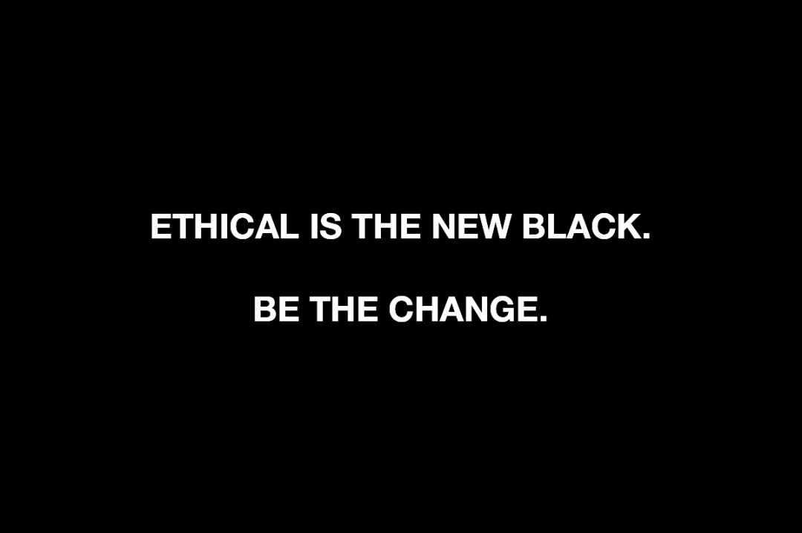 The Wrights sells wearable luggage as jacket. In order to get insight of the business, we conducted a SWOT analysis to see internal and externals factors. This includes strengths, weakness, threats, and opportunities with other companies in the outerwear industry. With a SWOT analysis, we can overcome our competitors in how to be more socially responsible. Methods such as making sure our jacket is made with recyclable materials and incorporating recycle programs. The Wrights want to meet the demand and satisfy our consumers to the fullest.

(Ethical fashion brands doing Black Fridays deals, 2016).

Strengths Weakness

|  |  |
| --- | --- |
| * Recyclable materials * Multiple pockets. (14) * Adjustable lengths * Fair trade * No animals cruelty * Small focused company * Highly funded | * Advertisements |
| * Knock off version * Brands sold in the same regions * Brand legacy / popularity | * Recycling programs * Expand globally |

Threats Opportunities

**Section 6 – Target Cusomer**

The Wrights’ consumer base is the second highest in the population bracket between the ages of 16 to 24. Our focus includes both males and females. The average consumer for our product would be at their peak career level and their career would require traveling quite often. The ideal consumer to shop at our stores would be one to appreciate our socially responsible activities, consider the high quality they search for in apparel products, be willing to spend a high amount, have a college degree and would travel often. The average income in Finland is $28,238/year in US dollars. 70% of men with 68% of women are in paid work; which is why we want to target both males and females (OECD, 2017). The most important factors affecting Finnish consumer behavior are quality, safety and the product origin. Brand is considered a strong signal of quality (Finland: Reaching the Consumer, 2017). The average consumer has a high quality of living, and purchases mainly with quality in mind, making our jacket number one in apparel for Finnish travelers.

According to Prizm Clusters, the lifestyle for our consumer would be described as the young accumulators, this group comprises of people who “…typically have college educations and work a mix of white-collar managerial and professional jobs. Found mostly in suburban and exurban areas, the large families in Young Accumulators have fashioned comfortable, upscale lifestyles in their mid-sized homes” (Clarita’s PrizmLife Stage Group, 2017). This group of consumers thinks about a more professional life and requires high quality brands. Our consumer is eco-friendly and cares for the environment, therefore, the use of our eco-friendly material which is an added plus to their clean-living country, is also a top choice of product for them. The psychographic breakdown of our consumer is best seen as strivers, experiencers, thinkers, and believers. They strive because they believe in better living and typically wear their wealth (VALS, 2017). They are experiencers because they “…want everything, are first in and first out of trend adoption, are up to the latest fashions, and spontaneous” (VALS,2017). They are also thinkers because they think of the multiple ways that the Wrights jacket can be worn. Lastly our consumers are believers because they have strong me-too fashion attitudes.

Behavioral Customs by the Finnish people come from different parts of life. As with any country growing the 21st century, e-commerce has become a big platform for the country to sell apparel. With the use of e-commerce, it allows the country to increase their ability to purchase goods at a higher frequency. Since the frequency of shopping had increased, this allows new labels and companies to create brand loyalty in the market. Although the core target market is still price conscious, this is due to the natural economic struggle that has recently just passed. Recent trends have started to bubble in the country of Finland, the idea of being socially responsible has become of huge importance to the youth of Finland. Brands such as Globe Hope are on Finland’s premier eco brands that we are currently targeting by using sustainable goods. The repurposing of old hospital textiles and use of other materials into uniforms, bags, shoes and accessories, Globe Hope have created more awareness in the country (Pantzar, 2013). With emphasis on sustainability, the market was able to expand into more of the target market in Finland and the world. Paola Suhonen’s Ivana Helsinki, an ethically made-in-Finland label, was the first-ever Finnish name to be invited to the prestigious Paris Fashion Week (Pantzar, 2013).. This market group has slowly started to mark the importance on being socially responsible, as not just a trend but a way to help increase the environmental footprint by making cleaner and better purchases. These strategic moves and brand growth in the department have helped Finnish consumers realize that being socially responsible can give customers better feelings on making purchases.

**Section 7 – Sourcing Structure**

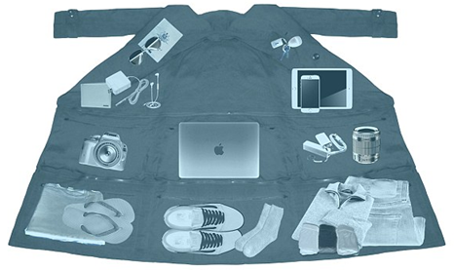 More consumers are curious as to where their products are sourced and how a company can give back to the environment. Many retail businesses are aiming towards a greener business and want to do better by the environment and the people they work with. For the company to source its products better and be truly socially responsible, we believe that it starts with the environment and taking care of the people who work for us. This means taking care of the environment we work in and fair trading will be the biggest practices that will be incorporated within our business plan.

(Thornhill, 2017)1

Corporate social responsibility (CSR) is not only becoming a regular practice in the retail world, but is expected of employees and consumers. By practicing this, it means that the business is not only doing right by the people and environment, but also good for business. Although fair trade and organic products are a great way to be socially responsible, “one of the most common ways to engage in CSR is to support a charitable organization**. Look for a group that supports a cause you believe in, get in touch, and strategize on how you can support them” (Nicasio, 2016). Not only should The Wrights be working within the company, we should be working with others to do better to achieve a larger goal and see the bigger picture. “**…an informal study of 390 consumers found that ‘over 75% of respondents agreed that they would be willing to pay more for clothing produced using responsible labor practice” (Nicasio, 2016), understanding this, we know that people would not mind paying the extra dollar knowing it would go to a better cause. Price is not going to be an issue when it comes to our product. Our consumers know that our jacket would be a great product to invest in as well as making the world a better place.

Social responsibility should not stop at your business plan. It should extend further and penetrate other markets that can help other people. “…companies that ensure they are giving back or reducing the impact of their industry on humanity and ecology will enjoy more loyalty from their customers than those that do not” (Fallon, 2017). Companies such as Do Good Buy Us, Krochet Kids and People Water would be good companies to team with even if they are helping a different cause. Even though we are a retail company, doing the right and ethical thing goes further than just the fashion industry.

Forbes writer Susan McPherson states that there are 8 CSR trends that are emerging in 2015. One trend is companies solving these social and environmental problems at a bigger scale. Because we live in the technology age, we are more exposed through our smart phones and the internet. “…we have a powerful new way to unite people and drive solutions that truly solve some of the biggest social and environmental issues around the globe" (McPherson, 2014). Another CSR trend that is coming about is the increasing focus that is coming to women in position of power, “…advance the economic empowerment of girls and women – from education and technology access programs” (McPherson, 2014).

Fair trading would take place in our products materials. “Fair trade boils down to promoting sustainable, fair price trading at all levels of business. Most efforts focus on individual or small group producers in third world countries” (**Fair Trade Practices**, 2017). Support for local farmers and paying people, whether third world country or not, receive a livable wage. By abiding to fair trading policies, this means we open our account reports to the public; the company should have nothing to hide from the public if we are doing the right thing. The company should also promote good working conditions, taking care of our employees would be top priority because the better we take care of them, the more loyal they will be to our company and our consumers would see the ethical belief in that. “Fair Trade Organizations are aware of the health and safety conditions in the producer groups they buy from. They seek, on an ongoing basis, to raise awareness of health and safety issues and improve health and safety practices in producer groups” (10 Principles of Fair Trade, 2017).

Companies such as Google and Target have been investing into being a greener company. This not only helps lower costs but keeps the company efficient. “Google Green is a corporate effort to use resources efficiently and support renewable power… Google has seen an overall drop in power requirements for their data centers by an average of 50 percent. These savings can then be redirected to other areas of the business or to investors” (Moreno, 2015).We can learn from Google and their aim towards a greener business which would save money for the company and be able to invest more products or penetrate a new market.

**Section 8 – Marketing**

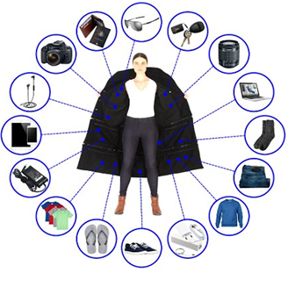The Wrights is a multipurpose wearable luggage jacket. It’s stylish but still meets the needs for travelers to carry almost everything in this jacket. As a company we looked at our 4 P’s and understood how to promote this jacket as a socially responsible product. The jacket is going to meet the needs for all types of travelers, no matter if you’re a person who travels locally or internationally. The jacket includes 14 deep pockets holding up to 33 pounds. The pocket features can fit up to two pairs of shoes, a 13 inch laptop, a tablet, 2 sets of clothes, a camera, lens, sunglasses, and headphones among other things. Every jacket will include a detachable portable duffle bag in the dimensions 55cm x 40cm x 25cm. This will give travelers the option to fold their jacket into the duffle bag if they prefer not to wear it as a jacket. We want to let our customers know the making of the jacket is completely cruelty free and the whole jacket is water resistant. The jackets will have a lifetime warranty so customers will not have to spend more money to getting another jacket. The Wrights is aware with costly environmental regulations therefore, our location will be in Helsinki, Finland, where it’s the most traveled country. Since the country is small, it gives The Wrights the opportunity to focus on every part of the business and do better. The Wrights wants to outsource the brand from Europe and then internationally. Our jackets are priced at an average rate of 190-290 euros depending on the season of jacket they are buying. Looking at our competitors, we saw that jacket was considered a luxury or expensive item. The Wright wants to pursue exclusively but also affordability, but consumers should know what they are paying for. The mark up includes a percentage that goes to fair trade making sure our employees earns benefits, better working conditions and no dangerous manufacturing factories. Since we’re a brand new company starting up, we will market the brand through social media and putting ads at public transportation stops. (Bus stops & train stations). Finland is a small country itself and it’s not a well known outside especially the United States (Kalb, 2014). People are less likely to purchase something with no clear image or something to remember from that brand (Kalb, 2014). Today, we live in the digital world where everyone is surrounded by a smartphone or rely on Wi-Fi (Fromm, 2016). The Wrights wanted to take advantage of all social media platform like Instagram, Facebook, Snapchat and etc. to spread the word about this wearable luggage jacket. Social media will also cut down on marketing and advertising costs.

(Thornhill, 2017)2

**Section 9 – Budget**

Since our budget of $750,000 to start up this retail company location and inventory, we have allocated $70,000 in remodeling the location to meet our company standards and aesthetic. The store front at 1,900 sq. feet gives us enough space to have visual layouts but leaves a small enough size to be considered a boutique. The monthly rent for the storefront is $2,000 which would leave us with a very good price monthly rent and a yearly rental of $24,000. Out energy bill would be at around $900 month, totaling to about $10,800 annually. This utility charge includes all heat and energy for the storefront. Since we are in a high traffic area, this will help pay for maintenance cost and utilities. The cost of repairs are usually covered by a 3% factor which is to allow for situations such as heating or air conditioning going down or a generator breaking down. The ability for us take out this percent of revenues for repairs allows us to use a retail repairing company which is on call when we need for these situation. This may seem pricey but signing a two year contract at a rate of $30,000 actually is better in the long term. This price is for all things that need manual labor repairs and with this contract, we have flexibility of negotiating a better deal if possible. These are three major keys to running a successful business and if these sections are not handled correctly and priced reasonably, they could bankrupt us. It is vital for us especially when stating that we are expanding into a new country so finding the best possible situation in rental and repairs plus utilities was very high up on our expansion plans, we knew that this was very important to our future success. Remodeling is the only high ticket price item, however, after one remodel, we would not have to pay for it again. This means after the remodel, the company can focus on paying its rent, making profit and finding better ways to make out product better.

Finnish people do not have a universal minimum wage law, however, the company compensates by giving people a company contracts that protects their wage and salary (Telegraf, 2016). The average salary is about 3,300 EUROs a month (Uutiset, 2016). A full time manager would be making $3621.16 USD per month and make $43,900.80 annually. Items in Finland are less expensive than in New York City and other high traffic tourist places so the pay rate is bound to be cheaper. Finland has an amazing and extensive benefit package. The Wrights was to incorporate a socially responsible act with working for our company. One of the most extensive packages is maternity and paternity leave. Finnish people get tax-free check of 140 EUROs and can be increased by the chance of multiple children. This is offered to both biological and adoptive parents (Chait, 2013). “…women are allowed to start maternity leave 50 working days at the earliest and 30 working days at the latest before the estimated delivery” (Chait, 2013). Finland even encourages and supports same sex parenting and they can also obtain the same rights and benefits. This includes money and tax-free checks that can be used for their child. What is amazing about this program is that Finland understands that childcare does not stop at babies. They have extended this through to children who are 17 and under and single parents get more money to raise their child. They also can “…receive a child home care allowance or claim private day care allowance in order to work” (Chait, 2013). The Wrights think that this is a great way to incorporate social responsibility and care about our employees. Therefore, The Wrights will pay enough for insurance for our employees and at least a 3,300 EURO salary per month to all our full time employees. Since Finland has shorter working hours, we would not need too many full time employees and can pay hourly rates of 4-5 EUROs to sales associates. With this information, we can easily have enough money to hire 10-15 employees with two of them being full time.

The Wrights’ jacket would be made of wool which costs about $1.45 per pound in the United States. The United States is where we would manufacture the jackets (sheep 101, 2013). Since our jackets are being made with multiple pockets, we have an estimated weight of each jacket being at least 8 pounds. With our sizes varying from size small (s) to extra-large (xl), our store would carry 30 units of each size, making a total of 120 units. A reorder of the jackets would total to be 960 pounds each shipment. Shipping cost from the United States to Finland would equal to $4,454.40 each shipment carried out by FedEx (International Shipping Calculator, 2017). We would reorder at least once a month, depending on sales for each month. With our winter jackets priced at 290 Euros each, and our spring jackets at 189 Euros; our gross profit for each seasons jacket if all are sold, would be approximately $38,031.60. We expect our winter jackets to sell out faster because of the climate in Finland. This would total to $34,800.38. As for our spring collection depending on how fast we sell each month our gross profit for each month should total to approximately $24,786 for the 120 unit we start with, making that to be $22,680.15.

**References**

Average monthly Salaries inch up to 3,300 Euros. (2016, September 29). *Uutiset.* Retrieved from http://yle.fi/uutiset/osasto/news/average_monthly_salaries_inch_up_to_3300_euros/9199534

Brandao, A. (2015, April 9). Copy of Company Research PEST and SWOT Analysis: The North Face. *Prezi*. Retrieved from: https://prezi.com/7qrdpzgn8du9/copy-of-company-research-pest-and-swot-analysis-the-north-face/

Burrell, I. (2014, October 10). Canada Goose: From Arctic Utility to Urban Chic. *Independent Co. UK.* Retrieved from http://www.independent.co.uk/life-style/fashion/features/canada-goose-from-arctic-utility-to-urban-chic-9780145.html

Canada Goose (2017). Fur and Down Policy. *Canada Goose.* Retrieved from http://www.canadagoose.com/ca/en/fur-and-down-policy/fur-and-down-policy.html

Canada Goose (2017). Our History. *Canada Goose*. Retrieved from https://www.canadagoose.com/us/en/our-history.html

Chait, J. (2013, June 6). Finland’s Family Benefits Prove Why It’s Ranked the Number One Place in the World to be a Parent. *Inhabitots.* Retrieved from http://www.inhabitots.com/finlands-family-benefits-prove-why-its-ranked-the-number-one-place-in-the-world-to-be-a-parent/2/

Claritas PRIZM Lifestage Group. (2017). Retrieved, from https://segmentationsolutions.nielsen.com/mybestsegments/Default.jsp?ID=38&id1=CLA.PNE&webid=&id4=F2&social=no

Columbia. "Social Responsibility | Columbia Sportswear." *Outdoor Clothing, Outerwear & Accessories*. N.p., 2017.

Ethical fashion brands doing Black Fridays deals. (2016, 24 November). *The Eco Edit.* Retrieved from http://www.theecoedit.co.uk/ethical-brands-black-friday-deals/

Euromonitor. (2017, January). Retailing in Finland. Retrieved from http://www.euromonitor.com/retailing-in-finland/report

Europe. (2016, July 13). Retrieved from http://www.worldatlas.com/webimage/countrys/europe/finland/filand.htm

**Fair Trade Practices. (2017). Fair Trade Practices. *Fair Trade Magazine*. Retrieved from http://www.fairtrademag.com/fair-trade-practices/**

Fallon, N. (2017, April 25). 15 Great examples of Socially Responsible Businesses. *Business News Daily.* Retrieved from http://www.businessnewsdaily.com/5499-examples-socially-responsible-businesses.html

Fashion and Apparel. (2017). Retrieved from http://www.vault.com/industries-professions/industries/fashion-and-apparel.aspx

Fashion of Finland. (2016). Retrieved from https://www.statista.com/outlook/244/135/fashion/finland#takeaway

Finland. (2017). Retrieved from http://atlas.media.mit.edu/en/profile/country/fin/

Finland Average Salaries & Expenditures. (2007). Retrieved February 26, 2017, from

http://www.worldsalaries.org/finland.shtml

Finland GDP (purchasing power parity). (2016). Retrieved from

http://www.indexmundi.com/finland/gdp_(purchasing_power_parity).html

Finland Inflation Rate | 1961-2017 | Data | Chart | Calendar | Forecast. (2017). Retrieved from http://www.tradingeconomics.com/finland/inflation-cpi

Finland: Reaching the consumer. (2017). Retrieved, from https://en.portal.santandertrade.com/analyse-markets/finland/reaching-the-consumers

Finland Retail Sales YoY. (2017). *Trading Economics.* Retrieved from http://www.tradingeconomics.com/finland/retail-sales-yoy

Finland Unemployment Rate | 1959-2017 | Data | Chart | Calendar | Forecast. (2017). Retrieved from http://www.tradingeconomics.com/finland/unemployment-rate

Fromm, J. (2016, December 16) What Marketers need to know about social media and Gen Z. *Forbes*. Retrieved from: https://www.forbes.com/sites/jefffromm/2016/12/19/what-marketers-need-to-know-about-social-media-and-gen-z/#64aff0aa7e65

GDP (current US$). (2016). Retrieved from http://data.worldbank.org/indicator/NY.GDP.MKTP.CD?locations=FI

Helsinki Shopping. (2017). Retrieved from http://www.frommers.com/destinations/helsinki/shopping/overview

Helsinki Shopping Districts. (2016, July 6). Retrieved from http://www.world-guides.com/europe/finland/uusimaa/helsinki/helsinki_shopping.html

Hoover’s, Inc. (2017). Apparel Manufacturing Industry Profile. Retrieved from https://www.firstresearch.com/industry-research/Apparel-Manufacturing.html

Illustrated map of Finland. Travels. (2017). Retrieved from https://www.shutterstock.com/image-vector/illustrated-map-finland-travels-441424558?src=AU-CY5cC-GgQTV7pprjb_Q-1-48

International Shipping Calculator | Shipping from USA. (2017). Retrieved, from https://www.myus.com/pricing/calculate-shipping/

Luhta.A. (2017). About Luhta. *Luhta.* Retrieved from http://www.luhta.com/about

Luhta B. (2017). Over Hundred Years of Experience. *Luhta.* Retrieved from http://www.luhtasportswearcompany.fi/en/about-us/about/

Luhta.C. (2017). *Luhta.* Retrieved from http://www.luhtasportswearcompany.fi/en/responsibility/

Kalb, M. (2014, February 6) Finland has a shyness problem. *BusinessInsider*. Retrieved

from: http://www.businessinsider.com/finland-has-a-shyness-problem-2014-2

Koket. (2015, August 31). Top 10 Designers, Top Models and Celebreties – The Fashion of Today. Retrieved from http://www.bykoket.com/blog/top-10-designers-top-models-and-celebrities-the-fashion-of-today/

Lang LaSalle, J. (2013, May 21). Finland’s Dynamic Shopping Centre Scene Continues to Grow. Retrieved from http://www.investinfinland.fi/-/finland-s-dynamic-shopping-centre-scene-continues-to-grow

Lepi, K. (2014, May 23). The Top 10 (And Counting) Education Systems In The World. Retrieved from http://www.edudemic.com/learning-curve-report-education/

Magrath, A. (2014, October 23). The world's most well-travelled nations revealed: Finns and Americans holiday 7.5 times a year... but Brits only take three trips. Retrieved from http://www.dailymail.co.uk/travel/travel_news/article-2802855/The-world-s-travelled-nations-revealed-Finns-Americans-holiday-7-5-times-year-Brits-

Malone, N. (2016, March 6). What Made This The Winder of the Canada Goose. *The Cut.* Retrieved from http://nymag.com/thecut/2015/03/what-made-this-the-winter-of-the-canada-goose.html

# McGrath, M. (2016, May 26). The World's Largest Apparel Companies 2016: Christian Dior, Nike And Inditex Top The List. Retrieved from https://www.forbes.com/sites/maggiemcgrath/2016/05/26/the-worlds-largest-apparel-companies-2016-christian-dior-nike-and-inditex-top-the-list/#2eadc1bc1fc3

McPherson, S. (2014, December 31). Eight CSR Trends to Watch Out For in 2015. *Forbes.* Retrieved fromhttps://www.forbes.com/sites/susanmcpherson/2014/12/31/five-csr-trends-to-watch-out-for-in-2015/#59e0484559e0

Media, T. (2017). Historic inflation Finland - CPI inflation. Retrieved fromhttp://www.inflation.eu/inflation-rates/finland/historic-inflation/cpi-inflation-finland.aspx

**Moreno, C. (2015, February 10).** Doing Their Part: 3 Excellent Examples of Corporate Social Responsibility. *Redshift.* Retrieved from **https://redshift.autodesk.com/doing-their-part-3-excellent-examples-of-corporate-social-responsibility/**

Nicasio, F. (2016, April 5). A Retailer’s Guide to Corporate Social Responsibility: Why Giving Back is Good for Business. Retrieved from https://blog.vendhq.com/post/64901828838/retailers-guide-corporate-social-responsibility-giving-back-good-business

Nordea, B. (2017). Finns save without a plan. Retrieved from https://www.nordea.com/fi/media/uutiset-ja-lehdistotiedotteet/press-releases/2011/2011-09-13-finns-save-without-a-plan.html

OEC – Finland. (2017). Retrieved from http://atlas.media.mit.edu/en/profile/country/fin/#Imports

Oecd. (2017). Finland. Retrieved from http://www.oecdbetterlifeindex.org/countries/finland/

Pantzar,K.(2013,November).Capital Shopping With a Social Conscience .Retrieved from https://finland.fi/life-society/capital-shopping-with-a-social-conscience/

Parliamentarism in Finland. (2016, January 22). Retrieved from

https://finland.fi/life-society/parliamentarism-in-finland/

Patterson, A. (2011, September 25). The North Face Advertising Strategy Plan.*SlideShare.* Retrieved from https://www.slideshare.net/AshPatt14/the-north-face-advertising-strategy-plan

Political system - Embassy of Finland, Riga : About Finland . (2017). Retrieved from http://www.finland.lv/public/default.aspx?nodeid=44903&contentlan=2&culture=en-US

Popponen, H. (2014, December 2). It’s time for Finnish fashion to take the next big leap. Retrieved from http://www.helsinkidesignweek.com/weekly/its-time-for-finnish-fashion-to-take-the-big-leap/?lang=en

Retail Industry Analysis 2017 – Cost & Trends. (2017). Retrieved from https://www.franchisehelp.com/industry-reports/retail-industry-report/

Teivainen, A. (2014, May 28). Finland has lowest income inequality in EU. Retrieved from https://www.helsinkitimes.fi/finland/finland-news/domestic/10727-finland-has-lowest-income-inequality-in-eu.html

The North Face. (2017). Our Story. The North Face. Retrieved from: https://www.thenorthface.com/about-us/our-story.html

The North Face. (2017). Responsibility. The North Face. Retrieved from: https://www.thenorthface.com/about-us/responsibility/product/clothes-the-loop.html

Thornhill, T. (2017, February 14)1. Avoid excess baggage charges…by wearing your luggage: The Airport jacket has enough pockets to hold 15kg of items. *Daily Mail.* Retrieved from: http://www.dailymail.co.uk/travel/travel_news/article-4224170/The-Airport-Jacket-means-wear-luggage.html

Thornhill, T. (2017, February 14)2. Avoid excess baggage charges…by wearing your luggage: The Airport jacket has enough pockets to hold 15kg of items. *Daily Mail.* Retrieved from: http://www.dailymail.co.uk/travel/travel_news/article-4224170/The-Airport-Jacket-means-wear-luggage.html

Trade Policy - Permanent Mission of Finland, Geneva : Fields of activities : Trade Policy. (2016, September 27). Retrieved from http://www.finlandmission.ch/public/default.aspx?nodeid=35478&contentlan=2&culture=en-US

The world's biggest travelers - which nationality takes the most trips? (2014, October 20). Retrieved from http://www.traveller.com.au/the-worlds-biggest-travellers--which-nationality-takes-the-most-trips-11979j

Sheep 101INFO. (2013). Retrieved from http://www.sheep101.info/wool.html/

VALS™ | VALS™ Types | Believers | SBI. (2017). Retrieved April, from

http://www.strategicbusinessinsights.com/vals/ustypes/believers.shtml

Wagner, N. (2017). Analysis of the Retail Apparel Industry. Retrieved from http://smallbusiness.chron.com/analysis-retail-apparel-industry-70514.html

WeatherOnline (2017). Finland. Retrieved from http://www.weatheronline.co.uk/reports/climate/Finland.htm

Wei, W. (2016, January 09). Finland’s current situation: The Macroeconomic Perspective. Retrieved from https://thehieno.com/2015/10/13/why-finland-is-not-for-the-ambitious-the-macroeconomic-perspective/

Who Sells What? Finnish Retailers. (2017). Retrieved from http://www.expat-finland.com/shopping_in_finland/retailers.html

Worldometers. (2017). Finland Population (LIVE). Retrieved from http://www.worldometers.info/world-population/finland-population/

Ylä-Jarkko, M. (2016, August 12). Retail trade sales grew by 0.8 per cent year-on-year in June. Retrieved from http://www.stat.fi/til/klv/2016/06/klv_2016_06_2016-08-12_tie_002_en.html

You want to work in Finland? Average salary is 4.000 Euros, and here is what you need. (2016, March 29). *Telegraf.* Retrieved from www.telegraf.rs/english/2069249-you-want-to-work-in-finland-average-salary-is-4-000-euros-and-here-is-what-you-need

Zigu. (2017). Columbia Sportswear SWOT Analysis | USP & Competitors | BrandGuide. Retrieved from http://www.mbaskool.com/brandguide/lifestyle-and-retail/3577-columbia-sportswear.html

10 Principles of Fair Trade. (2013). 10 Principles of Fair Trade. *WFTO.* Retrieved from http://wfto.com/fair-trade/10-principles-fair-trade