Trend Analysis of Skirts
Jane Lee, Gabriel Tossas, Zehra Ahmad, Amanda Lopez, Jenniffer Quezada

Trend Forecasting and Social Media
Professor Roberts
May 14, 2018

The Plaid Skirt
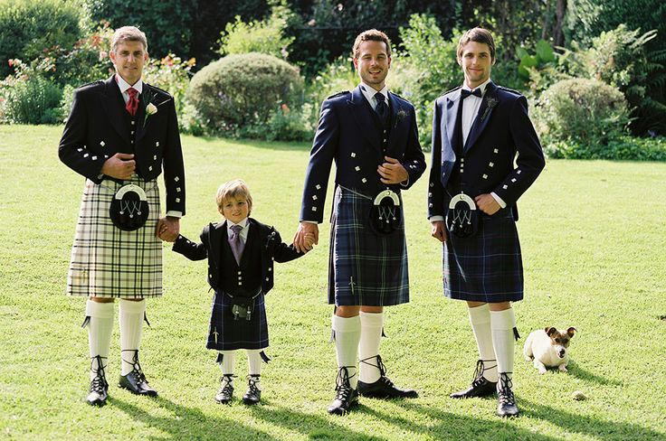
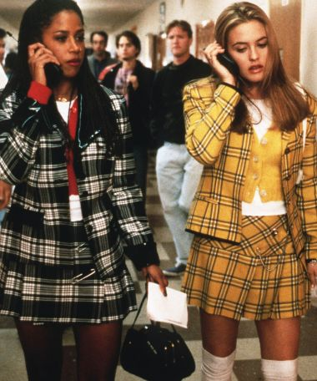
Plaid has long been a defining pattern in fashion. It has been used in many different garments such as skirts, flannels and linings of jackets. The fabric of plaid can be made from many different materials. Wool and cotton are perfect examples of plaid skirts. Styling this iconic plaid skirt has gone through many phases. In the 1500’s, the Scottish used tartan to differentiate between one geographical region to another. We can predict that the styling of this skirt will go through the fashion pendulum. For now, it’s a mini, it’s a very Clueless kind of theme since nostalgia is making a comeback. Since the Spring/Summer season is approaching, there are several colors that this can come in. There are two different directions of color, “on one side towards a strong, vibrant palette, that recalls fauvist pictures, on the other towards pastel hues on light and destructured garments for an ethereal look,” (Olivia, 2018.) Several colors that are trending currently include lavender, rapture rose, military green, sky blue, milk white, yellow and chocolate brown. Silhouettes come in A-line and but will eventually become longer. Since the pendulum is on the shorter side, it will eventually change over to the longer side maybe when the seasons change again. This chic garment and pattern is a staple in an urban girl’s wardrobe.
(Figure 1 – Scottish Kilts, 2018)
Plaid has had a long history in fashion. It has gone through many phases in history, skipping to the 1970’s, it is a form of “liberated, devil-may-care style” (Atwood, 2014). Plaid became a huge pattern and was put on everything from garments to interior elements. It has been part of the punk and grunge movement which will later on become a symbol of rebellion. Going into the 1990’s, plaid became a huge garment statement for bands and other people who were into grunge fashion. However, it was not only grunge. As stated before, plaid was incorporated into the movie Clueless, plaid was no longer only rebellious, it was popular like Cher.
(Figure 2 – Clueless, 1995)
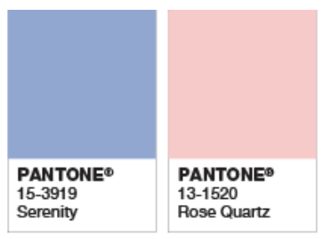
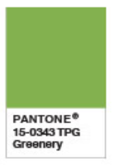
The colors chosen feel like they came straight out of the ‘90’s. Nostalgia and old pop culture movies are popular again and everyone is copying those movies. Even though the style is old, it is becoming modern again by just changing the color to be more on trend. Color plays an integral part of a garment being on trend or not because color is ever changing. Predicting Spring/Summer 2020 color trends will be an array of colors. Fashion is always in a cycle, colors reoccur, silhouettes return in a newer and chic way and styles gain a new and revived look. Colors such as rose quartz was trending back in 2016 and since the cycle will return for the warmer season, this color may come back, possibly in a lighter shade. Other colors were lilac gray and serenity, (DeSimone, 2015). Pantone has also stated that rose quartz and serenity are the colors of the year back in 2016 (Pantone, 2018) so they will either be reoccurring in the coming years or have a variation of it. Interestingly enough, in 2017, the color of the year was called greenery. “A refreshing and revitalizing shade, Greenery is symbolic of new beginnings… evokes the first days of spring when nature’s greens revive, restore and renew. Illustrative of flourishing foliage and the lushness of the great outdoors, the fortifying attributes of Greenery signals consumers to take a deep breath, oxygenate and reinvigorate.” (Pantone, 2018). This was right after the election and this color signified that there will be a new beginning and to take a deep breath for what would be coming next. Color also needed to reflect the zeitgeist of the time.
(Figure 3 – Pantone Color of the Year, 2016)
(Figure 4 – Pantone Color of the Year, 2017)
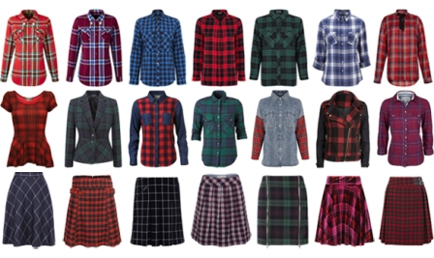
Plaid is still a forceful pattern in the industry. Since it is so diverse, it can be used on so many different kinds of garments, shapes, colors and silhouettes. Plaid may change by color and length in skirts. The skirt will keep their classic colors such as navy blue and forest green but maybe the colors might change to a new shade of pink or orange when Spring/Summer 2020 come along. Plaid will always be a classic in every person’s wardrobe whether it is a jacket or skirt.
(Figure 5 – The Real Skinny on Dressing Slim, 2015)

This skirt trend will appeal to women who are in the age range of 15-25. By conducting a VALS survey, forecasters understand that this is going to attract the younger age range because this is a trending item. It’s also about the shape and silhouette, older women are going to appeal to the pencil skirt trend much more than they would appeal to this plaid school girl trend. Older people are going to aim more towards to classics and the timeless pieces versus younger generations who are still trying to understand their style and what they like.
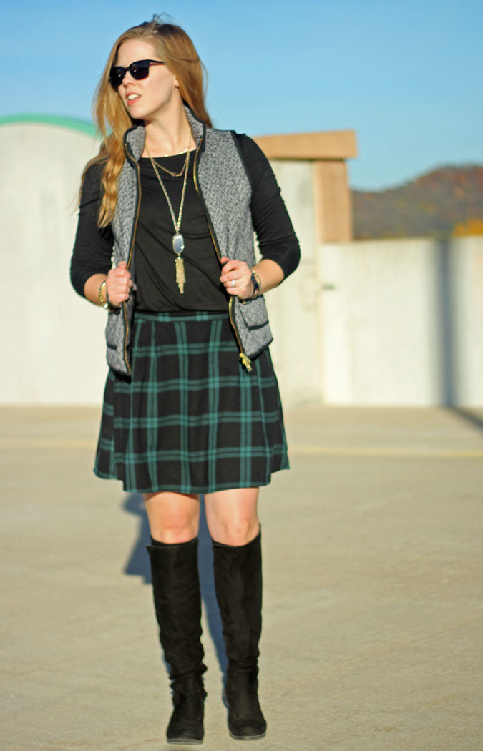
As stated before, the changes will be coming from color. Length will also be a changing factor because of the pendulum swing. The pendulum swing goes from one extreme to the other, therefore, when it reaches an extremely short length, the pendulum will swing back bringing the skirt back to the longer side. This can happen for a number for reasons such as season and longer skirts trending. The swing can also happen with color, since it seems as though the colors are turning towards a lighter shade, it will surely go back to the classic, dark colors as pictured in figure 4. Cultural causes play a big part in trends as well. Since forecasters are trying to predict trends for the year 2020, a huge political event will be upon us. The election played a huge part back in 2016, people started accessorizing with safety pins and many anti-Trump attire came out. The safety pin to show support “amid fears of abuse against minorities, immigrants, women and members of the L.G.B.T. community” (Safronova, 2016). Since the next election will be that year, there is a possibility that another round of the meaning of safety will come out. This means that plaid skirts may have safety pins or another sign of support on the garment. Although it is a repeating trend, there will be new parts added to the skirt or the materials may shift to a lighter material.
(Figure 6 – Schoolgirl, 2015)
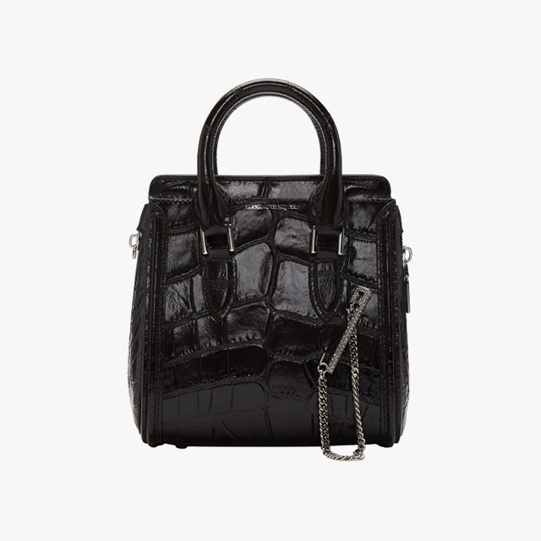
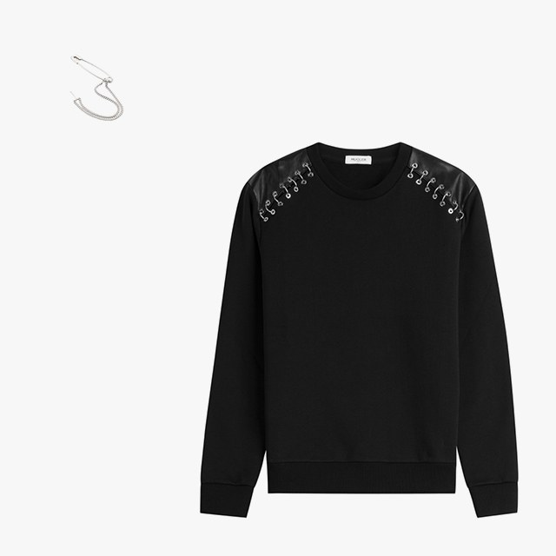
Several factors that will be affecting the trend will be seasons changing and climate change, pop culture, social media and the presidential election. Seasons always have an influence in fashion because climate change is “becoming less predictable each year” (fashioncloudsoftware, 2018). As this continues, trends will be affected because designers need to adapt to these changes. Pop culture is also a driving factor with trends changing. It only takes one person who has enough reach to make a trend, untrendy. This ties in with social media. Social media is a wide platform that anyone can use, this opens up the door to people who are just emerging into the fashion scene, entrepreneur brands as well as larger brands. Social media is another factor that will affect the trend because there is no gatekeeper there, it is open for every single person. Fashion is becoming much more accessible to everyone who wants to see it and trends are changing because it seems as though the cycle is being pushed through faster. “The market is so saturated with new bloggers wanting to break into the industry” (Fateh, 2017). Since it’s much easier to access an app than to pay for a subscription, trends are seen here much faster than the traditional publication. It is almost as if the gatekeeper is becoming obsolete with the coming of social media tools. The presidential election is going to be a groundbreaking event in 2020 and will definitely affect trends that are emerging in the time. In 2016 when the election was happening, there was much talk of safety and with all the protests and the Black Lives Matter Movement happening, it was a turbulent time and the trends reflected that. The same thing will be happening in 2020 if Trump will be running again, the safety of people will be in question. The plaid skirt will change through all these factors. Change is inevitable in the world of fashion, however, trends often reoccur with new additions to it.
(Figure 8 – Farra, Alexander McQueen 2016).
(Figure 7 – Farra, Maison Margiela 2016).
In the Spring/Summer 2020 season, forecasters can expect that the length will be shorter, the silhouette will keep its classic shape as pleated but the color is what will be the most distinctive changed factor of the garment. Depending how the election goes, it could get to a darker shade of colors depending on the outcome. Designers have to understand how the nation feels and reflect the zeitgeist.

The Ruffle Skirt
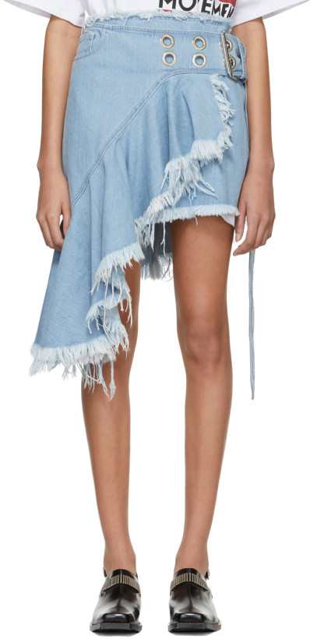
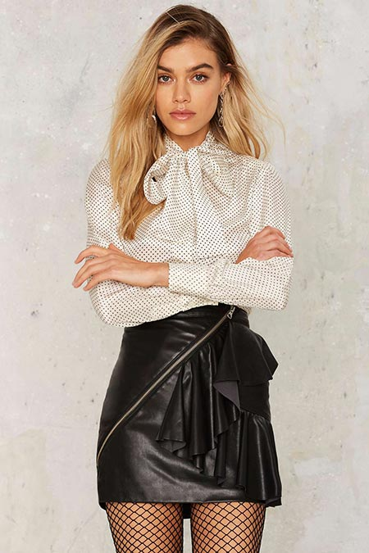
Recently, ruffled skirts were presented differently in varying materials. Several examples include materials such as patent leather, leather, and denim. The style was a mini skirt and the color was in burgundy, reds, black, purple, and green. It was bold but dark at the same time. The fit was square and the silhouette overall was a boxy fit. This trend was very rocker chic and grunge (Dobrzykowski, 2017), since it gave off this vibe, this trend was very rebellious as well. Sometimes zippers were added for an edgy look. Also, the skirts would have many ruffles much like the ones on shirts and dresses (Sutton, 2016).
(Figure 9 – Nasty Gal, 2017)
Forecasting ruffled skirts will be a trend in the coming years, style, color, silhouette and material will all play a crucial role in the prediction. Fabrics such as satin and organza will be in (Newland, 2016). The style will be a midi skirt also known as mid-length skirt. The choice of colors will be whites and yellows. The fit of the skirt would be a bit fitted on top and loose on the end. The silhouette overall will be like a flowy body-con.
Ruffles were very popular in the 1950s, however, historically, it was a unisex characteristic of the garment (Newland, 2017). It made it seem that a woman was delicate, much like how people viewed women at the time. Ruffles were known to be ultra girly as well. When you think of ruffles you think of old fashion and romantic wedding kind of feelings.
(Figure 10 – Marques Almeida, 2018)
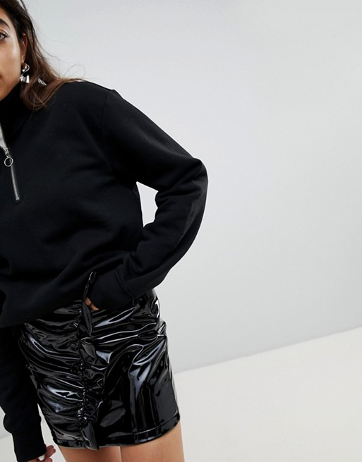
Ruffles have not only been in fashion lately, they have also been incorporated into interior design. They have been incorporated onto bed sheets, curtains, dresses, shirts and shawls.
Mermaid skirts are very elegant and gives a princess look. It is a bit form fitting, usually around the hip area to show the shape of the woman.
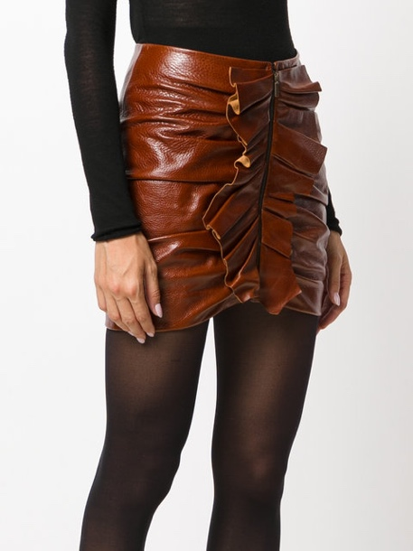
Forecasters went with colors that seemed refreshing. Forecasters have noticed that consumers have taken a break from the color black, therefore, the lighter colors are going to be trending. Colors such as white and yellow are new and bright to the eye. Since the season is also changing, this is the reason why people are shying away from black and going towards lighter, more vibrant colors. Forecasters have also noticed how blues and greens have been in. Pantone announced the color of the year 2017 was green (McGowan-Ellis, 2017). As for 2018, the color of year is ultra violet (Pantone, 2018). Forecasters can now predict that the color yellow will be in.
(Figure 12 – Saint Laurent, 2018)
(Figure 11 – Mango, 2017)
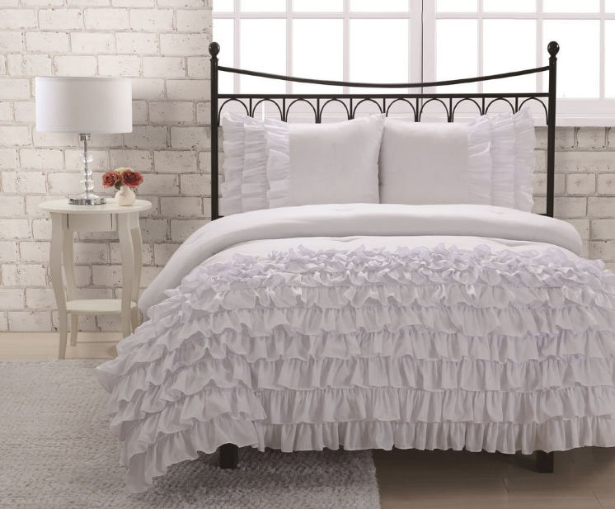
Forecasters have seen ruffles take over, the trend is applicable for many creative pieces of work. Ruffle skirts will still trend but in a sophisticated and modernized way. Ruffled skirts will be part of the norm soon.

(Figure 13 – Yes Rail, 2018)

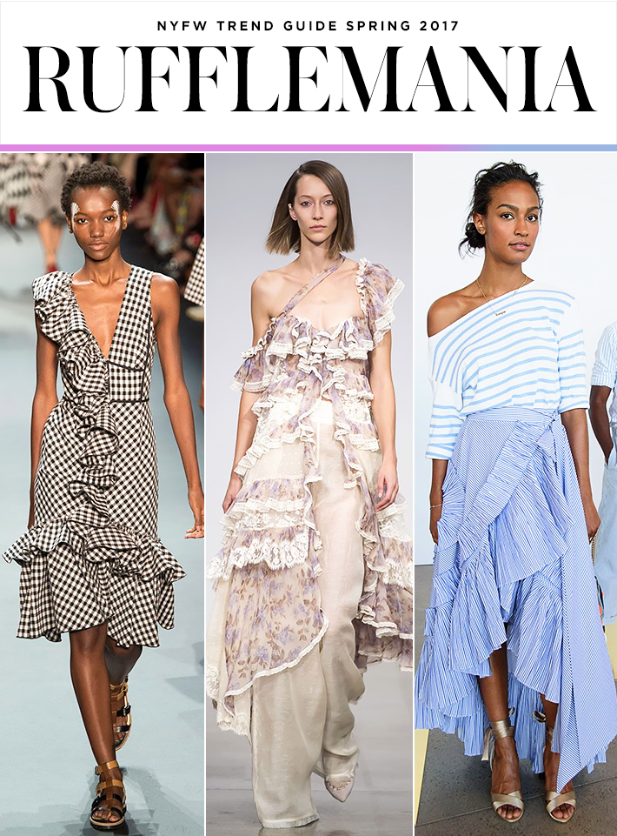

(Figure 14 – Parkin, 2017)
Frills were BIG at NYFW, both in terms of proportion (some looked capable of swallowing models whole) and in terms of popularity (you’d be harder pressed to find a show that didn’t feature a little bit of flounce). The styles we’re most eager to get a hold of, though, were those that balanced the femininity with a little sleekness or ease—think asymmetrical dresses, one-shoulder tops, and voluminous skirts styled as effortlessly as a pair of jeans. (Parkin, 2017)
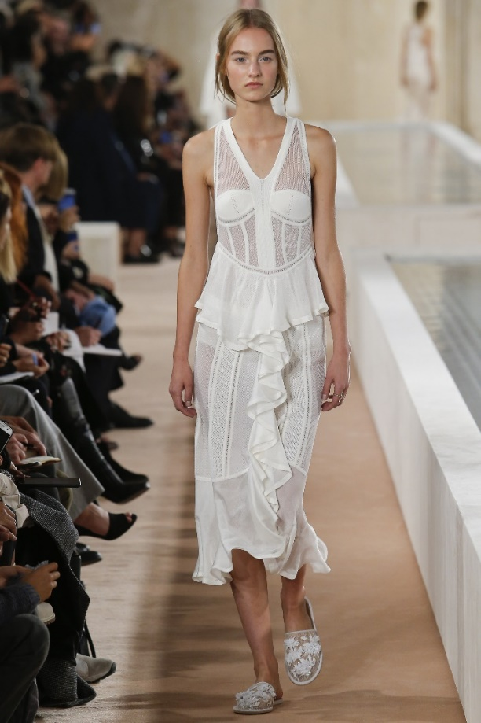
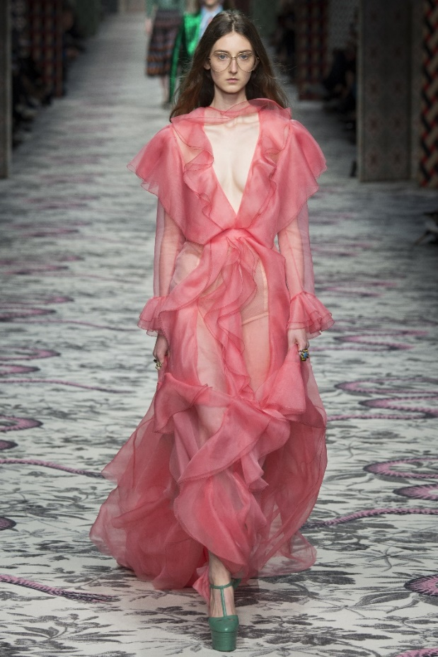
(Figure 16 – Balenciaga Spring/Summer 16, 2016)

(Figure 15 - Gucci Spring/Summer 16, 2016)
This all began to shift in spring/summer ‘16, when designers from Gucci to Balenciaga popularized the flourish all over again. Whether layering frills on chiffon dresses or carefully structuring ultra-modern hemlines, sartorial demand for the ruffle seemed to reignite. This gives us the insight that we will still continue the ruffle trend but in a modernized way.
This particular flourish — flying upward from shoulders and adorning asymmetrical tops — could be thought of as the power ruffle. It’s the perfect combination of womanly and forward-thinking, and to wear one means to embrace a surprisingly fearsome legacy. The ruffle was once worn by royalty and revolutionaries of both genders, to connote strength and exceptional power (Newland, 2017).
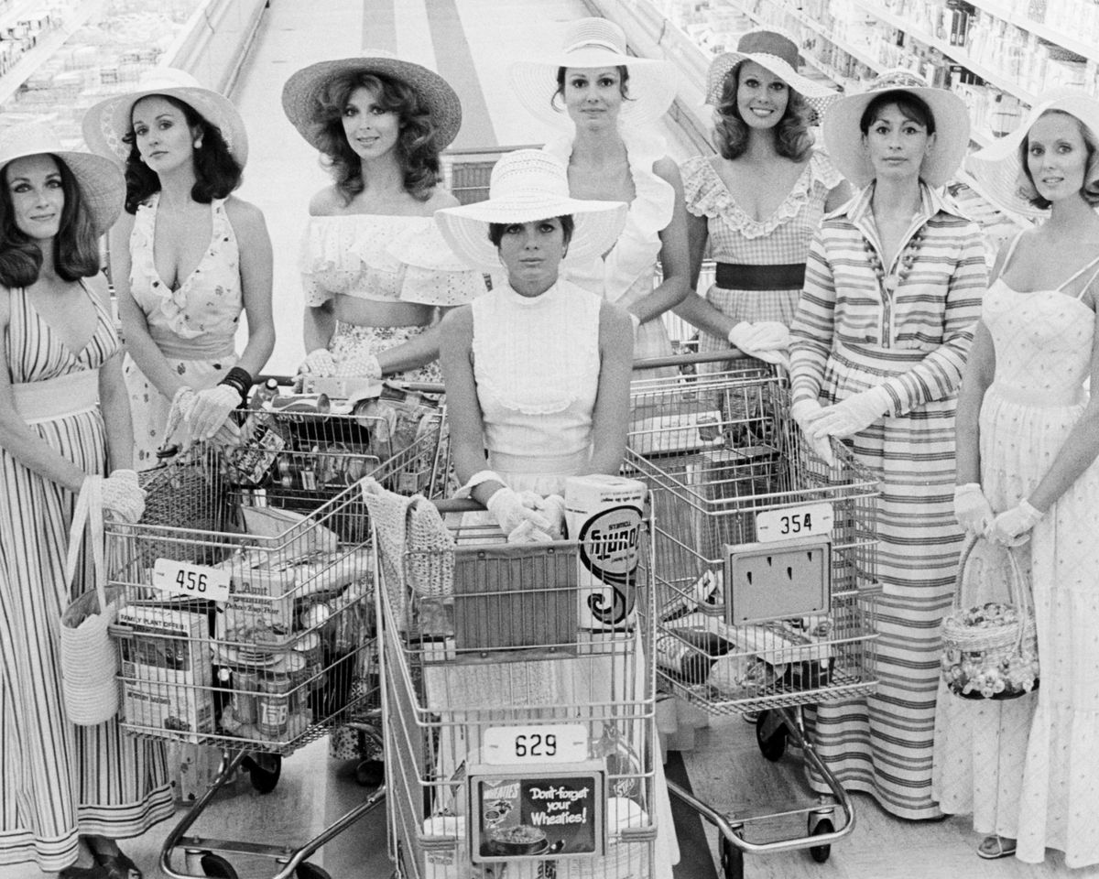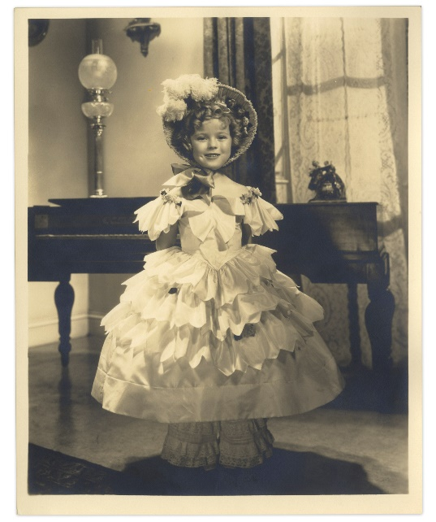
(Figure 17 - The cast of The Stepford Wives, 2017)
(Figure 18 – Shirley Temple, 2016)
The 1975 film The Stepford Wives, a series of docile, cheerful housewives push shopping carts through sterile supermarket aisles. Blank-eyed, fabulously attired, and with limited brain capacity, they’re robotic replacements for real women. Their wardrobes are all pastel and cream, featuring floppy hats, lush curls, and — most notably — elaborately ruffled blouses and dresses. The ruffles are a throwback to the ’50s — and a clear statement of delicate womanhood. (Newland, 2017)
As a dress detail, the ruffle has a long and sometimes checkered history. It’s seen as one of the most obviously feminine fashion statements — often, as with The Stepford Wives. Ruffles conjure up insipid images of Shirley Temple. A grown woman can swan through the streets in a baby-pink coat or a vertiginous pair of heels, but until recently, ruffles could be a difficult thing to pull off without feeling like a walking confection. (Newland, 2017)

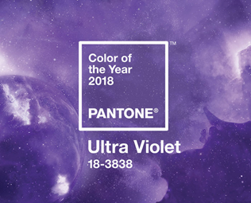
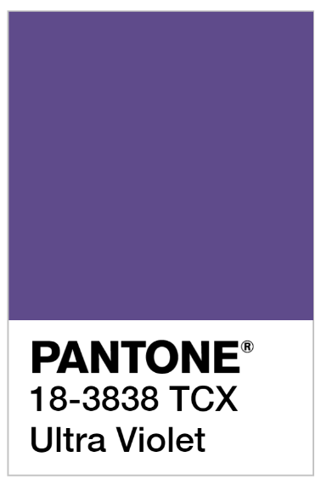

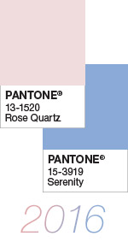
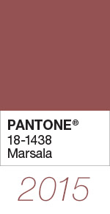
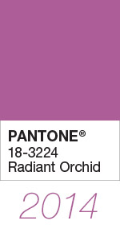

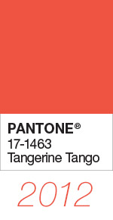
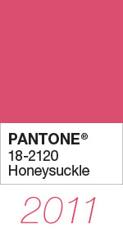
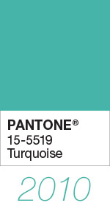
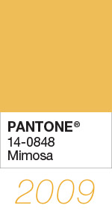
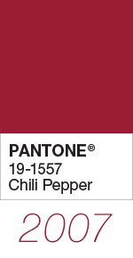
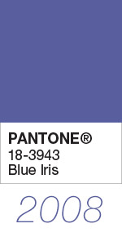
Looking at the past color trends, it helps us predict the following trending colors. We believe Yellow will be the next color trend because we have seen different tones of violet and green for now. We will transition to a nice sunshine yellow, similar to the color Mimosa from the year 2009 but with a lighter tint.
(Figure 19 – Announcing PANTONE 18-3838 Ultra Violet, 2018)

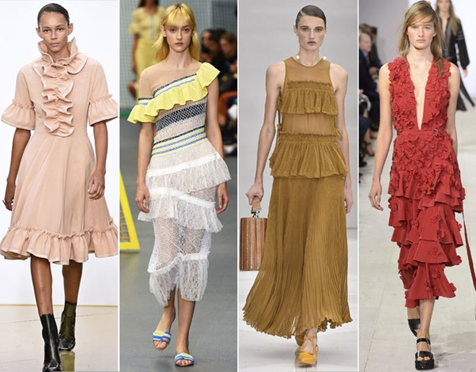
(Figure 20 – Instyle, 2016)
In 2016, the spring collections were rife with ruffles. The detail swept the runways, including at (from left) J.W. Anderson, Peter Pilotto, Salvatore Ferragamo, and Michael Kors Collection, trimming hemlines, tiers, and sleeves with its frills. It's the perfect way to sweeten up any look. (Parente, 2016)
Looking at the year 2016, 2017, and 2018 helped forecasters predict how trendy the ruffle has been. It is here to stay but as for silhouette, it will be a bit more midi and maxi just as in figure 17 compared to figure 9, 10 and 11.

The Pencil Skirt
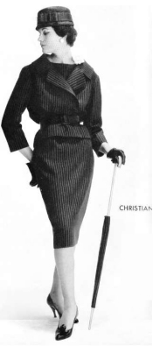
The genius of the pencil skirt is its ability to not only manufacture its sex appeal for a woman but also personify class and become the modern uniform for woman. During the 1940s, Christian Dior cultivated this skirt by embracing the sleek design, ridding the skirt of its excess ruffles at the time (Wright, 2016). By doing this moderation, Dior created a classic that would allow women to fully embrace the femininity of their curves and still allow them to go to the work place. The length of the pencil skirt made it perfect for the modern work place in the beginning periods and still created an aura around itself by being so different from previous renditions of skirts with designs of a-lines & ruffles. The new pencil skirts allowed women to show off their feminine curves, and not be quite as impeded from going about the business of daily life as they would have been in the immediate post wartime fashions (Wright, 2016). Furthering the classic pencil was Marilyn Monroe. She was a huge proponent of the look and making it look sexy and classy in a classic way.
(Figure 21 – Christian Dior, 2010)
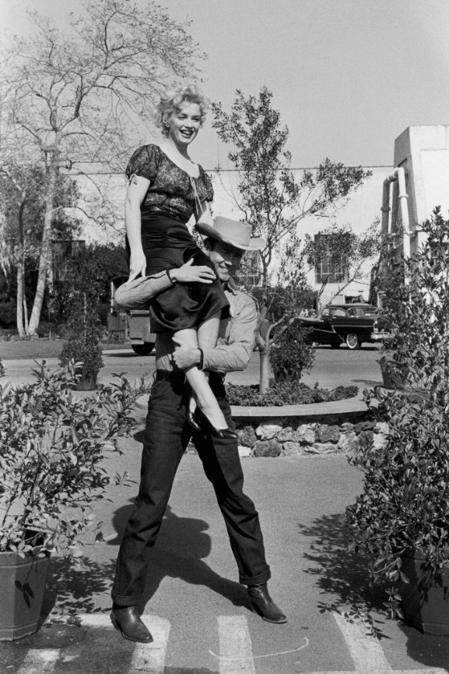
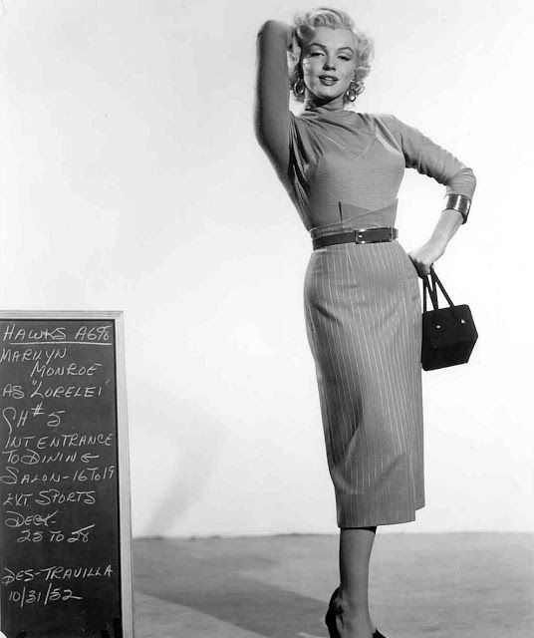
2018 revealed shortening lengths of many designs including the skirt. The pencil skirt style is cut straight down, and when laid flat, forms a rectangle (Schwanke, 2015). Using the cut straight down look, the pencil skirt reaches down all the way to right above the women’s knee. The length also allows the skirt to fully drape down the woman’s body giving it elegance and visual perception. Yet through time and generations, a new creation was created in the 60s. Mary Quant was using new altered designs to create new mini pencil skirts well above at 6-7 inches above the knee (Sew-simple, 2010). This full embrace of womanhood and power will full be on display during the Spring/Summer 2020 seasons as themes of women empowerment and cultural movement in continuing to push forward the narrative of societal equality and be a major trend.
(Figure 22 – Marilyn Monroe, 2016)

(Figure 23 – Marilyn Monroe and Man, 2016)

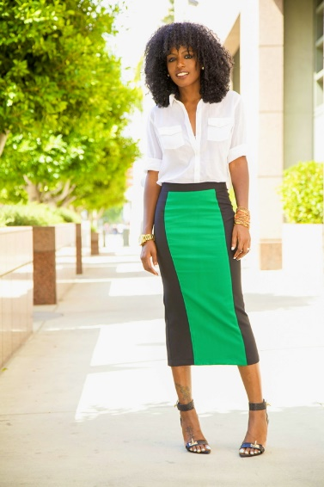
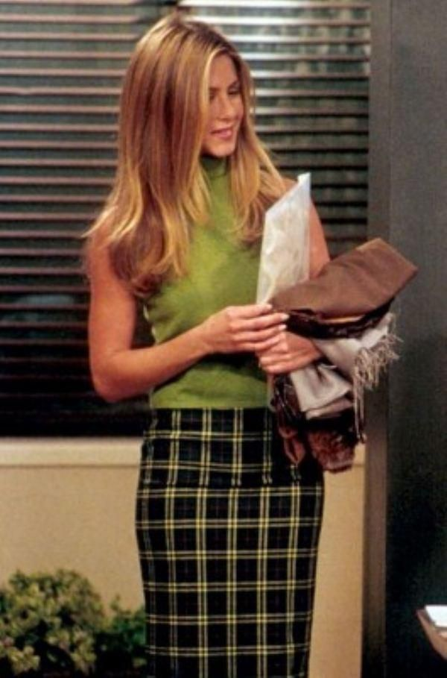
Christian Dior created the pencil skirt to be sleek and to be a full embracement of the woman’s body. While doing this, he used bold colors and flat patterns that fully complimented the woman. With the pencil skirt being so in trend, it has popped up throughout pop culture including the TV show Friends. Rachel not only wears a pencil skirt but it is also using a light color green with a plaid design included. The versatility of the pencil skirt is in the aspect that it can be used in many different patterns by checkered print, and various others such as animal print, color block and many more. The pencil skirt design allows it be a chamelon in the form of its many patterns and color use. For Spring/Summer 2020, the pencil skirt would use various color blocking themes with tertiary color in lays as the meshing allows for more outfit versatility and showing the continuing trend of women and power with business accents from the classic pencil skirt designs of its beginning by Dior.
(Figure 25 – Style Pantry, 2013)
(Figure 24 – Friends, 2018)
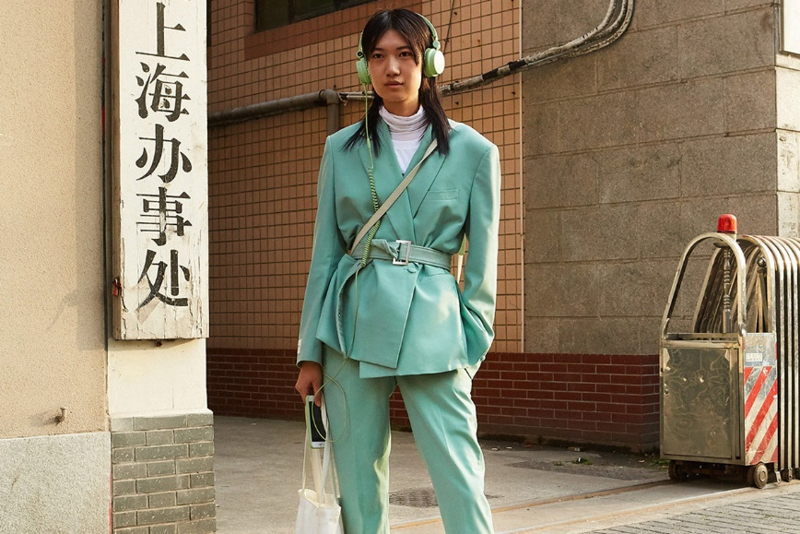
(Figure 26 – Neo-Mint, 2018)
With trends of design and color constantly changing, there is never an exact science to understanding what could be the next it trend. Thankfully, companies like WGSN use a combination of social science, deep insight and instinct to predict trends up to 24 months before they enter the retail space (Grobe, 2018). These companies help predict colors such as the new neon green forecasters think will be hugely popular in the year 2020. Pencil skirts will join in this mega color trend and join the fray. The reasoning comes in two folds, when it comes to a color for 2020, neo mint is an oxygenating, fresh tone that aligns science and technology with nature. Recently, there’s been a huge pop culture reinvestment in popular ’70s genre cyberpunk, it is a sci-fi genre that warns against the power of technology and AI to overpower humanity (Grobe, 2018). These two factors easily help in pushing the pencil skirt forward as its versatility has always played a huge part in its patterns used and color usage over the decades.
Spring/Summer 2020 will play mostly with varying degrees of color and length. The skirt had been created for women during a time of tremendous progress and we can expect that in the year 2020. There will be change in not only political elections but social climate will continue to empower women in a more progressive manor. This would be allowing the pencil skirt trend to fluctuate in length, color and societal ideas. With all these factors expect more color such as the neo green lay out to be used to explore the freedom of expression through color theory. This all adds up to the pencil skirt becoming a force again for women in the corporate office to party wear. With its ability to manipulate length, pattern and color, the pencil skirt is truly a chameleon in its own right.
The Wrap Skirt
Wrap skirts are timeless and adds a playful twist on a pencil skirt. Although one might say Diane Von Furstenberg was the inventor of the wrap dress, during the Great Depression, “Hooverettes” were popular (Brackman, 2010). They had a wrap design, however it was on the upper bodice, not on the skirt. The Dictionary of American Regional English defines Hoover Aprons as “slang for a coverall or house dress with an overlapping reversible front and the wrap-front dress could be worn until the bodice was dirty and then the overlap reversed to reveal a clean area.” (Cassidy & Hall, 1985). These were used for women to do work around the house and reflected the zeitgeist of the times.
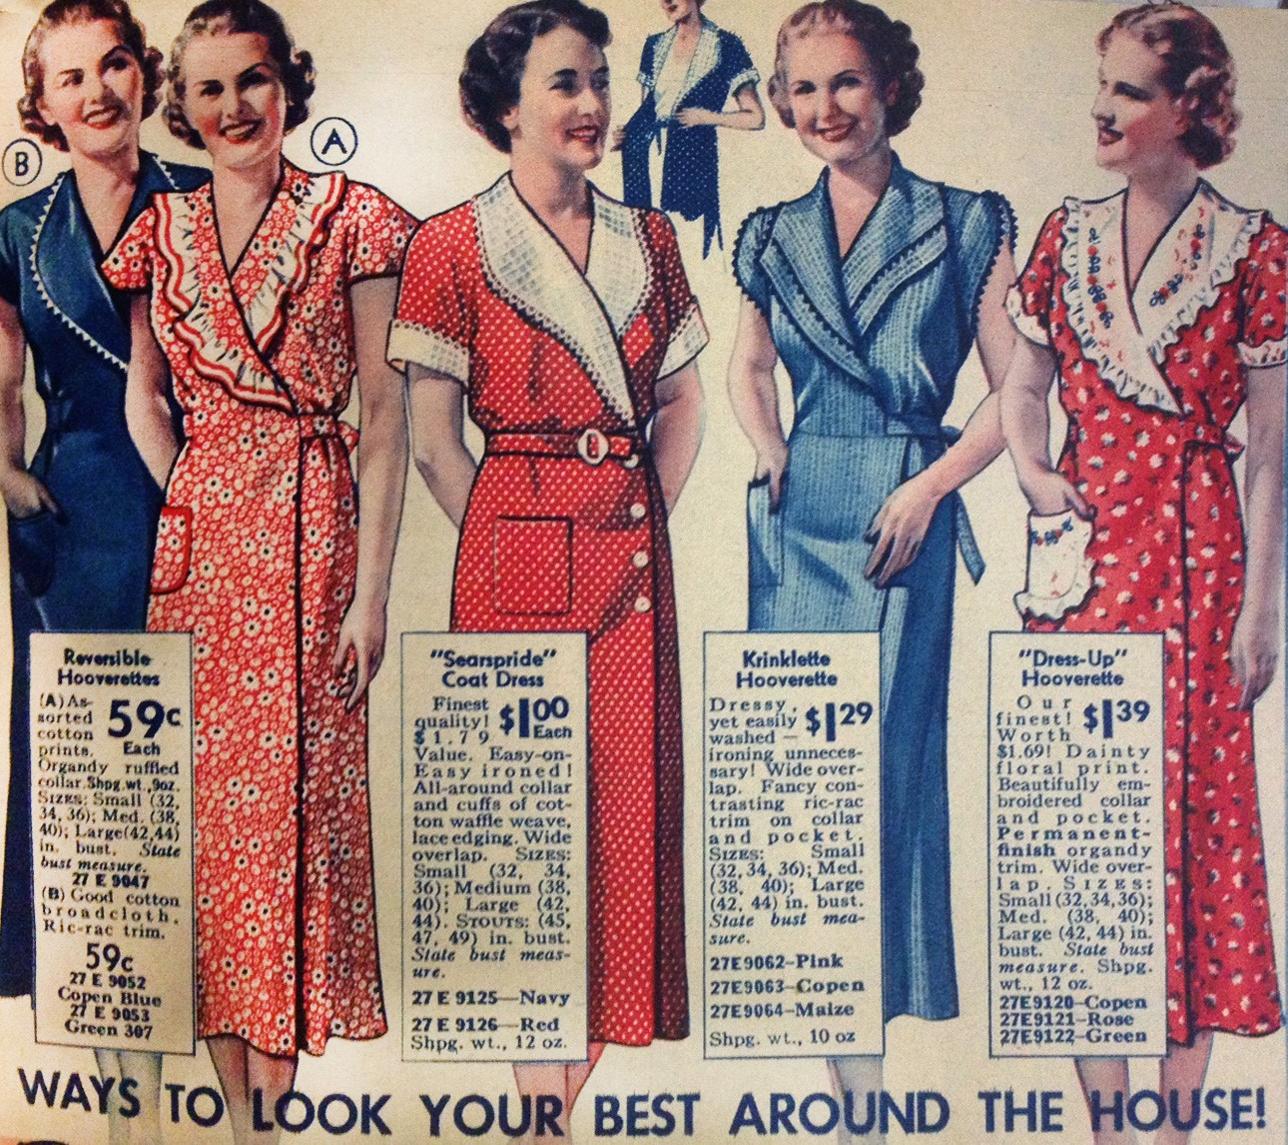
(Figure 27 - Hooverettes, 2010)
Diane Von Furstenberg made the wrap dress popular in 1974 when she rolled out the design as her signature (Cuccinelli, 2015). A 70s western vibe has been trending for some years now in fashion. Since this dress became popular in the 1970s and then again in 2010, it would be a trend once again in 2020 because of the pendulum swing of fashion. More innovations can be made with this skirt because of its simplicity yet unique silhouette. The trims can be of a different fabric such as lace, and can be styled in innovative ways.
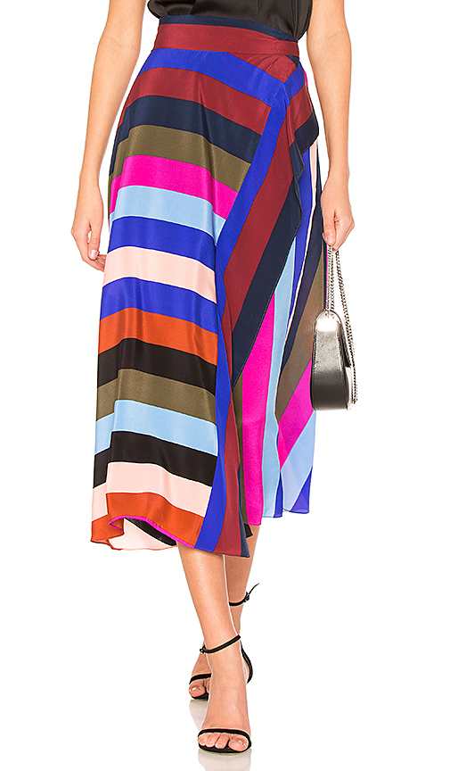
(Figure 28 – Diane Von Furstenberg Wrap Maxi Skirt, 2018)
The fabrics that will be trending for the wrap skirt will be satin, a lightweight cotton, even a polyester because light to medium weight fabrics will drape better. The fabrics that were popular before was a clinging jersey material. It will be at a mid-length, also known as a midi skirt (R & Butler University, 2011). For a wrap skirt, the lengths will differentiate. It can range from a mini to a maxi, however, wrap skirts will still trend in different ways. The fit may become looser and stray away from clinging to the body.
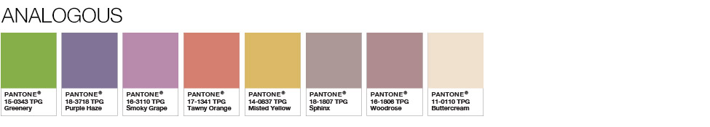
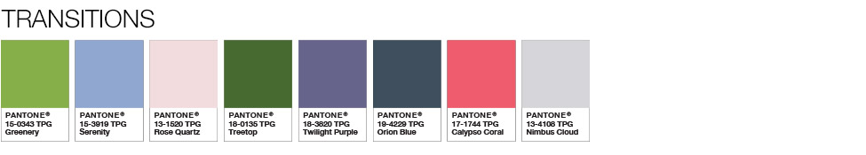
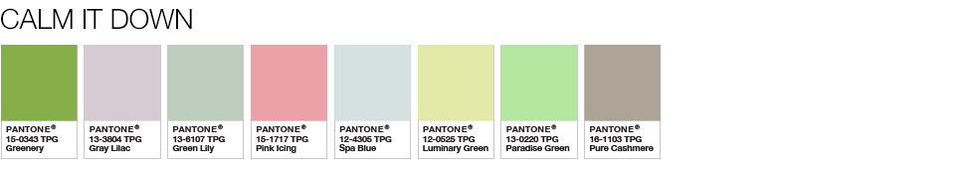
For the upcoming seasons, the colors that will be trending will be core tones which are more bold yet subtle because they are fresh muted tones of the bolder colors. Colors will be in the neutral earth tones such as earthy olives, muted yellows, and rusted oranges. These colors can change a look to become dramatic or subtle. Recently for spring/summer, tropical colors and pastel colors have been trending because of the change in weather. These colors will die down and become more muted bold colors once the temperature drops and the season changes, it will be a refreshing twist on these colors (Ispo, 2017). It will redefine vibrancy and calm down traditional primary and secondary colors. Pantone’s Greenery shade can act as a transition through these forecasts. According to Pantone, Nature’s neutral, PANTONE Greenery is a versatile “trans-seasonal” shade that lends itself to many color combinations. Greenery has also been used on another trend, the plaid skirt. As displayed in the 3 palettes below, Greenery is paired with neutrals, brights, deeper shades, pastels, metallics and even the enduring presence of PANTONE Color of the Year 2017 (Pantone, 2018).
(Figure 29 – Past colors of pastels, 2018)

(Figure 30 – Transitions into trending colors, 2018)

(Figure 31 – Fresh muted tones of bold colors for 2020, 2018)

References
Figure 1 – Celtic Life. (2018). Scottish Kilts [Picture]. Retrieved from https://celticlife.com/scottish-kilts/
Figure 2 – Demaria, M. (2017). Clueless [Picture]. Retrieved from https://www.refinery29.com/clueless?bucketed=true&bucketing_referrer=https%3A%2F%2Fwww.google.com%2F
Figure 3 – Pantone. (2016). Pantone Colors of the Year [Picture]. Retrieved from https://www.pantone.com/color-of-the-year-2016
Figure 4 – Pantone. (2017). Pantone Color of the Year [Picture]. Retrieved from https://www.pantone.com/color-of-the-year-2017
Figure 5 – Nix-Rice, N. (2015). The Real Skinny on Dressing Slim [Picture]. Retrieved from https://www.nancynixrice.com/the-real-skinny-on-dressing-slim-part-6-plaids/
Figure 6 – Schoolgirl. (2015). Schoolgirl [Picture]. Retrieved from http://www.puppiesandpretties.com/2015/11/11/schoolgirl/
Figure 7 – Farra, E. (2016). Maison Margiela [Picture]. Retrieved from https://www.vogue.com/article/wearing-safety-pins-after-election-brexit-trend-marc-jacobs-gucci
Figure 8 – Farra, E. (2016). Alexander McQueen [Picture]. Retrieved from https://www.vogue.com/article/wearing-safety-pins-after-election-brexit-trend-marc-jacobs-gucci
Figure 9 – Dobrzykowski. C. 11 Best Leather Mini Skirts That Are Trending Now. Updated on January 17, 2017 http://www.fashionisers.com/fashion-news/best-leather-mini-skirts/
Figure 10 – Ssense. Marques Almeida Blue Denim Wrap Buckle Frill Skirt. https://www.ssense.com/en-us/women/product/marques-almeida/blue-denim-wrap- buckle-frill-skirt/2787098
Figure 11 – Asos. Mango Vinyl Ruffle Front Mini Skirt http://www.asos.com/mango/mango-vinyl- ruffle-front-mini-skirt/prd/8437775
Figure 12 – Farfetch. Saint Laurent, ruffle trim mini skirt For Saint Laurent's AW17 collection, https://www.farfetch.com/shopping/women/saint-laurent-ruffle-trim-mini-skirt-item-12252732.aspx
Figure 13 – Simple Bedroom with White Full Miley Mini Ruffle Comforter Set, White Plain Ruffle Bed Skirt, White Plain Ruffle Bed Skirt, and Round White Bedside Table http://www.yesrail.com/white-bedspreads-and-comforters/simple-bedroom-white-full-miley-mini-ruffle-comforter-set-white-plain-ruffle-bed-skirt-black-metal-bed-frame-round-white-bedside-table/
Figure 14 - George-Parkin, H. (2017, March 06). The Top 10 Trends from New York Fashion Week Spring 2017. Retrieved from http://stylecaster.com/nyfw-trends-spring-2017/
Figure 15 & 16 & 17 - Newland. C (2017, February 13) The Top 10 Trends from New York Fashion Week Spring 2017 https://www.racked.com/2017/2/13/14461300/ruffle-history
Figure 18 –Sanders. D.N. (2016) Shirley Temple. https://natedsanders.com/lot-41529.aspx
Figure: 19 -Pantone. Announcing PANTONE 18-3838 Ultra Violet, PANTONE® Color of the Year 2018.https://www.pantone.com/color-of-the-year-2018
Figure 20 - Parente, A. (2016, March 20). 7 Pretty Pieces that Have Us Swooning for Ruffles this Spring. Retrieved from http://www.instyle.com/fashion/clothing/shop-spring-2016-trend- ruffles#1214151
Figure 21- Christian Dior. (n.d.). Retrieved from http://sew-simple.com/sewing/pencil-skirt-history/
Figure 22 and 23 - Wright, J. (2016, September 02). Marilyn Monroe, Marilyn Monroe with Man Retrieved from https://www.racked.com/2016/9/2/12482408/pencil-skirt-history
Figure 24- Friends. (n.d.). Retrieved from https://www.pinterest.com/joliebeauty/ross-and-rachel/?lp=true
Figure 25 - Button-Up Shirt Color Block Pencil Skirt. (n.d.). Retrieved from http://stylepantry.com/2013/05/16/button-up-shirt-color-block-pencil-skirt/
Figure 26 - Grobe, M. (2018, May 03). Neo Mint: The Big Next Color Trend for SS20. Retrieved from https://www.highsnobiety.com/p/big-next-color-trend-ss20-according-experts/
Figure 27 – Brackman, B. (2010). Hooverettes. Retrieved from
http://barbarabrackman.blogspot.com/2010/08/hooverettes.html
Figure 28 – Diane von Furstenberg Draped Wrap Maxi Skirt in Carson Stripe Black Multi from
Revolve.com. Retrieved from
http://www.revolve.com/diane-von-furstenberg-draped-wrap-maxi-skirt-in-carson-stripe-
black-multi/dp/DVF-WQ35/
Figure 29 – Pantone. (2018). “Calm It Down” COLOR OF THE YEAR 2017 - Pantone Color of
the Year 2017 | Greenery | Nature's Neutral. Retrieved from
https://www.pantone.com/color-of-the-year-2017.
Figure 30 – Pantone. (2018). “Transition” COLOR OF THE YEAR 2017 - Pantone Color of the
Year 2017 | Greenery | Nature's Neutral. Retrieved from
https://www.pantone.com/color-of-the-year-2017.
Figure 31 – Pantone. (2018). COLOR OF THE YEAR 2017 - Pantone Color of the Year 2017 |
Greenery | Nature's Neutral. Retrieved from
https://www.pantone.com/color-of-the-year-2017.
Figure 32 – Flora Tie Front Wrap Skirt. (n.d.). Retrieved from
https://www.francescas.com/product/flora-tie-front-wrap-skirt.do
Figure 33 – L. (n.d.). Beautiful Tempest Navy Blue Print Wrap Maxi Skirt. Retrieved from https://www.lulus.com/products/beautiful-tempest-navy-blue-print-wrap-maxi-skirt/370042.html
Atwood, T. (2018, March 23). How Did Plaid Become Popular? Retrieved April 10, 2018, from https://www.bustle.com/articles/20343-how-did-plaid-become-popular-a-brief-and-grungy-fashion-history
Brackman, B. (2010). Hooverettes. Retrieved from
http://barbarabrackman.blogspot.com/2010/08/hooverettes.html

Cassidy, F. & Hall, J. (1985). Dictionary of American Regional English. Cambridge, Mass:
Belknap Press of Harvard University Press.
Color palette spring/summer 2019. (2017, September 28). Retrieved from
https://www.ispo.com/en/awards/textrends/color-palette-springsummer-2019
Cuccinelli, J. (2018). When Did DVF Create The Wrap Dress? Retrieved from
https://www.bustle.com/articles/76804-when-did-diane-von-furstenberg-invent-the-wrap-dress-5-enduring-lessons-the-famous-frock-can
DeSimone, L. (2015, November 16). These Are The Colors To Start Decorating With In 2016. Retrieved from https://www.elledecor.com/design-decorate/color/g2804/colors-trends-decorating-2016/
DuLux. Where do trends come from? https://www.dulux.co.uk/en/articles/where-do-trends-come
Fateh, A. (2017, January 19). How social media is changing fashion? Retrieved May 5, 2018, from https://www.huffingtonpost.com/entry/how-social-media-is-changing-fashion_us_587edd29e4b06a0baf64918f
Grobe, M. (2018, May 03). Neo Mint: The Big Next Color Trend for SS20. Retrieved from https://www.highsnobiety.com/p/big-next-color-trend-ss20-according-experts/
How Will fashion seasonality Affect What We Wear? (n.d.). Retrieved May 5, 2018, from http://www.fashioncloudsoftware.com/blog/how-will-fashion-seasonality-affect-what-we-wear
Miller, A. C. (2017). Diane von Furstenberg On Wrap Dresses And The Joys Of
Aging Gracefully. Retrieved from
https://www.huffingtonpost.com/amanda-christine-miller/diane-von-furstenberg-on-_b_8
1590.html
Oliva, S. (2018, January 10). The ten color trends for Spring Summer 2018. Retrieved April 10, 2018, from http://www.vogue.it/en/fashion/trends/2018/01/12/the-ten-color-trends-for-spring-summer-2018/
P. (n.d.). Pantone Color of the Year 2016 - Pantone Color of the Year 2016 | Rose Quartz & Serenity. Retrieved May 5, 2018, from https://www.pantone.com/color-of-the-year-2016
Pantone. (2018). COLOR OF THE YEAR 2017 - Pantone Color of the Year 2017 | Greenery |
Nature's Neutral. Retrieved from https://www.pantone.com/color-of-the-year-2017.
Parente, A. (2016, March 20). 7 Pretty Pieces that Have Us Swooning for Ruffles this Spring. Retrieved from http://www.instyle.com/fashion/clothing/shop-spring-2016-trend- ruffles#1214151
Pencil Skirt History. (n.d.). Retrieved from http://sew-simple.com/sewing/pencil-skirt-history/
R., & Butler University. (2011, August 20). History of the Trend: Midi Skirts. Retrieved from
https://www.collegefashion.net/trends/history-of-the-trend-midi-skirts/
Safronova, V. (2016, November 14). Safety Pins Show Support for the Vulnerable. Retrieved May 3, 2018, from https://www.nytimes.com/2016/11/14/fashion/safety-pin-ally-activism.html

Smith, O. B. (2018, January 18). Why you need to rethink the pencil skirt- and how to wear one now. Retrieved from https://www.telegraph.co.uk/fashion/style/need-rethink-pencil-skirt-wear-one-now/
Sutton, S. (2016, September 21). The spring '17 Trend You Can Buy Now and Wear through Next Year. Retrieved from https://www.popsugar.com/fashion/Ruffle-Skirt-Trend- Spring-2017-42427635
Wright, J. (2016, September 02). How the Pencil Skirt Became America's Sexiest Staple. Retrieved from https://www.racked.com/2016/9/2/12482408/pencil-skirt-history
1950s Skirt Styles History | Full Circle Skirts to Pencil Skirts. (2018, March 07). Retrieved from https://vintagedancer.com/1950s/1950s-fashion-history-skirts/
n.n. (n.d.). Retrieved from https://themakersatelier.com/journal/brief-history-pencil-skirt
n.n. The Surprising History of Ruffle Dresses. (2017, October 09). Retrieved from https://umaandleopold.com/surprising-history-ruffle-dresses/

