Magnitude Comparator Circuit

Experiment 9

Michael Robayo, Galib Rahman

04/24/2017

Objective

- To build 1-bit and 2-bit Magnitude Comparator circuits using the Quartus 2 development software with the DE-2 board.
- To test the design by downloading the file into the DE-2 board, exercising the inputs with toggle switches and observing 3 individual LED’s

Materials
- Quartus II^{R} Web Edition V9.1 SP2 software by Altera Corporation
- Altera DE2 FPGA board
- USB Drive

Part 1:
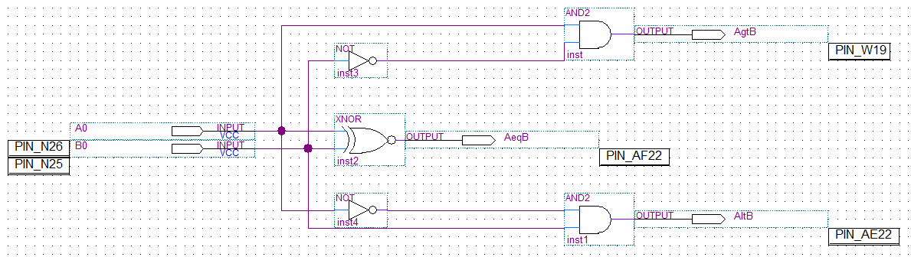

Inputs |  | Outputs
A0 | B0 | Agtb | Aeqb | Altb
0 | 0 | 0 | 1 | 0
0 | 1 | 0 | 0 | 1
1 | 0 | 1 | 0 | 0
1 | 1 | 0 | 1 | 0

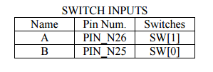
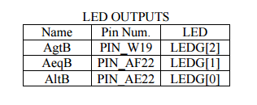
Part 2:
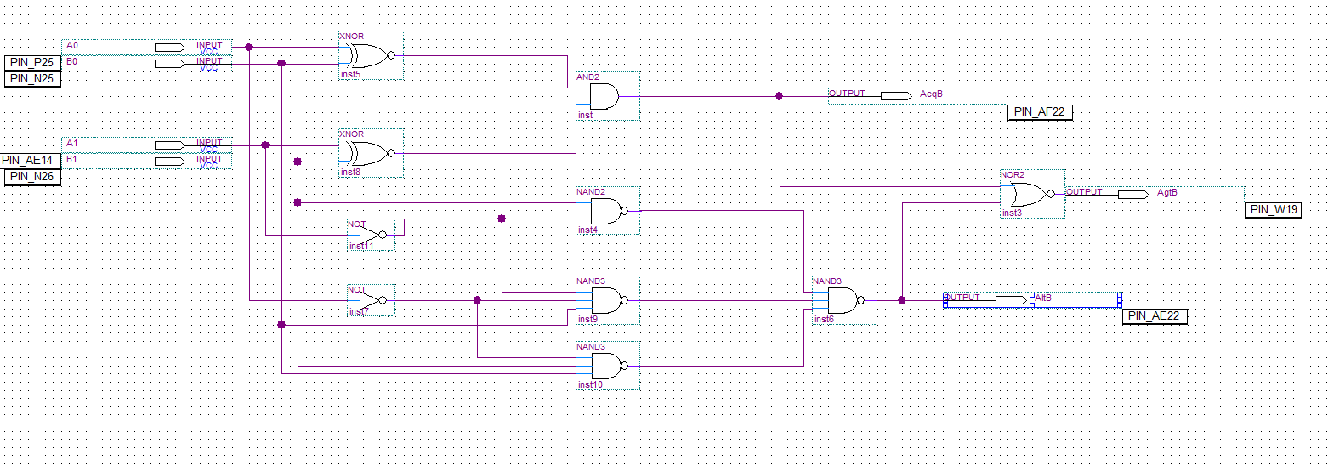

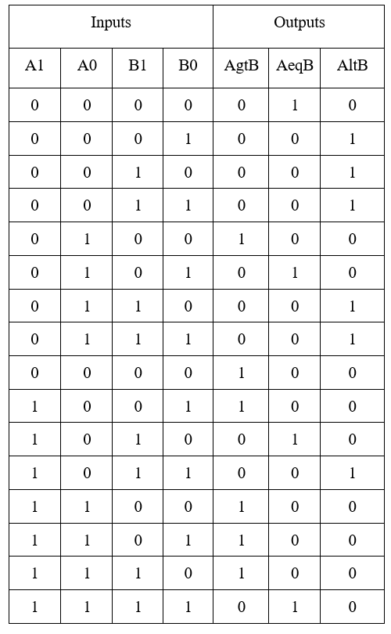
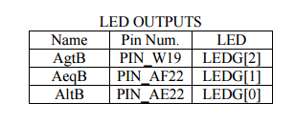
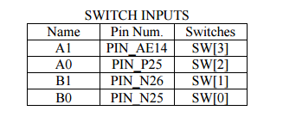
Conclusion
In this laboratory exercise we learned how to develop 1 bit and 2 bit Magnitude comparators using Quartus II software and were able to upload these designs into an Altera-DE2 board.

