7-Segment Display with VDML

Experiment 8

Michael Robayo, Galib Rahman

04/24/2017

Objective

- Use simple VHDL assignment statements to represent a function table
- Introduce the selected signal assignments WHEN-ELSE clause
- Display hexadecimal numbers (0 through F) on the 7-segment LED of the DE-2 board

Materials
- Quartus II^{R} Web Edition V9.1 SP2 software by Altera Corporation
- Altera DE2 FPGA board
- USB Drive

Part 01
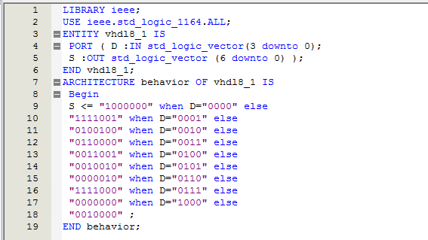
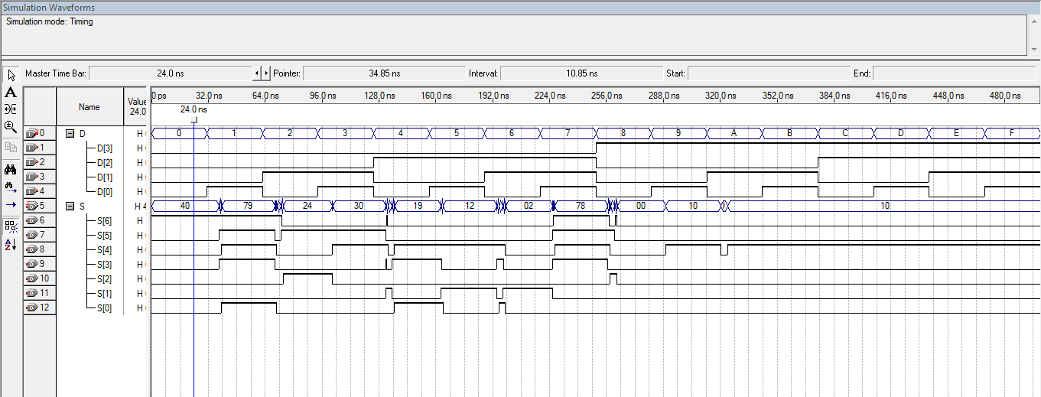
Part 02

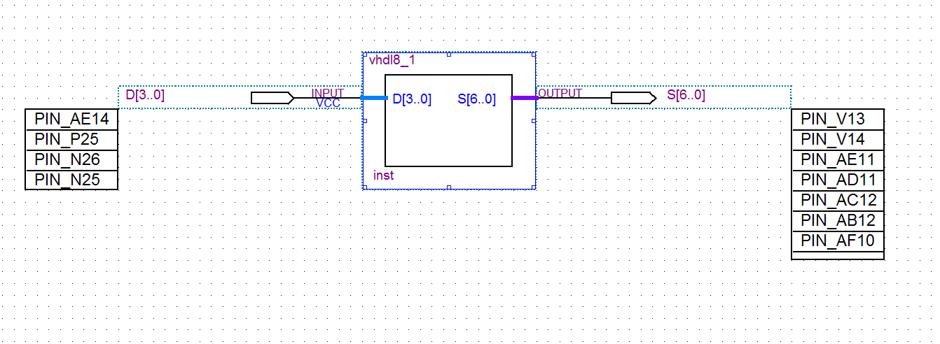
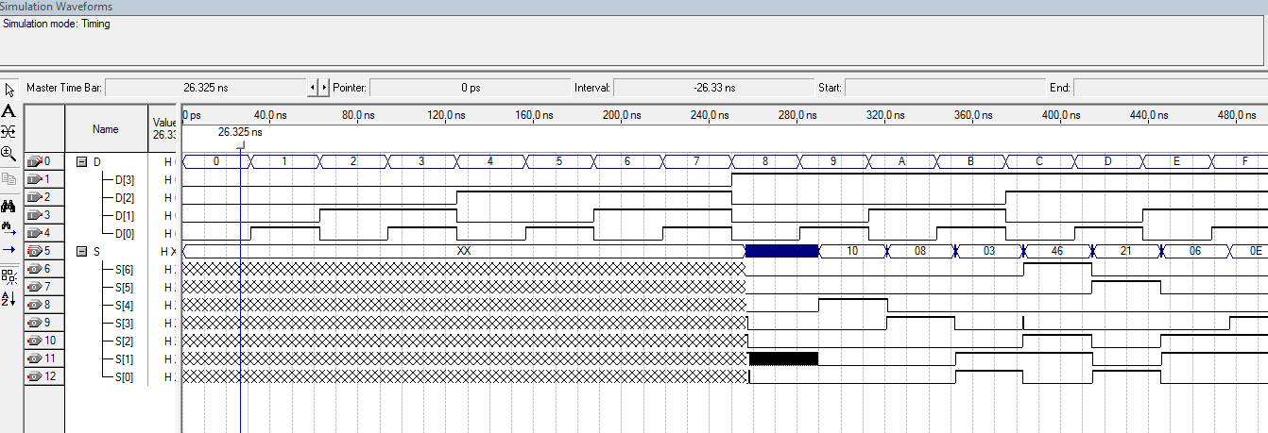

Conclusion
In this laboratory exercise we were able to use simple VHDL assignment statements to represent a function table,introduce the selected signal assignments WHEN-ELSE clause and display hexadecimal numbers (0 through F) on the 7-segment LED of the DE-2 board.

