Experiment 12
Michael Robayo, Galib Rahman
05/23/2017

Objective

The purpose of this laboratory exercise is to create a MOD 8 negative edge triggered UP counter using a JK flip flop.

Materials
- PC (Altera Quartus II V9.1 installed)
- DE-2 board
Part 1

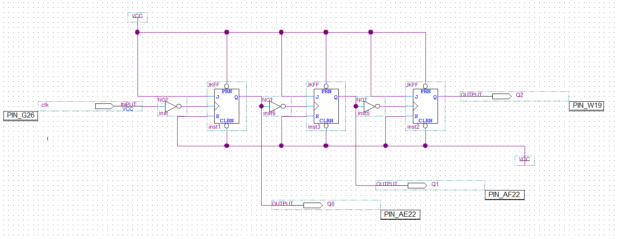
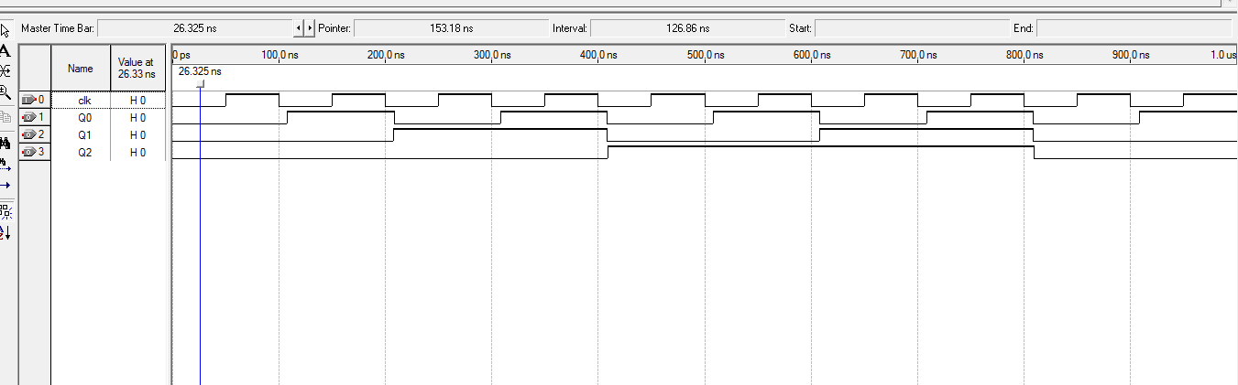

Conclusion
This experiment required us to build a MOD 8 negative edge triggered UP counter using JK flip flops on the Quartus II software. We developed the virtual block diagram and uploaded it onto the Altera DE-2 Board.

