Implementing Binary Adders

Experiment 10

Michael Robayo, Galib Rahman

05/22/2017

Objective

- Design a half adder and a full adder by extracting the Boolean equation from a truth table.
- Construct the half adder and full adder circuits from a Boolean equation.
- Design and test a 3-bit adder circuit using Quartus II and Altera DE-2 Board

Materials
- PC (Altera Quartus II V9.1 installed)
- DE-2 board

Part 1:Half Adder Circuit
Boolean Equations:
Carry= A_{O}B_{O}

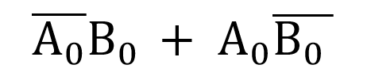
Sum=
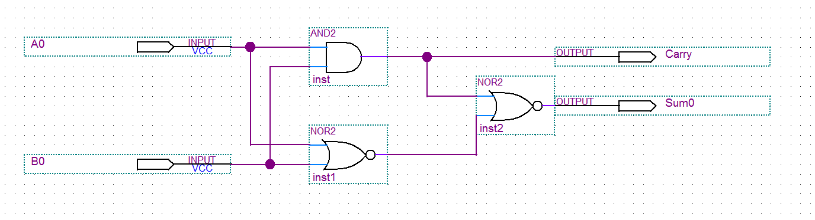

A0 | B0 | Carry | Sum
0 | 0 | 0 | 0
0 | 1 | 0 | 1
1 | 0 | 0 | 1
1 | 1 | 1 | 0

Part 2: Full adder circuit

Boolean equations:
Carry: (A⊕B)⊕C_{in}
Sum:(A * B) + ( Cin * (A ⊕ B))
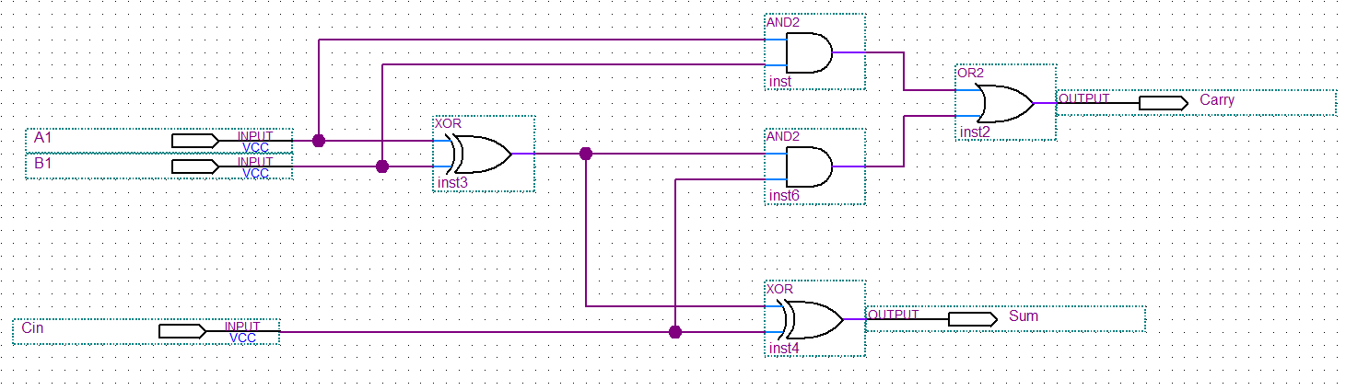

A1 | B1 | Cin | Carry | Sum
0 | 0 | 0 | 0 | 0
0 | 0 | 1 | 0 | 1
0 | 1 | 0 | 0 | 1
0 | 1 | 1 | 1 | 0
1 | 0 | 0 | 0 | 1
1 | 0 | 1 | 1 | 0
1 | 1 | 0 | 1 | 0
1 | 1 | 1 | 1 | 1

Part 3: 3-bit Full adder circuit
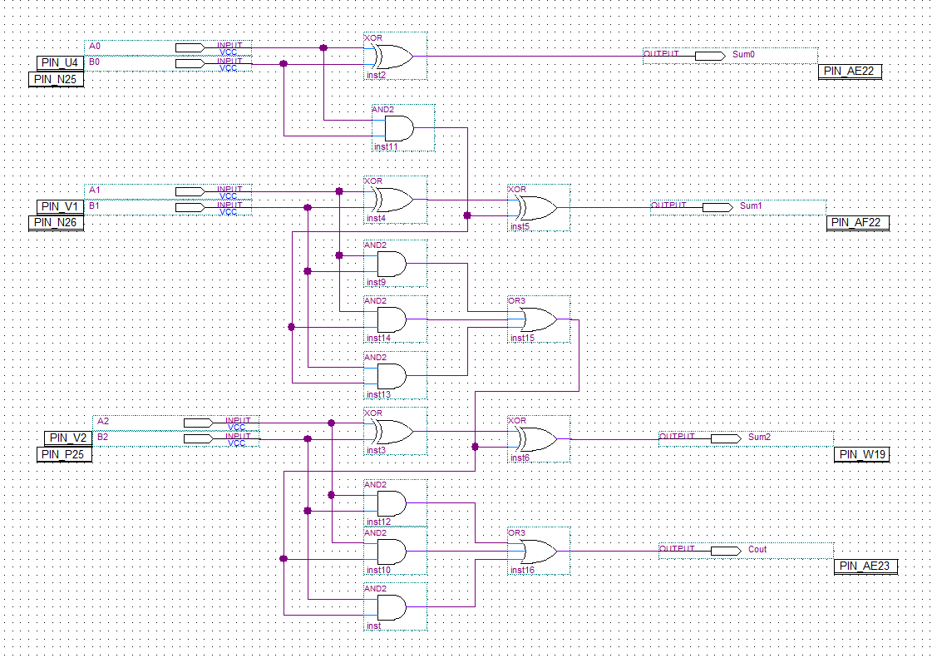
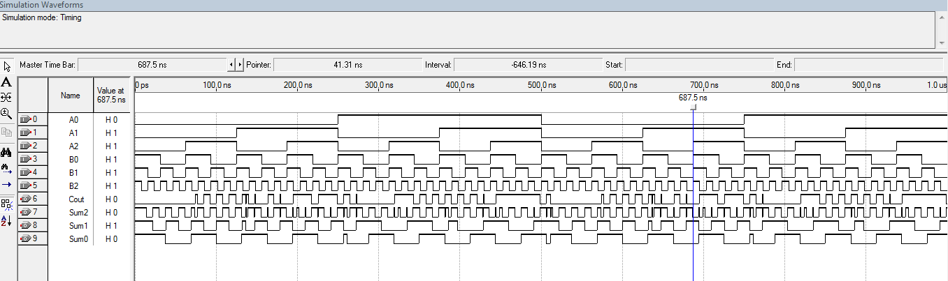
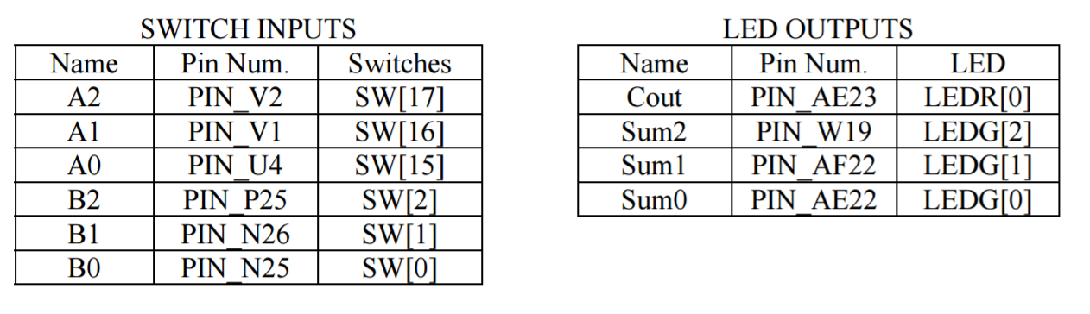
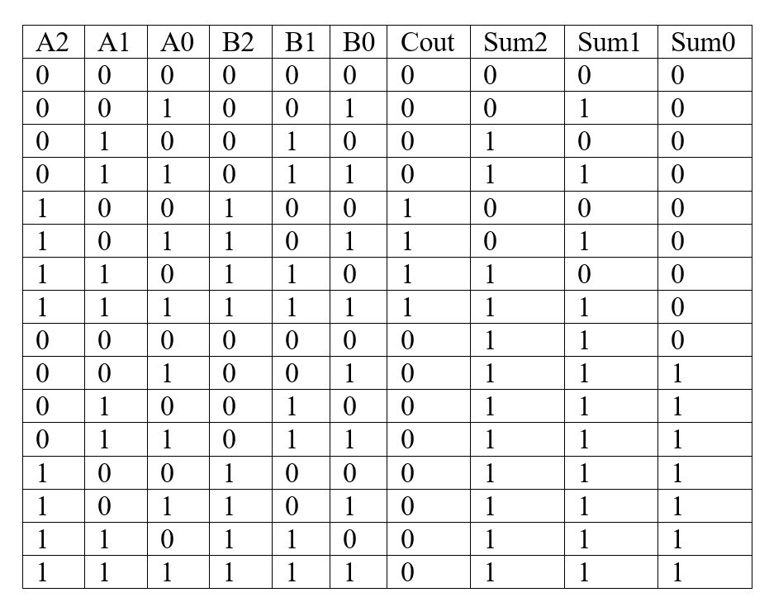

Questions:

- What is the range of values for an 8-bit unsigned binary number?
0-255

Conclusion
In this laboratory exercise we learned to design half adders and full adders onto a circuit using Quartus II software. In addition, we learned how to design and test a 3-bit adder circuit onto the Altera DE-2 board.

