Quartus II VHDL and DE2 Board

Experiment 7

Michael Robayo, Galib Rahman

04/24/2017

Objective

- To create and modify a text file using VHDL and symbol files
- To program the DE2 FPGA board by Altera

Materials
- Quartus II^{R} Web Edition V9.1 SP2 software by Altera Corporation
- Altera DE2 FPGA board
- USB Drive

Part 1

Source Code Block Design

Vector Waveform

Truth Table

A | B | X
0 | 0 | 0
0 | 1 | 0
1 | 0 | 0
1 | 1 | 1

Part 2

Source Code

Block Design

Vector Waveform

Truth Table Pin Assignments
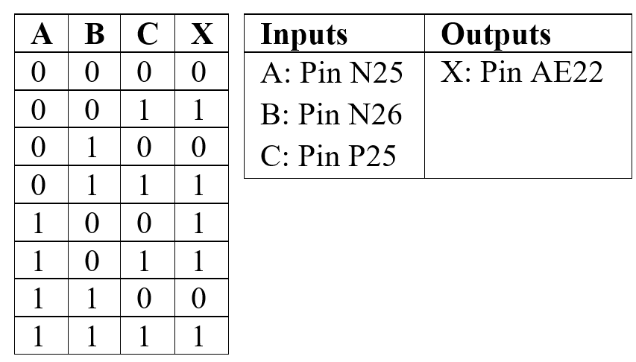

Conclusion

In this laboratory exercise we were introduced to VHDL, which is a high-level modular language. The V represents Very High Speed Integrated Circuit, whereas HDL stands for Hardware Descriptive Language. We designed VHDL Design files in the Quartus II Text Editor, and developed Block Symbol files. Through the Quartus II software we were able to manipulate the hardware to output desired outcomes.

