Universal Capability of NAND and NOR Gates

Experiment 5

Michael Robayo, Galib Rahman

3/28/17

Objective

- To understand how NAND and NOR gates can yield results as an inverter and how NAND/NOR Gates can be manipulated such that they can perform AND, OR, and all other logic operations.

- To design circuits using NAND and NOR gates forming functions consisting of AND’s,OR’s and NOT’s

Materials

- Digital Trainer (Logic Probe)
- Breadboard
- 7400 NAND gate
- 7402 NOR gate
- 7404 Inverter
- 7408 AND gate
- 7432 OR gate

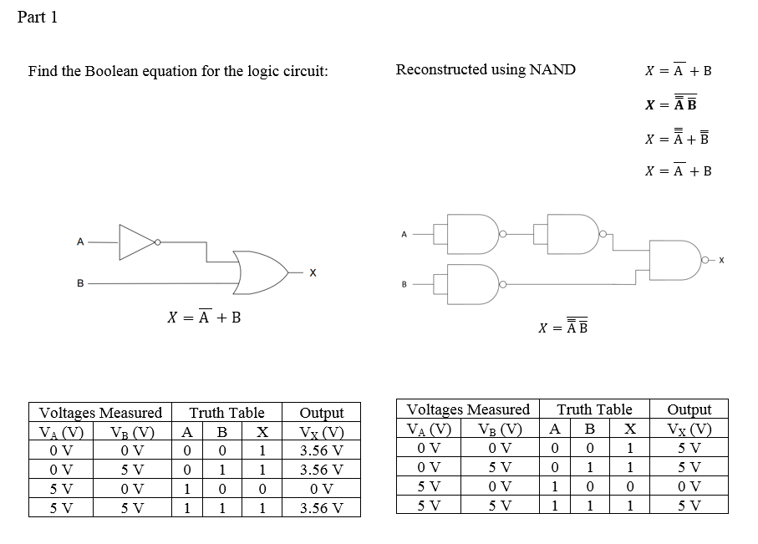

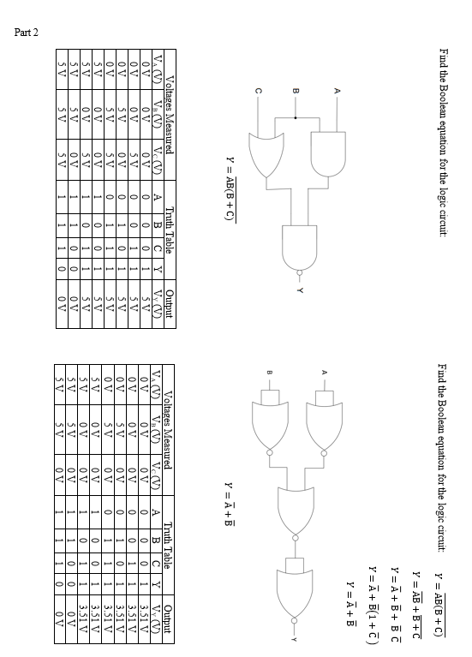

Questions:
- Why are NAND gates and NOR gates sometimes referred to as universal gates?
Because they yield the same results as any other logic gate/
- Why would a designer want to form an AND gate from two NAND gates?
Since NAND gates are universal gates, which allows us to manipulate it to yield the same output as other gates while AND is restricted to only AND operation.
- Using only four NAND Gates, Draw the Logic circuit for NOR Gate.
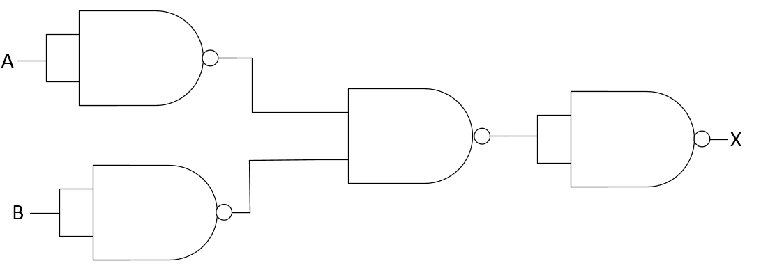
- How many inverters could be formed using a 7400 NAND IC?
4 inverters can be formed using a 7400 NAND IC.

Conclusion:
In this laboratory exercise we learned that the NAND and NOR gates are universal gates and may be utilized to manipulate any logic operation such as AND and OR. We were alse able to use NAND and NOR gates as inverters by tying the inputs together and creating a single output.

