Combinational Logic Circuits

Experiment 4

Michael Robayo, Galib Rahman

1/28/17

Objective

- To utilize Boolean algebra to represent given logic circuits’ characteristics

- To verify the validity of a deduced expression via comparison of truth tables to measured voltages

- To utilize theorems in Boolean algebra to derive a simplified expression of said logic gates and validate their equality to the characteristics observed to that of the unsimplified expression via comparison of truth table values.

Materials
- 5V DC Power Supply
- Digital Trainer (Logic Probe)
- Breadboard
- DIP Switch
- 7400 NAND gate
- 7402 NOR gate
- 7404 Inverter
- 7408 AND gate
- 7432 OR gate

Part 1
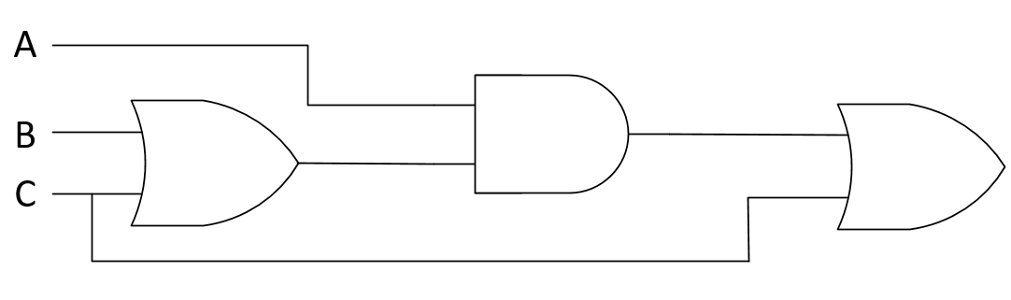

Boolean Expression: A(B+C)+C
Truth Table

Voltages Measured |  |  | Truth Table
V_{A} (V) | V_{B} (V) | V_{C} (V) | A | B | C | X | V_{X} (V)
0 Volts | 0 Volts | 0 Volts | 0 | 0 | 0 | 0 | 0 Volts
0 Volts | 0 Volts | 5 Volts | 0 | 0 | 1 | 1 | 3.56 Volts
0 Volts | 5 Volts | 0 Volts | 0 | 1 | 0 | 0 | 0 Volts
0 Volts | 5 Volts | 5 Volts | 0 | 1 | 1 | 1 | 3.56 Volts
0 Volts | 0 Volts | 0 Volts | 1 | 0 | 0 | 0 | 0 Volts
5 Volts | 0 Volts | 5 Volts | 1 | 0 | 1 | 1 | 3.56 Volts
5 Volts | 5 Volts | 0 Volts | 1 | 1 | 0 | 1 | 3.56 Volts
5 Volts | 5 Volts | 5 Volts | 1 | 1 | 1 | 1 | 3.56 Volts

Simplified Boolean Expression: AB + C
Simplified Circuit:
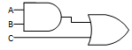
Truth Table [Simplified Circuit]

Voltages Measured |  |  | Truth Table
V_{A} (V) | V_{B} (V) | V_{C} (V) | A | B | C | X | V_{X} (V)
0 Volts | 0 Volts | 0 Volts | 0 | 0 | 0 | 0 | 0 Volts
0 Volts | 0 Volts | 5 Volts | 0 | 0 | 1 | 1 | 3.56 Volts
0 Volts | 5 Volts | 0 Volts | 0 | 1 | 0 | 0 | 0 Volts
0 Volts | 5 Volts | 5 Volts | 0 | 1 | 1 | 1 | 3.56 Volts
0 Volts | 0 Volts | 0 Volts | 1 | 0 | 0 | 0 | 0 Volts
5 Volts | 0 Volts | 5 Volts | 1 | 0 | 1 | 1 | 3.56 Volts
5 Volts | 5 Volts | 0 Volts | 1 | 1 | 0 | 1 | 3.56 Volts
5 Volts | 5 Volts | 5 Volts | 1 | 1 | 1 | 1 | 3.56 Volts

Part 2
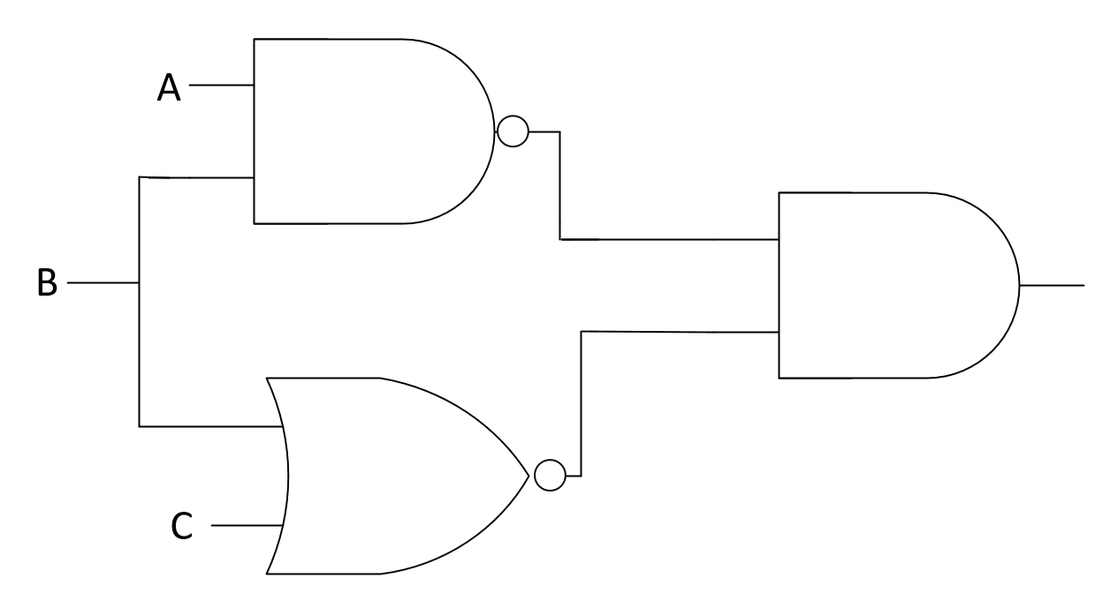

Boolean Expression:
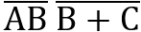
Truth Table

Voltages Measured |  |  | Truth Table
V_{A} (V) | V_{B} (V) | V_{C} (V) | A | B | C | X | V_{X} (V)
0 Volts | 0 Volts | 0 Volts | 0 | 0 | 0 | 1 | 3.56 Volts
0 Volts | 0 Volts | 5 Volts | 0 | 0 | 1 | 0 | 0 Volts
0 Volts | 5 Volts | 0 Volts | 0 | 1 | 0 | 0 | 0 Volts
0 Volts | 5 Volts | 5 Volts | 0 | 1 | 1 | 0 | 0 Volts
0 Volts | 0 Volts | 0 Volts | 1 | 0 | 0 | 1 | 3.56 Volts
5 Volts | 0 Volts | 5 Volts | 1 | 0 | 1 | 0 | 0 Volts
5 Volts | 5 Volts | 0 Volts | 1 | 1 | 0 | 0 | 0 Volts
5 Volts | 5 Volts | 5 Volts | 1 | 1 | 1 | 0 | 0 Volts

Simplified Boolean Expression:
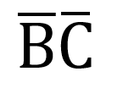
Simplified Circuit:

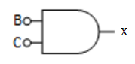
Truth Table
Voltages Measured |  |  | Truth Table
V_{A} (V) | V_{B} (V) | V_{C} (V) | A | B | C | X | V_{X} (V)
0 Volts | 0 Volts | 0 Volts | 0 | 0 | 0 | 1 | 3.56 Volts
0 Volts | 0 Volts | 5 Volts | 0 | 0 | 1 | 0 | 0 Volts
0 Volts | 5 Volts | 0 Volts | 0 | 1 | 0 | 0 | 0 Volts
0 Volts | 5 Volts | 5 Volts | 0 | 1 | 1 | 0 | 0 Volts
0 Volts | 0 Volts | 0 Volts | 1 | 0 | 0 | 1 | 3.56 Volts
0 Volts | 0 Volts | 5 Volts | 1 | 0 | 1 | 0 | 0 Volts
0 Volts | 5 Volts | 0 Volts | 1 | 1 | 0 | 0 | 0 Volts
0 Volts | 5 Volts | 5 Volts | 1 | 1 | 1 | 0 | 0 Volts

Questions
- Why is Boolean algebra used for combinational circuits?
When creating circuits utilizing logic gates, we represent them using Boolean expressions. Using Boolean algebra and Boolean theorems we can simplify a logic expression by reducing the number of terms in the expression reducing the complexity of the original circuit.

- What are three laws for Boolean algebra? Answer with simple examples.
Commutative, Associative, and Distributive laws.
Examples:
Commutative: A + B = B+A
Associative: (A + B) + C = A + (B + C)
Distributive: (A + B)(C + D)= AC + AD + BC + BD

- Why is De Morgan’s theorem important in the simplification of Boolean equation?
De Morgan’s theorem is quite useful in simplifying expressions in cases where a product or sum of variables are inverted. When the OR sum of two variable is inverted, it is equivalent to the ANDing of both inverted variables. When the AND product of two variables is inverted it is equivalent to the ORing of each inverted variable.

- Using DeMorgan’s theorem, you can prove that a NAND gate is equivalent to an (OR or AND) gate with inverted inputs.
The NAND gate is equivalent to an OR gate with inverted inputs.

- Using De Morgan’s theorem, you can prove that a NOR gate is equivalent to an (OR or AND) gate with inverted inputs.
The NOR gate is equivalent to a AND gate with inverted inputs.

Conclusion:
In conclusion, in this experiment we were able to construct logic gate circuits using schematic diagrams given to us onto a breadboard. Any logic gate circuit will have its own Boolean expression to represent every logic gate within the circuit. To simplify a Boolean expression the basic rules and laws of Boolean algebra and DeMorgan’s theorem can be used in order to reduce the number of gates but still have the same output.

