Logic Probe and Oscilloscope

Experiment 1

Michael Robayo, Galib Rahman

1/13/17

Objective:
- To understand and construct a circuit onto the breadboard from a schematic diagram.
- To use the Oscilloscope to measure the parameters of a Periodic waveform.

Materials:
- 5V DC Power Supply
- Logic Probe (from digital trainer)
- Oscilloscope
- Function Generator
- EMT 1250L Parts Kit

Schematic Diagram :

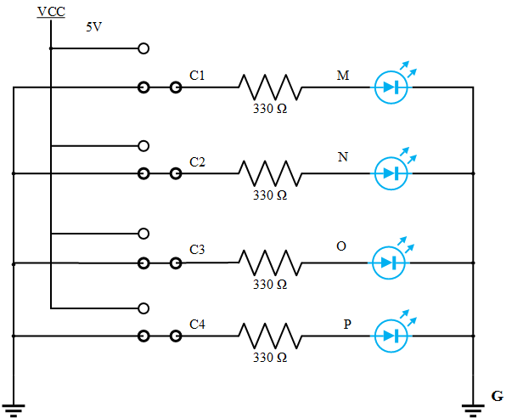

Data

V High | V Low | t hi (sec) | Period (sec) | Frequency (Hz)
3.04 Volts | 1.04 Volts | 500 μs | 1.0 ms | 1 kHz

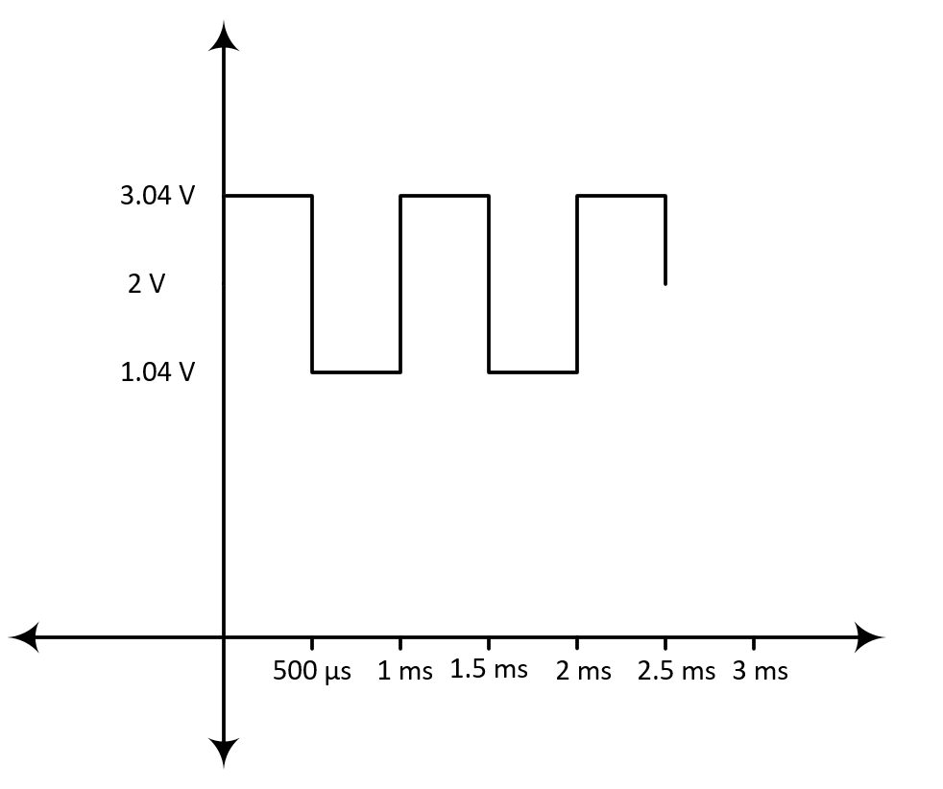

V High | V Low | t hi (sec) | Period (sec) | Frequency (Hz)
4.48 Volts | 1.92 Volts | 20 μs | 100 μs | 10 kHz

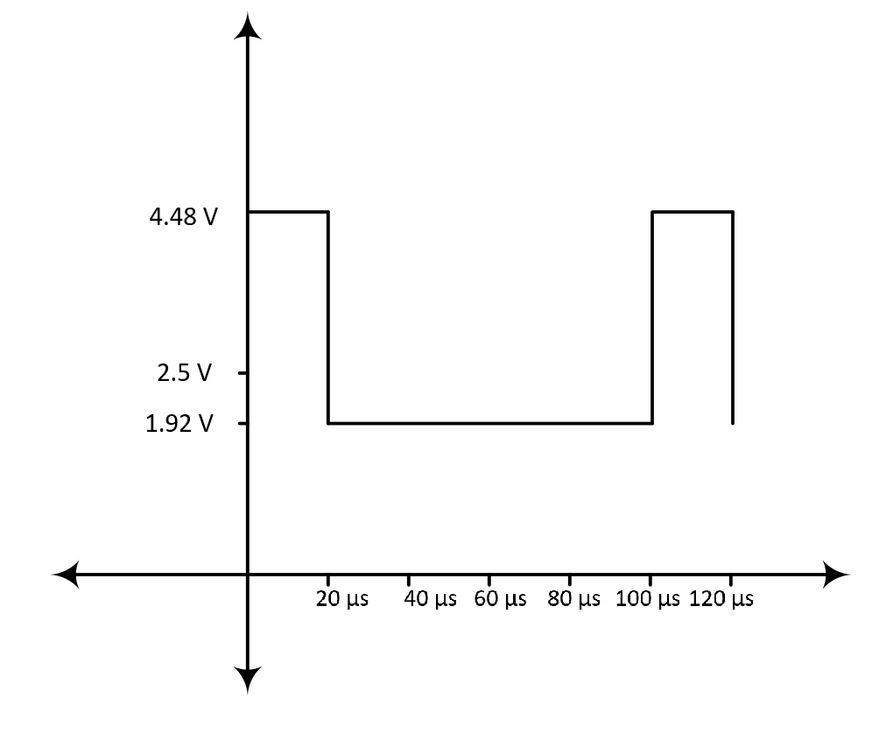

Data (cont.)

V High | V Low | t hi (sec) | Period (sec) | Frequency (Hz)
2.48 Volts | .480 Volts | 40 μs | 50 μs | 20 kHz

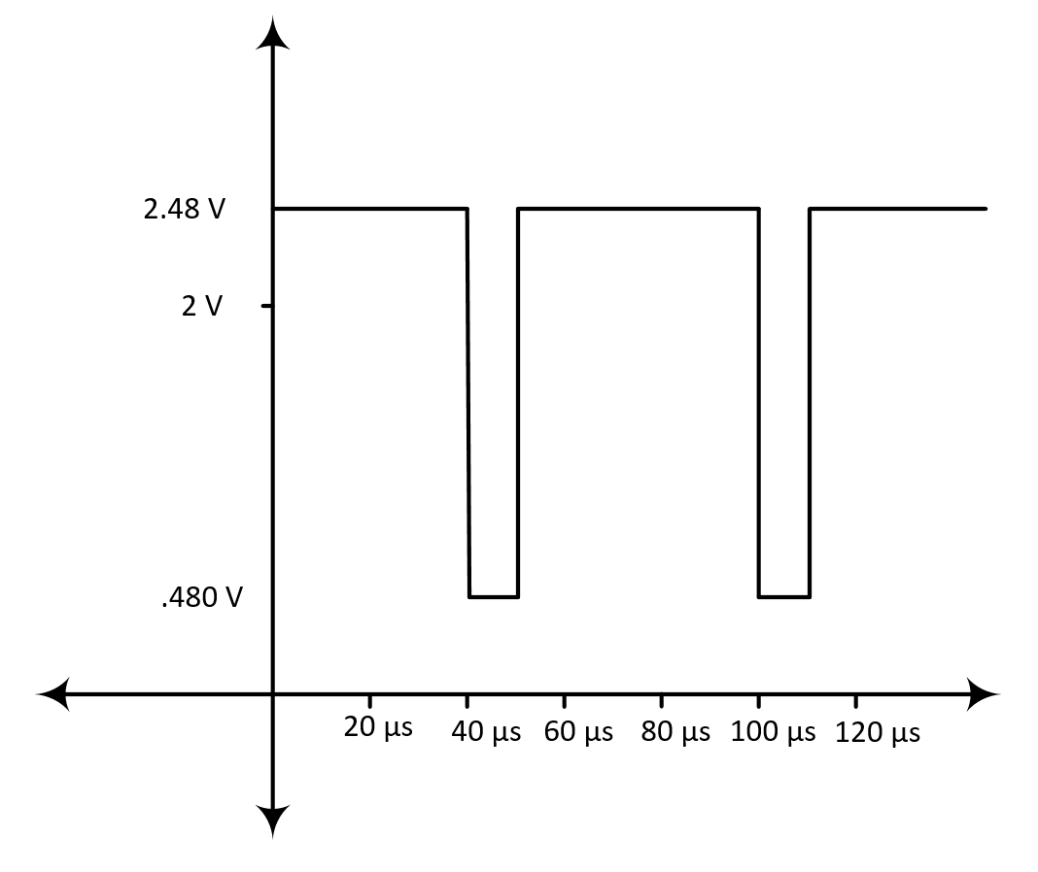

Questions and Answers:
- Compare using a Logic Probe VS Oscilloscope in debugging a circuit. State the advantages of each.
While performing the experiment, my partner and I came to conclude that using the Logic probe seemed to be much simpler and easier to use and setup compared to the Oscilloscope. Using our digital trainer and the circuit we constructed from the schematic diagram it was very easy to connect it all together and then use the logic probe to debug the circuit. Therefore, the advantages of using the logic probe would be that it is simple and easy to use and setup. On the other hand, the Oscilloscope gives more of a detailed representation of the circuit by displaying the frequency, period, and time of the wave. The advantages of using the Oscilloscope would be allowing the user to measure the the parameters of the periodic wave of the circuit.

- Calculate the Duty Cycle for the 3 Function Generators setting in Part 2 of the experiment. Use the Oscilloscope readings to calculate Duty Cycle. Do the calculated values agree with the Function Generator settings?

In this laboratory exercise, we recorded the observed values for t(high) and the period (T) from the oscilloscope’s readings for each function generator setting. To deduce the duty cycle from the oscilloscope readings, one must divide the t(high) with the period (T). In the first function generator setting the Duty Cycle was set to 50%, and our t(high) reading was 500 μs, whereas our period (T) was 1.0 ms or 1000 μs. Thus, the experimental duty cycle was 50 % which matches with our theoretical duty cycle. In the second function generator setting the set duty cycle was 20 %, and our recorded t(high) was 20 μs and period was 100 μs. Thus, the experimental duty cycle for the second function generator setting was 20 % as was the theoretical. In the final setting for the function generator the set duty cycle was 80 % and our reading for t(high) was 40 μs and the period was 50 μs. Therefore the experimental duty cycle was 80% which matched with the 80% theoretical duty cycle. In conclusion our oscilloscope readings matched perfectly with the set duty cycles.

Conclusion
After successfully completing this laboratory exercise we learned the properties of square waves and the influence of various factors such as the duty cycle, frequency,offset, & amplitude. We were also able to deduce these values via oscilloscope readings and generate functions with given parameters. Additionally, we learned to utilize a logic probe within a circuit, which incorporated resistors and diodes.

