EMT 1150 Electrical Circuits

Laboratory Report II

Resistance and Ohm’s Law Measurements

Ω

Written By: Galib Rahman, Ammar Krcic, Christopher Padilla
Professor: Aparicio Carranza
09|19|2016

Table of Contents

Resistance

Objective

Procedure

Materials

Data……………..………………………………Page 01

Conclusion………………………..…………….Page 02

Resistor Color Code………………..……….………Page 04

Ohm’s Law Measurements

Objective

Materials

Procedure………….…………...………………..Page 05

Data………………..……………………………Page 06

Graphs……………………………………….….Page 07

Objective
Resistance | Page 01
To utilize the Color Code System to derive the nominal value of resistance of said resistors. After deriving, the nominal values we will compare this data to the resistance value measured using a multimeter.

Procedure
Utilizing the 10 resistors we utilized the Color Code System to determine their nominal resistance & recorded their values. Afterwards, we measured the resistance of each resistor using a multimeter & collected those measurements as well. Next, we compared these two data types (nominal & measured values) and calculated the tolerance using the following formula:
$$|\frac{Measured Value-Marked Value}{Marked Value} |×100\%$$
Finally, we were given two unmarked resistors and derived the color code of each.

Materials
The materials utilized to perform this laboratory exercise are the following:
Number | Resistor Type | Number | Resistor Type | Number | Item
1 | 47Ω | 1 | 220 Ω | 1 | Multimeter
1 | 330 Ω | 1 | 620 Ω
1 | 820 Ω | 1 | 1 KΩ
1 | 470 Ω | 1 | 4.7 KΩ
1 | 68 KΩ | 1 | 270 KΩ

Data
1st Band | 2nd Band | 3rd Band | Marked Value (Ω ) | Tolerance | Measure Value | Tolerance (Calculated)
Yellow | Violet | Black | 47 | 5% | 47 | 0
Orange | Orange | Brown | 330 | 5% | 327 | 0.909090909
Grey | Red | Brown | 820 | 5% | 813 | 0.853658537
Yellow | Violet | Brown | 470 | 5% | 468 | 0.425531915
Blue | Grey | Orange | 68000 | 5% | 65700 | 3.382352941
Red | Red | Brown | 220 | 5% | 217 | 1.363636364
Blue | Red | Brown | 620 | 5% | 617 | 0.483870968
Brown | Black | Red | 1000 | 5% | 1000 | 0
Yellow | Violet | Red | 4700 | 5% | 4700 | 0
Red | Violet | Yellow | 270000 | 5% | 271000 | 0.37037037

Name of Resistor | Measured Resistance (KΩ) | Measured Resistance (Ω) | Potential Color Scheme
Unknown Resistor #1 | .056 | 56 | Green | Blue | Black
Unknown Resistor #2 | .83 | 830 | Gray | Orange | Brown
Approved Data _______________
Resistance | Page 02

Conclusion

Questions

- Determine the four band color code for these resistors if the tolerance is 5%:
395Ω | 3.39 KΩ | 1 Ω | 15 Ω | 11 Ω

Provided Resistor Value | Resistor Values (Ω) | Color Code
395Ω | 395 Ω | Orange | White | Brown | Gold
3.39KΩ | 3390 Ω | Orange | Orange | Red | Gold
1 Ω | 1 Ω | Black | Brown | Black | Gold
15 Ω | 15 Ω | Brown | Green | Black | Gold
11 Ω | 11 Ω | Brown | Brown | Black | Gold

- Determine the value range of these resistors if the tolerance is 2%

Provided Color Code |  |  | Value _{(Excluding Tolerance)} | Upper Range | Lower Range
Red | Red | Orange | 22000 | 20240 | 23760
Brown | Green | Red | 1500 | 1380 | 1620
Red | Red | Red | 2200 | 2024 | 23760
Orange | Orange | Orange | 33000 | 30360 | 35640

- Determine the value range of these resistors if the tolerance is 8%

Provided Color Code |  |  | Value _{(Excluding Tolerance)} | Upper Range | Lower Range
Blue | Gray | Black | 68 | 62.56 | 73.44
Brown | Black | Green | 1,000,000 | 920000 | 1080000
Green | Blue | Red | 5600 | 5152 | 73.44
Gray | Red | Red | 8200 | 7544 | 8856

Resistance | Page 03

In this laboratory exercise, we learned to determine the Nominal value of provided resistors by using the Color Code System. In addition, we compared the marked values to the measured values using a multi-meter to obtain said data. Resistors can be categorized in two groups, fixed or variable. A fixed resistor provides a constant value of resistance and cannot be changed. Meanwhile, a variable resistor has a terminal resistance that can be manipulated via a dial or knob – to a desired value of resistance, as implied by the name. A rheostat is a variable resistor that has 2-3 terminals. If the 3 terminal device is utilized for the control of potential levels – then it is often referred to as a potentiometer. In this experiment, however, we only worked with fixed resistors and determined the nominal value using 4 bands. To read a resistor we refer to the color values of each band. We refer to the band closest to the edge of the resistor as the first resistor and read from left to right. The first two bands represent a number value corresponding to the colors on the Color Code System. For example if the first two numbers read 1 & 0, the number represented from the first two bands is 10. The third band represents the multiplier. The number value corresponding to the third band say n, is equivalent to the value of 10^{n} (thus, if n was 3 the multiplier would result to 10 ³). This value is then multiplied to the number value derived from the first two bands- hence the name multiplier. The next band refers to the marked tolerance. Each marked tolerance band refers to the range of the nominal value. The colors corresponding to the tolerance band according to the (4 band) Color Code System refer to a percentage value for example, if the fourth band was to be a gold color the nominal tolerance would be ±5%. Thus if the other three bands represented 10 x 10³ – the fourth band indicates that the resistor’s range is of the following:

[(10 x 10³) - ((10 x 10³)*5%)] Ω to [(10 x 10³) + ((10 x 10³)*5%)] Ω
Or
9500 Ω - 10500 Ω

The Five Band Color Code System consists of three bands that represent a number value as the first two bands in the Four Band Color Code System. The fourth color band on a Five Band Resistor is the multiplier and the fifth band represents the tolerance – which indicates the resistor’s range. Some resistors even have six bands and follow the Six Band Color Code System, which follows the same components of that of a five band but has one additional band after the tolerance band. The last band on a six-band resistor represents the temperature coefficient. The diagram on the next page demonstrates the band representations for each color code system of the various band resistors.
Resistance | Page 04

Resistor Color Codes

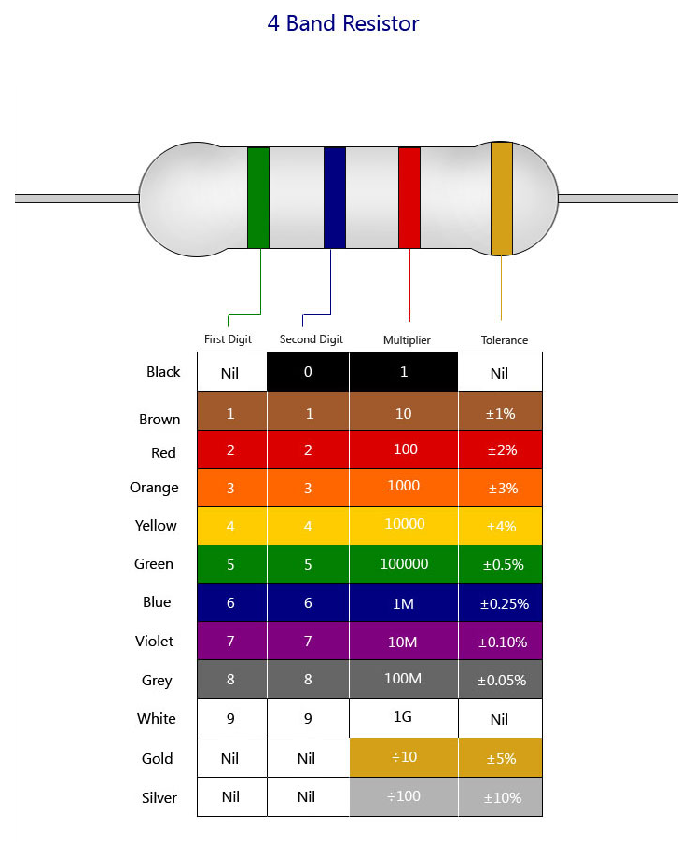

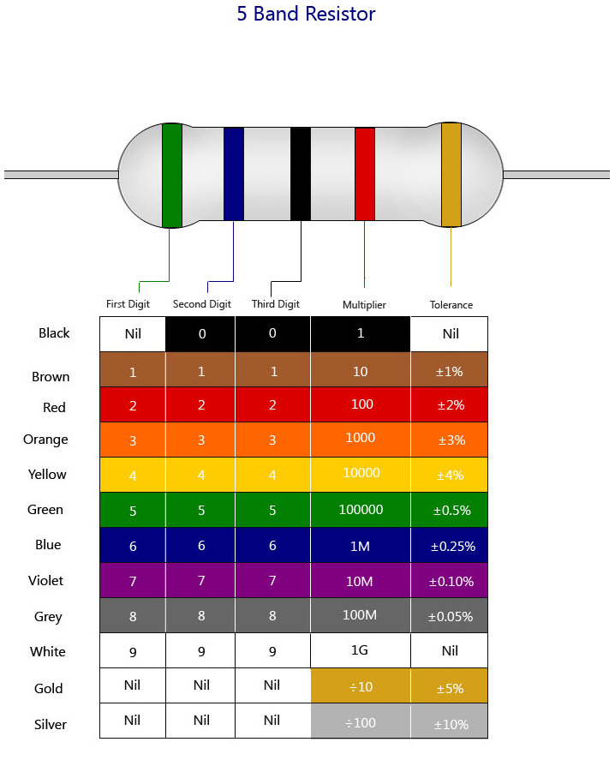

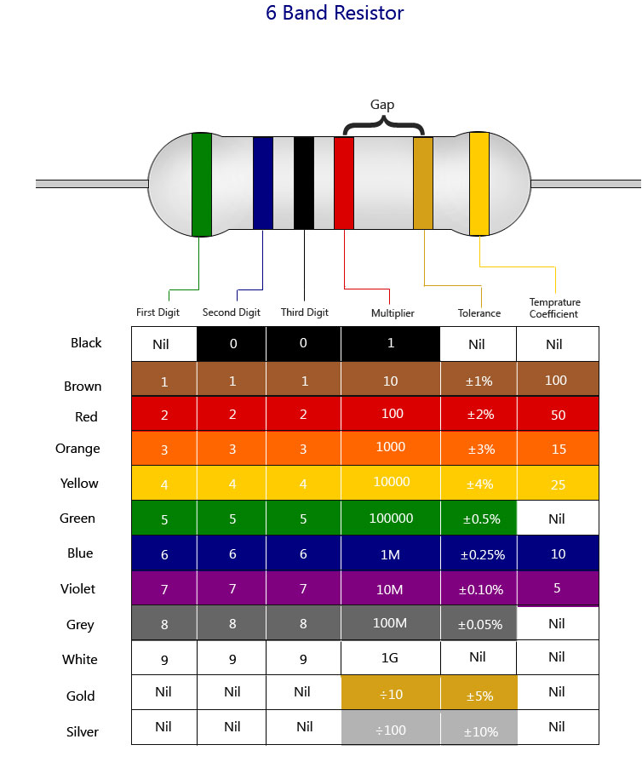

Objective
Ohm’s Law Measurements | Page 05
The purpose of this laboratory experiment is to analyze a circuit that has voltage & experiences resistance. By performing this experiment, we will also determine the relationship between a circuit’s voltage, current flow, resistance, and power.

Materials
The materials utilized to perform this laboratory exercise are the following:
Number | Material | Number | Material
1 | 47Ω | 1 | Breadboard
1 | 330Ω | 1 | Wires Kit
1 | 1KΩ | 1 | Meter
 |  | 1 | Switch

Procedure
Using the materials mentioned above, we designed a circuit using a resistor of 47Ω and utilized a direct current (DC) power supply- outputting 1 Volt onto a breadboard. The schematic of said circuit is show below:
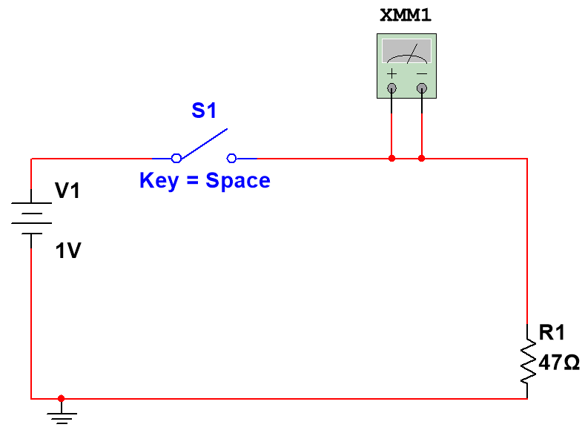

To study the relationship between voltage, resistance, current, and power we varied the power supply (Voltage) ,kept the resistance constant and measured the current using a multimeter.
Then, we changed the resistor on the breadboard circuit of a higher nominal & measured resistance value and varied the voltage as we did with the previous resistor. After measuring the current with the various voltages, we were able to calculate the circuit’s resistance and power.

Ohm’s Law Measurements | Page 06

Data

Sample Calculation:
Given:
Voltage (V) : 1 Volt Current (I) : 20.5 mA
$Resistance= \frac{E_{voltage}}{I_{current}} Ω$
$Resistance= \frac{1 Volt}{20.5 ×{10}^{-3 }Amps}$
$Resistance=48.8 Ω$

$Power= E_{voltage} × I_{current} mW$
$Power=1 Volt ×20.5×{10}^{-3} Amps$
$Power=20.5*{10}^{-3} Watts$
$Power=20.5 mW$
Table 3-1
 |  | Measured | R= 48 Ω
 | E (Volts) | I (mA) | R=E/I Ω | P=EI(mW)
 | 1 | 20.5 | 48.780488 | 20.5
 | 2 | 40.6 | 24.630542 | 81.2
 | 4 | 81.4 | 12.285012 | 325.6
 | 8 | 168.3 | 5.9417706 | 1346.4
Table 3-2
 |  | Measured | R=330Ω
 | E (Volts) | I (mA) | R=E/I Ω | P=EI(mW)
 | 1 | 3.1 | 322.58065 | 3.1
 | 2 | 6 | 333.33333 | 12
 | 4 | 12.1 | 330.57851 | 48.4
 | 8 | 24.4 | 327.86885 | 195.2
Table 3-3
 |  | Measured | R=1KΩ
 | E (Volts) | I (mA) | R=E/I Ω | P=EI(mW)
 | 1 | 1 | 1000 | 1
 | 2 | 2 | 1000 | 4
 | 4 | 4 | 1000 | 16
 | 8 | 8 | 1000 | 64

Conclusion
Given that the resistance is constant, the relationship between current and applied voltage is direct. Thus, an increase in applied voltage yields an increase of current – given that the resistance is constant. When we study tables 3-2 & 3-3 when the applied voltage is 4 Volts (and the resistance of Table 3-3 > the resistance of Table 3.2), once can observe that an increase in resistance results in a decrease of current flow. When the resistance is constant and the voltage is “doubled” - the current doubles and the power quadruples. Thus, if the voltage was to be “halved” – in the condition where resistance is constant, the current flow would be halved as well, while the power would be “quartered” or (multiplied by ¼).

Graphs
Ohm’s Law Measurements | Page 07

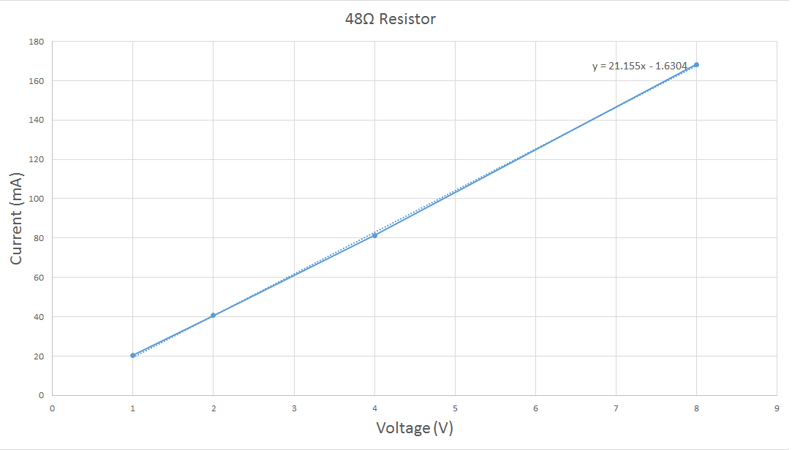

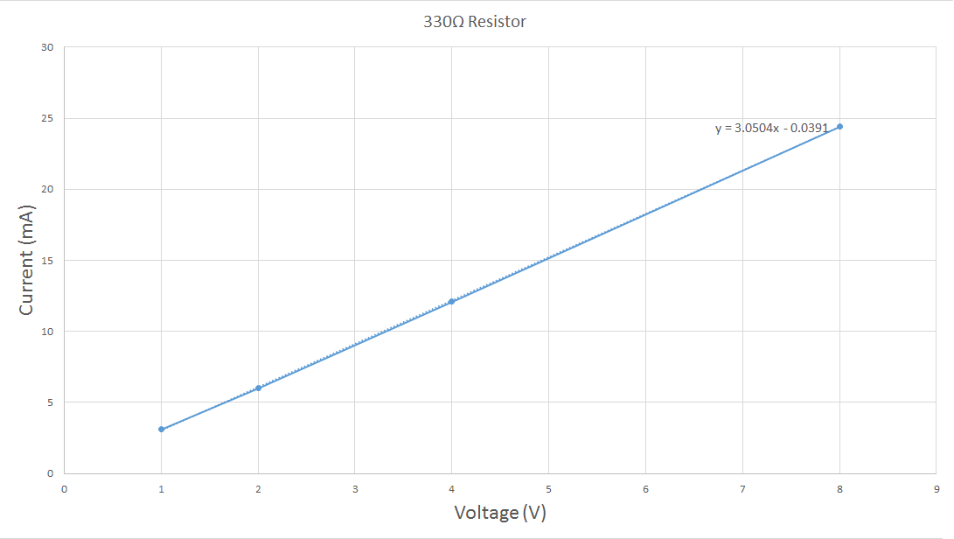

Ohm’s Law Measurements | Page 08

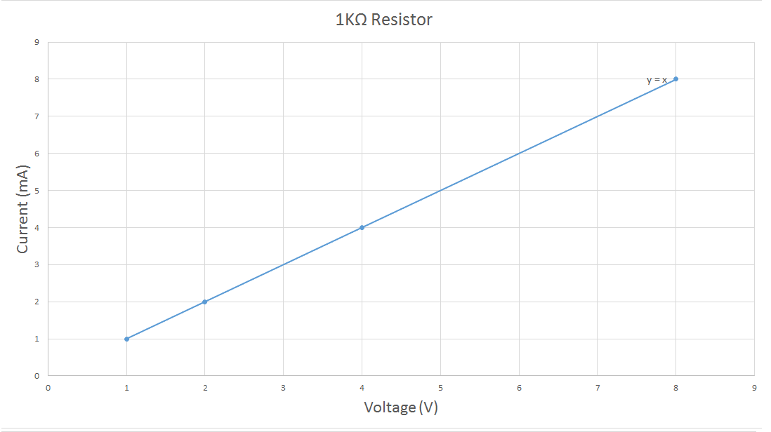

Ohm’s Law Measurements | Page 09

