Introduction to Multisim

Experiment No. 001

Lab Report Written By Galib F. Rahman
  - EMT 1150 Electrical Circuits Laboratory | Section D385
09/12/2016

Objective
The objective of this laboratory exercise is to introduce the student to software that simulates potential circuit designs i.e. Multisim. The utilization of such tools proves to be quite advantageous when attempting to design circuitry and foreseeing potential design flaws or even alternatives.

Procedure
In this experiment, we designed two separate circuits following the simple instructions provided in the manual (for experiment 01). The first circuit designed utilized two resistors one of 200Ω resistance & another of 1KΩ resistance (and tolerance of 5%), SPST switch (Single Pole Single Throw Switch), Direct Current Power Source, & a Ground connection. Afterwards we attached a virtual multimeter to measure the virtual voltage output near the 1 KΩ resistor, as shown below.
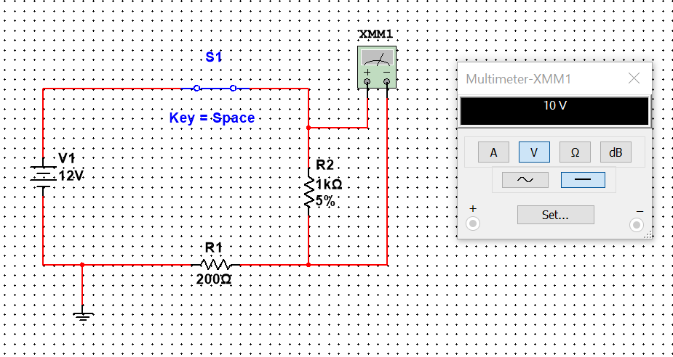

The second circuit’s design only specified to include 3 resistors (of any value) and a 15 V battery with multimeters across each resistor. The following displays the circuit designed fulfilling the specifications:
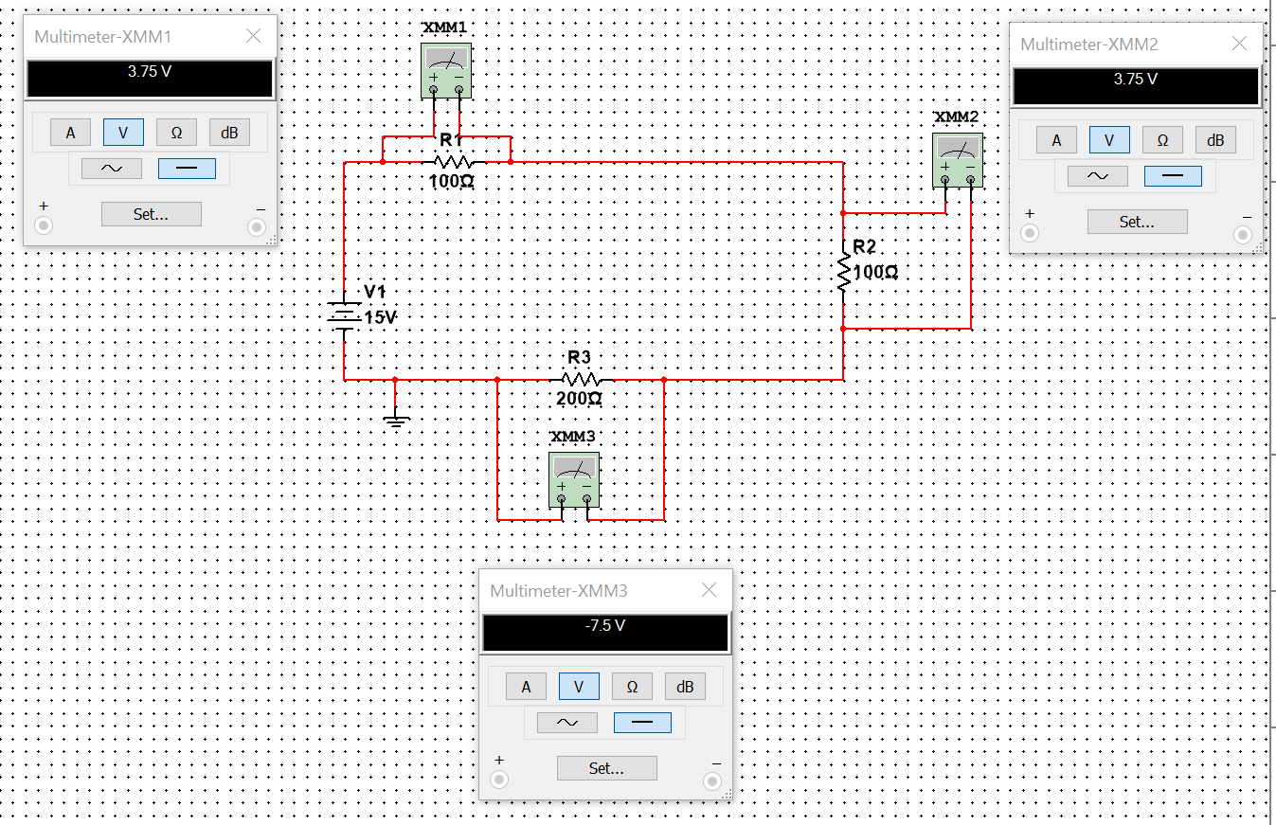

Conclusion
This experiment introduced us to circuit design and the components that are used commonly to create a basic circuit. In addition, we were able to simulate a virtual circuit and receive data based on the specifications of the components we applied in the software, Multisim.

