Complete the following information about the regions/appellations before class begins.

Country/Region/Appellation
United States/California/ Sonoma County
-Within the Sonoma County AVA there are a total of 17 sub-AVAs
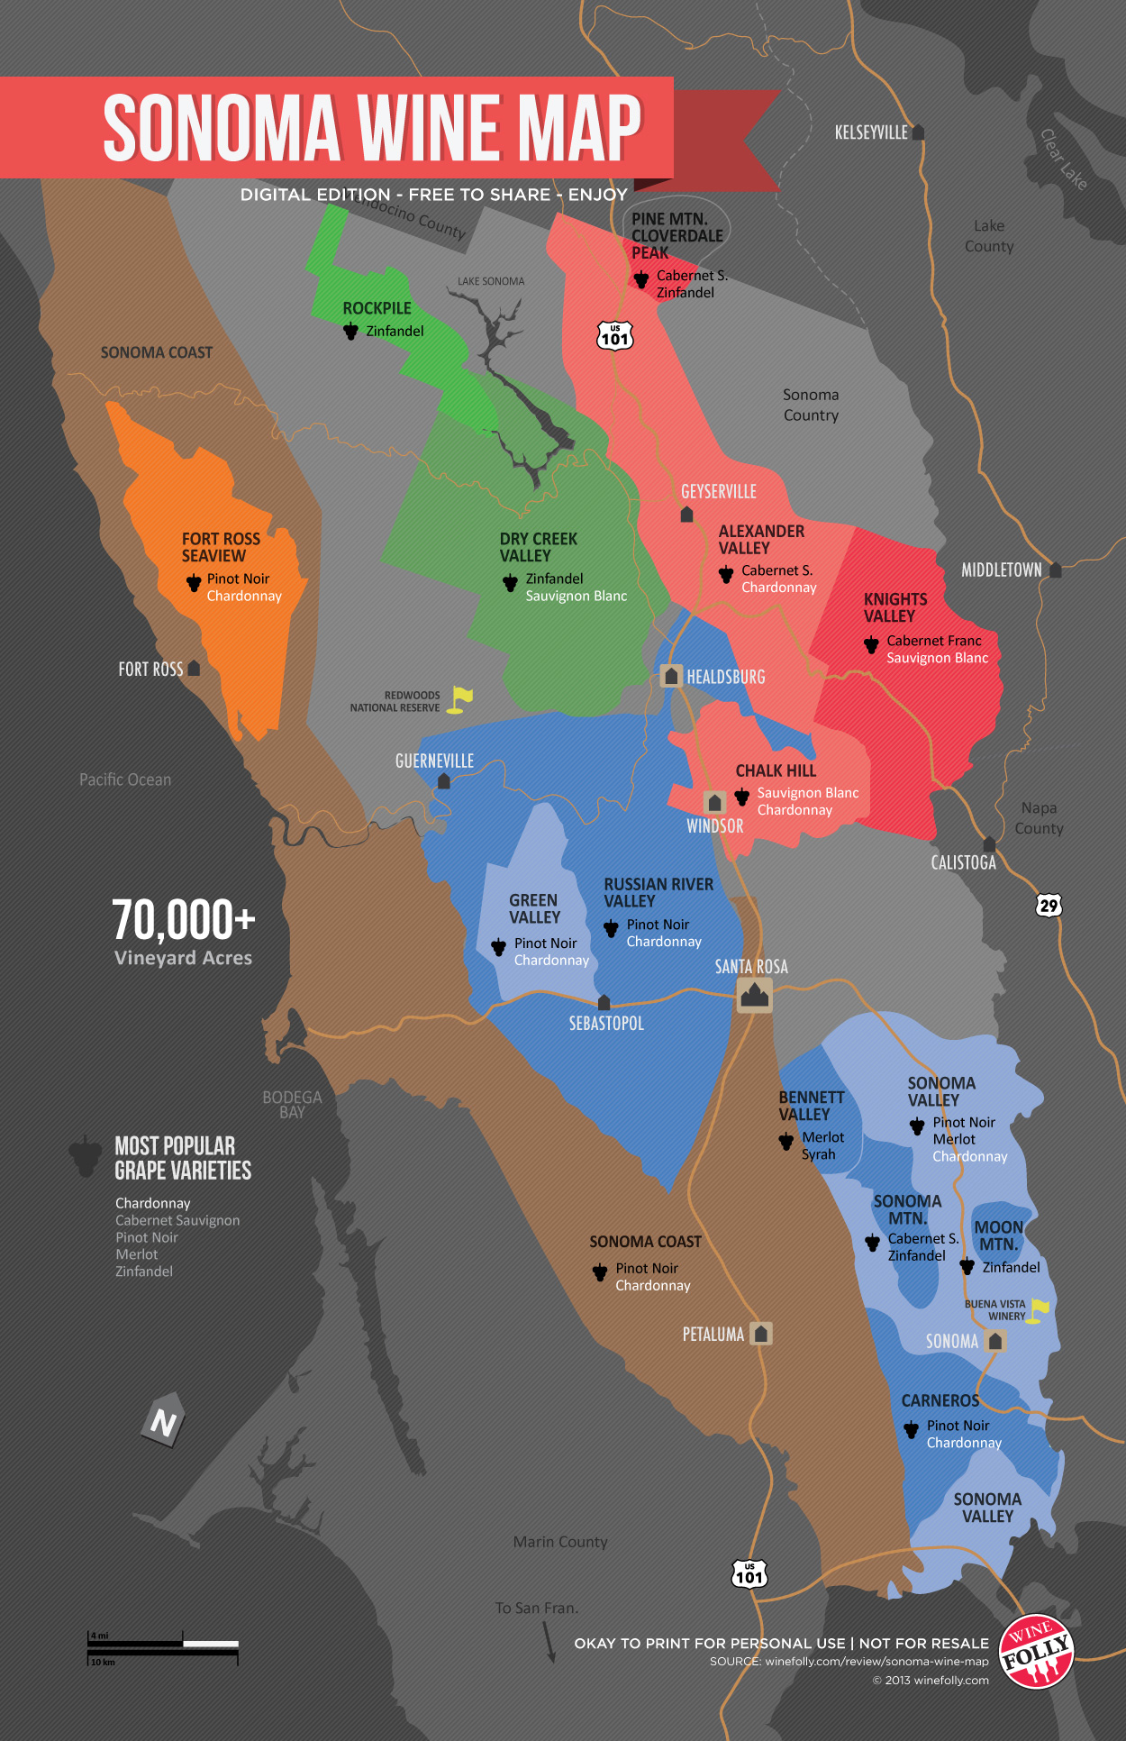

Grape variety
-Due to the wide range of microclimates within Sonoma county there are a huge variety of grapes with a total of 66 different grape varieties 44 being red wine grape varieties and the other 22 being white wine grape varities
-Some notable grape varieties are:
-Chardonnay
-Cabernet Sauvignon
-Pinot Noir
-Merlot
-Zinfandel
-Syrah
-Sauvignon Blanc
-These seven grape varieties make up more than 90% of the Sonoma County’s planted acres
Climate
-Being such a big region, Sonoma county is home of a huge range of many different microclimates.
-Towards the west side of Sonoma County near the Pacific Ocean, there tends to be more cooler and maritime climates due to being near the Pacific Ocean and also with the famous Sonoma Fog that counteracts California’s hot and dry climate.
-Towards areas like the Sonoma Mountains away from the west side of Sonoma County away from the Pacific you have a more continental climate similar to that of Washington and also being mostly placed above sea level to avoid the Sonoma fog. These areas are also prone to having diurnal temperatures.
Soil
-Being such a big region, Sonoma County has a lot of different soil varieties where due to the geographical history of the Sonoma County there has been 11 major formation types with 31 different soil series within these major formations.
-

Viticulture
-The Sonoma County AVA is very similar to the idea of the left and right banks of Bordeaux in terms of how the left and right banks are similar to the western and eastern sub AVAs of Sonoma County.
-As previously stated there are a a huge number of different grape varieties and viticultural practices in each sub AVA of Sonoma County.
- This site lists the following major grape varieites and major grape varieties of each sub AVA. https://www.sonomacounty.com/news/american-viticultural-areas-sonoma-county

Vinification
-Within Sonoma County they use stainless steel tanks and oak barrels for 6-20 months for their red wines.
-For their white wines they use cold fermentation which creates an acidity and bright fruit flavor in their wines.
Add additional notes about the regions/appellations/labels during.
How to Read a Wine Label
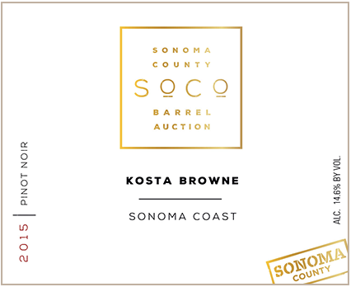
https://sonomawine.com/learn/conjunctive-labeling/
http://www.bobdogwine.com/fun-stuff/reading-the-wine-label/
Interesting fact
-Sonoma Wine Country lays claim to being the birthplace of California's modern wine industry and has the state's oldest commercial winery (Buena Vista) and the oldest, continuously operating family winery (Gundlach-Bundschu).
-Sonoma County is the most diverse premium winegrape growing region in the United States. In fact, it produces 6 percent of all the wine in California.
-Sonoma County's 18 wine regions are home to more than 400 wineries. They range from small, family-run operations to internationally acclaimed wine houses.

