Complete the following information about the regions/appellations before class begins.

Country/Region/Appellation – United States/ California/ Napa Valley

Grape variety: Cabernet Sauvignon, Sauvignon Blanc, Cabernet Franc, Chardonnay, Merlot, Petite Verdot, Malbec, Pinot Noir

Climate: Dry Mediterranean climate. Defined by mountain ranges and influenced by its proximity to the Pacific Ocean. It is perfectly suited to grow fine wine grapes. There are two main mountains in Napa Valley: The Mayacamas Mountain and the Vaca Mountain.

Soil- Consist of layers of gravel sand and silt that have decedent from the western Mayacamas Mountains. These soils are deep and well draining due to the mountain ranges..

Wineries:
Mondavi, V. Sattui Winery, Charles Krug

Viticulture:
This article provides a depth analysis of the viticultural practices that vineyard management from Napa Valley follow.
https://napavintners.com/napa_valley/viticulture.asp

Vinification:
Napa Valley winemakers use a combination of dried and true methods and cutting edge techniques.

Add additional notes about the regions/appellations/labels during.
How to Read a Wine Label

https://www.napavalley.com/blog/how-to-read-napa-valley-wine-labels/
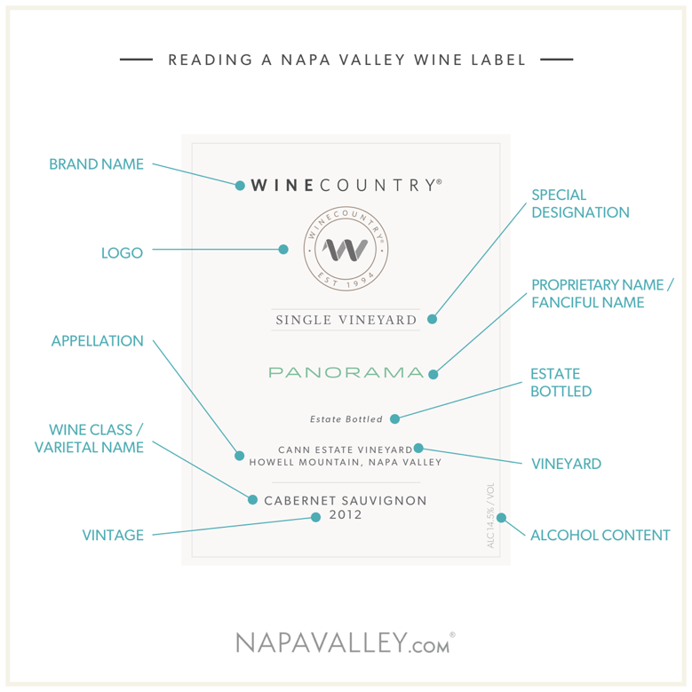

https://winefolly.com/search/napa+valley
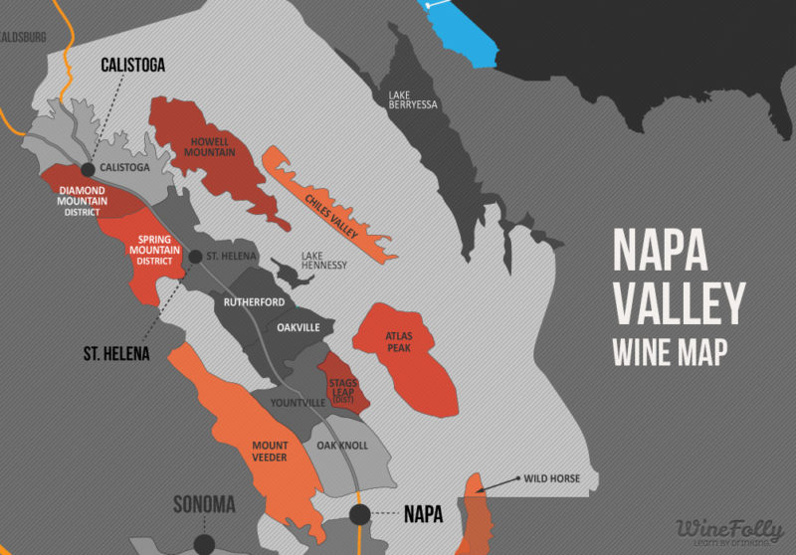

https://winefolly.com/search/napa+valley
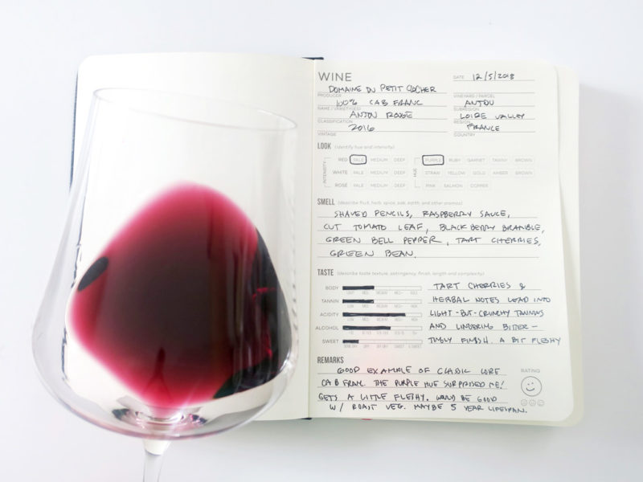

Interesting fact:
- There is a wine train that takes people on wine tours. It is a luxury experience that provides gourmet meals. This takes place in different wineries of Napa Valley.
- Napa Valley is one of the only premium wine regions to have a university experimental vineyard.
- “Though just 4% of California’s wine grape harvest, Napa Valley is small in size yet big in stature. It was the first American Viticultural Area or AVA to be designated in California in 1981.”

