VISIT TO RETAIL WINE SHOP

SHARAN HADA

PROFESSOR: GOODLAD
HMGT 2402
03/16/2018

I am very happy to mention my visit to the wine retail shop. For my assignment I choose a wine shop in queens. My experience is about a retail store is different from the suggestive list provided. The location I visited is in address 3500 48th street, Long Island City Queens. This store is located within the National Wholesale Liquidator discount store. Wines here are much cheaper and of wide varieties. As we know that cheap wine doesn’t means bad quality wine. The wine variety here is very good. The wine inventory in this store is massive from different parts of the world. Besides wine, this store has wide varieties of liquors from all continents.
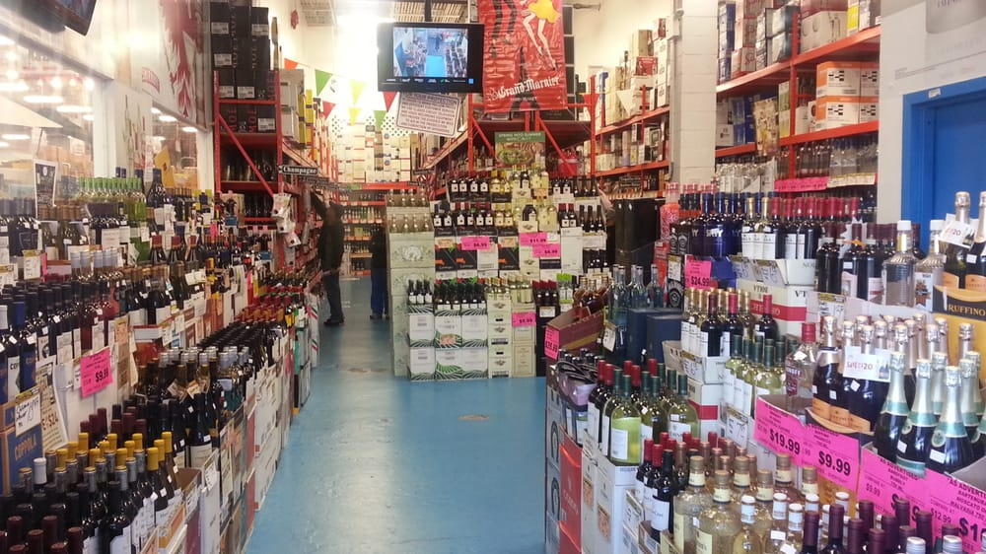
In this store I met an associates named Jordan. He is very friendly and helpful. He answered all my curiosity for the wine. During my visit, the store was quite slow and I took my time learning wines from the world. Jordan was busy stocking the inventory but was also answering my questions. He was very curious to know about my project and told me he never met any wine student before. He was also unknown about the wine class taught in college. I did educated him about our college and hospitality management degree. And he was very impressed to know about my school project. He even told me that the store has position open for a cashier job that will suit me since, I study wine.
I asked many questions about the wines, such as varieties, tastes, food paring, aging, alcohol level etc. He explained me showing different bottles and helpful posters to understand the wine tastes, varieties, alcohol level etc. According to Jordan, the most popular wine in the store these days are from Australia. And now I am much ready to learn about the wines from Australia. I could see and understand all different kinds of level in wine bottles as we studied wine in class. Being able to read the level mentioned as D.O.C, D.O.C.G, I.G.T, P.G.I, P.D.O, A.O.C, A.O.P, Q.B.A, Q.M.P etc. I felt myself proud that “I STUDY WINE”.
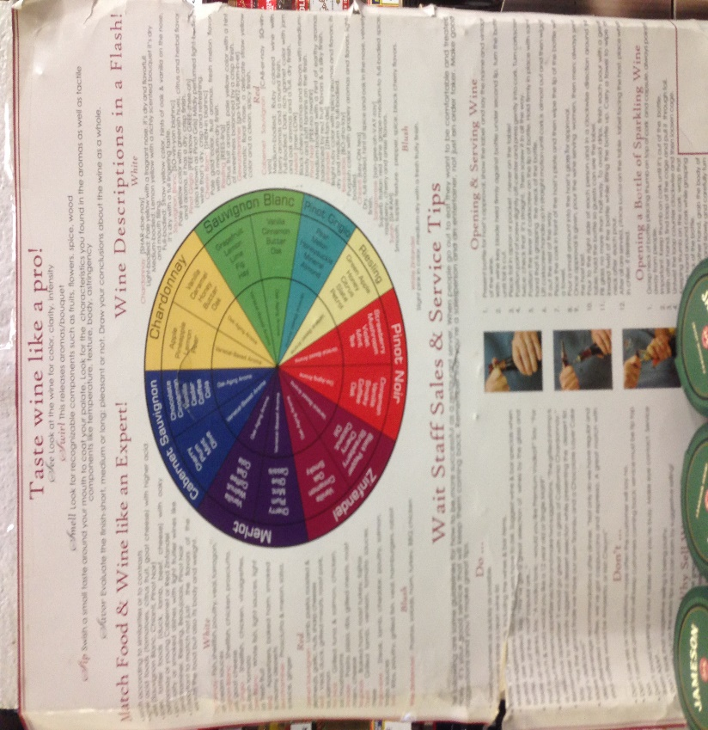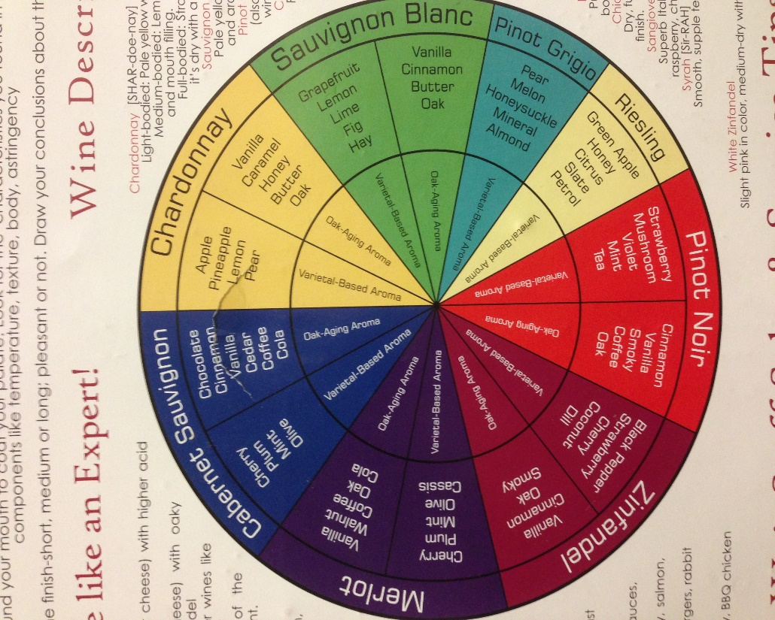
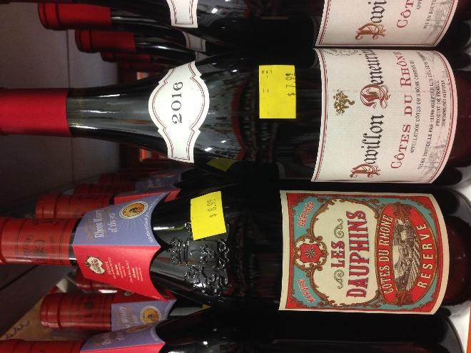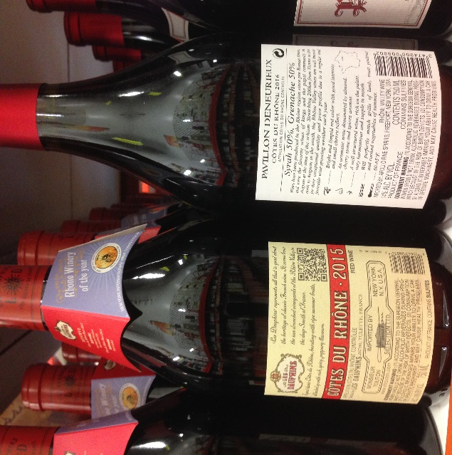
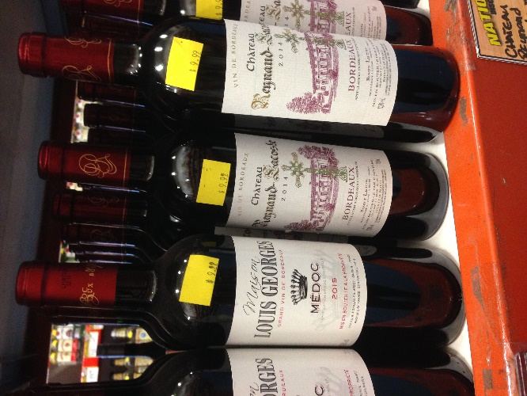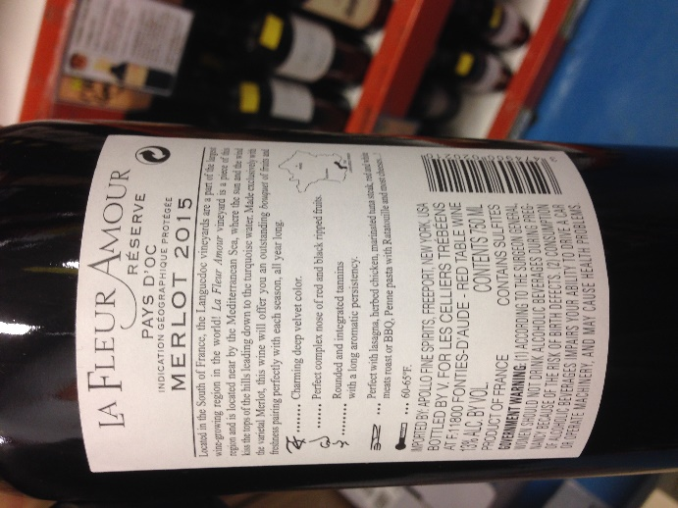

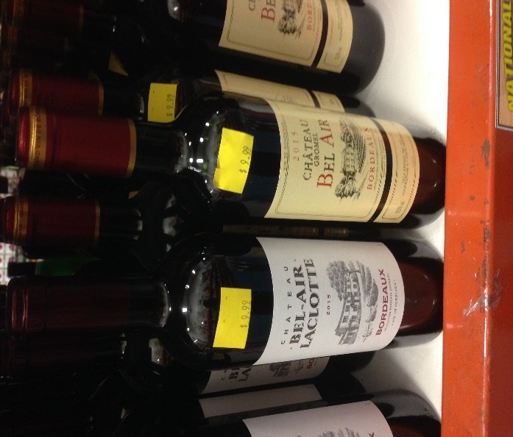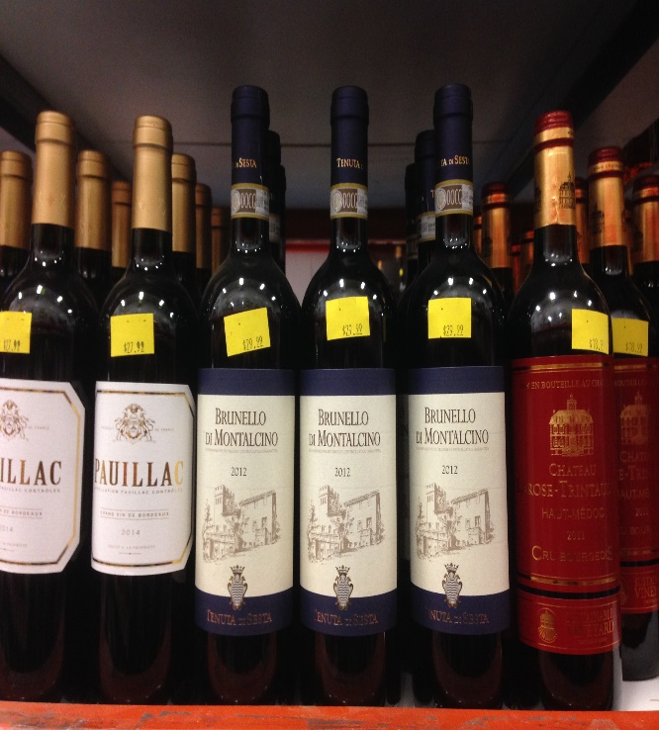
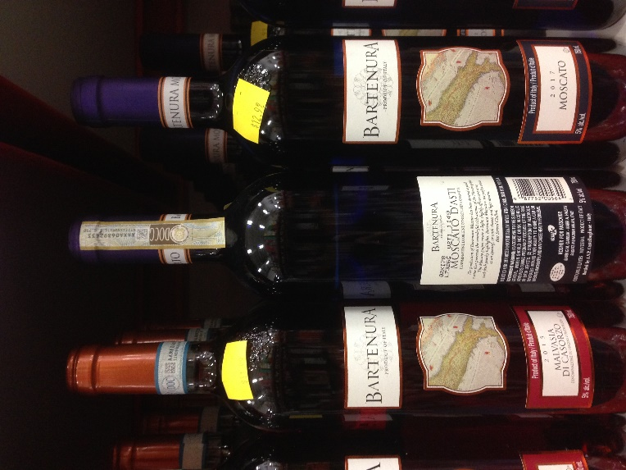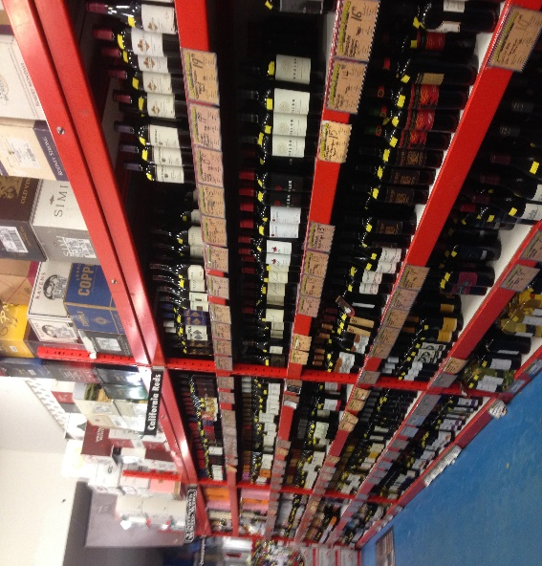

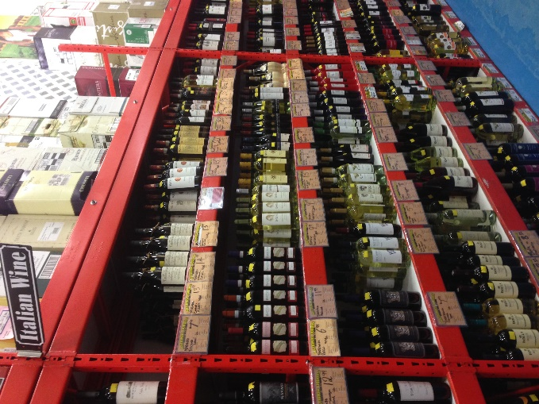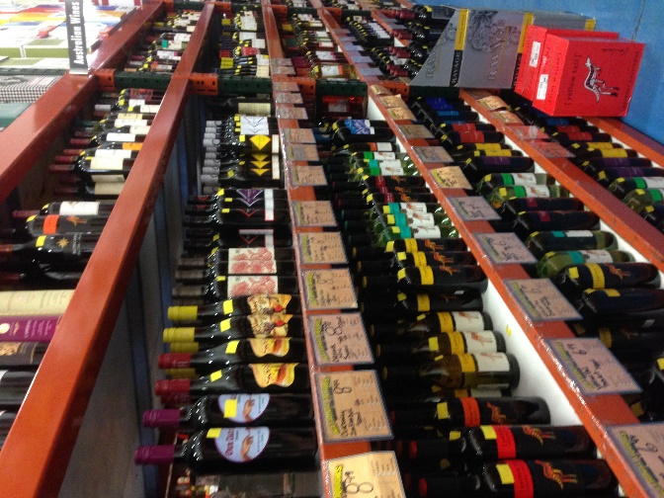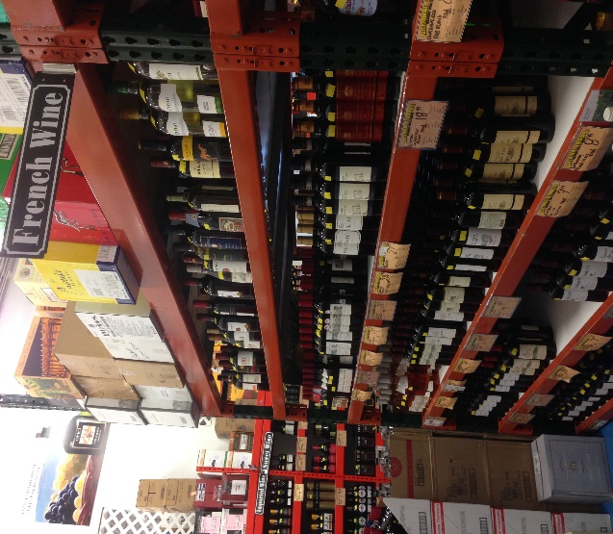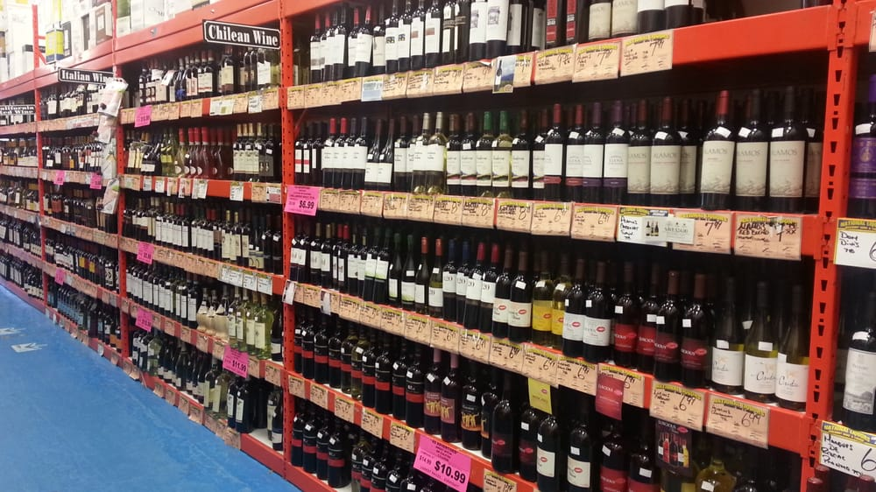

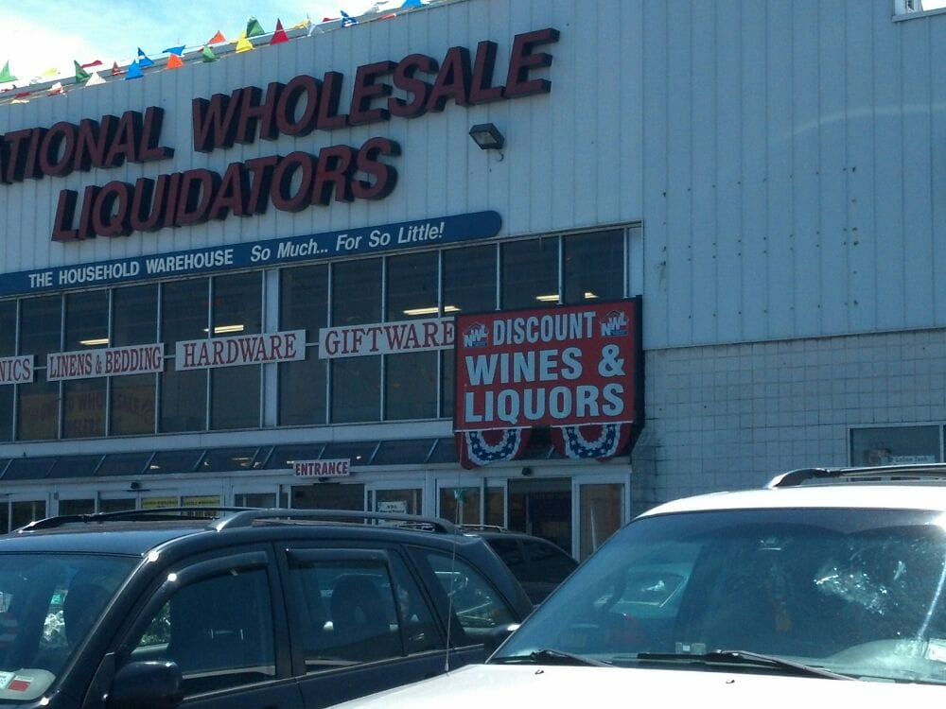
This retail has massive free parking area. Conveniently located nearby subway R & M in 46th street, Queens. Many fast-foods, and casual dining spots around. Many retail outlets for shopping and grocery stores. I highly recommend to take a tour or shop at this store for everybody.

