36 Hours in Red Hook
What to eat between sightseeing and gallery hopping.
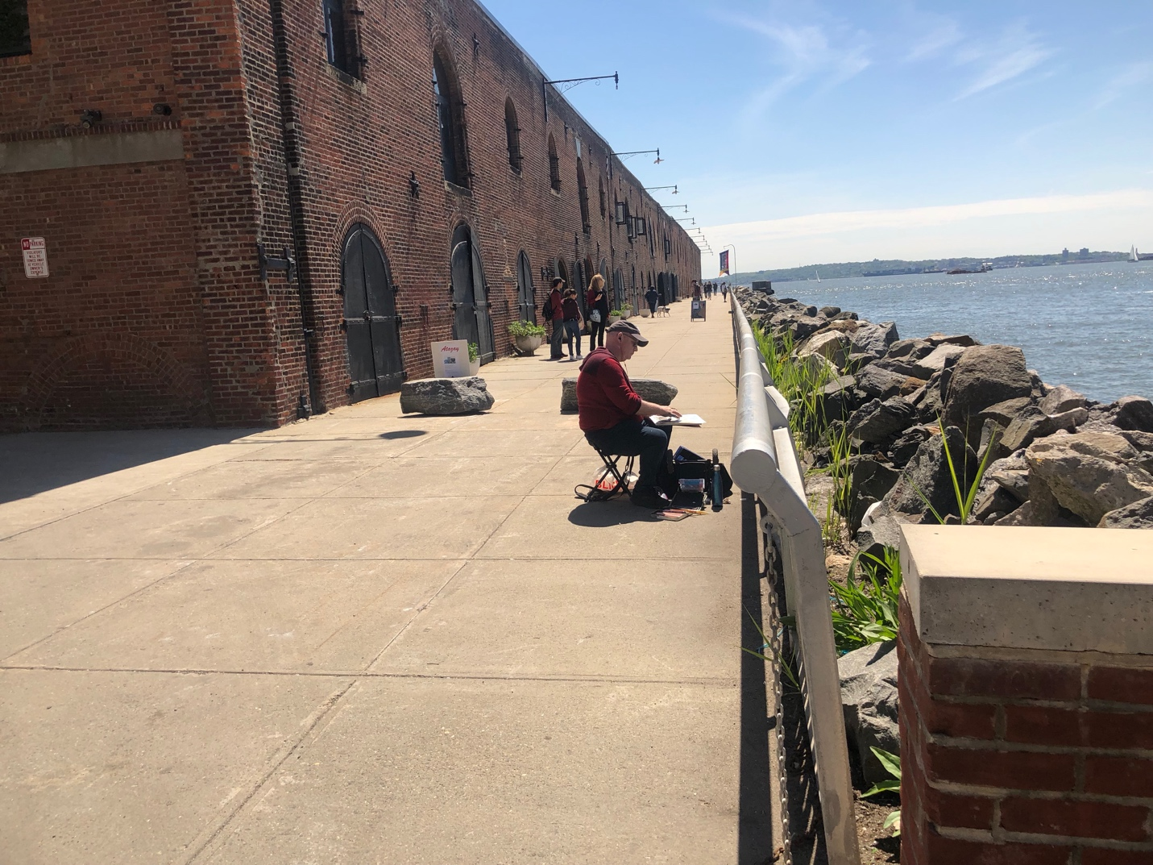
By Shianne Diop

May 12, 2019

Named by Dutch settlers for the color of the soils and shape of the land
Its cobblestoned and re-paved streets mirror mix of art and culture on the Brooklyn waterfront.

36 Hours in Red Hook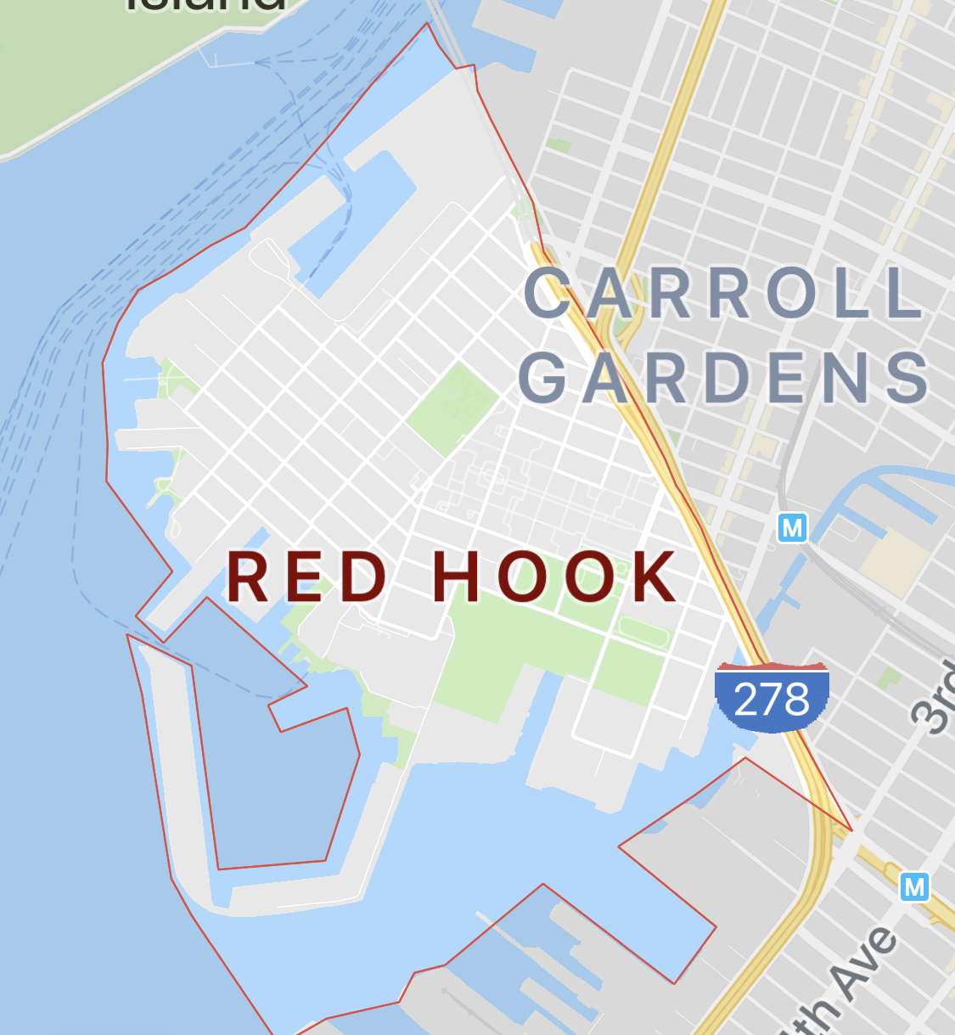

Friday
1) 12 p.m. Local Favs

F&M Café is defiantly a local favorite. Your classic neighborhood deli offering sandwiches, breakfast meals and rotating menu of buffet style lunch offerings. A small store, with counters that wrap around the walls and a few tables; this place feels like home.
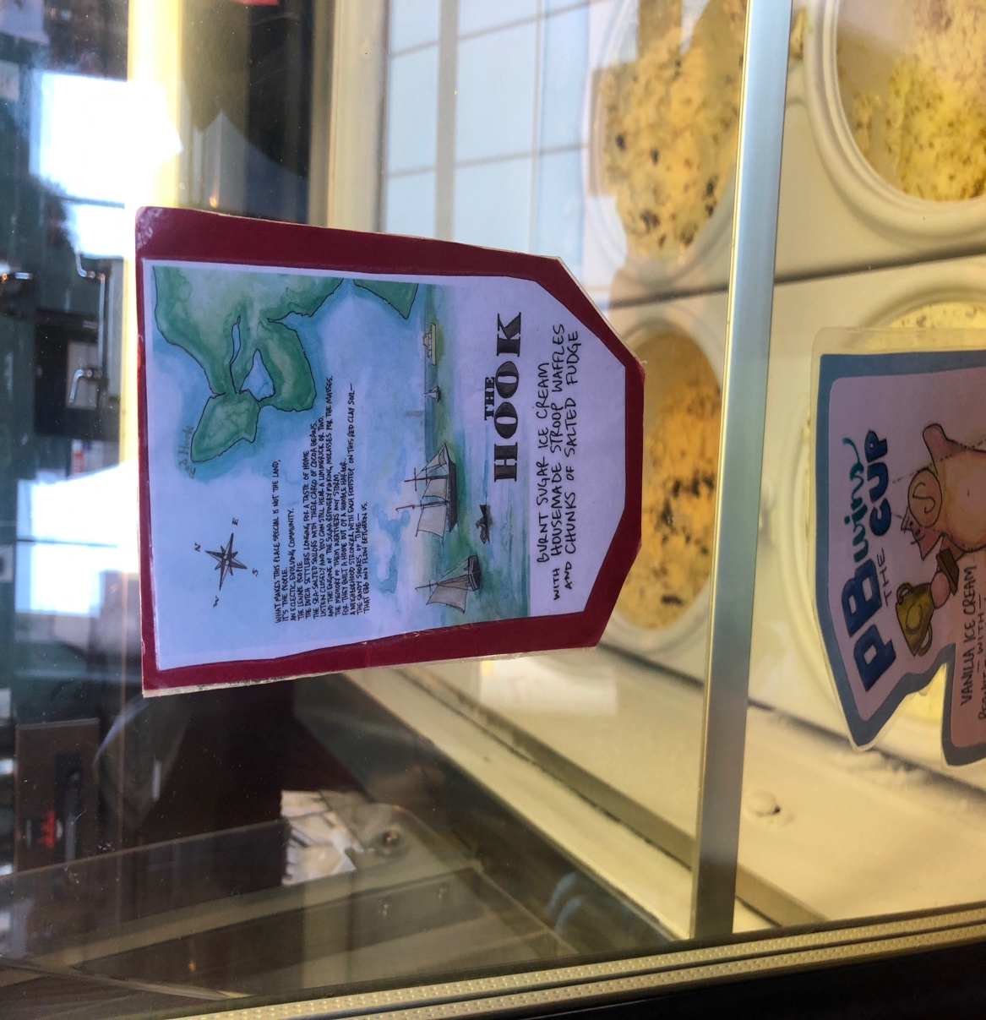
2) 1:30 p.m. Ice Cream

Ample Hills, an ice cream brand with locations throughout New York; adds a special flair to their Red Hook location. The location functions as a museum and an ice cream factory. Visitors can learn a little bit about the company history, see ice cream being made and tour the factory. Don’t leave without trying “The Hook” a flavor unique to their Red Hook location. It’s a burnt sugar ice cream with salted fudge.

3) 3 p.m. Wine

The area is home to wineries, breweries and distilleries offering tastings of their creations. The Red Hook Winery focuses on wines from vineyards around New York state and has 150 bottles of their own Red Hook Wine. For $18 they offer tastings of 4 wines by the glass or for $35 taste 4 Red Hook Wines and sample 2 aging wines straight from the barrel.

4) 5:30 p.m. Pizzzzzzzaaaaaaa

After tasting all the wine you could eat head to Mark’s Red Hook Pizza, another neighborhood favorite. Serving up classic New York style slices and other Italian fare.

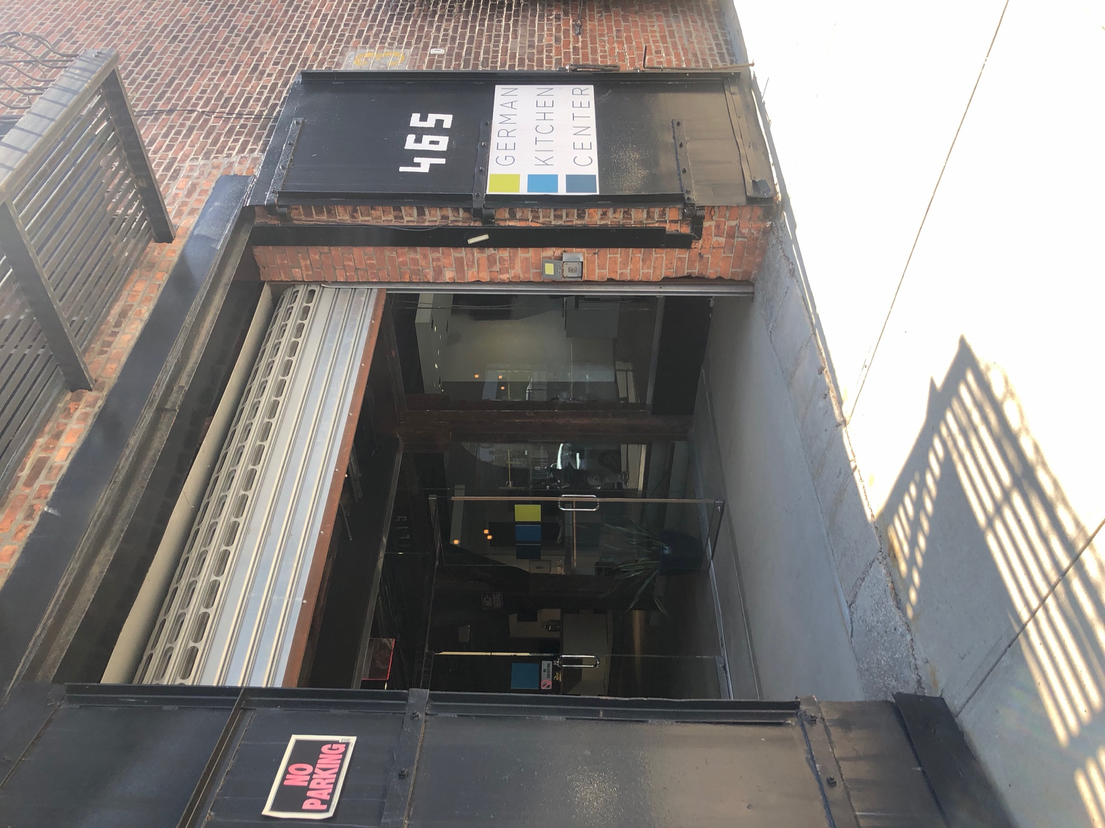
5) 7 p.m. New Kitchen

If you’re in the market for a kitchen makeover, check out the German Kitchen Center at their 2 Red Hook showrooms. Offering close up views of their craftmanship.

6) 8:30 p.m. Bar

End the night at one of the neighborhoods many history rich bars.

Saturday

7) 1 p.m. Sweets and Other Stuff

Hard to miss with their bright orange door, Baked makes sweet treats, sandwiches , hot and cold beverages. Offering both classic and unique breakfast options. Like the Hot Pocket (no not that hot pocket, but something like it); egg, meat and cheese incased in a flaky crust. Known as “the hangover cure” this savory breakfast treats will help you recoup from the previous nights libations. Baked is known for their pastries which they offer a wild variety of. The also offer flourless and gluten free options.

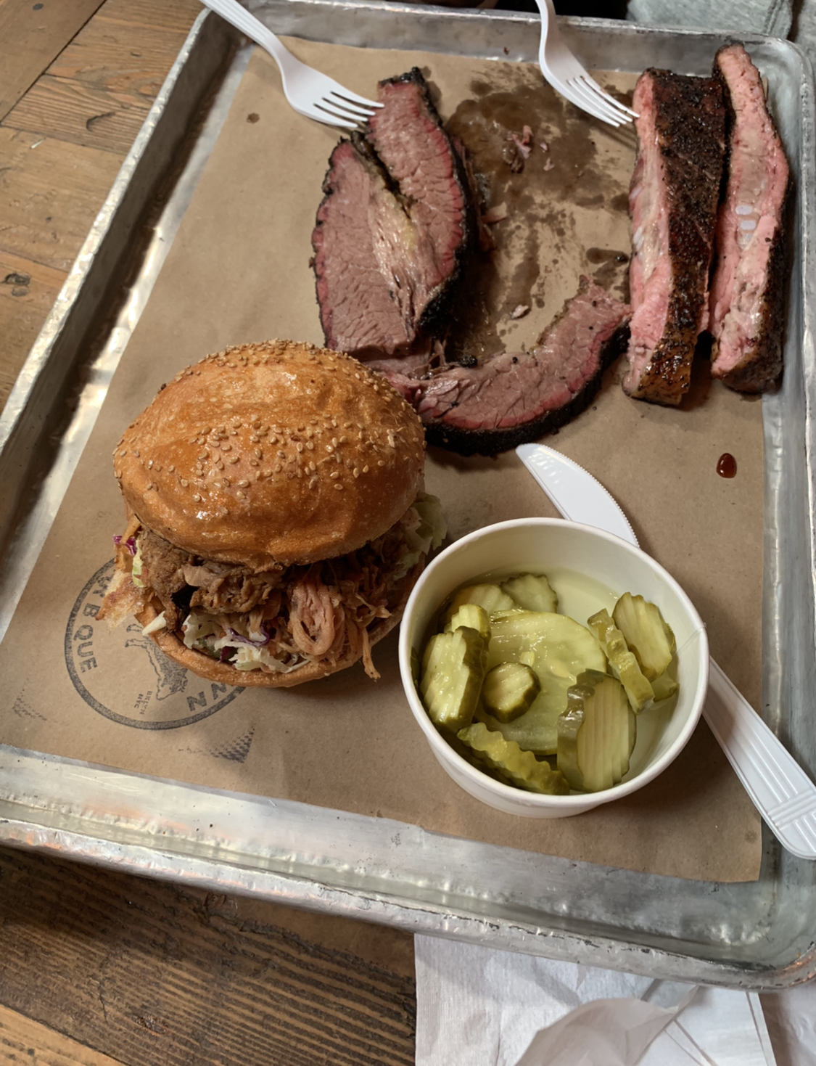
8) 2:30 p.m. Hometown Favorite

Simple, to the point and tasty. Hometown Barbeque is serving up platters of the best barbeque in town. There is no Opentable here, no table cloths and no express line but no one seems to mind. Lines stretching from one end of the large wooden interior building to the other incur wait times over 2 hours. The wait grants you permission to order from a small but complete menu. Meat, either on a bun or directly on your tray and it is delicious. The offer a couple of sides that pair well with barbeque and the 2 bars keeps patrons liquored up and ready to endure the long wait. Beware, the smell of smoke will leave with you. Expect to spend about $50 for 2 people and an additional $30 at the bar.

9) 5 p.m. Gardens, Baseball and food trucks

Journey through Red Hook Park to the baseball field. It is little league season. Swarms of families armed with coolers and folding chairs cheering on their little athletes. Right behind them, a row of food trucks ready to feed the hungry masses. Offering range from classic food truck fare like burgers and hot dogs to unique Argentinian and Colombian dishes.

10) 7 p.m. Seafood by the Seaside

Lodging
Area is sparse when it comes to lodging save for a few motels unless one is willing to travel nearby neighborhood of Sunset Park an AirBnB would be the best option for staying in the area. AirBnB’s in the area average from $60-$100 a night.

