36 Hours in Brooklyn
By Zhuopeng TAN
Brooklyn has evolved into a thriving hub of entrepreneurship, has great economy, cultural diversity and many famous spot attractions.

Friday
- 4 p.m. Exploring Nature
Appreciating nature is also an art. It gives you not only vision, but also the praise and feeling of nature from the heart. Brooklyn botanical garden is a good place for family to visit. If you like trees, flowers, and many other plants, especially love to see Cherry blossoms in Cherry Blossom Season, Overall, it is really a good place for relaxing time. The Brooklyn botanical garden definitely worth to go. (Monday is closed, Tue- Fri: 8 a.m. to 6 p.m.) The ticket for Adults is $15, free for children)
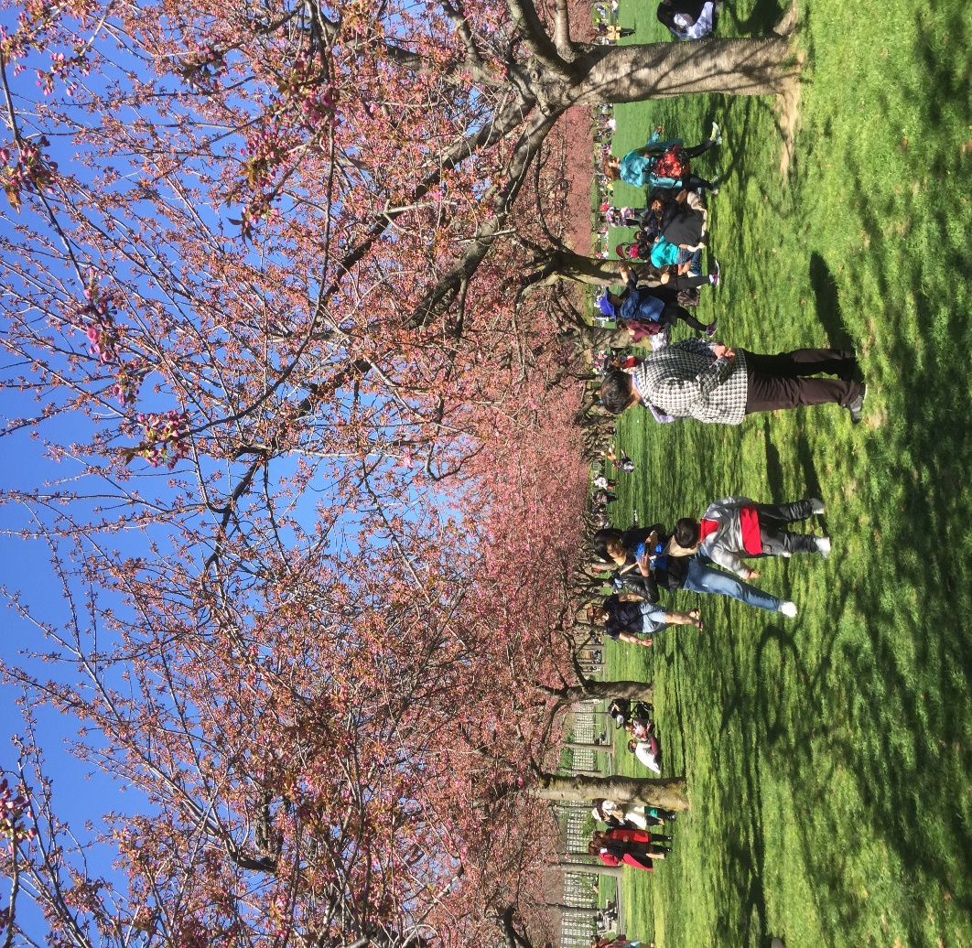
Photo by Zhuopeng tan

- 6:30 p.m. Viewing night scene through the bridge
With over 130 years of historic attractions — Brooklyn Bridge. The Brooklyn Bridge started construction in 1869 and was completed fourteen years later in 1883. Because of the unique design, the Brooklyn Bridge has become an icon of the whole area of Brooklyn and ranking among the city's most popular tourist attractions Since opening. Standing on the bridge, you can clearly see the high buildings of the entire city. Especially at sunset moment, the viewing is amazing. Many couples cross the bridge and put a padlock on a section of the chainlink fence. The lock represents their love, and it will stay there for all of eternity. 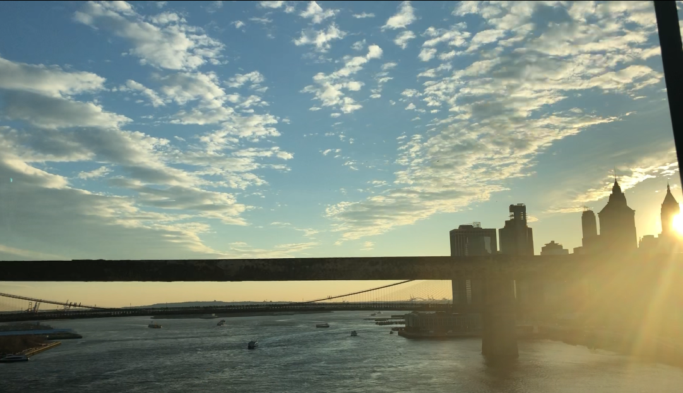
Photo by Zhuopeng tan

- 8 p.m. Chavela' s taco
20 mins away from the Brooklyn Bridge by talking subway, 2, 3, 4 train are available to Franklin Avenue. Chavela’s basically is Mexican style restaurant. Famous for delicious taco. CHavela’s is a great place for a date or cozy night out with friends. The food is not that expensive, and it has a very warm and chill ambience with a full bar and great selection of wines and beers, you have to make sure you are 21 and up before you order it. I believe that you will spend a wonderful night here. (The price around
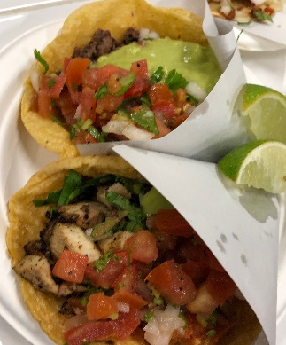
$20- $30 a person) photo by Zhuopeng tan

- Saturday
11 a.m. Moring at the Museum
Brooklyn Museum is a comprehensive museum of art and history. Covering 560,000 square feet, the museum's actual capacity is the third largest in New York City, with a collection of about 1.5 million works of art. You might find one that you really love. (Monday and Tuesday are closed, weekday hours are 11 a. m to 6p.m) The prices of ticket: Adults is $16, student with ID: $10.
- 1 p.m. Getting some dumpling in lunch time
There are so many places to eat dumplings in Brooklyn, it hard to find a good one. The dumplings & Things definitely is one of secret place of Brooklyn. It is located in 5 Ave and 3rd Street, their menu is simple and easy to understand, what I like is they have different kind of favor dumplings, they have chicken, pork and beef, even vegetable as well. They can make it fried and steam. The pork & chives is my favorite one, it is only $4, having 5 pieces one order. ($5-$8 a person). 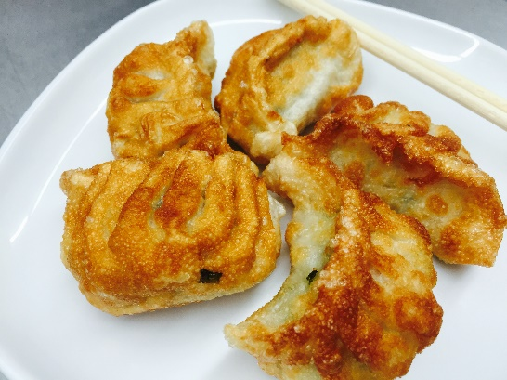
Photo by Zhuopeng tan

- 3 p.m. Sports in Sunset park
Sunset park, it is located between 5th and 7th Ave, 43rd street. There are some basketball courts in the park, there are so many people playing basketball at afternoon, they are so friendly, sometime even you don’t have your ball, and you want to play, just ask to play with them, they would make a group for you. Sunset park is a recreation center, and there is an outside swimming pool out there, therefore, it is free for public in each summer. It is a good place for beginner to learn how to swim.

- 7 p.m. sitting in beach and see the sunset
Coney Island, it is located in downtown Brooklyn, which is taking D, N, R, Q, F train to the last stop of downtown Brooklyn Bound train. During the week, rides and attractions may open at noon and run until the late evening. During the weekends, the same rides and attractions open around noon and may run until the early morning. Sitting in the beach, listening to the sound of the sea and seeing the sunset are great things to do in life. 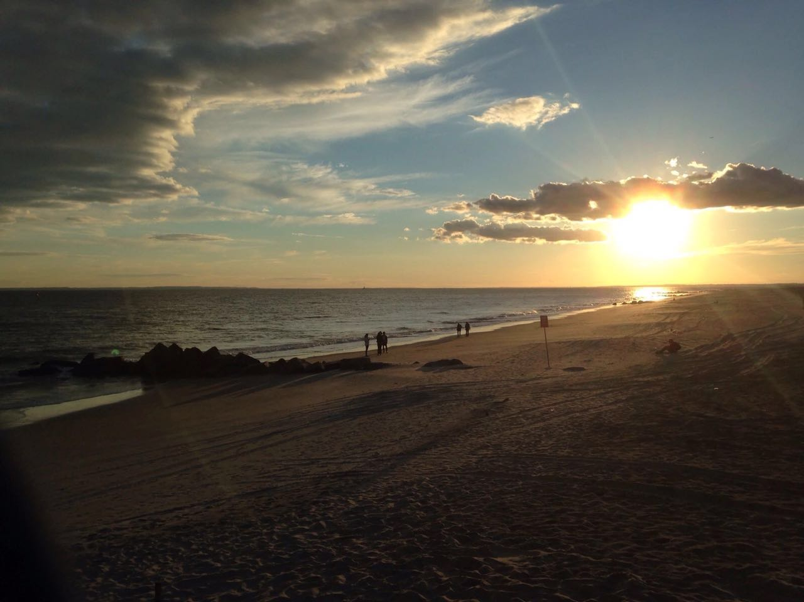
Photo by Zhuopeng tan

- 7:30 p.m. Nathan's Famous – the most famous hotdog in Coney Island
Nathan's Famous is an American company that operates a chain of fast food restaurants specializing in hot dogs. The original Nathan's restaurant stands at the corner of Surf and Stillwell Avenues in the Coney Island neighborhood of the Brooklyn borough of New York. It always stands a long line to order it. Having different sauces offer. ($8-$10)

- Sunday
10 a.m. A day in Brooklyn bike tour
After numerous places to visit in Brooklyn without any sightseeing outside of Manhattan I thought it was time to get out and explore the outer boroughs. It is great opportunity to join the group, and you will get unforgettable experience from it. The ticket to join into the group is $88.

- 1 a.m. Shopping in century 21
Century 21 is an American chain company for shopping. Is good to spend some time with family in the mall. They always have some discount for the clothes and shoes, especially this Mother’s Day, it a good time to save money. You also can subscribe them by E-mail, they would send you an E-mail when they have on sale in something. 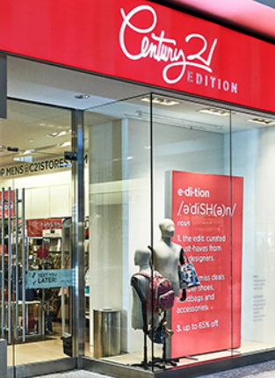

- Lodging
The Pod Brooklyn Hotel I would choose to stay for this trip. Because this hotel is a 3 stars hotel and offer great services. The price in this hotel is reasonable, it costs $130-$140 a night. It is a wonderful hotel. The bed is comfortable. The room was virtually soundproof and being a city person that was a true blessing. Many roof gardens and lounge areas. It is definitely a great hotel to stay with.

