36 Hours in Brooklyn
By: Tenzing Lhamo
May 13, 2019
Located in far western end of Long Island, Brooklyn is one of New York City’s five borough. The city has been through several transformation in the past few decades, and has become one of most desired places to visit in New York. The city reflects various culture, according to a book by DeSena and Shortell (2012) This city has seen has been through constant changes and through its development, embraces “the world.” This is the place where you can get the feel for art, customs, and experience the various culture that is deeply embedded in the city. Also, presently, this place is referred to as one of the “hippest” places in New York.
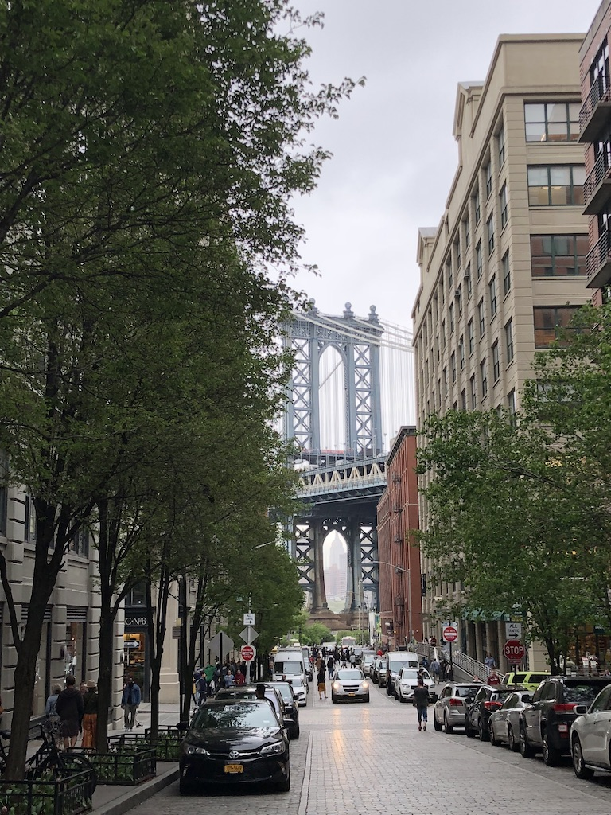
Manhattan bridge. Photo by: Tenzing Lhamo
Thursday
- 2 p.m. ABOUT GLAMOR
Head to Bedford to a vintage store called About glamor, a multi-retail space, that sells clothes and exhibits various arts. Visitors can find unique clothing, accessories for both male and female, and artworks, for instance you can find various products that ranges from European classic designer wear to traditional British tea cups to American vintage jeans, with prices as low as $48 to over $300.

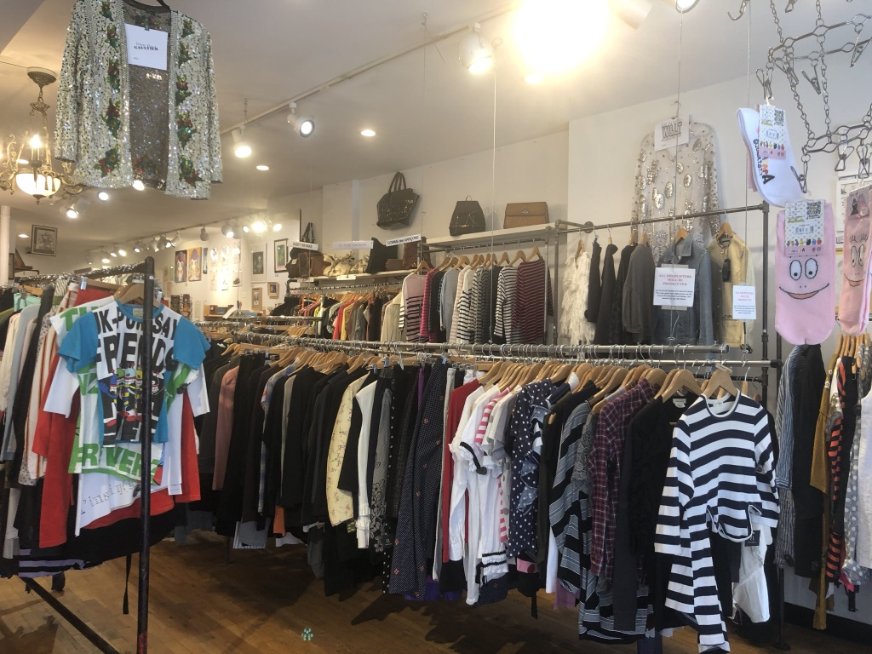
About Glamor. Photo by: Tenzing Lhamo

- 3:30 p.m. PEMA
Few blocks down the street, is a store named Pema that is one of the original boutiques of Williamsburg. Here you can find female clothes and accessories that showcases colors that is inspired by the traditions of native Tibet, and as well as exhibits eye-catching bright patterns and designs of todays modern women’s fashion. The shop displays boho-styled clothes ($80 and over), accessories ($40 and over), and footwear from designer collection.

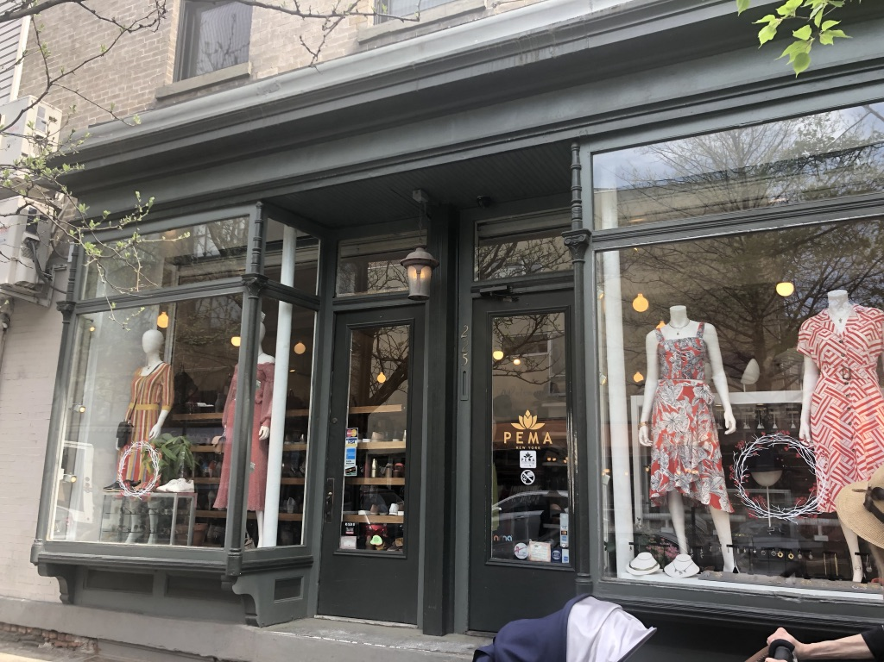
Pema. Photo by: Tenzing Lhamo

- 5 p.m. NORBU
Head to Norbu, (which is owned the same person who owns Pema), this store is located in the heart of Williamsburg and showcases jewelry that is boho-inspired with a mix of modern, and antique flair. This store exhibits carefully handpicked jewelry from talented upcoming designers and artists from all over the world. This boutique carries pieces from over 100 independent designers to keep every customers interest.

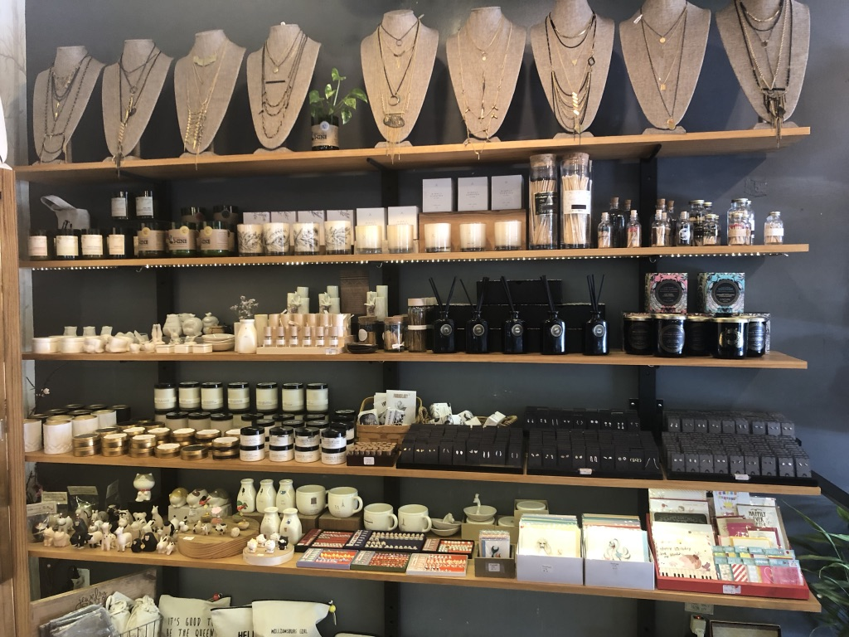
Norbu. Photo by: Tenzing Lhamo

- 6 p.m. CATBIRD
Catbird is another jewelry store that is located right down the block of Bedford Avenue. This store has been around since 2004, and showcases various selections of fine timeless and trendy pieces by contemporary designers like the Digy+Iona, Bittersweets NY, and Polly Wales as well as many cool indie designs.
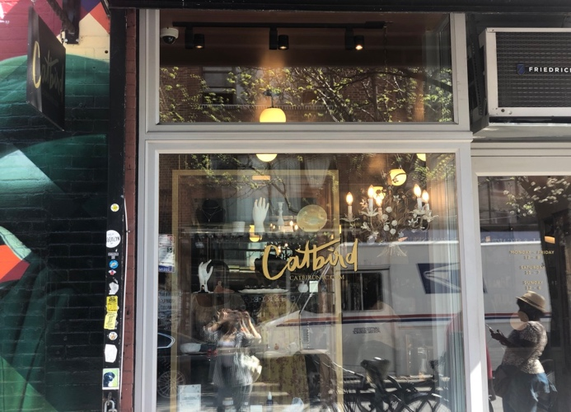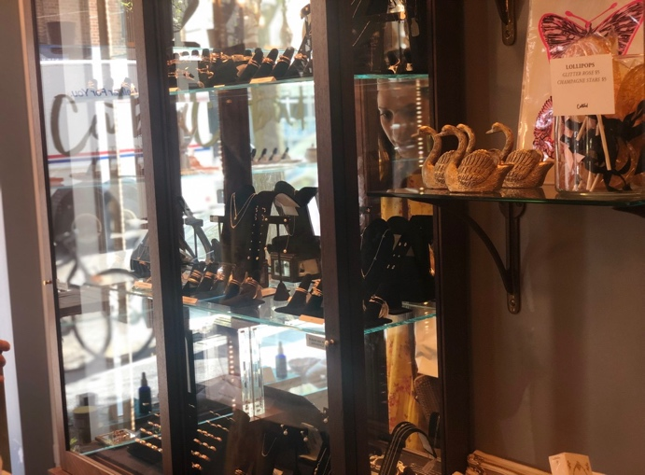
Catbird. Photo by: Tenzing Lhamo

Friday
- 12 p.m. BIRD
A clothing store located at Grand St. of Williamsburg, named Bird, is owned by Jen Mankins. This store focuses on locally and sustainably produced independent collections and presents customers with unique clothing that does not follow the fashion trend but instead pays attention to what the wearers impression on their quirky clothing that is filled with bright and soft colors with different hues of dark and light clothing.

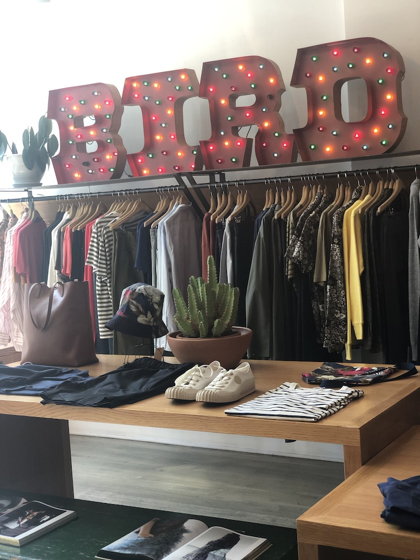
Bird. Photo by: Tenzing Lhamo

- 5 p.m. BARNEYS NEW YORK
Another famous clothing store located at Atlantic Avenue, called, Barneys New York, is an American chain of luxury department store, that presents buyers with many trendy products by famous designers like Saint Laurent, Isabel Marant, Stella McCartney, Belenciaga etc.,. This store presents various products from clothing, to footwear, bedding, furniture, jewelry to beauty products and housewares.

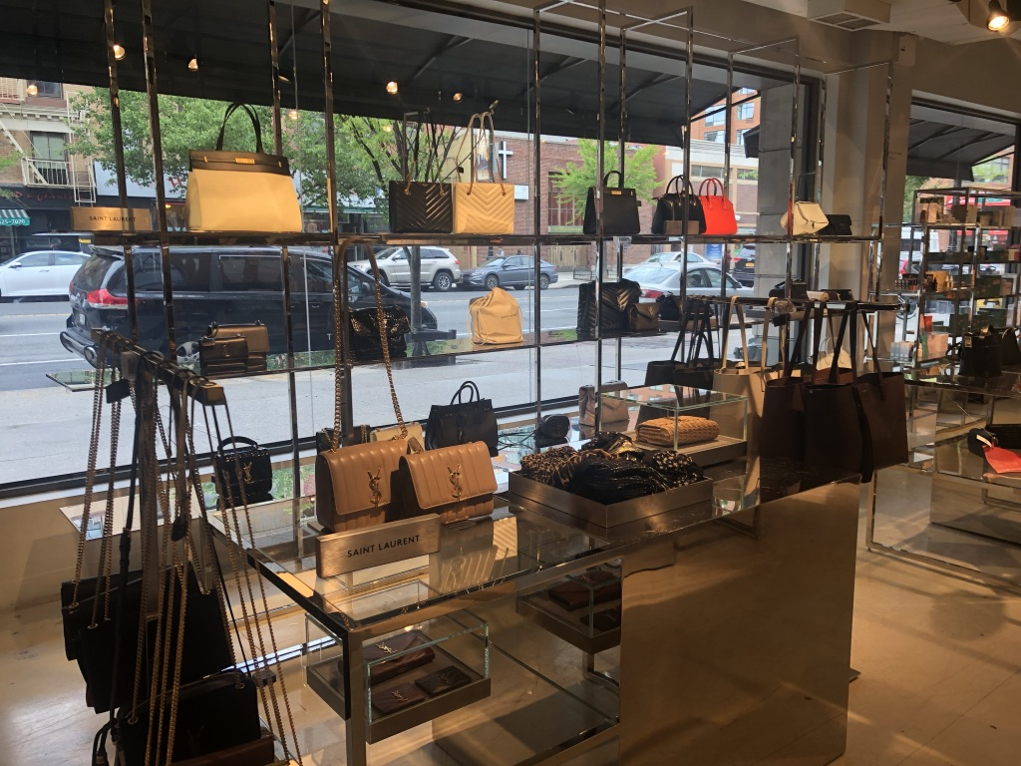
Barneys New York. Photo by: Tenzing Lhamo

- 6 p.m. WRITTEN BY FOREST
Written by Forest, is another famous jewelry store located in Atlantic Avenue, that showcases accessories that are whimsical, nature-centric wares and have practical everyday jewelry. This store showcases reasonably priced birthday gifts to wedding rings.

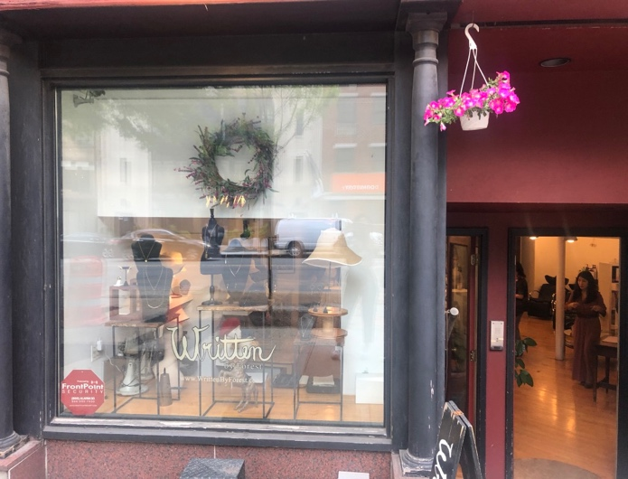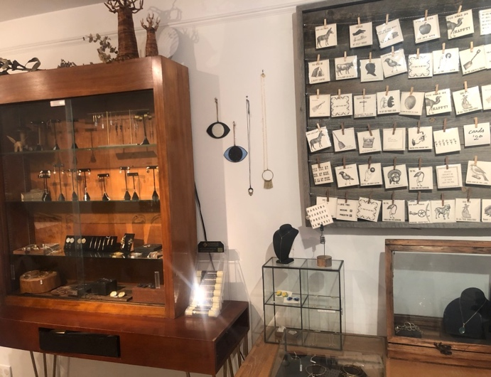
Written. Photo by: Tenzing Lhamo

- 6:30 p.m. PACHUTE
Pachute is boutique that is located in the upper east side of Brooklyn, and is known for its various types of clothes of chambray shirts, weekend-ready denim, and Euro sneakers. Pachute means “simple” in Hebrew, and this store has clothes that are simple yet elegant and carries pared-down women’s and children’s clothing and accessories from labels like Pip-Squeak Chapeau, Khadi & Co., Philippe Model and Christina Lehr.

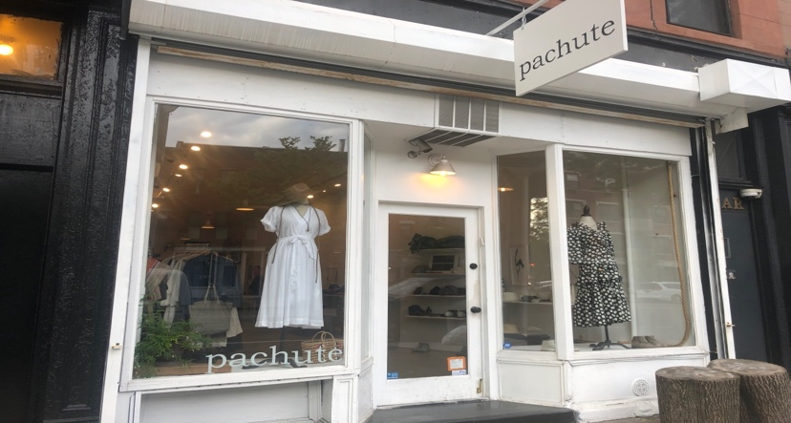
Pachute. Photo by: Tenzing Lhamo
Saturday
- 2 p.m. CONSIGNMENT BROOKLYN
Eva Gentry Consignment is thrift shop that has various collections of carefully curated selection of designer clothing, shoes, and accessories. They support designs that are on trend and present products that are highly demanded by customers, which makes them a store that constantly adapts to different trends. They showcase merchandise that has been produced by collectable high-end designers such as Chanel, Saint Laurent, Alaia, Emilio Pucci, Missoni.

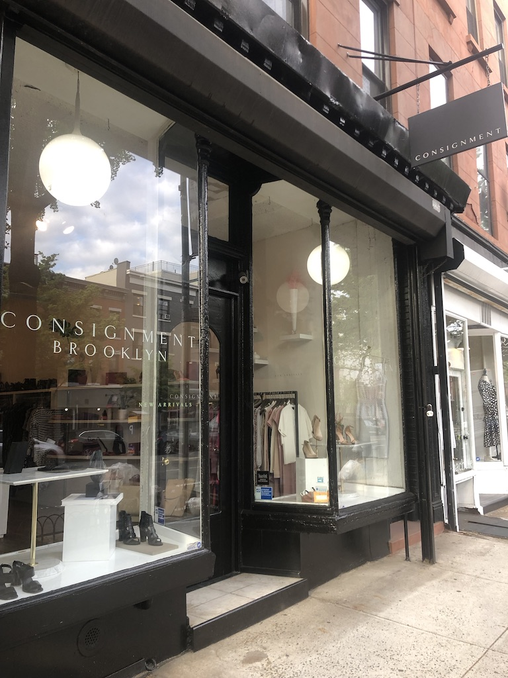
Consignment Brooklyn. Photo by: Tenzing Lhamo

- 4:30 p.m. FRIENDS NYC
Friends NYC, is another clothing store, located at East Williamsburg, that has various selections of new and vintage clothes, and features products from local Brooklyn designers. The store carries some unique accessories and jewelry at reasonable prices, as well as gift and home items for tourists who wants to buy souvenirs for their loved ones.

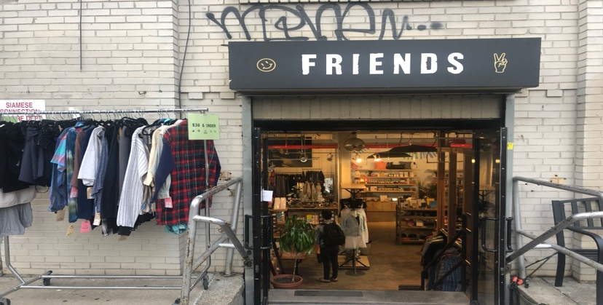
Friends NYC. Photo by: Tenzing Lhamo

- 5 p.m. URBAN JUNGLE VINTAGE AND THRIFT
Few blocks down at Knickerbocker Ave, is another vintage-clothing shop, called Urban Jungle Vintage and Thrift, that showcases some unique over the top t-shirts and sweatshirts from the ‘80s and ‘90s . Here you’ll also find some awesome Mexican cowboy boots, ponchos, fur coats, with prices ranging from $12 and over.

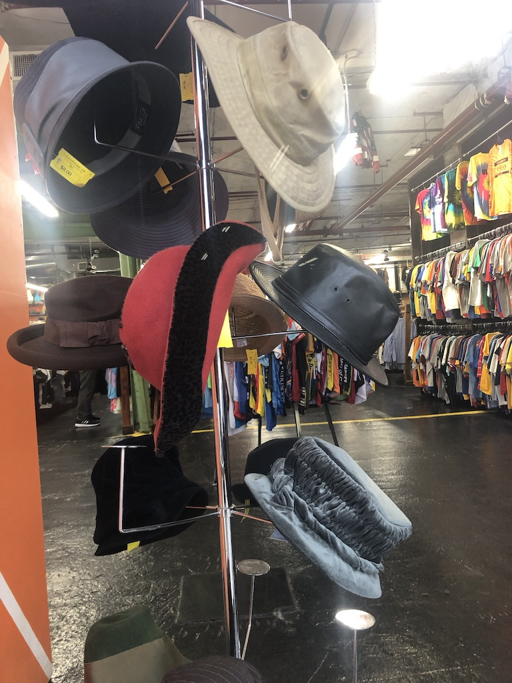
Urban Jungle Vintage and Thrift. Photo by: Tenzing Lhamo

- 8 p.m. PINKYOTTO
Pinkyotto is another clothing store located in Williamsburg, that has some up-and-coming clothes by local designers and showcases a selection of distinct and uniquely cut, vintage inspired pieces. They carry various form of clothing for different occasions from feminine daytime wear to clothes for daring dressers, with reasonable prices.

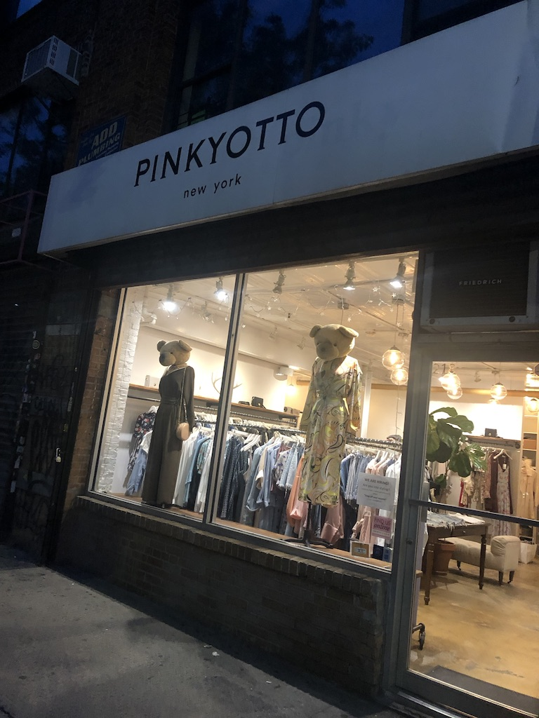
Pinkkotto. Photo by: Tenzing Lhamo

References
DeSena, N. J., Shortell, T. (2012) The World in Brooklyn. Lexington Books. Retrieved from https://books.google.com/books?hl=en&lr=&id=g_BP-LiDDX0C&oi=fnd&pg=PR5&dq=Brooklyn+multicultural&ots=ORiawD0S4n&sig=ZaO4sZjw_XxUNw_KmKHDU30TitU#v=onepage&q=Brooklyn%20multicultural&f=false
About Glamor. (n.d.). Retrieved May 15, 2019, from http://aboutglamour.strikingly.com/#about
Pema. (n.d.). Retrieved May 15, 2019, from https://pemany.com
Norbu. (n.d.). Retrieved May 15, 2019, from https://www.norbu.us
Catbird. (n.d.). Retrieved May 15, 2019, from https://www.catbirdnyc.com
Bird. (n.d.). Retrieved May 15, 2019, from https://birdbrooklyn.com
Barneys New York. (n.d.). Retrieved May 15, 2019, from https://www.barneys.com
Written Forest. (n.d.). Retrieved May 15, 2019, from https://www.writtenbyforest.com
Pachute. (n.d.). Retrieved May 15, 2019, from https://pachute.com/pages/about
Consignment Brooklyn. (n.d.). Retrieved May 15, 2019, from
https://www.consignmentbrooklyn.com
Friends NYC. (n.d.). Retrieved May 15, 2019, from https://friendsnyc.com
Urban Jungle Vintage. (n.d.). Retrieved May 15, 2019, from
https://urbanjunglevintage.wordpress.com
Pinkyotto. (n.d.). Retrieved May 15, 2019 from https://www.pinkyotto.com/ourstory

