36 Hours in Brooklyn New York
Manhattan isn’t the only place you can “Live a little” in! Brooklyn has a lot of fun things going. Here’s some tips on how to get the “Living My Best Life” motto in.
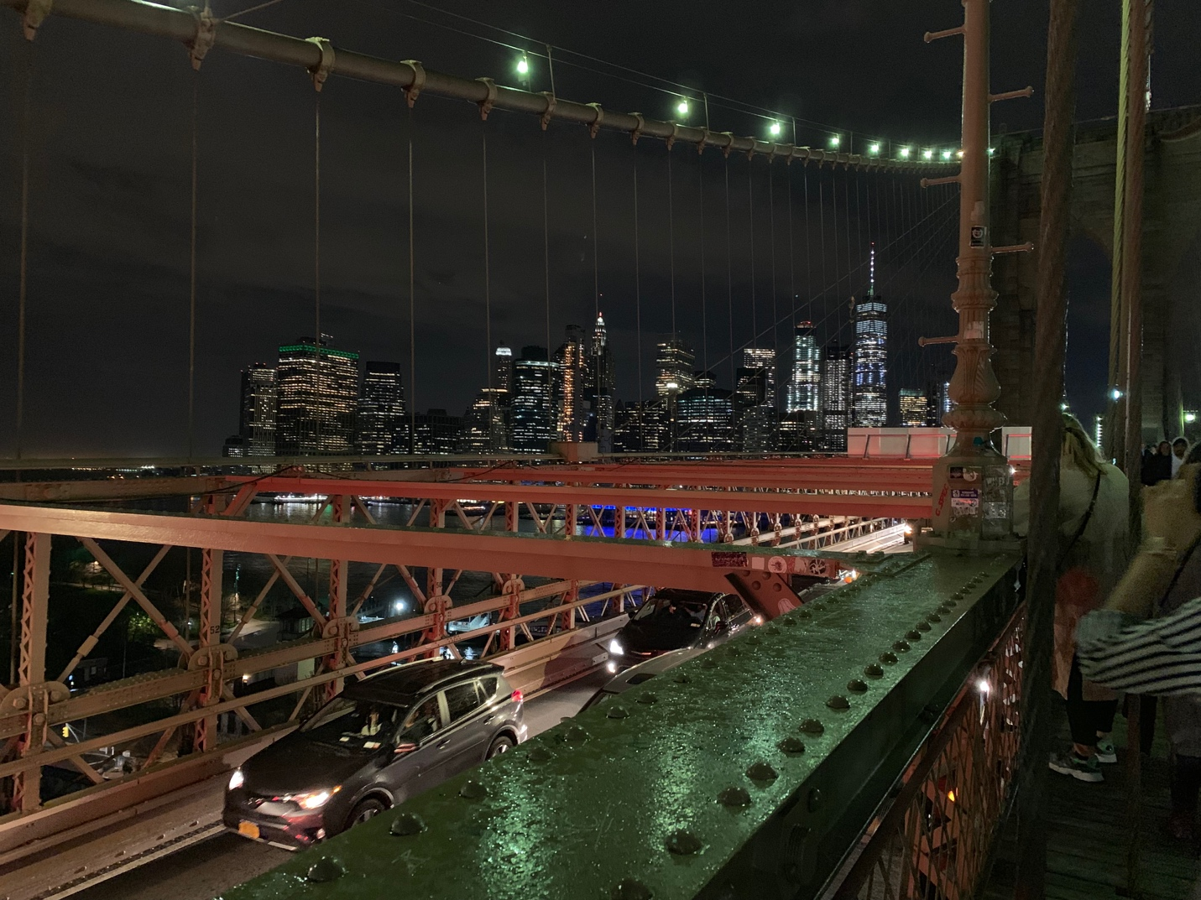
Brooklyn Bridge Late Night traffic and city lights in action. (photo taken by myself)

By Blessings McNeil

April 23rd, 2019

There’s about eight thousand six hundred and twenty-three million people who reside in the New York population. And about two thousand six hundred and forty-nine million reside in the borough of Brooklyn alone! This place is a melting pot of heritage! Now most people know New York as the city that never sleeps and while that is very true there’s plenty to do in the morning and afternoon as well as in the night that has given New York it’s spicy reputation for night life outings. From theme parks, bridge walks, garden tours, even cemetery tours, museums and more you can seriously never get bored here and you can save a penny or two! You just need the right tour guide and to be open minded. This is what led you here to my article. Now its adventure time. Come on, let’s go down memory lane of the places I saw.

Friday 4PM Are you hungry?

I sure was! But I wasn’t looking for any kind of food. I needed something that had essence behind it however I wanted it to also be made quickly or already made but fresh as well. So, I found myself at Union Square Park. Home of Green Market Co. This is a place where you can find many things! Fresh cuts of meat, Freshly baked pies and homemade bread. I also found smoked pig ears! The options varied but were amazing to see. There were also plants that you were very much edible. Freshly picked and just as red as ever cherry tomatoes with cucumbers to taste were there also and guess what? The tastings were free! I did a lot of tastings and ended up buying a huge cinnamon roll bread for about six dollars. I also purchased a bag of pig ears for five dollars along with a medium sized bottle of freshly homemade syrup! And here’s why. I was given a sample and not only was it sweet without the extra stickiness, it was light. It wasn’t overwhelmingly thick like store brands and it had a fresh taste that left you wanting more. It actually tasted healthier than store brand syrups. You can buy food anywhere but farmed fresh food is a part of heritage! Farmers have been producing fresh foods over decades and it’s never changed how they do what they do best. Yes, they invest in more equipment to help at times but the process remains traditional and has been passed down generations to generations.
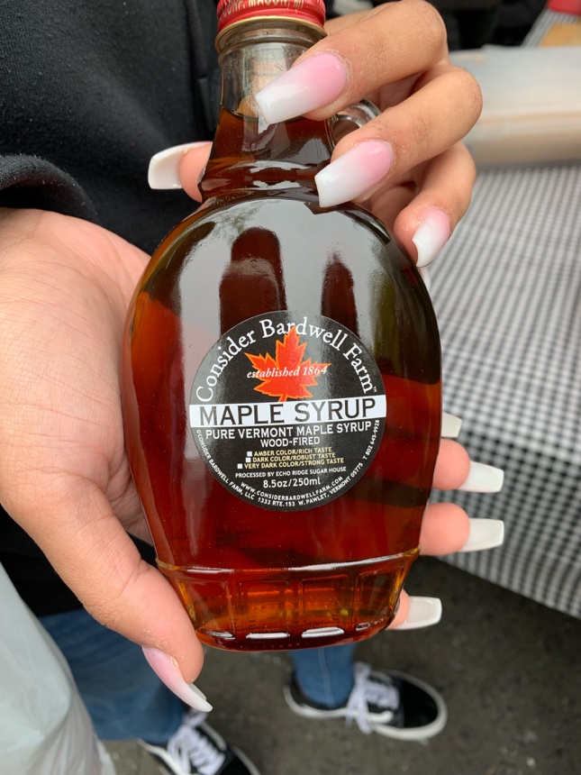 (Photo taken by myself) Fresh Farm Syrup! This particular bottle cost me around 10 dollars.

Wednesday 7:40 PM It hit 70 degrees! Time to Mermaid!

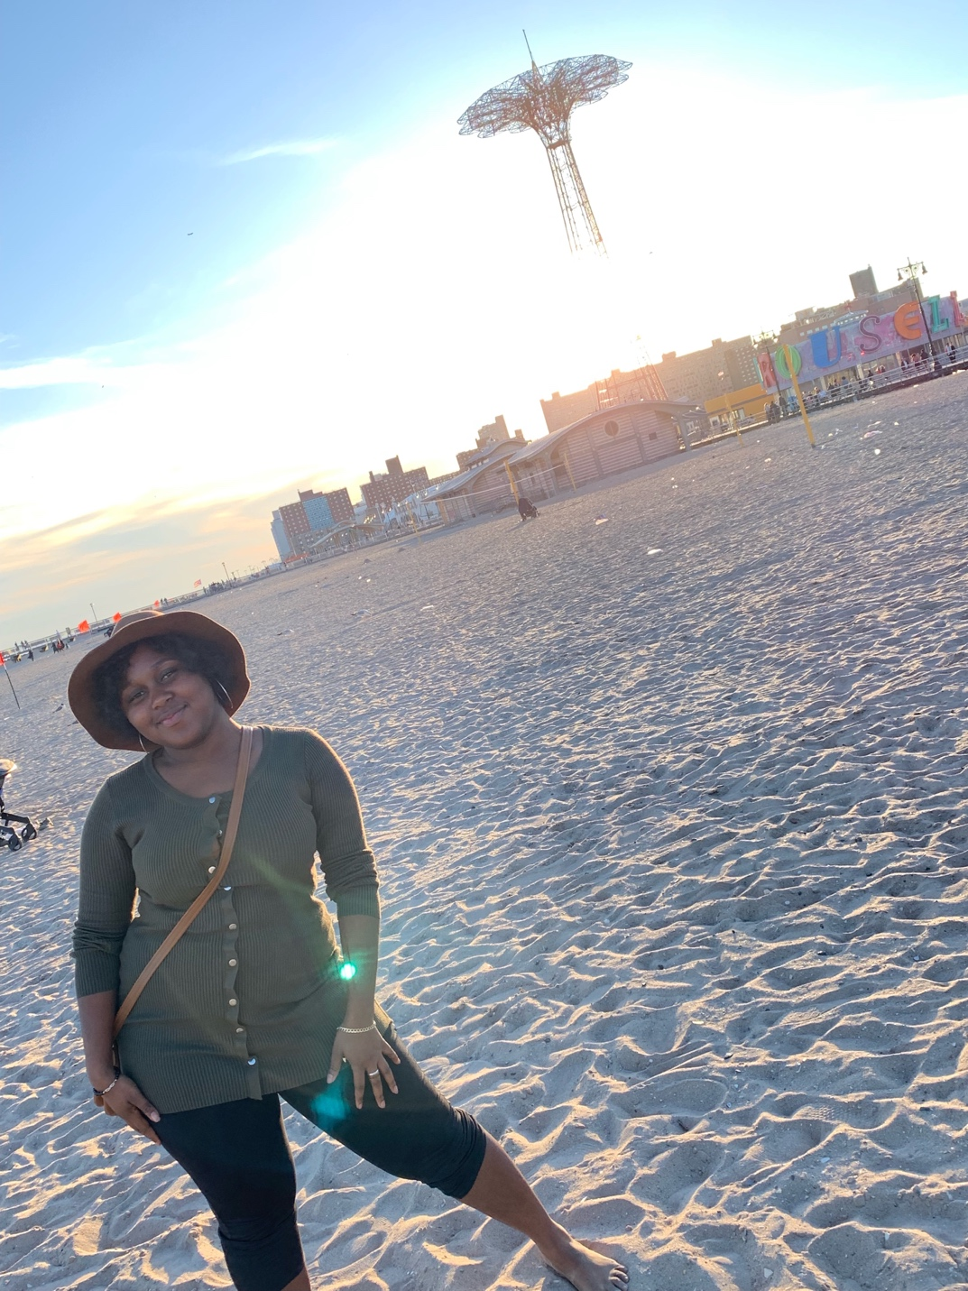
Here we have a phot of myself in front of the water, but what lies behind is me is what has been most known in Brooklyn’s history. Coney Island, or now known as Luna Park. It’s a theme park that has been around since THE 1800’s! But do you know what the best part about coney island is for me? The beach! Now I’m not much of a swimmer but the view is awesome and on days like this one you simply can’t beat walking that lovely boardwalk, hearing music play, watching people sing, eat, dance, talk, get in the water or even go in the private events that are hosted on the boardwalk. Such as day parties held by party hosters from all around, most of these parties cost around 15-30 dollars depending on who will be there and trust me celebrities show up here! This is one of the amusement parks that hold an actual parade as well! Every June there is a Mermaid Parade with floats and designs and people dressed up as mermaids! This park has a true love for mermaids and I have always been a mermaid fan myself so I do plan on attending this year if I am not busy. Are you in the mood for food after some tail flapping and dipping your feet in the water? Head out and go to one of many stands that sell the most famous funnel cake. I have yet to taste funnel cake in any part of New York City that tastes better than Funnel Cake at coney island. Funnel cake will usually run you about seven dollars.

Thursday 10:02PM. You don’t need anything fancy for a stay, aren’t you here to get out and play?

For lodging I have a few tips, the best tip for wanting to spend little to zero money is stay with relatives, close friends, a partner or whomever you are close with. The second tip of course to be get something nice but reasonably priced if you’re going to a hotel. However, if a hotel is a bit much you can always use my last tip…which is to book an Air bnb! This is the new trend that has hotels breaking out in sweat! It’s a convenient way of booking a nice place to stay without the hassle of hotel prices, large lumpsums of taxes and dealing with more than one person when it comes to paying your rate. Its quick and easy. But if you really prefer a hotel I would surely suggest The New York Moore Hostel. It’s a groovy and trendy designed hotel located on 179 Moore street in Brooklyn. The outside view isn’t as nearly interesting as the inside. The rooms aren’t your usual designs but in New York what is actually usual? Other than something out of the normal? Trendy is what’s in and this hotel is it and making trends happen is something we tend to pass down all the time! If you’re looking for a six day stay you can find a 1 room for two guests for one hundred and seven dollars per night. Not bad compared to other rates you might find.

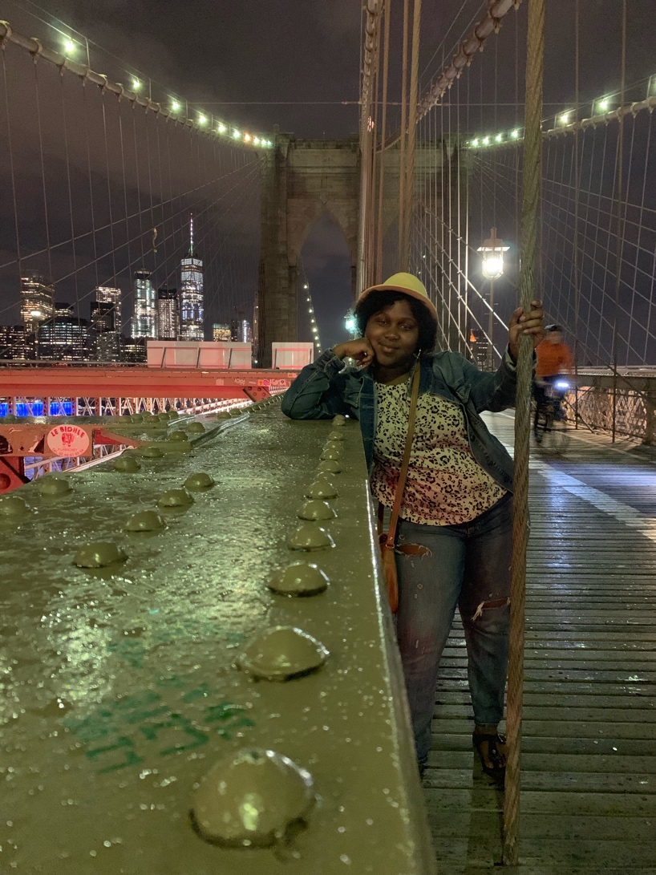
Tuesday 9:01PM. Just casually walking across a bridge. (photo taken by my friend Tenzing)
Is there any other way to spend a drizzling rain kind of night rather than being on the Brooklyn bridge? I think not! This was so much fun. This bridge is not only an important part of new York history it is at this point a known monument that is definitely apart of New York Heritage now. On the bridge you can walk amongst many other tourists along with bike riders and regular everyday New Yorkers going to and from where they need to be. You can also see information and facts about the bridge on the parts that were built for viewers who walk it.

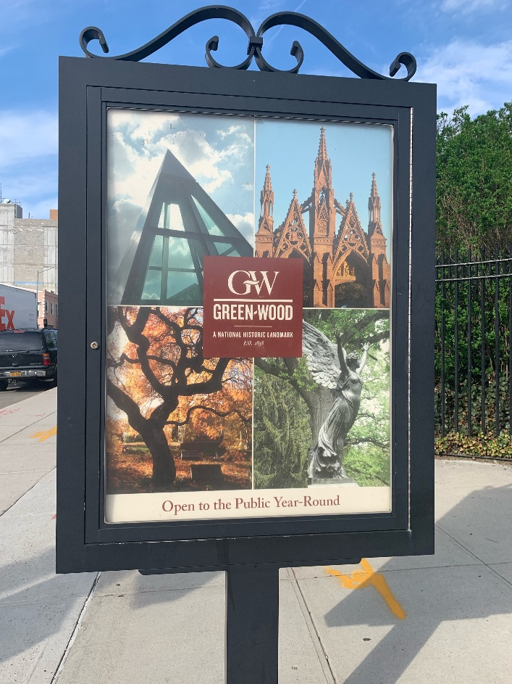 Tuesday 5:23PM Free cemetery tour anyone?
Yes I went to self-tour a cemetery. And you should too! Greenwood cemetery isn’t just any cemetery! It’s almost like a little town itself. It’s so big and spacious that when you decide to do a guided tour you are most likely going to ride in the trolley to get a view of everything there. You heard right they have their own trolley. Before you walk in there is a driveway to pass through that looks like the entrance to a castle. The place itself is a beautiful sight to see. The trees are a big part of this place too. It’s a section on the map that points out the “Tree Families” which is all the different kinds of trees here. There are hundreds of different trees here. My favorite is the Japanese cherry blossom.

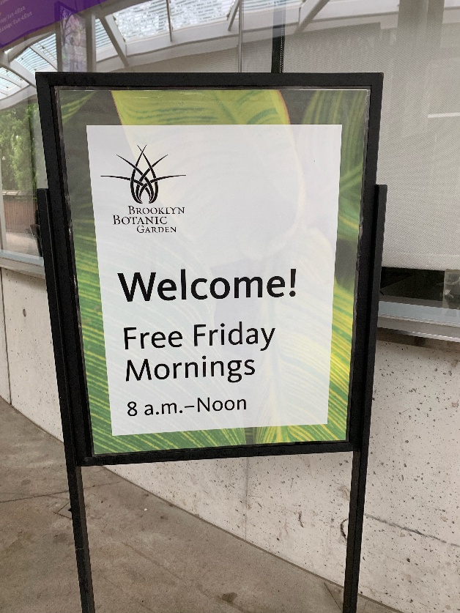 Friday 11:01AM. Let’s get lost in the garden.
A Friday morning spent in a walkway garden is probably the most calming experience one can have. But if you’re looking for the loud life there are actual flower festivals with music that occur on certain days. There are also ponds and waterfalls that reside in this huge garden. All types of flowers grow in this garden and are taken care of properly. There is quiet areas by the pond waters where you can sit by and do your drawings, meditations, napping, readings, whatever it maybe that you do.

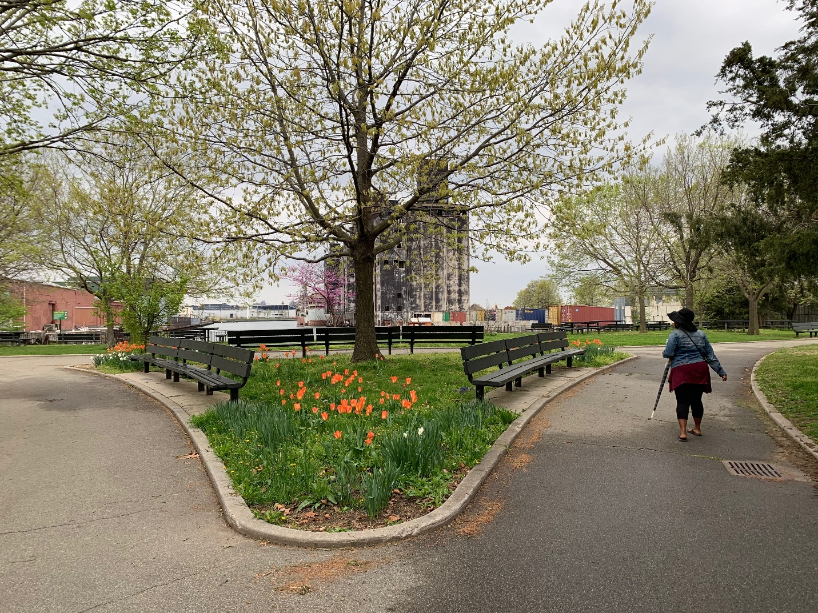

Thursday 6:25PM. Red hook, what wonders will I find next?
This place was a true gem to discover. I found two soccer fields in this park and two fields with overgrown grass that are meant for football. There is a recreational center right across the street as well. This is something that we will have for years to come. Nature and parks. This is what heritage is about. It was peaceful and I spotted two school teams (baseball and soccer) jogging and working out. If you’re looking for quiet time this is the place to find it. And the walk around each section of this larger than I expected park was very well worth it.

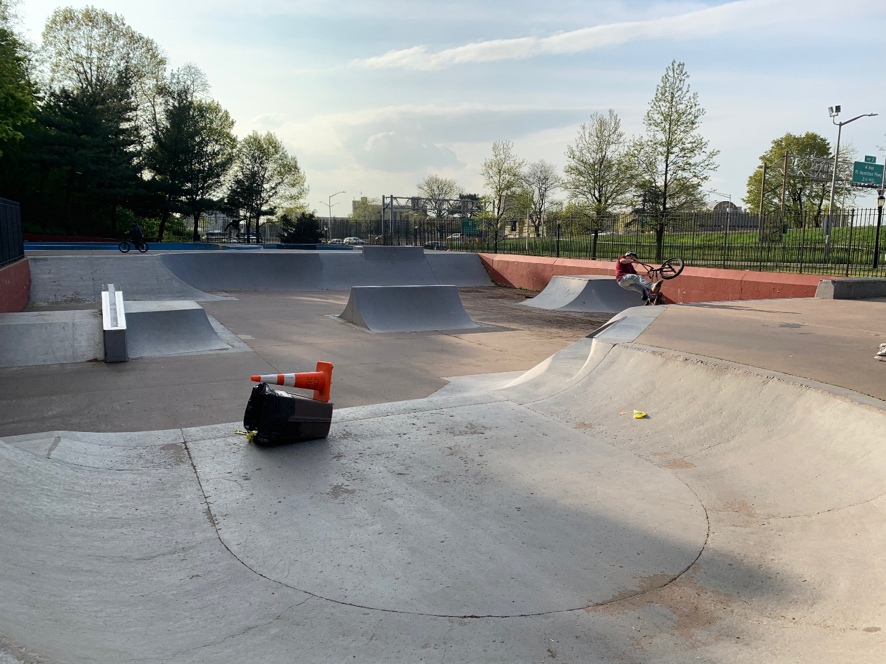
Tuesday 5:50PM. Skateboarding and by the highway for one please! Photo taken by myself.
Near park slope you can find the millennium skate park. Skateboarding is not only an activity but a sport. Another form of self-expression, a way of life for some people. You’d be surprised at how many skate parks there are around. These skaters I saw have been clearly doing this for a good while. They seemed highly experienced and enjoying their time.

