NYCCT,CUNY Kelvin Burdiez
Hospitality Management HGMT 1101 Prof. Goodlad
December 10th, 2015
36 Hours in The Brooklyn Waterfront
By Kelvin Burdiez
Brooklyn Now is Better!
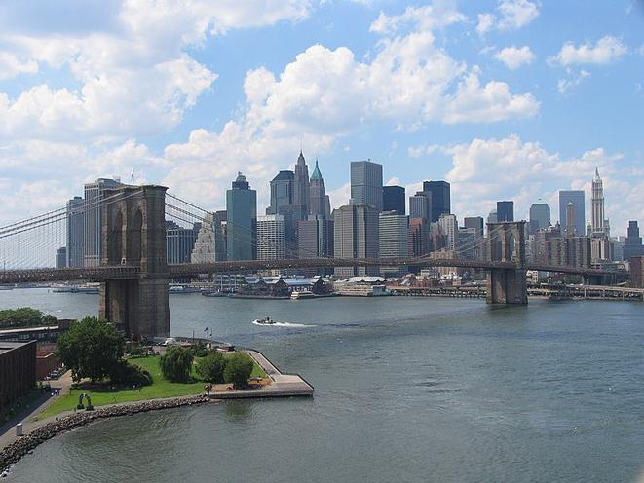
Brooklyn is a borough in New York and it has come a long way. Brooklyn many years ago was all about the hood, which means back in the day Brooklyn was filled with people who did drugs, sell drugs, gang wars, gun fights, and gangsta people. Many people were afraid to live in Brooklyn because of its violent past but now Brooklyn is different it has changed drastically. From having gang wars and selling drugs, Brooklyn is now all about hipsters and people with money with nice clothes, nice houses or apartments and nice areas to eat around.
Friday
1.Coney Island 2pm
Coney Island has been a historic place in New York for a very long time, Coney Island has many things to do such as walk on the board walk, go to the beach, get on the amusement park rides, play quick games that win prizes, many places to eat at and etc.… Coney Island was discovered in 1609 by Dutch explorer Henry Hudson, Coney Island has been in Brooklyn for about 406 years. In 1884, the first ever roller coaster opened in Coney Island. In 1923, the Coney Island boardwalk opens up to the public which is great because now any tourist can go and visit the boardwalk and see everything around Coney Island. You can get to Coney Island in train by Taking the D, Q, N or F train to Stillwell Avenue. This takes about 45 - 60 minutes from midtown Manhattan.
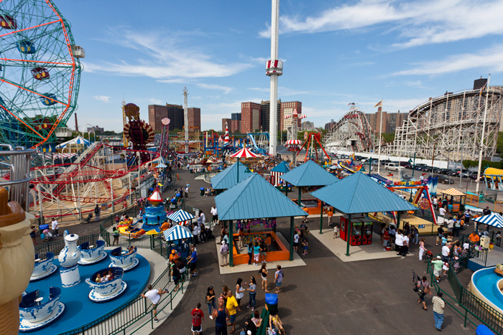
Photo credit (google images)
2. Coney Island USA 5pm
In Coney Island USA you can do many things as in get on rides and attractions, food, fire works on the beach, circus shows, museums, and a tour around the whole Coney Island. You can get on rides, some rides that they have are, Scream zone and the Cyclone roller coaster. The circus shows have many different times that you can watch it and the prices for adults are $12 dollars and for kids is $8 dollars. Pretty cheap price to watch a circus show, somewhere else it could be a lot more expensive. There’s many different types of shows depending on the season or the time of the year. For example, they have holidays shows for Christmas, New years’ eve, Halloween, Easter, and the regular circus shows that they do regularly. The circus shows aren’t open every day they are mostly open on the weekends so take advantage of that when you can. 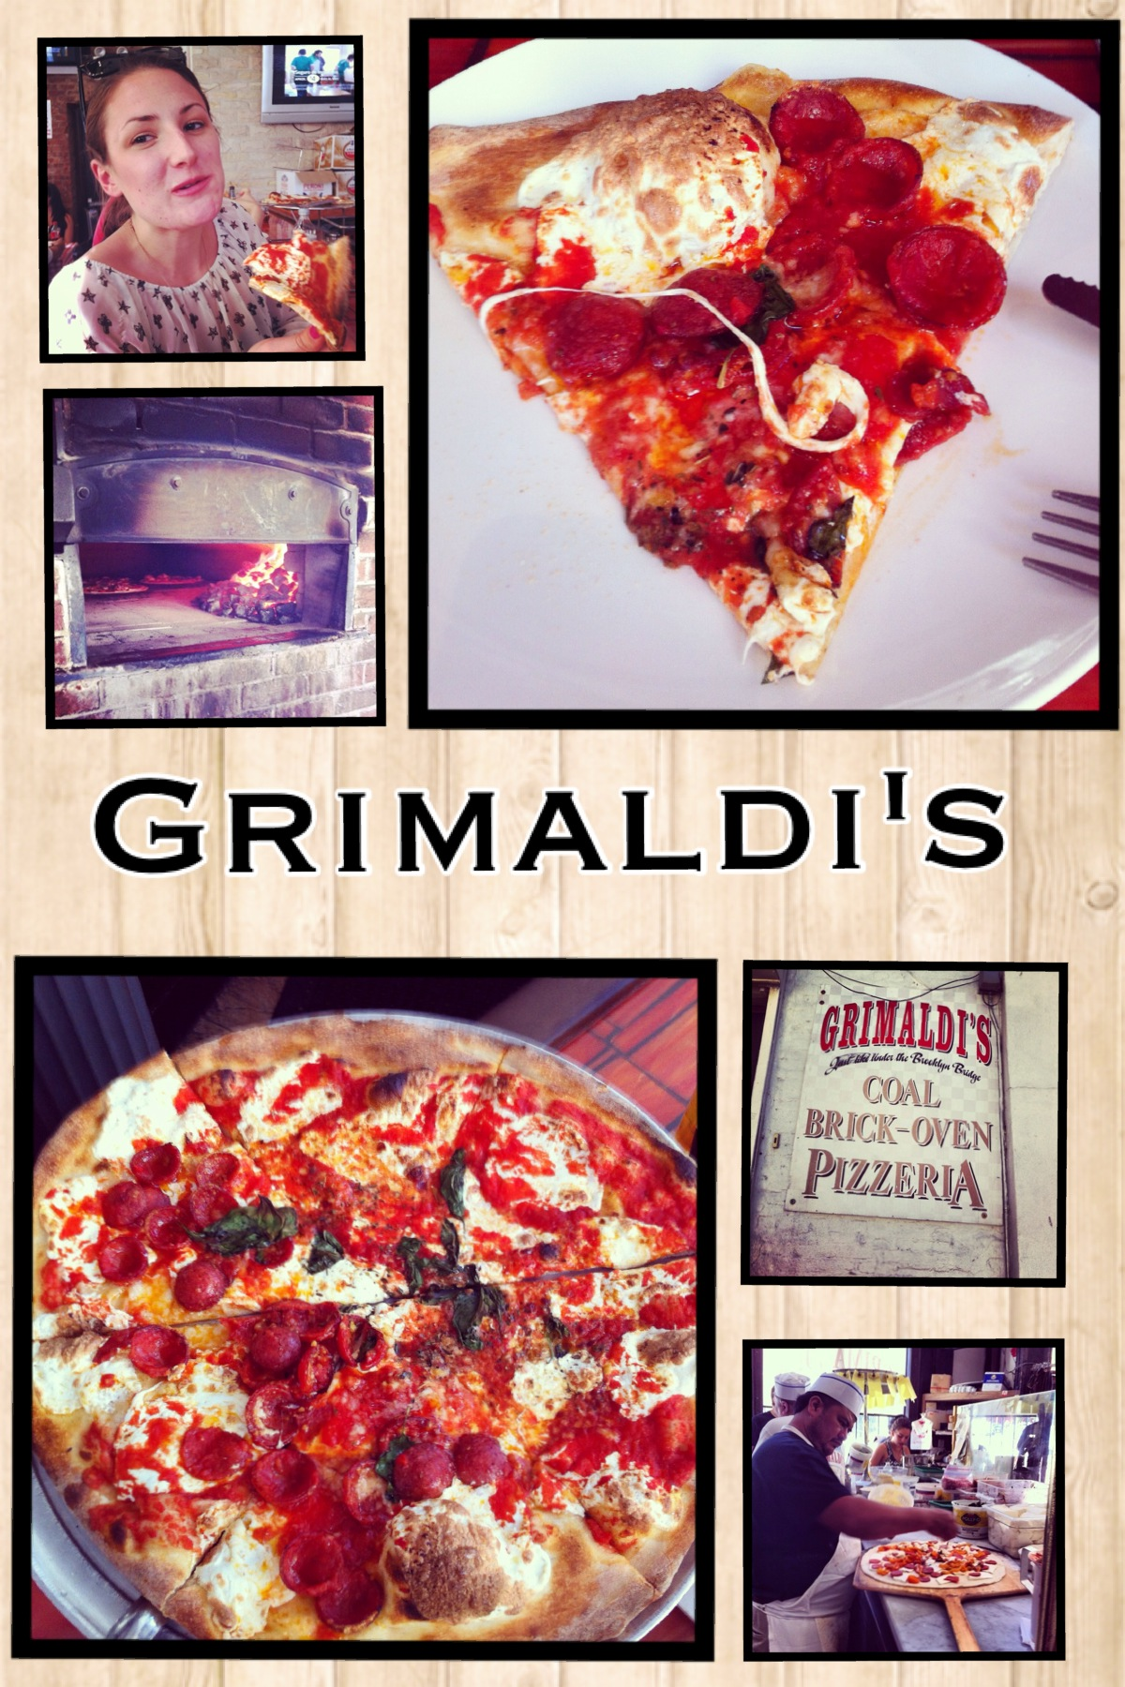
Photo credit (google images)
3. Grimaldi’s Coney Island 8pm
Grimaldi’s is a very famous pizzeria in Brooklyn. They are known for making good pizza and pasta. Grimaldi’s Coney Island is located in 1215 Surf Ave, Brooklyn, NY 11224, they are open from 12pm-10pm on week days, on weekends they are open from 12pm-11pm. Grimaldi’s was established in Downtown Brooklyn in the year of 1990. Grimaldi’s pizzeria has many varieties of food such as, portabellos, salads, soups, pizza, calzones, and drinks. My favorite in Grimaldi’s is the pizza beside of everything, everything is great but the pizza is really good and you can only order pizza pies not slices. The pizza pies in Grimaldi’s range from the small pie which is $14 dollars and the large pie which is $18 dollars. Grimaldi’s Coney Island isn’t your typical pizzeria in Brooklyn, this pizzeria is so much better than the others, I recommended to go.
Saturday
4. Breakfast in Brooklyn 10am
To start off the morning right you always need a good breakfast with a good cup of coffee. Clark’s Corner is a restaurant that sells American food and makes amazing breakfast too. Clark’s corner is located in 80 Clark St, Brooklyn, NY 11201, they are open from 9am-11pm everyday This diner sells everything from breakfast to lunch and dinner. Breakfast is the best though, you can eat from many varieties of food such as, eggs and omelets, eggs benedict, breakfast wraps, griddles, French toast, waffles, and for the healthy people you can eat fruit with yogurt. The pricing of the food at Clark’s corner is also economical its not expensive, it is a great price for the quality of the food you are getting. Many people have said that Clark’s corner is the best diner in Brooklyn and Clark’s has gotten many great reviews also. You can definitely enjoy yourself and have a great time with family in Clark’s corner. ‬‬‬

5. Bikelyn Tours around Brooklyn 12pm
After waking up in the morning you can head into Downtown Brooklyn for some exercise. Now a day’s people are more careful with their diet and like to do exercise a lot, especially woman. For those who like to exercise you can go to Bikelyn tours and get a workout in a tour around Brooklyn which is located at 269 Baltic Street, Brooklyn, NY 11201‬. The price for each person in the bike tour is $85 dollars and you go from Williamsburg to DUMBO and see many shops, parks, historic and cultural exuberance, sky scrapers from the city and waterfronts. They also provide you with nice orange looking bikes that is secure and they provide you with all the gear so you can have a safe bike tour. ‬‬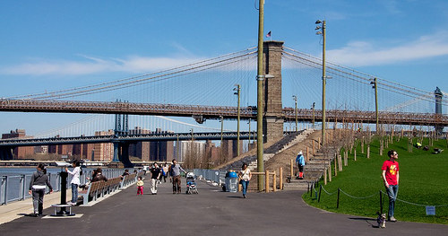‬
Photo Credit (google images)
6. Brooklyn Roasting Company Coffee 5pm
Who wouldn’t like some coffee at 5pm? I know there’s many people who would like some amazing coffee around that time. Brooklyn Roasting Company is located in 25 Jay St, Brooklyn, NY 11201 and is open everyday from 7am-7pm. Brooklyn Roasting Company has many different types of coffees that you can try such as, Sumatra, Brazil, Mexican, Colombian, Hazelnut, and American coffee. Brooklyn Roasting Company was founded in 2009 by Jim Munson who owns other coffee shops, he started the company fast and now they are improving and are the best coffee spot in Brooklyn.
7. River Café 8pm
River Café is a high class restaurant with amazing food but really expensive, it is definitely worth the try though mostly if you want to taste amazing and different varieties of food. River Café is located in 1 Water St, Brooklyn, NY 11201-1393 (Old Fulton St.‬). Transportation to get there is easiest by train and bus and the way to get there is by taking the A or C train to High Street/Brooklyn Bridge; 2 or 3 train to Clark Street; F train to York St.; Bus #41 to Old Fulton St./Cadman Plaza West. River Café consists mostly of seafood but they also have chicken, lamb, steak, halibut, and wellington. The prices range from the least of $100 dollars and up. The River Café opened in June of 1977 it took them 12 years to try and get the restaurant and they obtained it in 1974. You can have private events, weddings, and also reserve the place for a party. The River Café is very exclusive in the Brooklyn area.‬‬‬
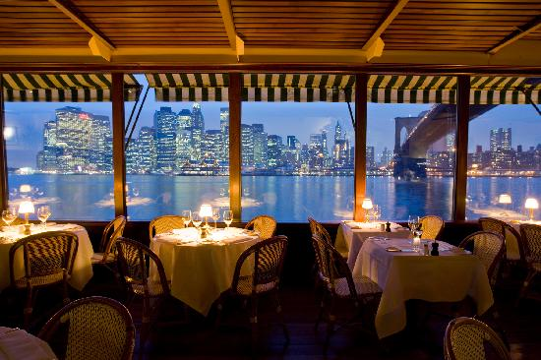
Photo credit (google images)
Sunday
8. Last Breakfast in Brooklyn 10am
Jack The Horse Tavern is a nice high class restaurant in 66 Hicks Street, Brooklyn, NY‬. In Jack the Horse Tavern you can eat many great breakfast meals such as eggs, griddles, omelets, sandwiches, and grills. You can also have morning and brunch drinks if you are a morning drinker. Brooklyn is probably really expensive for others who come down to New York because back in any other country the currency is different from New York. ‬But can definitely have a great time.‬
9. Cadman Plaza Park 1pm
On a beautiful Sunday afternoon, you can head to Cadman Plaza Park as your last visiting location in Brooklyn. Cadman Plaza Park is located on Cadman Plaza West and Tillary Street, Brooklyn, NY 11201. Many tourists that go to Brooklyn have visited this park, its not as famous as the Brooklyn Bridge Park but its still a great recreation in Brooklyn where you can have picnics with friends and families, play basketball, baseball, soccer, and football on the fields and the turf fields that they have. For the healthy ones that like to workout and keep their bodies in shape you can run or jog around the park, while jogging/running around the park you can see the beautiful sights around the park and in Brooklyn. There are also historic memorials in the park, one main memorial was designed by Charles Keck, a world war 2 memorial that is 24 feet tall and its one of the largest memorials in New York City. Cadman Plaza Park is a great park in Brooklyn. ‬‬
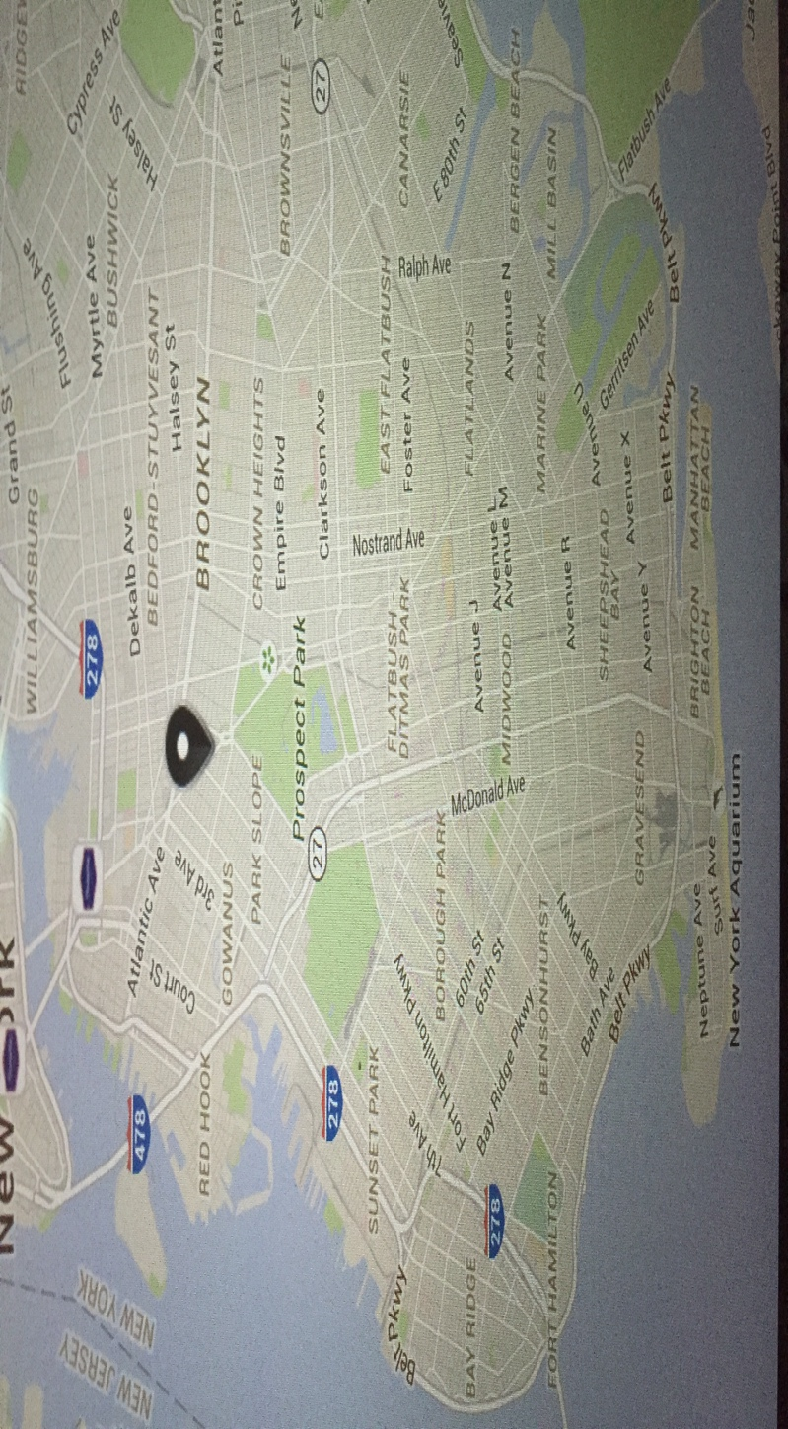
Photo credit (google images)
Lodging
With a prime location near the Brooklyn bridge, there’s the New York Marriott Hotel which is a very good hotel that you can sleep very comfortable in. The New York Marriott hotel is located at 333 Adams Street Brooklyn New York 11201. In the New York Marriott hotel in Brooklyn you can choose from many varieties of rooms such as, the king room, double room, executive room, skyline view, king suite, presidential suite and etc.… They also have spa’s for mainly the ladies who like to go to the spa, they have fitness for the men or woman who like to workout on a daily basis too. Inside of the hotel they have a bar if you would like to get a drink and they also sell food such as, breakfast and lunch. For a night in the New York Marriott hotel the cheapest you can get a room is $249.00 US dollars a night.

Reference page
1.Information. (n.d.). Retrieved from http://therivercafe.com/information
2.Brooklyn Roasting Company - Dumbo New York | Upright Coffee. (n.d.). Retrieved from http://uprightcoffee.com/brooklyn-roasting-company/20101215/
3. Bikelyn's Brooklyn Bike Tours. (n.d.). Retrieved from http://www.bikelyntours.com/privatebiketoursofbrooklynNY.htm
4. Tourist Information. (n.d.). Retrieved from http://www.coneyisland.com/tourist-information
5. Grimaldi Pizzeria Menu. (n.d.). Retrieved from http://www.grimaldisconeyisland.com/menu/
6. Cadman Plaza Park. (n.d.). Retrieved from http://www.nycgovparks.org/parks/cadman-plaza-park-and-brooklyn-war-memorial/history
7. Your session has timed out, but you can continue your hotel search right here. (n.d.). Retrieved from http://www.marriott.com/reservation/rateListMenu.mi

