36 Hours In Brooklyn Waterfront
By Steven(Zifeng)Liu Dec 9,2015

Brooklyn Waterfront was Originally used for importing exporting goods. In the recent decade it has a tremendous amount of change there are lots of new culture had moved into this place, it also had a great influence on the local culture. Greatest example would be photographing as a lot of tourism going to on the Brooklyn Bridge photographer had moved in as well. They came here to take wedding photos and landscape pictures too, because of this there are more people came to visit and move into the waterfront. Therefore, foods, different culture had moved to here in the past decade.

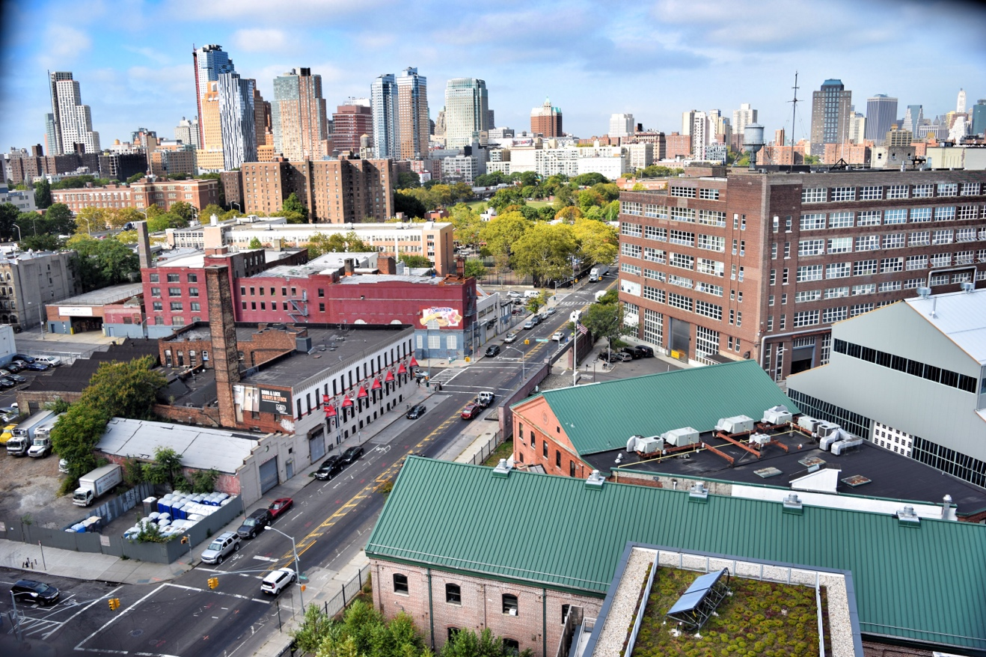

Brooklyn Navy Yard. Steven(Zifeng)Liu

Friday
Magical photographing place 1:00 PM
Brooklyn Bridge started in 1883; it took about 14 years to finished this bridge. Brooklyn Bridge is the landmark that impacts the photography and tourism culture; people came to visit this place from all over the world because they want to see the beauty of this bridge that has stood for over 125 years. The bridge built in the 1800s, and it soon became a landmark. It is totally free to walk the bridge. Stay for about an hour to enjoy the walk to the midpoint and turn back.

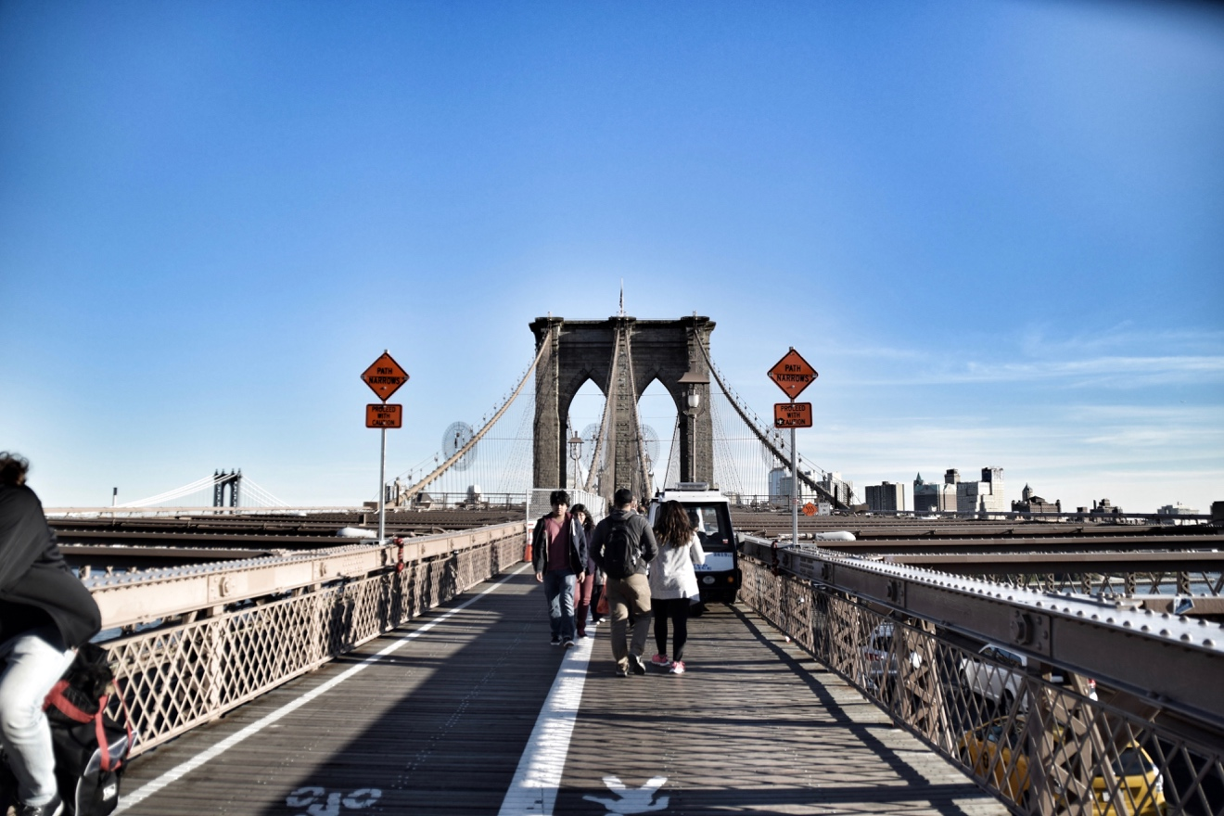
Brooklyn Bridge. Steven(Zifeng)Liu

Taste of the Sea 3:00 PM
Lobsters are one of the best seafood in the world. After visiting the Brooklyn bridge, they can simply go under it and try this. What they provide are incredible they have the lobster roll, crab roll. Is price range around 16-40 USD depends on the meal? Luke's Lobster is a walk out restaurant. You can enjoy the view in the park while eating it's very beautiful.

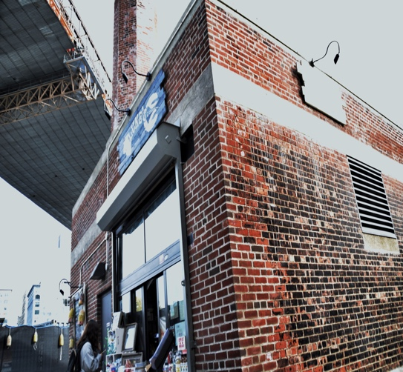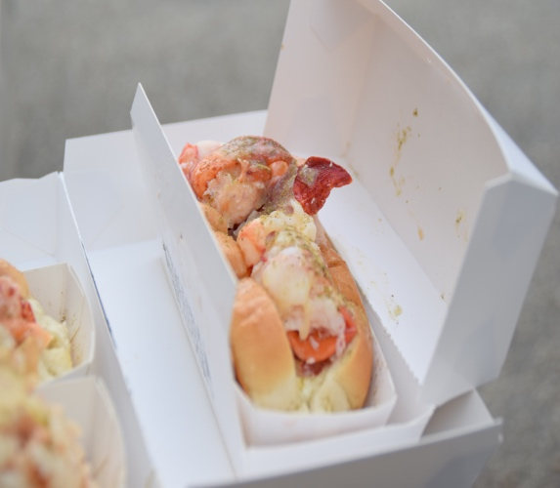

Luke’s Lobster. Steven(Zifeng)Liu

A Romantic in the City 5:00 PM
Another beauty of Brooklyn is Jane’s Carousel, located at the Brooklyn Bridge Park. It was built in the early 1900s. This place is open on Thursday, Friday, Saturday, and Sunday its admission is only $2.00! This place is very beautiful during the night because you can see the Manhattan skyline and all the lights were up like telling us that this is a city that never sleep. That is a place where the magic happens, people propose marriage to their loved ones here, people take their wedding picture in here. This place symbolizes love.

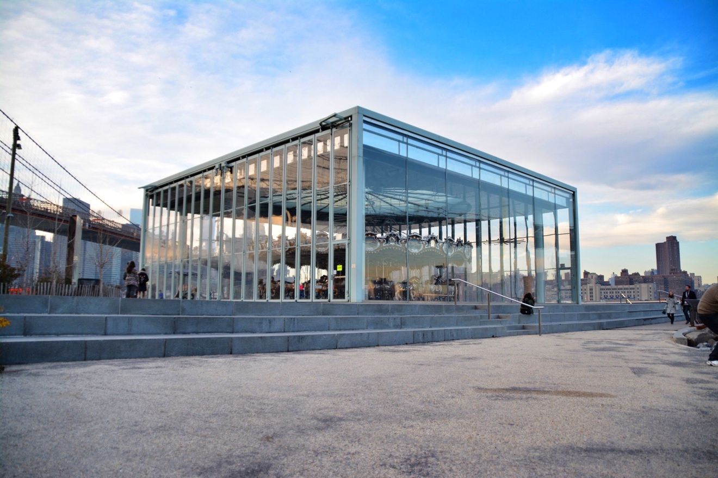
Jane’s Carousel Steven(Zifeng)Liu

Dining with the City 7:00 PM
The river café is right next to the Brooklyn bridge. It is a fine dining place after a long day of touring around the Brooklyn Waterfront you can visit this place for a nice dinner. But before you go in, you need to just up probably because this place has a dress code. It would be a good idea eating dinner here, because it provides an incredible view that you will never forget, you can see across the river when the light is all up at night it's very beautiful.
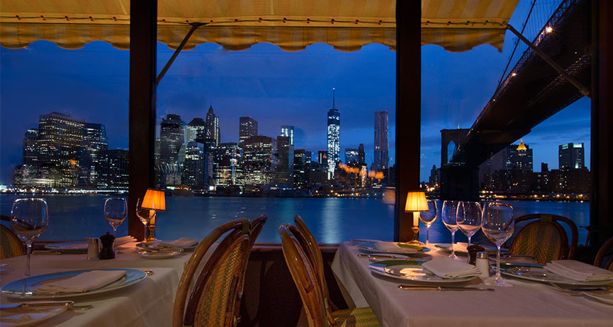
The River Café. Website

Lodging Marriott 9:00 PM
A four stars’ hotel near the Brooklyn Bridge, after a long day visiting Jane’s Carousel and Brooklyn Bridge the guests can stay here overnight. Marriott is an international hotel company that provide over 4200 hotels in 80 countries according to the website. They have over 90 years of experience they can give you a feeling of home. Their price is around 200-300 per night overall is a nice experience.
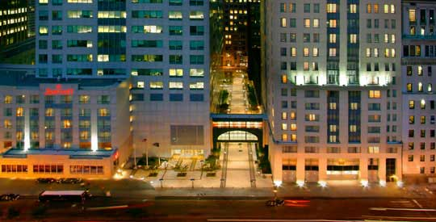
Marriot. anonymous

Saturday
A Real Coffee with the Local Taste 2：00 PM
Brooklyn Roosting company is near the Dumbo. It has a cultural effect on the coffee industries. As you know, drinking coffee becomes a hobbit for lots of people. The significant of this place is that you get to see how the coffee is made, and they provide variety type of coffee. After you wake up, you can simply take 15 minutes from Marriott and get a cup of coffee.
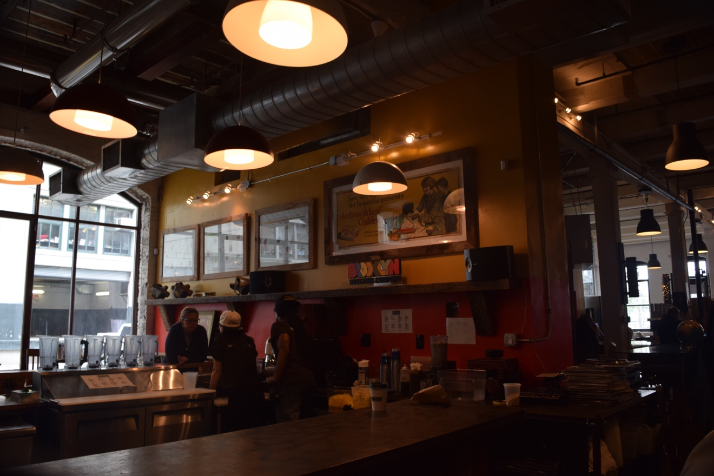
Brooklyn Roosting Company. Steven(Zifeng)Liu

Tasting the culture 3:00 PM
Smorgasburg is a food event that take place in Williamsburg. This event takes place on every Saturday. Here, they provide different kind of vendors, the diversity of food can amaze you. It is a small place but full of surprise, because you might find some interesting food fro Japan or some homemade food that you never tried before. This place expands the food culture even further and it is not an expensive place at all it charges around 9-20 depends on the vendor.
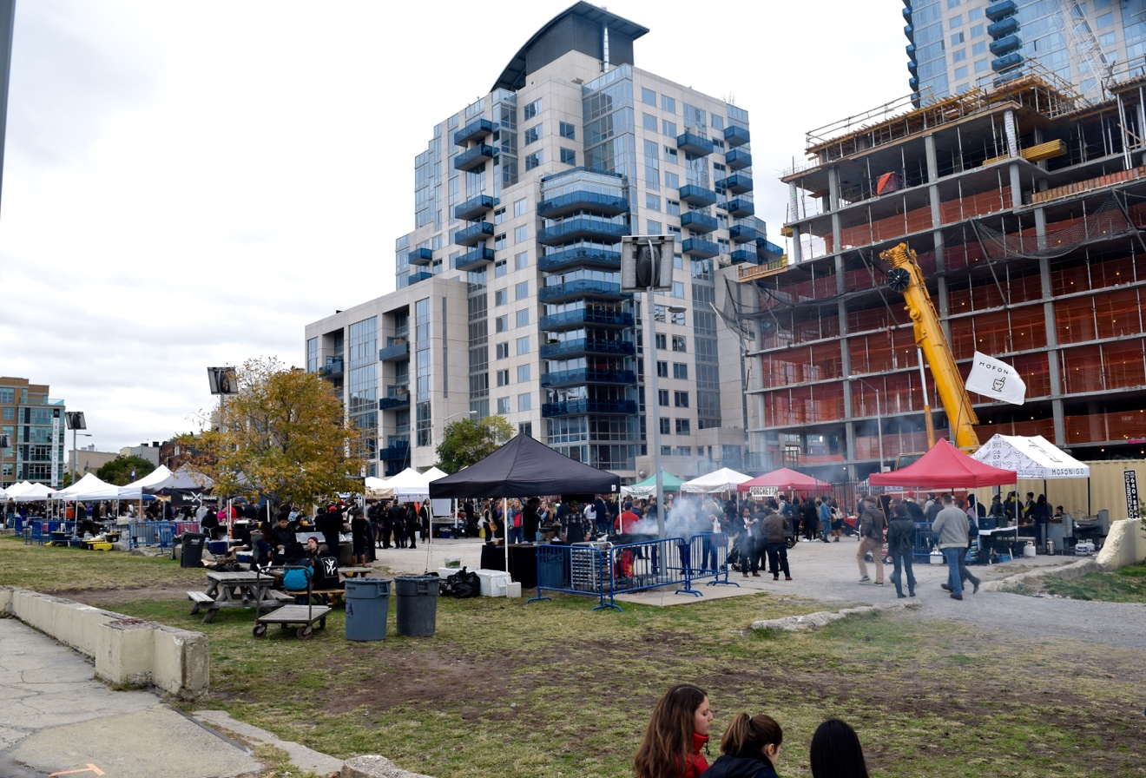
Smorgasburg. Steven(Zifeng)Liu

Farm on the Top 4:00 PM
Brooklyn Navy Yard is a shipyard that is located on the waterfront. On the top of the building, there is a place call Brooklyn Grange. Brooklyn Grange is a rooftop garden. If you have a chance visit the Navy Yard, you should go to the top because it gives you a view of the city and you can see how a rooftop garden works. It has a significant cultural effect on Brooklyn because as a growing city people want their fruit and vegetable to be fresh by having a rooftop garden is changing the tradition farming culture.

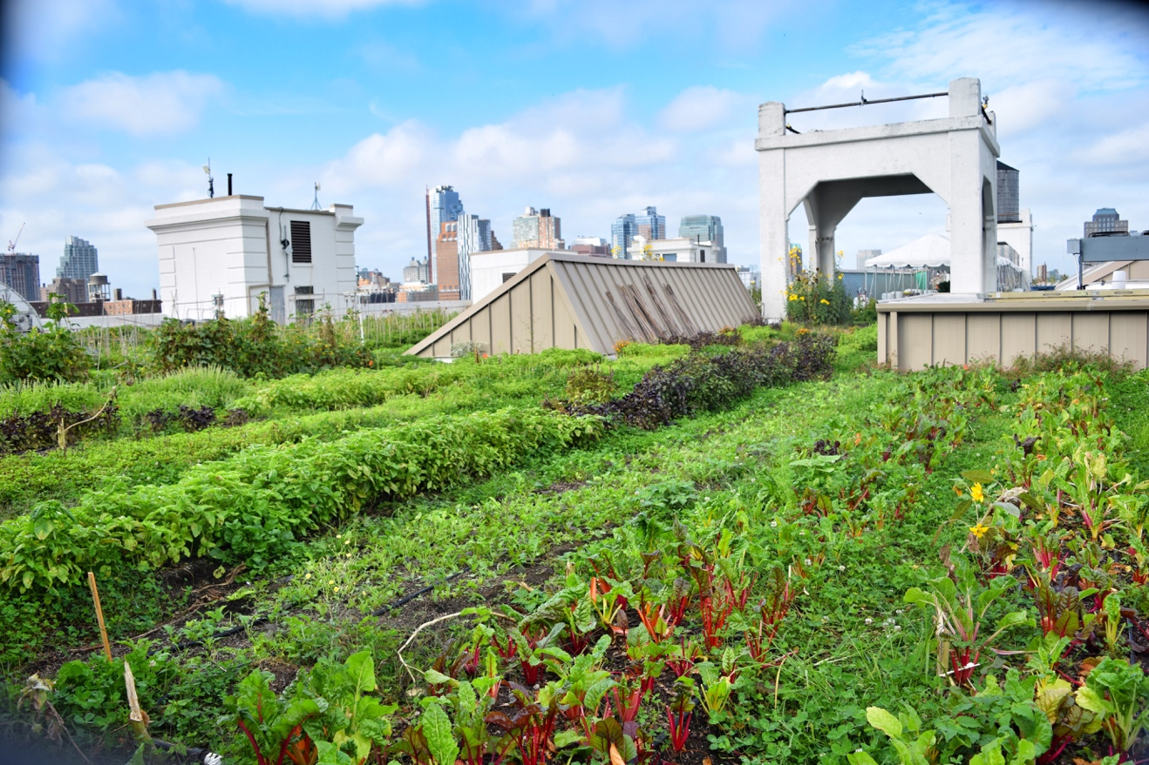

Coney Island 6:00PM
Coney Island is one of the significant places in Brooklyn Waterfront not only in history but also they hold lots of big event such as the celebration of July 4th. Every year during the summer they provide firework on Friday night especially on July 4th you wouldn't want to miss that part. Also, they have wondered wheel, so it would be very nice that if you were sitting on the wonder wheel and watching the sunset and the firework. They have the best hot dog in the area that's why every year there is a hotdog context in here. They also have a beach, so in a hot summer day you can simply just lay on the beach and relax for a little bit it would be a good idea.
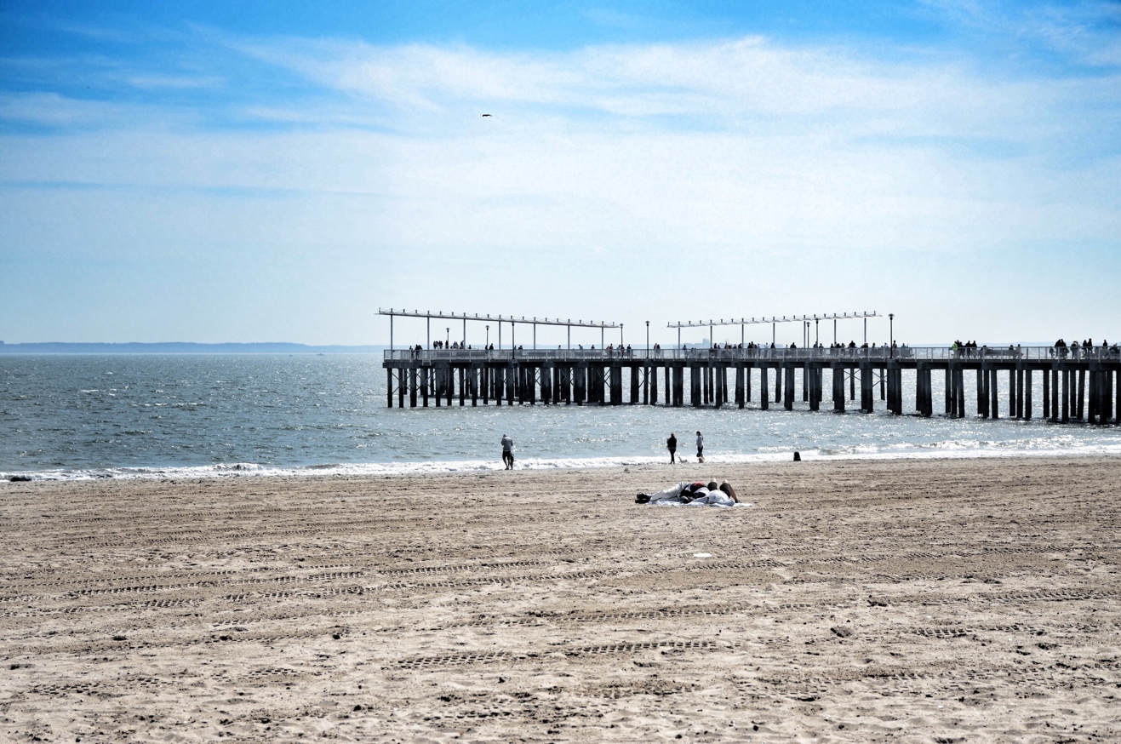
Coney Island, Steven(Zifeng)Liu

Brooklyn Navy Yard.Steven(Zifeng)Liu

An Escape from the City 8：00 PM
Pier 69 is a place that you can escape from the city. Here you can fish, you can bike, and you can jog around if you are a photographer you can come here too because you can see Manhattan and the Verrazano Bridge. This place located at Bay Ridge 69th street near Belt Parkway. It surrounds the Belt Parkway and at night you can see the Verrazano Bridge is glowing like is a bridge that is going to the heaven. While enjoying the view you can fish and talk with a friend or read a book, it just a silence

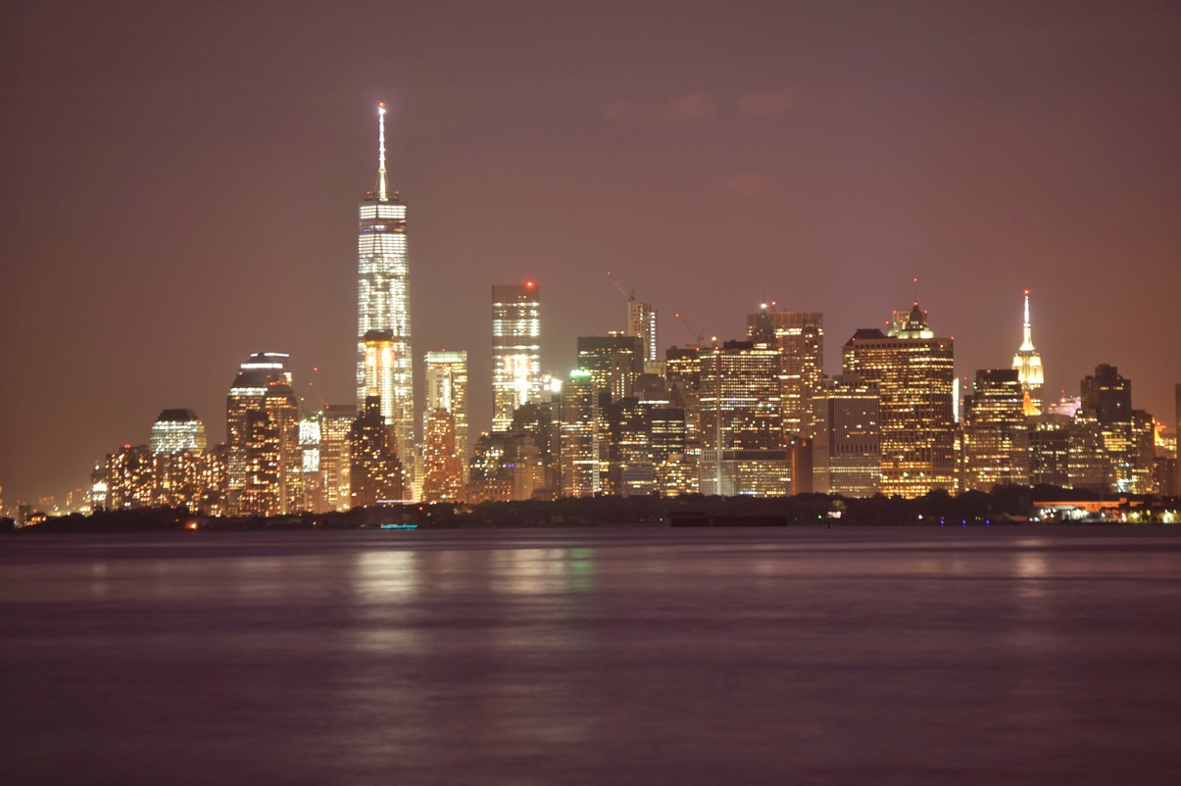

Bay Ridge Pier 69. Steven(Zifeng)Liu

Reference

Brooklyn Waterfront History. (n.d.). Retrieved December 10, 2015, from http://www.brooklynwaterfronthistory.org/story/where-coffee-was-king/

Find a Hotel. (1996). Retrieved December 10, 2015, from http://www.marriott.com/default.mi

Top of Form
The River Café | Home. (1977). Retrieved December 10, 2015, from http://therivercafe.com/

