36 Hours in Brooklyn Waterfront

Culture within Everything

By: Gion Xavier Dec 10, 2015
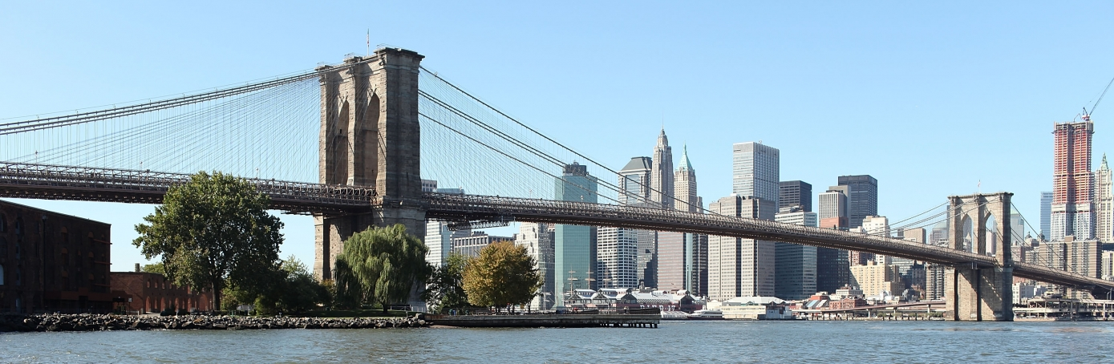

Brooklyn has many places that have culture to it within the food we eat, activities we do, and places we walk around. During the 1900’s, many immigrants came to Brooklyn as refugees or to start new lives. Today, not only Brooklyn’s wonderful view of the Brooklyn Bridge, East River, and the World Trade Center attract people. But for its history and culture. As the year went by, Brooklyn has become a popular spot for tourists when they visit New York.

Friday

1. Brooklyn Bridge Park, 11 am
On the left side of the Brooklyn Bridge is a park name after the bridge. The park is known for its “Salvaged Beauty” where sites that existed before the park was created are used in order to preserve the cultural legacy of the site. The park is divided into Piers and each of them has many activities people can do while they are in the Waterfront. This park is perfect for a picnic, just grab food from local restaurants or bring your own and eat while having a wonderful view of the Brooklyn Bridge and Downtown Manhattan. (http://www.brooklynwaterfronthistory.org/story/salvaged-beauty/) (http://www.theshopsatonebrooklyn.com/sitemap.php)
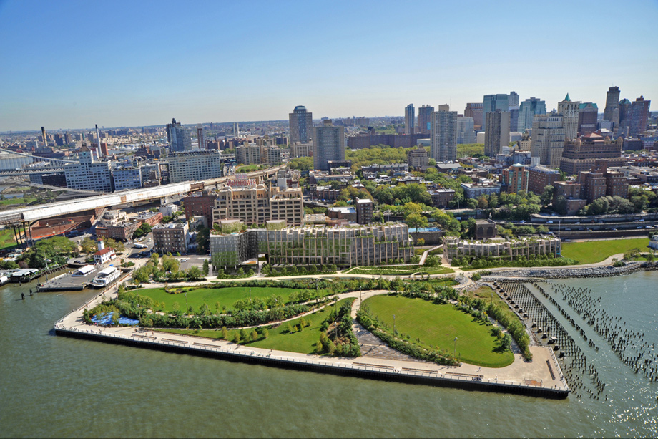
Photo Credit: Google

2. Pizza Competition, 3 pm
Two pizzerias next to each and are the most popular in Downtown Brooklyn. Grimaldi’s and Juliana’s are pizzerias that have a different type of service from each other. Juliana’s is both a dine in or take out type of pizzeria. Unlike Grimaldi’s, where its mostly a take out type of pizzeria that dining in would be impossible. Lines extended outside the pizzeria and can only buy pizza as a pie (no individual slices). Both pizzerias claim to be the “number 1” in Brooklyn, but let the customers decide which one is really the best. (http://www.villagevoice.com/restaurants/the-julianas-and-grimaldis-rivalry-bite-by-bite-6563319) (http://www.julianaspizza.com) (http://www.grimaldis-pizza.com/home)

3. Jane’s Carousel, 4 pm
On the other side of the Brooklyn Bridge is Jane’s Carousel. This carousel is inside a giant glass box that can be open during a perfect weather. This carousel was made in 1922 by the Philadelphia Toboggan Company and was originally installed at Idora Park in Youngtown, Ohio. The horse’s design is very artistic with its color. When the carousel spins, the horses look like they are really running around. The carousel is open 6 days a week (closed on Tuesdays) and its hours are from 11 am to 7 pm. Tickets to ride are 2 dollars but you can also get 12 tickets for 20 dollars. (http://janescarousel.com/history/)
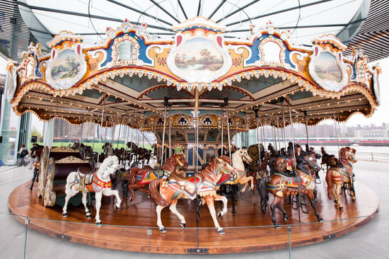
Photo Credit: Google

4. Smallest beach in the Waterfront, 5 pm
Just right across Jane’s Carousel is a little beach that is not your typical beach. The beach is not like what you see in Coney Island or Far Rockaway; this beach has a rocky setting to it instead of a sandy one. Waves that crash on the beach are mostly caused by the boats that pass by the East River. Many people go there to watch boats pass by, see the view of the Brooklyn Bridge and the Manhattan Bridge, and even for wedding photos.
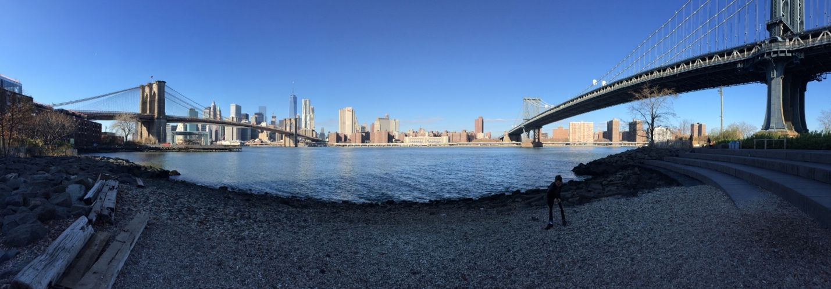
Photo Credit: Gion Xavier

5. Iron Chef Dinner (Not the TV show), 9 pm
When you think Iron Chef House, you might think the Iron Chef you see in TV. But actually this restaurant serves Japanese cuisine to it customers. Of course there is sushi in the restaurant which has more than a hundred different flavors. Entrée can be teriyaki, tempura, or noodles (Udon). House specials are served with a choice of salad or soup that will come along with the entrée. Have a katsu which is a fried cutlet of meat that can be a choice of chicken, fish, or pork served with a brown sauce only for 13 dollars. Other choices can be the special combination box which has a choice of chicken, steak, or fish teriyaki with sushi and tempura all just for 17.95. If you want a taste of Japanese culture, the Iron Chef House is the perfect place to go to for a Japanese dinner. (http://www.ironchefbrooklyn.com/home.html)

Saturday

6. Coffee of Different Cultures, 10 am
Just a few blocks away from the Jane’s Carousel is a popular coffee shop called The Brooklyn Roasting Company. This coffee shop is located in 25 Jay St, Brooklyn. During the trip, we stopped by there to get some details on what they do and what kinds of coffee they have. They have different kinds coffee that are imported from other countries such as Colombia, Brazil, Asia, and East Africa. Each coffee has a different taste to it, such as the Brazilian coffee which has a strong taste to it than most coffees do. This coffee shop I believe is trying to bring coffee from different countries so their customers can taste coffee from different cultures and know how its different from coffee here. (http://www.brooklynroasting.com)

7. Bike Anywhere in the Waterfront, 11 am
Touring around the Waterfront by foot is an option for people. But, you can actually go biking instead of walking. Biking around Brooklyn is mostly common in the New York culture. Citibank had started to create what they call Citibikes. This citibikes are found in a lot of places in New York and are used to bike around all over the city. To use the bikes, you simply just need a debit card and it will allow you to use one bike which you can ride it anywhere as long as you return it to its station.

8. Not Just a Burger & Fries, 1:30 pm
Forget about having Mcdonalds or Burger King as a spot to eat for lunch. Have a burger and fries from Shake Shack at Old Fulton St right under the Brooklyn Bridge is open from 11 am to 11 pm. Shake Shack is a popular fast food restaurant that can mostly be found in the Manhattan. Order yourself a shackburger (add a bacon for just $1.50 +), cheese fries, and a soda for only just $12.40 which you can have to go or to stay. (https://www.shakeshack.com)
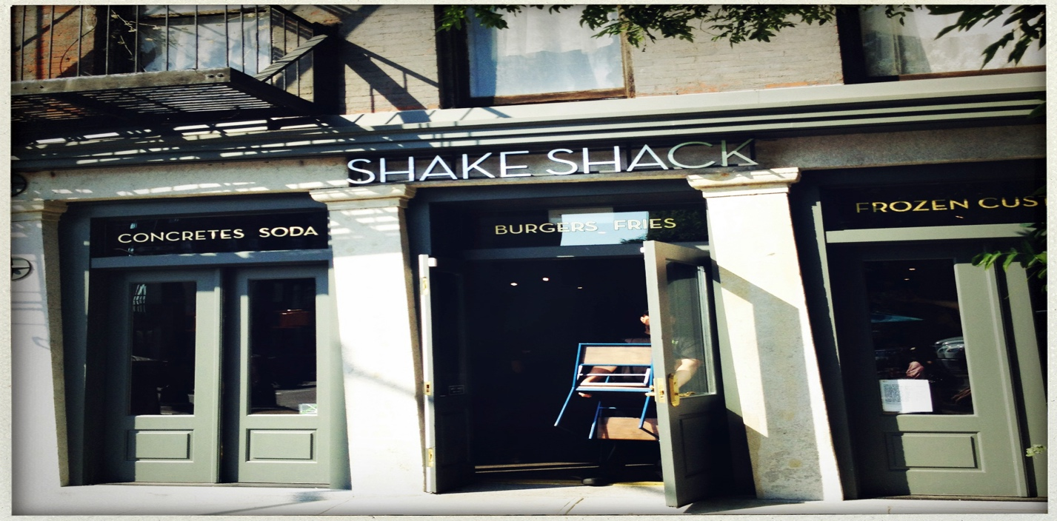

Sunday

9. Authentic Hand Rolled Bagels for Breakfast, 10 am
Le Bagel Delight is the perfect place to have a bagel for breakfast. They sell a different variety of flavors for bagels like onion, egg, pumpernickel, etc. This bagel shop has some Italian culture towards its food like the eggplant parmesan and and chicken parmesan (which is available for lunch). For breakfast, order yourself a bagel with cream cheese for only $2.07 or cream cheese with jelly for $2.32. Breakfast specials are good choices as well, such as the strawberry and blueberry croissant for $2.50. To start your day perfect, breakfast from Le Bagel Delight will certainly give that to you. (http://www.labageldelight.com/breakfast.html)

10. Bargemusic, 4 pm
Like to listen to live music on a boat, the Bargemusic is the perfect place to do that. Tickets to enter the Bargemusic is $35 for the whole concert which is 2 hours long. This “floating concert hall” was built in 1899 and served as a working vessel in the harbor. Musicians that come here to play music is not like a concert where someone sings in a big stage. More like composers who play instruments like the piano, violin, or the cello. (http://www.bargemusic.org/about.html)

Lodging

The NY Marriott at the Brooklyn Bridge in 333 Adams St is perfect place to stay since its near the Brooklyn Bridge and DUMBO. They have different variety of rooms you can pick when staying at the hotel. You can stay in either a suite or a regular guestroom. A regular guestroom would at least be 400 square feet/ 36 square meter with fit up to 3 people, a TV with LCD screen and cable, and wireless internet ($440 per night). Got people with you when traveling, you can stay in a suite which has 2 large LCD TVs, a living room, wireless internet, and could fit up to 4 people ($590 per night). If you want a hotel near the Brooklyn Bridge and DUMBO, then the Marriott at the Brooklyn Bridge is the perfect spot for you. (http://www.marriott.com/hotels/travel/nycbk-new-york-marriott-at-the-brooklyn-bridge/)

Red Lion Inn & Suites located on 279 Butler St is a hotel you can stay at since its right next to the Barclay Center and the Piers of Brooklyn Bridge Park. A standard guestroom has free wireless internet, cable that has over 70 channels, and 2 queen beds (from $201 per night). Traveling in a group, make reservations for a suite with a hot tub, free wireless internet, and bathroom amenities. They also have offers and packages that will include more hospitality services. (http://www.redlion.com/brooklyn)

Reference

Salvaged Beauty. (n.d.). Retrieved December 9, 2015. From http://www.brooklynwaterfronthistory.org/story/salvaged-beauty/

Site Map of Brooklyn Bridge Park. (n.d.). Retrieved December 9, 2015. From http://www.theshopsatonebrooklyn.com/sitemap.php

Snuck, Laura. (2013). THE JULIANA'S AND GRIMALDI'S RIVALRY, BITE-BY-BITE. Retrieved December 9, 2015. From http://www.villagevoice.com/restaurants/the-julianas-and-grimaldis-rivalry-bite-by-bite-6563319

Juliana’s Pizza. (n.d.). Retrieved December 9, 2015. From http://www.julianaspizza.com

Grimaldi’s Pizzeria. (n.d.). Retrieved December 9, 2015. From http://www.grimaldis-pizza.com/home

Jane’s Carousel. (n.d.). Retrieved December 9, 2015. From http://janescarousel.com/history/

Iron Chef House. (n.d.). Retrieved December 9, 2015. From http://www.ironchefbrooklyn.com/home.html

Brooklyn Roasting Company. (n.d.). Retrieved December 8, 2015. From http://www.brooklynroasting.com

Shake Shack. (n.d.). Retrieved December 9, 2015. From https://www.shakeshack.com

La Bagel Delight. (n.d.). Retrieved December 9, 2015. From http://www.labageldelight.com/breakfast.html

Marriott at the Brooklyn Bridge. (n.d.). Retrieved December 9, 2015. From http://www.marriott.com/hotels/travel/nycbk-new-york-marriott-at-the-brooklyn-bridge/

Red Lion Inn & Hotel. (n.d.). Retrieved December 9, 2015. From http://www.redlion.com/brooklyn

Bargemusic. (n.d.). Retrieved December 9, 2015. From http://www.bargemusic.org/about.html

