36 Hours on the Brooklyn Water Front
By Kathy Jiang December 10, 20
Brooklyn Water Front is a remarkable place that people could not forget after visit.
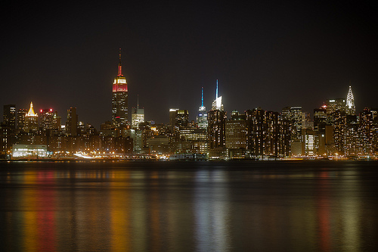
Photo credit: Google
Brooklyn is one of the most populous boroughs in New York City. People that come from all around the world want to come here to live. It has a long history. And most important events occurred in Brooklyn,
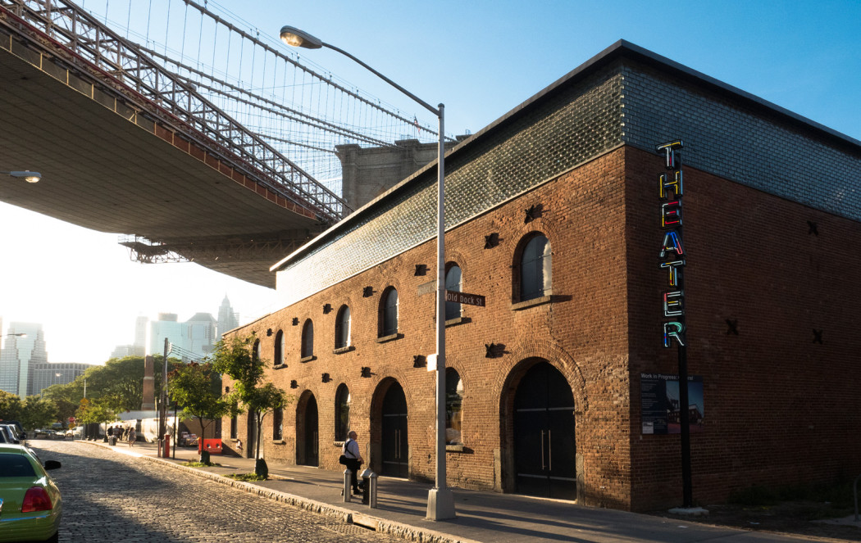
Photo Credit: Google.
Friday
1. ST. Ann’s Warehouse in Dumbo, 3p.m:
ST. Ann’s Warehouse is a performing arts institution in Brooklyn, New York City. This theater always bring amazing plan of productions from around the world to people. St. Ann’s Warehouse becomes a vital niche in New York City’s cultural landscape because there are open space for artists to stretch their creativeness with carefree. Inside of the ST. Ann’s Warehouse, there is a large, versatile theater for performances and concerts, such as Henry IV by William Shakespeare, A Streetcar Named Desire by Tennessee Williams, and there is enough space for customers to sit comfortable.
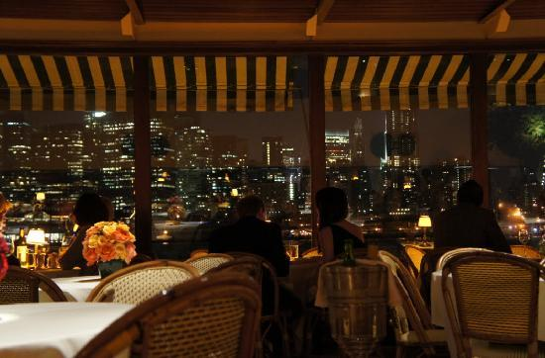
Photo Credit: Google.
2. Dinner time, 6p.m:
Get hungry? Go to The River Café. The River Café (located at 1 Water Street
Brooklyn, New York 11201) is one of the most unique restaurants in New York, because it is a restaurant that can let people dine with beautiful night view of Manhattan. In addition, because the highest level of cuisine, The River Café has been a favorite destination for New Yorkers and visitors from around the world. From the beginning, The River Café knew that the best way to keep the honor of the restaurant is to find out the finest and freshest ingredients available and utilize them, because most people always think that they deserve the best.
Saturday
3. Williamsburg smorgasburg, 9a.m:
Want to enjoy foods that come from all around the world? Just go to Williamsburg smorgasburg. Smorgasburg is an outdoor food market that held by over hundred vendors every Saturday on the Williamsburg Waterfront at East River State Park, and open from 9a.m to 5p.m. All Vendors are selling different type of food to people. For instance, Vietnam’s fried anchovies ($6, “a delicate fish that tastes like the ocean”), cold sesame noodles ($5), the griddle of the Queen’s Danh Tù’s cold rice noodles and pickled vegetables with pork shoulder; and banh xeo ($11). Smorgasburg is like a summer rock festival for food, make people feel exciting, and carefree.
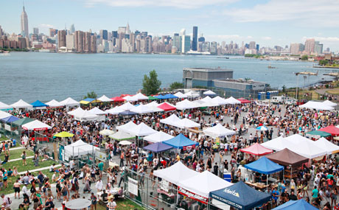
Photo Credit: Google.
4. Kings Country Distillery, 1p.m:
Kings County Distillery is New York City’s oldest operating whiskey distillery, founded in 2010. Distinctive whiskey was hand making by New York grain and traditional distilling equipment by Kings County in the Brooklyn Navy Yard. Its products are Moonshine, Bourbon, and Chocolate whiskey. Also, it has gift set too, visitor can buy these unique whiskey from this whiskey distillery. For these distinctive whiskeys, people can visit Kings County Distillery without any reason. Especially it is open for tours to taste their wines every Saturday.
5. Shake Shack, 5:00p.m:

After finished tasting the wines, visitors should search a place for food. And my suggestion is Shake Shack. Shake Shack is one of the famous fast-food counter-serve chain restaurants, located at 1 Old Fulton Street on the Corner of Water Street, Brooklyn, NY 11201. There are a lot of food can choose, People could eat 100% all nature Angus beef burgers, cheese fries, frozen custard, flat-top dogs, and drink fresh brewed iced tea, and Shack-made Lemonade, etc.
6. Nice breakfast, 8a.m:
Wake up for a cup of Starbucks coffee is excited. People get the power for the whole day from the coffee. Coffee can make people clear-headed, thinking with logic. People can enjoy their breakfast there. In the Starbucks, there are Peppermint Mocha, Chestnut Praline Latte, iced tea, iced coffee, and Caramel Brulee Latte, etc. And you can order sandwich and other foods too.
Sunday
7. Jane’s Carousel, 11a.m:
Feel free to back to your childhood. Jane’s Carousel is a place for adults and children to play with carved horses. It is historic because it has a long history. The manager Jane Walentas began to restore these horses, in order to make people have chance to ride them. And it is very romantic because it can make girls feel that they are waiting for a prince to say “marry me”.
8. Brooklyn Ice Cream Factory, 3p.m:
The Brooklyn Ice Cream Factory is the most famous ice cream company in New York City. It has different type of flavors of ice creams, there are all-natural flavors, and there is all taste good. When you are finished playing and walking from other places, it is good to grub the ice cream, and then enjoy it. People would feel cool after eating it.
Lodging:
Wythe Hotel is a boutique hotel that located in the historic factory on the Brooklyn waterfront (80 Wythe Ave, Brooklyn, NY 11249). This hotel is convenience because there is a “5-minute walk from the seasonal Brooklyn Flea and 0.4 miles from the nearest subway station”.

References
OLIVER STRAND. JULY 5, 2011. “Brooklyn Market: Woodstock of Eating”. The New York Times. Retrieved from:
http://www.nytimes.com/2011/07/06/dining/reviews/smorgasburg-in-williamsburg-brooklyn-for-food-lovers.html
Kings County Distillery. Retrieved from:
http://kingscountydistillery.com/about/
Shake Shack. Retrieved from:
https://www.shakeshack.com/food-and-drink/#fries
The River Café. The River Café.com. Retrieved from:
http://therivercafe.com/history/
ST. Ann’s Warehouse. Retrieved from:
http://stannswarehouse.org/tobacco-warehouse/
Starbucks. Retrieved from:
http://www.starbucks.com/menu
The Brooklyn Ice Cream Factory. (2003). Retrieved from:
http://nymag.com/listings/restaurant/brooklyn-ice-cream-factory/
Wythe Hotel. Retrieved from:
http://wythehotel.com/
Jane’s Carousel. 2015. Retrieved from:
http://janescarousel.com/history/

