36 Hours on Brooklyn Waterfront
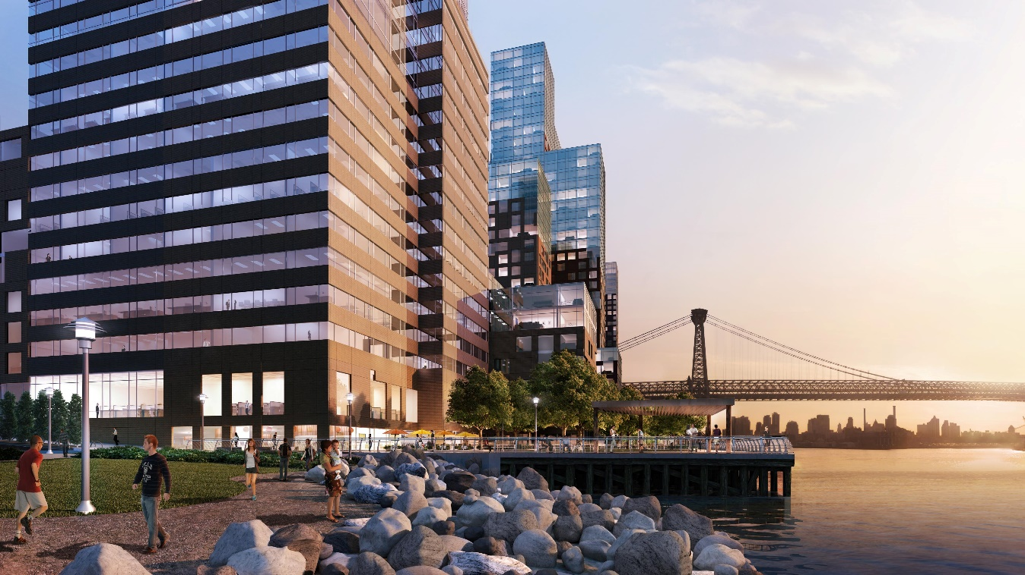
By: Nancy Huang Dec. 10, 2015
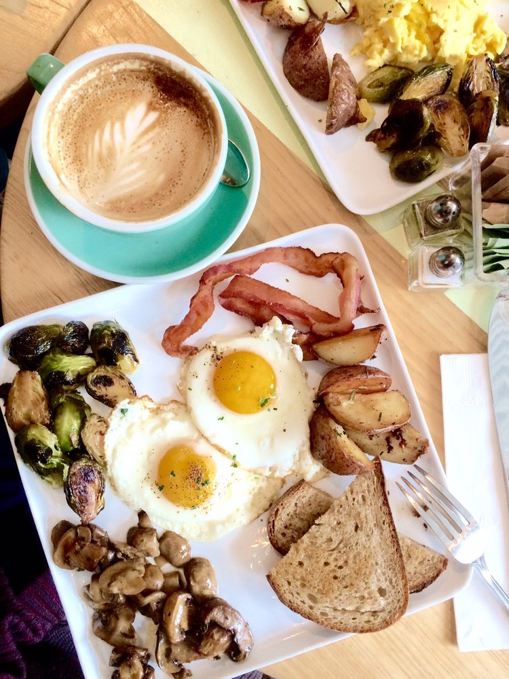
Photo Credit: citylandnyc.org
Have you ever been to New York City before? If you are interesting to visit New York City, the first place you should go is the Brooklyn Waterfront. It have a lot of exercises, parks, bridges, and restaurants between the Brooklyn Waterfront.

Photo Credit: Carson L. (Yelp)
- Re.union Friday 9:00am
A beautiful morning should be start with a perfect breakfast. When people wake up from the beautiful morning, they can go to re.union with a delicious breakfast. Re.union is located at Union Avenue, it’s between Withers St and 10th St. Re.union is like people’s home because of its soft bright lights, warm ambience, a hand-scrawled chalk art and menus. Re.union use lot of eggs to be their food’s material. The most famous menus are Shakshooka and Avocado Toast. It only cost $12 to $13 for the menus. It is a perfect way to make people be more health because people should be eat some protein in the morning.

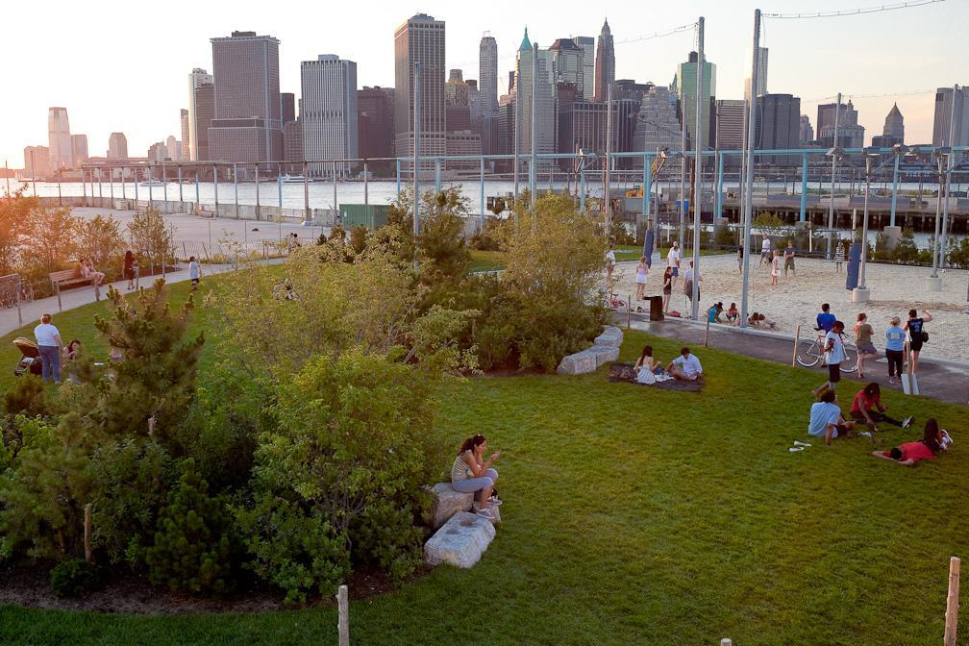
Photo Credit: Etienne Frossard
- Brooklyn Bridge Park 11:00am
After people finish eating their breakfast, they can walk to the Brooklyn Bridge Park. People can choose to sit on the chair or lying on the grass. People also can enjoy the time with their parents, friends or their own time. It is free to all visitors and people can come what time they want.
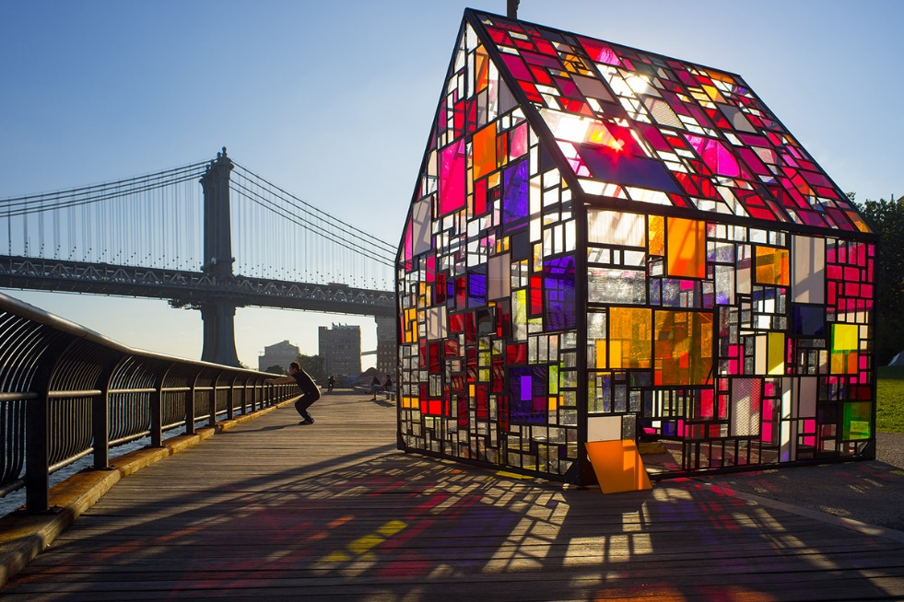
Photo Credit: Tom Fruin
- Tom Fruin Artist Talk 1:00pm
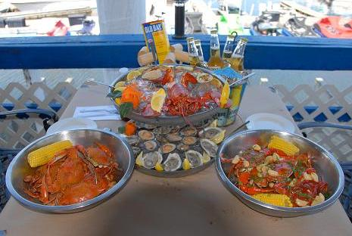
Do you want to live inside of this house? Artist had pieced together the multicoloured glasses into a wonderful house. It seem amazing when the sunshine reflect into the house. People should get there at least once because they might get surprise how beautiful it is. It is also a great time to take the selfies.
Photo Credit: clementescrabhouse.com
- Clemente’s Maryland Crabhouse 3:00pm
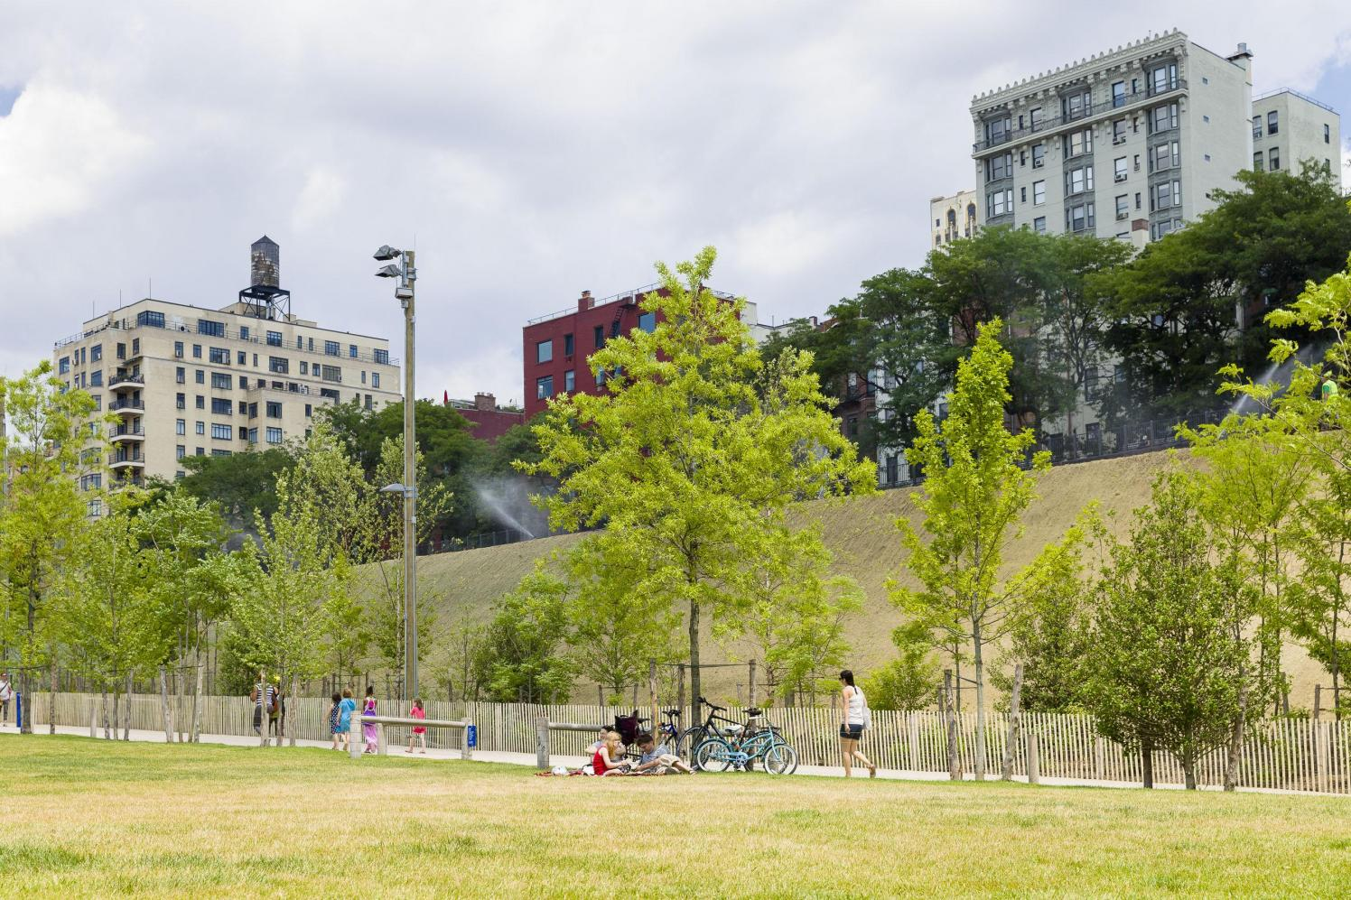
Do you like to eat oyster? In Clemente’s Maryland Crabhouse, people can found out the most fresh oyster, lobster, and crab in Brooklyn Waterfront. People who love seafood probably also love this restaurant. Clemente’s Maryland Crabhouse has lot of seats for guests. Guests can enjoy the fresh air and beautiful scenery of the sea.
Photo Credit: Etienne Frossard (brooklynbridgepark.org)
- Pier 3 Greenway Terrance 5:00pm
The Brooklyn Bridge Park’s Pier 3 is located at Atlantic Avenue to Jay Street. People has lots of space to let people do inside the park such as running, biking, sitting, relaxing, sleeping, etc. In Pier 3 Greenway Terrance, people sit on the glass. Most of the glass will be clean and fresh.
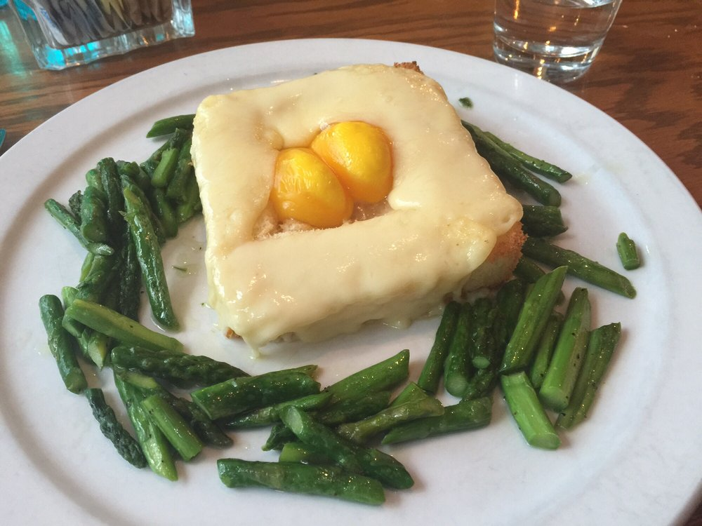
Photo Credit: AlMar Caf
- AlMar Saturday 9:00am
Have you ever eat the egg toast before? People probably are not familiar with the egg toast. It tasted delicious and interesting to eating this food. AlMar Café is located between at Washington Street and Adams Street. People can use F train to get there. AlMar is like a café, a bar, or an restaurant because of its diversified menus and decorate. The prince range is between $12 to $15.
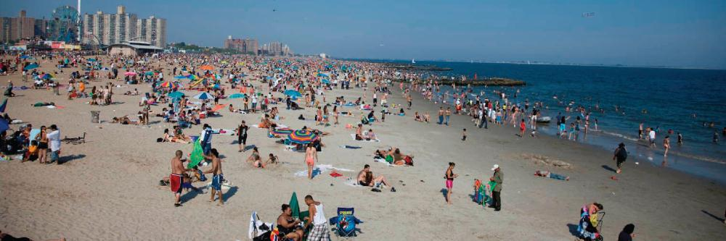
Photo Credit: coneyislandfunguide.com
- Coney Island Beach and Boardwalk 11:00pm
People probably already have a chance to visit Coney Island Beach and Boardwalk. Coney Island Beach and Boardwalk is located at Steeplechase Plaza, which the last stops of N, D, Q, and F trains. People can easy to get there and it is free to all visitors. If people can wake up before the sunrise, they can see the sunrise inside of the Coney Island Beach. It is a amazing to hearing the surf with bird tweet and watching the beautiful sunrise.
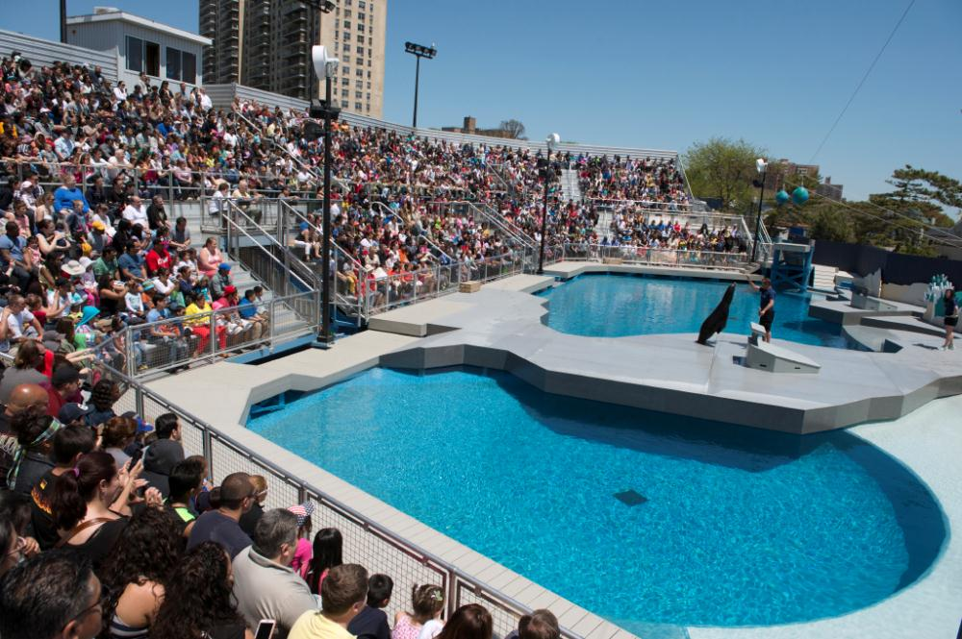
Photo Credit: coneyislandfunguide.com
- New York Aquarium 1:00pm
New York Aquarium is familiar with most of people who live in Brooklyn. New York Aquarium is located at Surf Avenue between W 8th Street which the last stops of N, F, D, and Q trains. People can look see to glovers reef, sea cliffs, sea lions, and different types of fish. The ticket of New York Aquarium is between $13 to $15. People also can buy some souvenirs in New York Aquarium Gift Shop. Although Gift Shop has sold the toys, cups, clothes, and towels but the price will little expensive than outside.
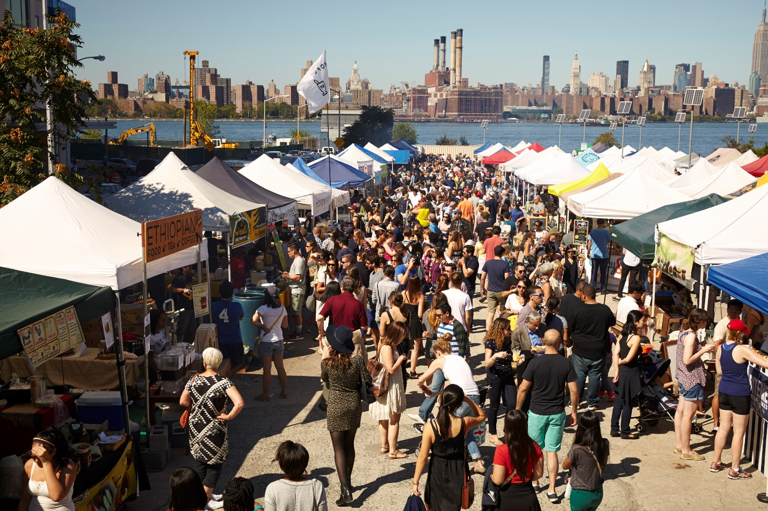
Photo Credit: Smorgasburg.org
- Williamsburg Smorgasburg 3:00pm
Do you know that the Williamsburg Smorgasburg only open in Weekend and outdoor markets will close for the season? It have some Smorgasburg are located at different areas. But the Williamsburg Smorgasburg will be the more close to Brooklyn Waterfront. Williamsburg Smorgasburg is located at Industry City, Sunset Park.
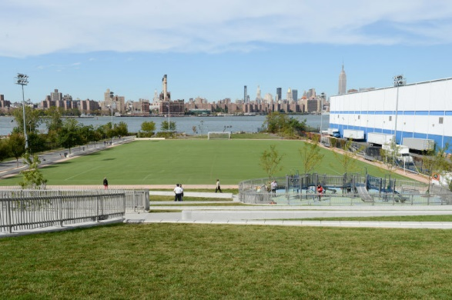
Photo Credit: nycgovparks.org
- Bushwick Inlet Park 5:00pm
Bushwick Inlet Park probably are not familiar with most of people because it is not big as Central Park and not beautiful Brooklyn Bridge Park. Bushwick Inlet Park is near to Williamsburg Smorgasburg. After people finish eating their lunch, they can walk around in Bushwick Inlet Park.

Work Cited
- Yelp (n.d) Yelp, retrieved
http://www.yelp.com/biz/re-union-brooklyn-4
- Reclaimed Southern Yellow Pine, Hector Ducci, retrieved June 29, 2010
http://www.brooklynbridgepark.org/blog/park-updates/reclaimed-southern-yellow-pine-in-bbp
- Reading the Streets: Tom Fruin’s Icon series, Iiana Novick, retrieved September 22,2015
https://www.liveauctioneers.com/news/columns-and-international/kelsey-savage/reading-the-streets-tom-fruins-icon-series/
- Beach & Boardwalk, Hudson Horizons, retrieved 2015
http://www.coneyislandfunguide.com/Attraction/Beach-and-Boardwalk.htm
- New York Aquarium, Hudson Horizons, retrieved 2015
http://www.coneyislandfunguide.com/Attraction/New-York-Aquarium.htm
- AlMar, AlMar Dumbo, retrieved 2012
http://almardumbo.com/

