36 Hours on the Brooklyn Water Front
By BaoYing(Boey) Zhang Dec. 10, 2015

This is a city can warm your heart with love; a city you can hear people say “Hi” to each other with a smile on face every morning, though they don’t really know each other.

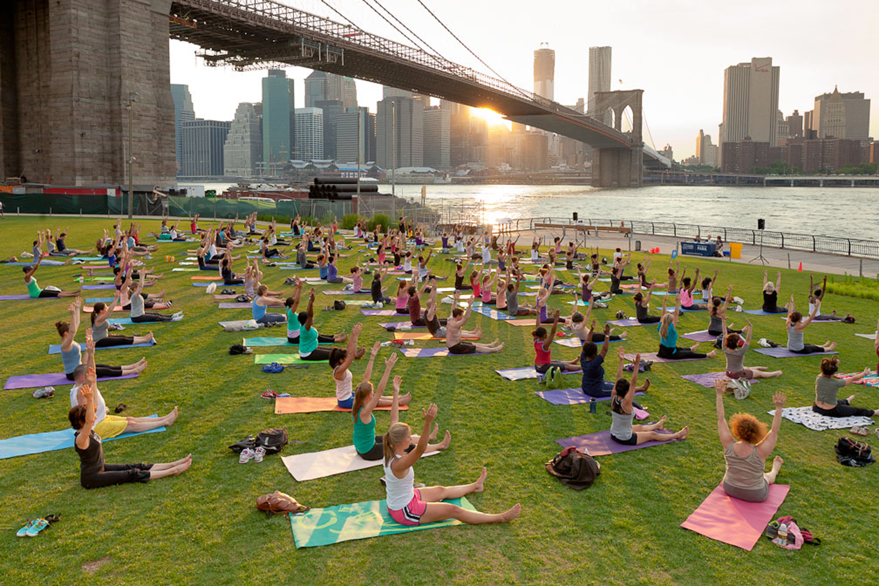
Waterfront workouts. Photo credit: Brooklyn Bridge Park

Brooklyn is finally in Travelers’ radar. Brooklyn is a combination of modern New York and old-fashion New York. This is a city with magic, it makes you knows there are many possibilities can happen in your life as long as you open your heart to actually feel it. You are going to fall in love with this city. You never know when you will meet a person who stops their work and starts talking to you; you never know what amazing story they will bring to you; you never know how the amazing and unknown world they are opening just for you. Brooklyn is a place full of art and love.

Friday

Part of the delicious Pizza from Juliana’s. Photo credit: Juliana’s pizza

P-P-P-P-IZZA 1 P.M.

You can’t leave Brooklyn without having a piece of pizza. Juliana’s Pizza is a New York-style pizzeria. (19 OLD FULTON ST, BROOKLYN, NY 11201) New York-style pizza is always hand-tossed. The website of Juliana’s pizza indicates that “Juliana’s is located in a one-story building, the area was a small but active community.” There are two different choices for the menu, one is “Dine In Menu” and the other is “Take Out Menu” A basic form of tomato sauce, with cheese and place the topping you chose for your pizza, tossed it, the pizza you want is finished.
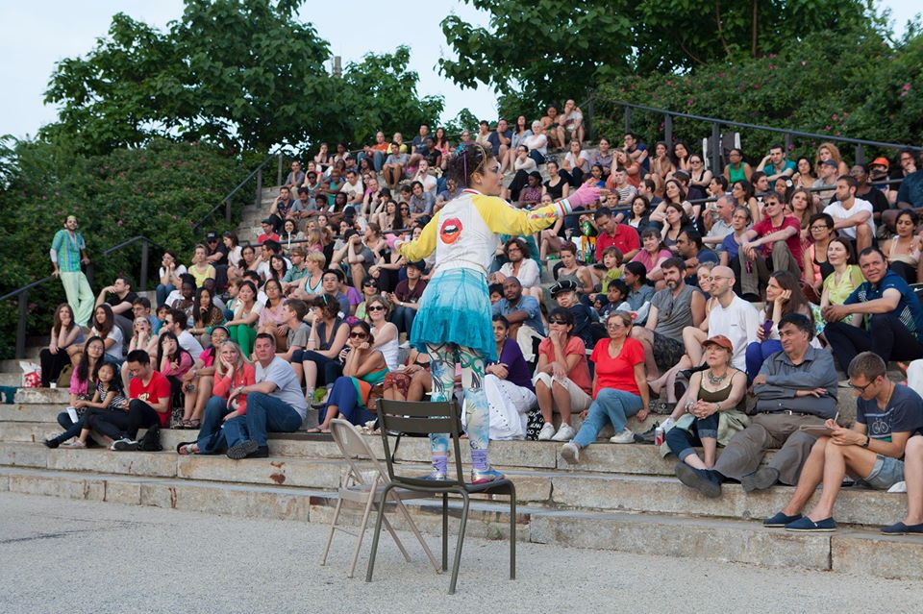
Shakespeare at Sunset. Photo credit: Alexa Hoyer

MEET CLASSIC 2 P.M.

How can you not hear about Shakespeare in Brooklyn? There is no other better place for watching a Shakespeare show than Brooklyn waterfront. “Since 2010, the Brooklyn Bridge Park Conservancy has partnered with theater groups from around NYC to bring William Shakespeare to the park.” There are lots of artists in Brooklyn, they can make you actually fall in love with William Shakespeare, people who acting the show actually bring the sense from novel to our real life. They make you having fun while you learning the classic.

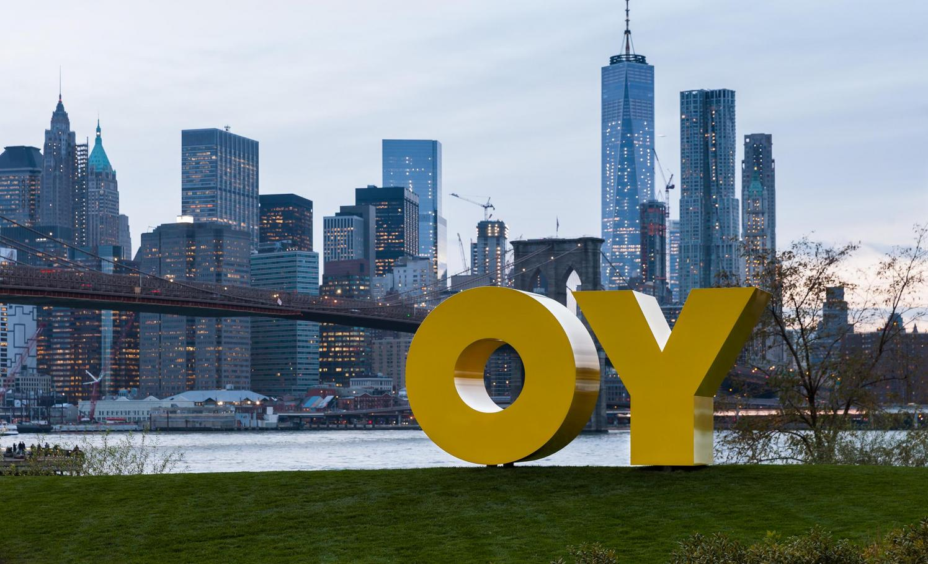
DEBORAH KASS: OY/YO. Etienne Frossard

YO 4 P.M.

There is always a random art pop up while you walking around Brooklyn. The artwork, this time, is designed by “Acclaimed artist Deborah Kass’ monumental sculpture OY/YO” It’s always a funny thing to explore by yourself to find out all the amazing sculpture around Brooklyn waterfront. A perfect place for taking a picture or sitting down to read a book and enjoying your silent moment.

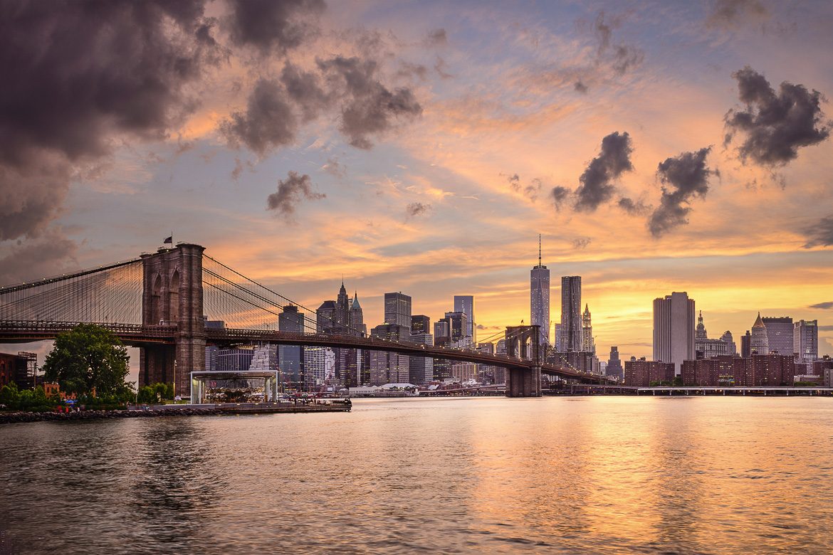
The sun sets behind Manhattan and the Brooklyn Bridge. Photo credit: New York Habitat

ROSY, FIREY, CLAM 5 P.M.

The Brooklyn Bridge is definitely a “have to go” place when you travel to Brooklyn. It is a bridge that connects the two major boroughs of Manhattan and Brooklyn. On the Brooklyn Bridge website you can learn: “Since 1883, its granite towers and steel cables have offered a safe and scenic passage to millions of commuters and tourists, trains and bicycles, pushcarts and cars.” The view from Brooklyn Bridge is always amazing, but the sunset is the most stunning view. It’s absolutely relaxing when you lean on one side of the bridge with your friends or family and just watching the sun sets down.

Saturday

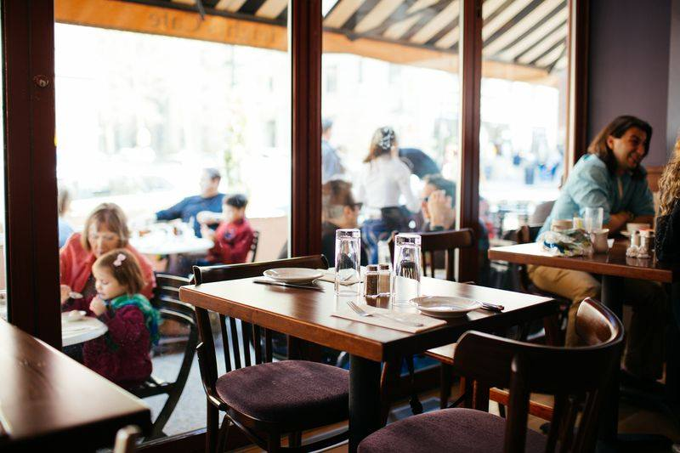
Brunch at Heights Café. Photo credit: Heights Cafe

A MORNING ALARM 11 A.M. (Heights Café)

Wake up for food is definitely a good choice. Always the early bird gets the worm. What better place to have your first meal than a place with nice atmosphere and delicious food. Enjoy your egg-based brunch with a cup of coffee, have a conversation with you friends or family, look outside for all the old-fashioned building. Your day should start with cozy mood.

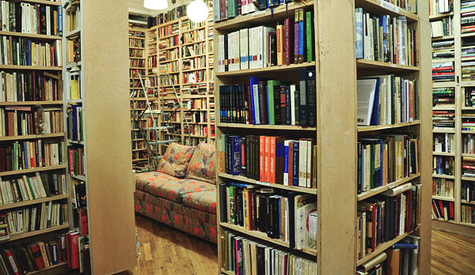
Inside of Bookstore. Photo credit: P.S. Bookstore

SWIM IN THE BOOKS 1P.M. (P.S. Bookshop)

You should never miss a bookstore while you traveling. A bookstore can represent the culture of the city. “A used bookshop, by definition, is conservative. It can mock right wing public figures, boast a unique selection of books on avant-garde art, punk music and recreational drugs. These values can be either of historical import or simply anachronistic.” There is nothing can compare to find an amazing value book to read. Every used book tells a story. Come to P.S. Bookshop if you want to know the stories of the books

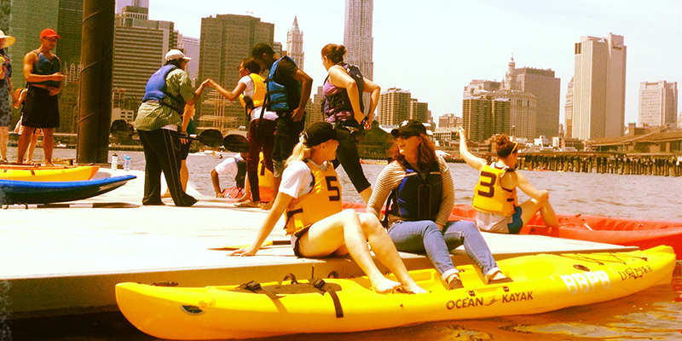
People waiting for the Kayak. Photo credit: The Brooklyn Bridge Park Bathhouse

GET ON THE WATER 2 P.M (Kayaking)

Brooklyn is a city built on islands, and people live in Brooklyn understand and appreciate the water that surrounds them. This Kayaking program is free for everyone. As Tom Potter, who hosted lessons for kids about kayak describes, “Nothing brings a person closer to the water than paddling a kayak.” We can’t live without water, we can have a lot of fun with water! Kayak is a sport have all kinds of fun, it’s not only let you have fun, but also a sport helps you being healthy.

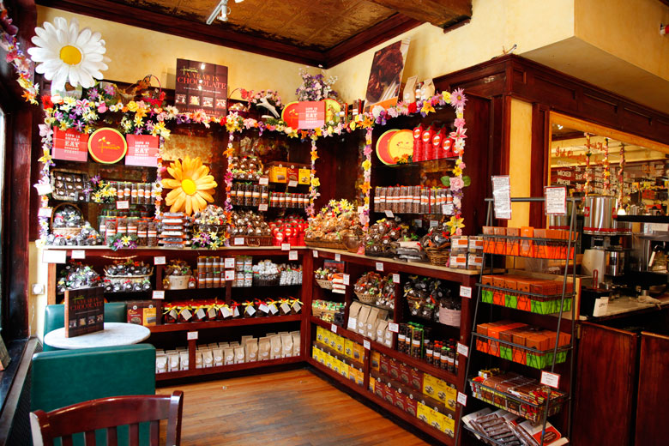
Inside of Jacques Torres. Photo credit: Jacques Torres Chocolate

SWEET YOUR DAY 3 P.M (Jacques Torres)

Chocolate is all seasons favorite. Jacques Torres is a must-go place for the chocolate lover. Just the moment you open the door, the chocolate air is around you immediately. “Jacques Torres Chocolate is committed to creating fresh, authentic and handmade artisan chocolates for all to experience and enjoy. We utilize only all-natural ingredients of the highest quality so our food not only tastes better – it is better for you.” You are going to love this place though you don’t like chocolate, or you may start loving chocolate after you visit the place.

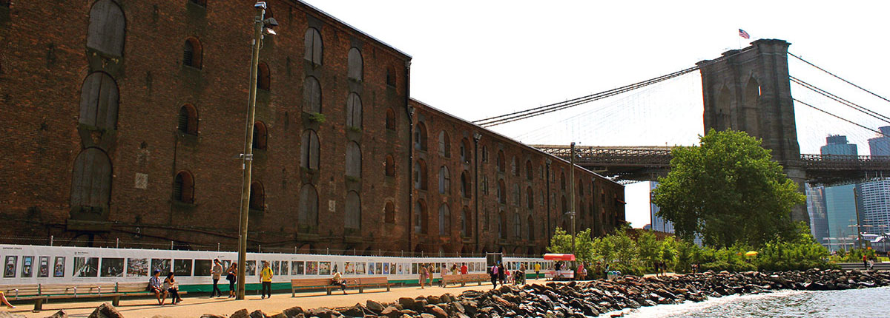
THE FENCE – Brooklyn (2013). Photo credit: The fence

WALK WITH ART 4P.M. (The Fence)

THE FENCE is an annual, summer-long, outdoor photographic exhibition inaugurated in Brooklyn Bridge Park. New Yorkers are always proud of their artworks, no matter it’s the scrawl on the wall or the art collection held in fancy place. Art shows the sense of New Yorkers and the culture of United States, artists use their way to show America in their eyes. It’s a really good way to learn culture from the eyes of artists.

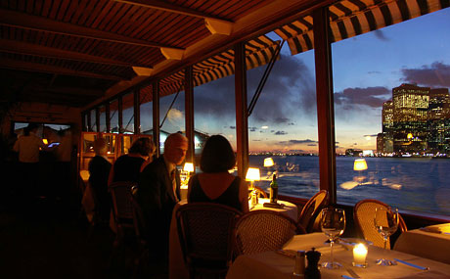
The River Café. Photo credit: Adam Leach

DINNER WITH A VIEW 6P.M. (The River Café)

Flowers around you; A piano player is intoxicated with his music; a reflection of Brooklyn bridge show on the glass of wine; a breathtaking view show to you right next to your window. The River Café is a romantic restaurant perfect for a date with no doubt. The price (Three-course $115 fixed-price dinner) is expensive but it definitely worthwhile. People should treat themselves good. This is a perfect place to end your day in Brooklyn.
Lodging

Every traveler wants a comfortable, “feels like home”, place to stay after they finish a long day walk on the Brooklyn waterfront. Boutique hotel Hotel Le Bleu (370 4th Ave, Brooklyn; www.hotellebleu.com; from $159) has excellent customer services, and “simple elegance” guestrooms can fulfill your dream without paying over your budget. It’s only three miles walking distance from Brooklyn Bridge, with very convenience transportation. The room features and amenities include almost every thing you expect in a hotel.

If you are looking for a hotel to be kind of fancy, so that you can take good care of your business; or dating a person who means a lot to you, and you want to choose a hotel that can let you and your soul mate have no regret, then Marriott at the Brooklyn Bridge (333 Adams Street Brooklyn; www.marriott.com; from $299) is a very good choice. They have the full-service spa to let you have a comfortable mood to end your day, a fitness center for the person who likes to work out everywhere, a pool to enjoy the beauty of water and an awesome meeting event space to make this hotel a perfect place for every event.

Reference

“About Us.” Juliana’s Pizza. www.julianaspizza.com

“About Us.” Heights café. www.heightscafeny.com

Beth Schermer and Tom Pottor. Brooklyn Bridge Park Conservancy. www.brooklynbridgepark.org. Mar 5, 2013.

“About.” The Fence. fence.photoville.com

YO/OY. www.brooklynbridgepark.com

P.S. Bookshop. psbookshopnyc.com

Pete Wells. “An Old Flame Reignited.” New York Times. May 20, 2014. www.nytimes.com

