Brooklyn has many hidden secrets. The waterfront isn’t one of them. Places along the waterfront have beautiful views and or even scenery better enjoy them while you can. I’m here to help you do just that.

- Friday 5pm
Welcome to Brooklyn. At this time you have just arrived to your home for the next 3 days. Welcome to the Sheraton Hotel. The staff is lovely. Glad to assist you with everything.
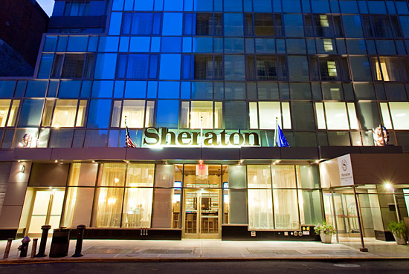

2. 8pm:Dinner
Where better to eat dinner than at Waterfront Ale House. Just steps away from Brooklyn Bridge Park it’s the ideal place for dinner. The Pub has an extensive menu for beers and wines, to pair with your entrees.

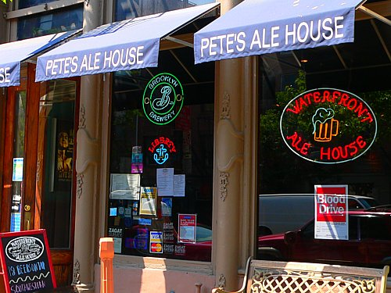

3. Saturday: 10am Breakfast
Say goodmorning to buttery goodness. Just a short walk away from the hotel awaits breakfast. Buttermilk Channel right. Aside from what might be a long wait it’s all worth it. The end justifies the means. I would suggest having their Fried Pork Chop and Cheddar Waffles. It runs for 16 dollars. But it will be the best 16 dollars you have ever spent.
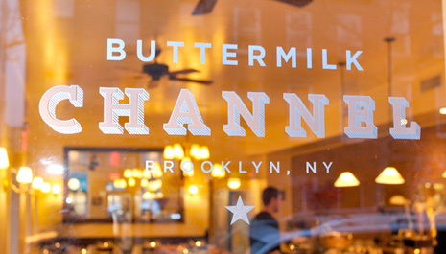

4. 12pm: History
Time to be fascinated. 12pm on Saturday this is a must. Visit the Plymouth Church of Pilgrims. Why,you may ask. Simple this church holds a piece of Plymouth Rock. No Brooklyn isn’t the first place to come to mind when you think of settlers but it will be now.
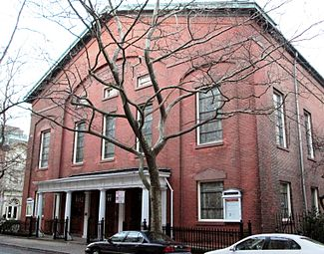

5. 1pm: Lunch

Is it time for lunch already? I know just the place Grimaldi’s. The ambiance of the restaurant is casual but still finds a way to be pretty amazing. The ingredients taste fresh. The pizza is authentic. The recipe they use was made by their founder and has not failed them yet. Suggestion here hit the ATM before arriving. The line can get a little crazy. Individual slices aren’t sold here. But you can get personal sized pie.
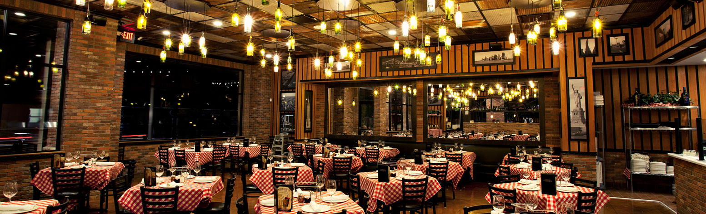

6. 3pm: Red hook Boaters
That whole rule on wait 10 mins after eating before going into the water forget about it. Time to break some rules. The Red Hook Boaters host Kayaking sessions on the harbor. This give opportunity to see stunning views. Perfect for taking selfies. Just don’t drop your electronic in the water.
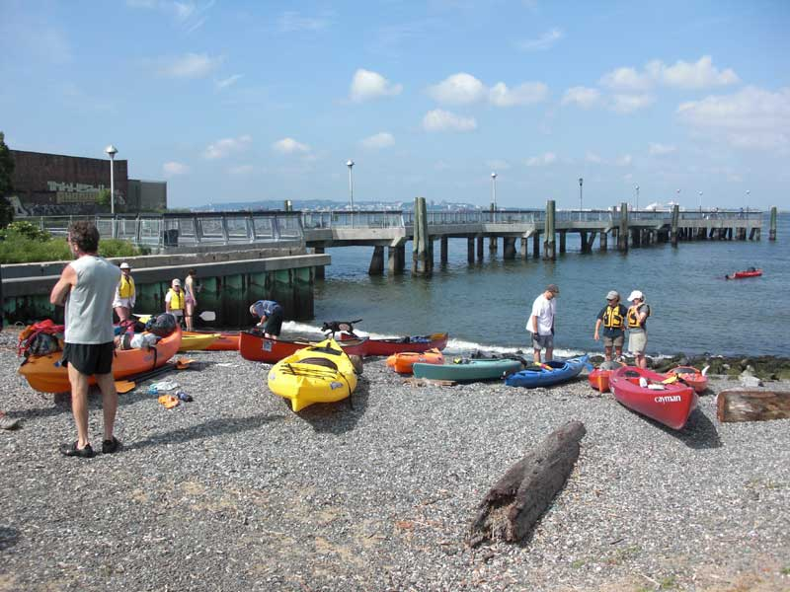
7. 7:30pm Dinner: The Good Fork
This restaurant is where upscale restaurant meets reasonable pricing. The menu is full Asian inspired with a twist of European. The average cost for a main course is $17. Enjoy
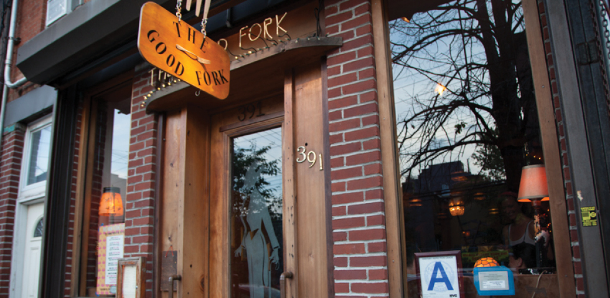

8. Sunday 12pm:
Enjoy brunch at a the River Cafe. Environment is subtle but beautiful. You will also receive a beautiful view of the Manhattan skyline. Also you’ll get a good luck at the Brooklyn Bridge.
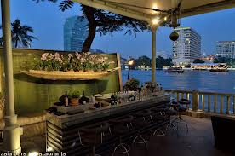
9. 2:30pm Green-Wood-Cemetery
I love this place because the gothic architecture. I find it to be quite amazing and suggest it gets a visit from you. Also on the property is Battle Hill which is free to climb on if you wish.
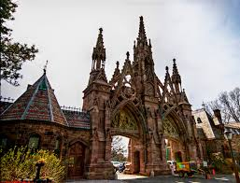
10. 4:00pm Brooklyn Promenade
I’ve visited here so many times it’s unbelieveable. Just sit and enjoy the view. You will find something new with every visit. Sitting just above the BQE brings balance of what you expect of New York, with what you’ll find on the countryside. It gives a gorgeous view of the manhattan skyline. It’s even better when caught at sunset.
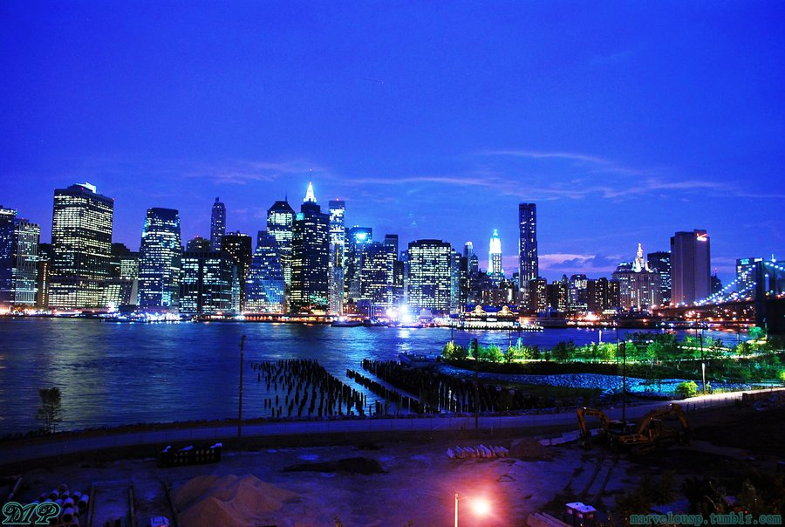
11. 6pm Brooklyn Bridge Park
With the parks large lawn. It is the ideal place to catch the sunset. While laying on the grass smelling that earthy smell with an amazing view. It’s nothing less than relaxing.
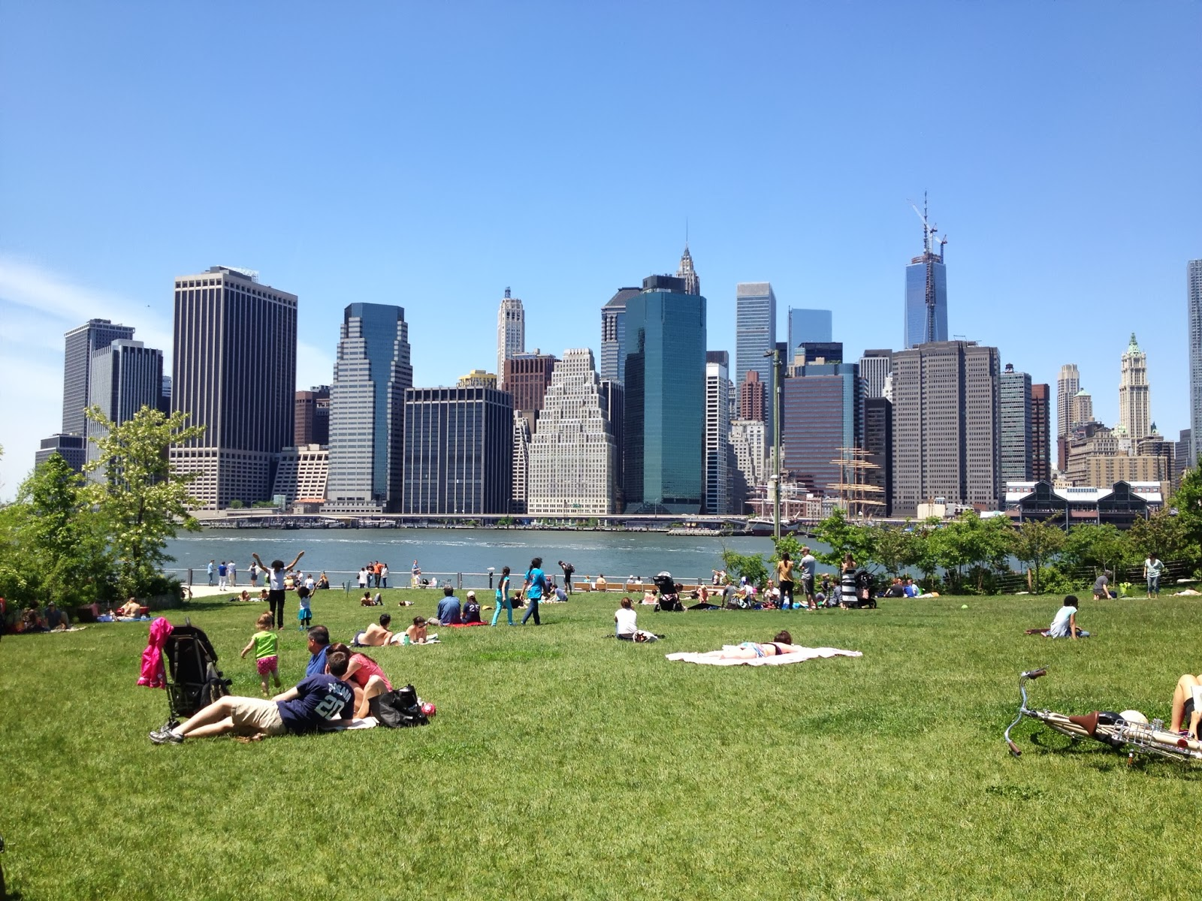
12. 8pm Dinner: Hometown Bar-b-que
Wanna get down and gritty with the food this is the place to go. The waiters will pour your beer and whiskey only thing you need to worry about is that one pound brisket coming your way. The environment is just fun. A great way to end your visit to the Brooklyn Waterfront.
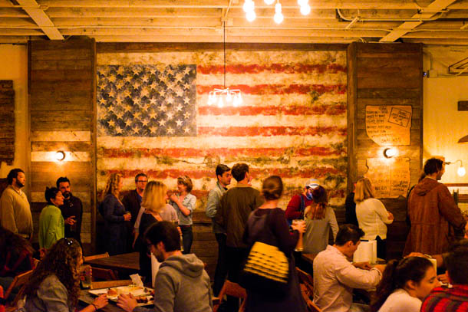

No copyright intended. All photos for this presentation were taken from google.com

