HMGT 1101 Jeffrey Grannum Jr.
36 Hours December 16th, 2014
36 Hours in Brooklyn, New York

You’ve picked a marvelous time to visit one of the world’s most amazing cities. During the summer months the city erupts with events that showcase Brooklyn as being the one of the unique melting pots for food, culture, and entertainment in the world. From nature to history to sports this city is sure to captivate any audience.

Your Accommodations- 6 P.M.
Set your bags down and take a load off at one of Brooklyn’s premiere hotel destinations. Centrally located in Brooklyn Heights the Brooklyn Bridge Marriot combines the Mariotts’ historic class, and high standard of customer service with convenient access to the cities greatest attractions. This 4 star hotel dons a full bar and dining room, a spa, a fitness center, and pool. The rooms themselves besides providing superb comfort also exhibit some of the city’s most iconic views.
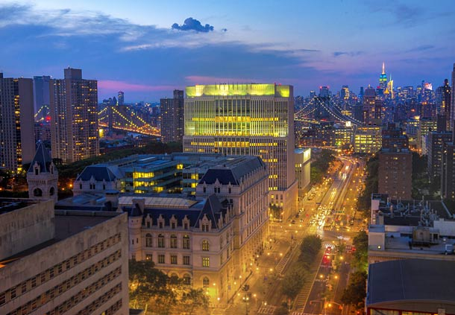

The Past Meets The Present- 10 A.M.
Your stay begins as you toe the line of past and present with a trip to the historic Brooklyn Waterfront. Just a short walk from your hotel, the newly renovated Brooklyn Bridge Park offers a wide selection of sites and activities. Once a central port for ships exchanging goods the pier has now been transformed into a beautiful park that over looks downtown Manhattan. Numerous grassy fields and lush plant life provide a truly beautiful landscape. Capture it all while you jog, bike or just lay out in one of Brooklyn’s newer treasures.

Good Eats!- 2 P.M.
By now I’m sure you’ve worked up quite the appetite, how does a Brazino crusted with shrimp and chorizo, grilled baby zucchini and a romesco sauce sound? Just outside the park lies one of Brooklyn’s most prestigious and iconic restaurants, The River Café. Opening its doors in 1977 this Michelin star restaurant has best known for its fusions of modern and classical American cuisines.

A Scoop Of Romance- 8 P.M.
You can end your evening with some homemade ice cream from Brooklyn Ice Cream Factory while you enjoy a romantic evening on the Brooklyn Promenade. Specializing in in-house made small batch ice creams flavors such as Vanilla Chocolate Chunk, and Peaches and Cream have made the Brooklyn ice cream factory a fan favorite while the Promenade boast what I believe are the most amazing Manhattan skyline views in all of Brooklyn.
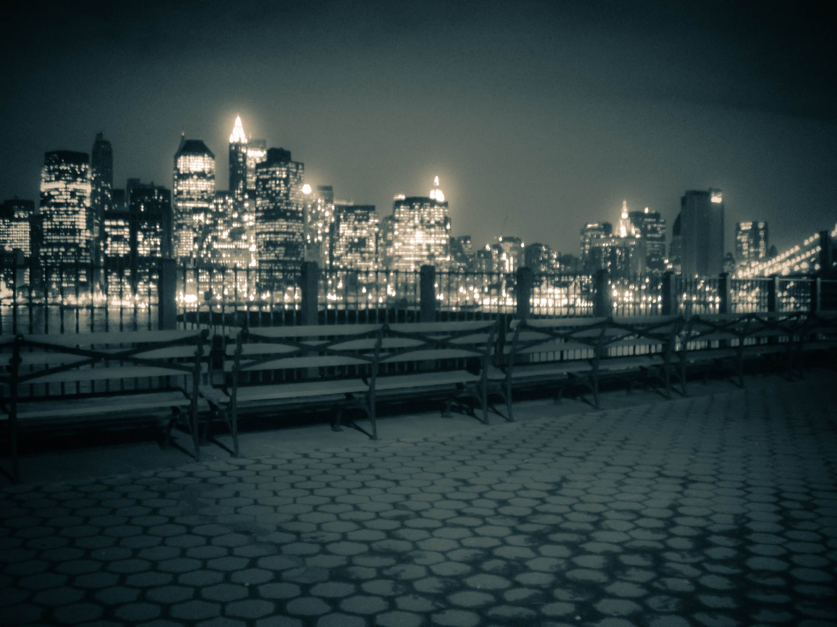

Island Flavor- 11 A.M.
Today we venture inland as you’ve chosen just the right time to visit. Today, the first Monday of September is the Caribbean West Indian Day Parade. This is Brooklyn’s largest annual parade and an incredible showcase of some of the pride, culture, and diversity that is the foundation for this great city. There are colorful floats, unique cuisines, and vibrant music as you dance your afternoon away. The parade is a full day’s adventure so make sure you bring your camera, your appetite, and some good walking shoes!

An Artistic View- 12 P.M.
On our last day we’ll take a more serene vantage point of Brooklyn. Just a brief train ride away, located in the Prospect Heights section of Brooklyn we find the Brooklyn Museum. The museum exhibits a diverse selection of styles and pieces including Egyptian exhibits, and European paintings as well as contemporary art. The museum also houses pieces by several-famed artist including Georgia O’Keeffe, Norman Rockwell, and Edward Hopper.

Brooklyn On The Green- 4 P.M.
About a 10 min walk away we arrive at one of Brooklyn’s often forgotten treasures, Prospect Park. Designed by renown designers Frederick Law Olmsted and Calvert Vaux this 585 acre public park makes for a beautiful addition to any Brooklyn visit. Though there are some subtle modern influences and renovations to the park, there remains something magical about seeing nature in such a pristine state in the heart of the concrete jungle. From the ponds to the vast fields to the wildlife the park offers something for everyone to enjoy.

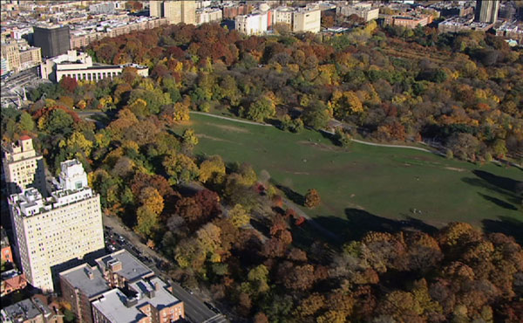
All Images Via
Google.com
FineArtsAmerica.com
Panarameo.com

