Phone Review: iPhone 8 Plus (Apple’s Perspective)
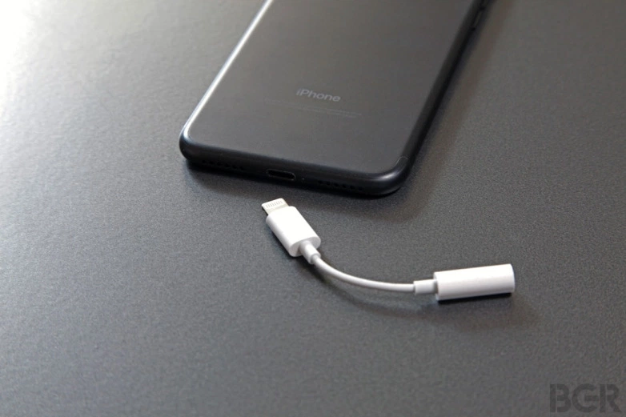
With the iPhone 8 Plus, we have removed the conventional headphone jack and added the new apple headphone jack. This will allow us to rip you off and force you to buy this adapter if you want to use regular headphones.
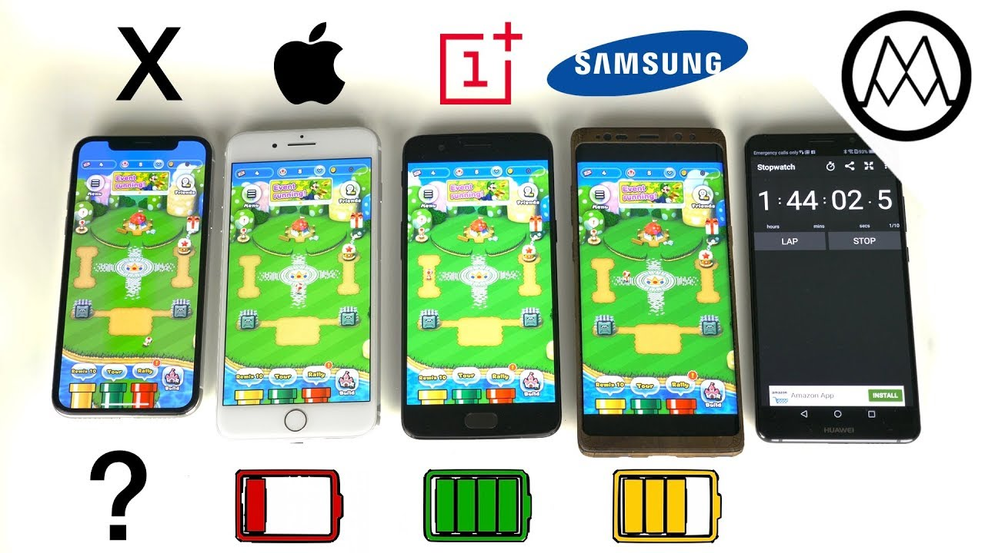
Compared to other popular phones, the Apple iPhone 8 Plus battery life is terrible. If you need a battery replacement, we can provide you with one for $50 knowing that the reason your battery is dying is because we have terrible batteries.
Now that you know how “amazing” our phone is, come to your nearest carriers’ or apple store and we can provide you with one for just the low price of $799! Just so you know, the front and back of our phone is covered with glass so if you break it and want another one, you can just buy another for $799.

