Stenyah Pierre-louis
ENG 1121 D421
Professor Gold
1 May 2019

Genre Assignment
Genre: Lament poems
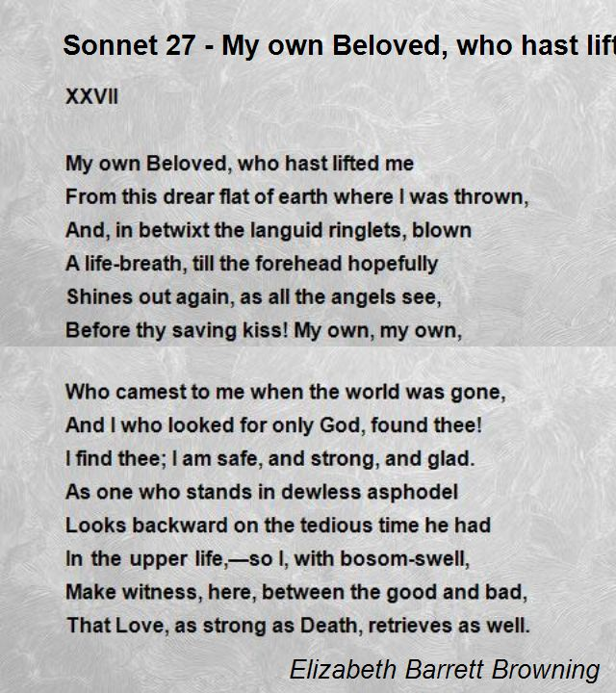
Step 1:
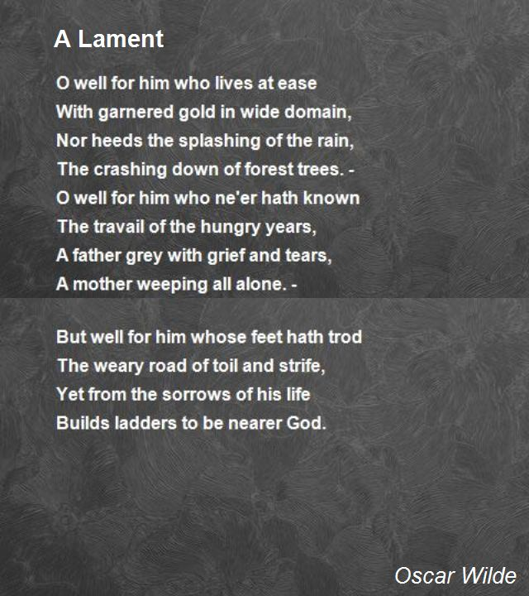

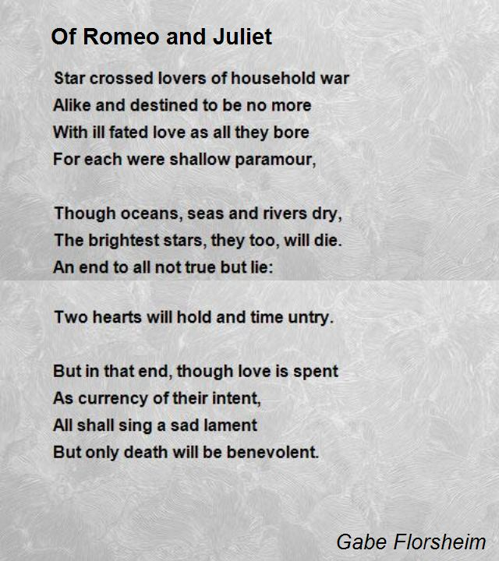
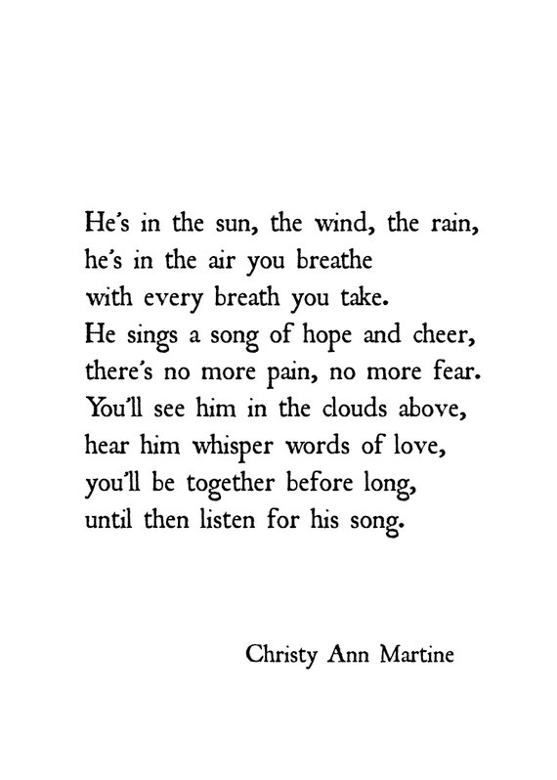
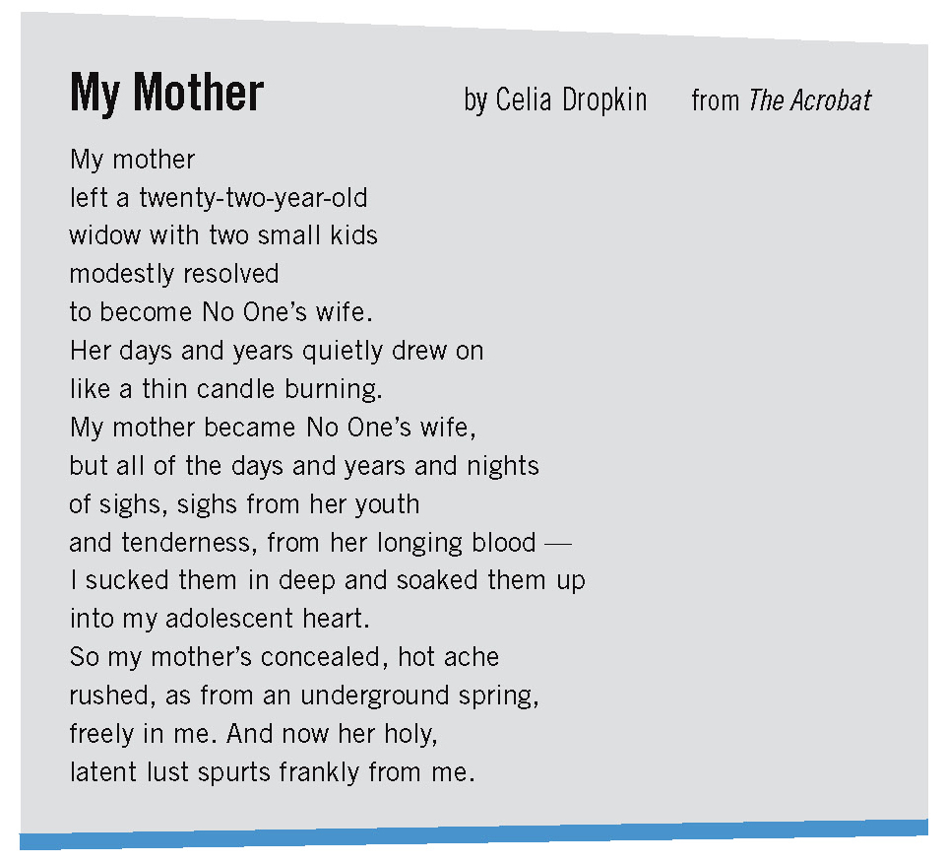

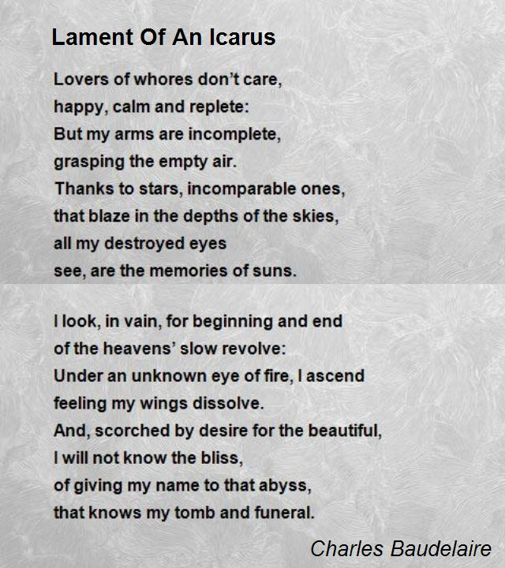

Step 2:
- This genre is important in our society and in our live because it allows people to mourn in a way where you can express how much you cherished the person you lost.
- Some well-known people who have written Lament poems are Charles Baudelaire, Robert Seymour Bridges, Percy Bysshe Shelley, Sir Walter Scott, William Wordsworth, John Milton, Charles Beaumont and Oscar Wilde.
- The discourse community that is usually connected to this genre is a type of personal poetry created typically by adults above the age of 20 because they usually experience more loss than those of a younger age.
- Lament derived from the ancient Sumer which is known to be the world’s first urban civilization. This genre is usually performed by women in both early and modern traditions and it can be seen as an appeal for divine in help and distress in some Psalms.
- There is no particular audience to whom this genre is typically directed because those who are mourning can connect to lament poems but also people who has yet to experience any kind of loss can as well.
- The forms of this genre can be produced in writing such as elegies, dirges, and requiems.
- There are people who are most important to have produced in this genre such as Robert Bridges, Charles Beaumount and Pablo Neruda. Their work is significant because it allows people to connect to real genuine feelings of loving someone dearly and loosing them to a point where you feel abandoned.
- People have responded to this genre by writing journal entries and personal essays about how they feel about the loss, and it gives them a way to mourn with a peace of mind.

Step 3:
- The main message of these samples is that losing someone you truly love or even loosing yourself might be difficult and fearful, but the memories in which you had would never die. “So my mother’s concealed, hot ache rushed, as from an underground spring, freely in me. And now her holy, latent lust spurts frankly from me.” (Dropkin, lines 14-17) These lines from Celia Dropkin’s My Mother poem shows how her mother being a widow also affected her given the fact that she was left to be a single mother. Dropkin also emphasizes how she see’s herself in her mother.
- They all have a somewhat similar message that losing someone can take a toll on someone as they mourn.
- I would say the constraints that are associated with each example is not being able to share the great experiences and memories each person had before losing them.
- The audience in which these examples are directed it to a person’s mother, a child, friend, and yourself cause at times people even loose themselves.
- The significant difference I would say about my examples are the tone. In Charles Baudelaire’s poem Lament Of An Icarus, his tone starts off very harsh then it calms down to a very soft tone. “Lovers of whores don’t care, happy, calm and replete: But my arms are incomplete, grasping the empty air.” While Christy Ann Martine’s poem throughout has a soft and beautiful tone about someone you lost who’s spirit still stays with you when you need comfort. “He’s in the sun, the wind, the rain, he’s in the air you breathe with every breath you take.”
Step 4:
- The author of this sample is Christy Ann Martine
- The message I get from this sample is that the person in which we lost spirit will surround us whenever and wherever when you need comfort.
- In this particular sample, I think the audience is her son.
- The constraints I would say for this sample is that the author isn’t able to really explain the fear and pain they went through before realizing that they would be together again someday.
- The sample is important to me because when I lost my aunt, I left so much pain but also anger because I didn’t get t see her much before she passed. Seeing my mom and other aunts grieving made me sad as well. This is important to society and other discource communities because it shows how you can get over from mourning the person you lost, know that you now have a guardian angel and will feel their spirit to comfort you when you need them.
- The concept that I find most important in this example text is that it’s not like most lament poems. It doesn’t really have a tone where its dark and gloomy. The sample rather has a warm tone and acknowledges that the person is gone but still sensing their spirit.
- The thing I find most significant about this text is that it is very relatable. Any person reading the poem can actually imagine their loved one “in the clouds above” and “whispering words of love”. It has a strong sense of imagery and I find that very significant that you can allow the reader to connect in that way.

Step 5:
Tatie
A heart that was once filled with love and joy
is now stone cold.
Without you we all feel incomplete,
everyone has drifted off
and parted their own way.
Oh, how I miss the times when we all gathered together
For Sunday dinner or a random occasion
to laugh and enjoy one another.

I will forever remember that broken smile you had upon your face,
Even if you stressed about not having enough money
You always made sure you helped anyone before yourself.
I wish I was more thankful for you,
For the littlest things like making sure I ate,
Completed my homework and had clothes on my back.
Everything you did that made you feel like another mother to me.

Without you I no longer see the meaning of living
in such a blinded world.
When you took your last breath
and told us your pain was no more
we knew we couldn’t keep you any longer.
My Tatie, my love
The world would never be the same without you
The memories we treasure together will forever be embroidered in my soul.
Works Cited:
https://www.britannica.com/art/lament-poetry
https://quillsliteracy.org/sonnet-27-my-own-beloved-who-hast-lifted-me-by-elizabeth-barrett-browning-1338/
https://dailypoetry.me/oscar-wilde/a-lament/
https://womensvoicesforchange.org/poetry-sunday-celia-dropkins-adam-and-my-mother.htm
Beaumont, Charles. (2010). Elegy
James Cowan. (1930). Dirges, Laments. — (Tangi, Apakura) - The Maori: Yesterday and To-day. Whitcombe and Tombs Limited, 1930, Christchurch.

