Michael Pamesa
Eng 1121 Prof. L. Gold
5/1/19
Discourse Community / Genre Assignment
Step 2
I believe that Java Source Code programming can count as a literature. Java, an object oriented language was created in 1991 by James Gosling and his fellow partners. They had based the structure of it to be similar to another coding language called C and C++ because it too was an object oriented language. The goals for Java were simple, to make it easier to use than C or C++, to be able to make it readable on any device and finally to be easy to use. Over the years, the type of people who are able to use and understand Java have been increasing. People such as the Java developers to even the people who want to learn how to use Java for the first time can understand it. As the programming language was getting more and more developed such as Markus Persson and Adobe Inc, have become very influential and caused a widespread use of Java.
Java: Object Oriented programming language does have some rules when reading the source code. It is usually read just from the top to bottom and from left to right. Due to it being a coding language, then there are also specific words that need to be understood such as “import”,”system.out.print”,”Scanner”, “Data Types”, and “Methods”. When people read the Java source code they would tend to read the entirety then have to reread it to make sure it makes sense and that there would be no errors for the program to work. It is similar to how an editor proof reads a book for errors.

Step 3
Throughout the many different Java Source Code, the difference source codes can have different purposes but all have the same structure. The Java source code is written based on the functions it is supposed to do. Even though the struce for written Java Source code are all the same, there many ways to write. For there are many ways to write Java source code, there are also different preferences on how the Java Source Code is written. It is like how someone can state a wall to be red while someone else can describe the wall as reddish Orange. Even though both are completing the function of describing the Wall, both statements are written differently just like how different writers for Java code can type up their codes differently. Another style difference that some creators have would be when some leave Comments, which are notes that the creator can leave behind so that if someone else were to read the Source Code then they can understand what the creator was writing.
When writing Java Source Code there is some common language that can be found in the different examples of Java Source Code. In most of the examples of Java Source Code, each case of can have a variable and usually have a way to ask a question as well as receive information. Due to there being a normal structure for Java there are some constraints that appear when writing Java Source Code. Some constraints when writing it would be that the Java System is very logical and would require there to be no mistakes when writing it. An example of such would in “Naming Variables Example” you can see that there is an error in the program due to the different naming of the variables “TaxAmount” and “Taxamount”. The reason why this is a constraint is that due to the difference in the names, Java would see it as two different variables leading to an error in the function of the program. Another type of constraint is that at the very end of every complete statement requires a semicolon or else there would be an error.

Step 4
The creator of the Java Source Code is Markus Persson and his developer team for the game Minecraft which released on 2009. The image of the Java source code is very important because it is the base foundation for the game. If the source code does not work properly then it would lead to there being problems within the game. The importance of the Java source code is very important for many people, such as future / current creators in Java, people who are interested in Java, and even people who want to make modifications to the java program. In the Minecraft java source code on line 20, there is a line that says “private LoginForm loginForm;” is very significant because this is the beginning part of the launcher that asks the user for the login information such as their Username and password. Without the word “private” at the very beginning of the line would lead to the program changing it to allow the user or even other people who use the computer can go and find the information can be viewed publicly. Even this sample of Minecraft java source code has some constraints, such as all of the different statements of “import ..” from lines 6 through 14. WIthout those “imports” then there would be parts of the program that would not work to its desired purpose. If it does not work to its desired purpose then the it would lead to parts of the game not working and finally end up with an unfinished product.
In conclusion Java Source Code should count as a genre due to people being able both read and write it up. Instead of there being stories and books about java source code, there are programs and tutorial books about Java. The type of people reading and writing it have their own discourse community in which they can talk about and help each other when it comes to writing Java programs. Without Java and the people who are constantly creating different applications that utilize Java and those who are trying to improve
Sources:
Gaddis T. (2015)Starting Out with Java: From Control Structures through Objects
6th(Pearson ©2015).
Olsson, M. (2013). Java quick syntax reference (Expert's voice in Java).

https://link-springer-com.citytech.ezproxy.cuny.edu/book/10.1007%2F978-1-4302-4693-0
https://www.freejavaguide.com/history.html

Step 1 Java Source Code Samples.

Adobe Java Source Code Example
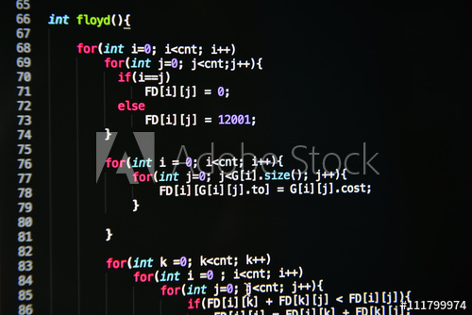

Simple Java Source Examples
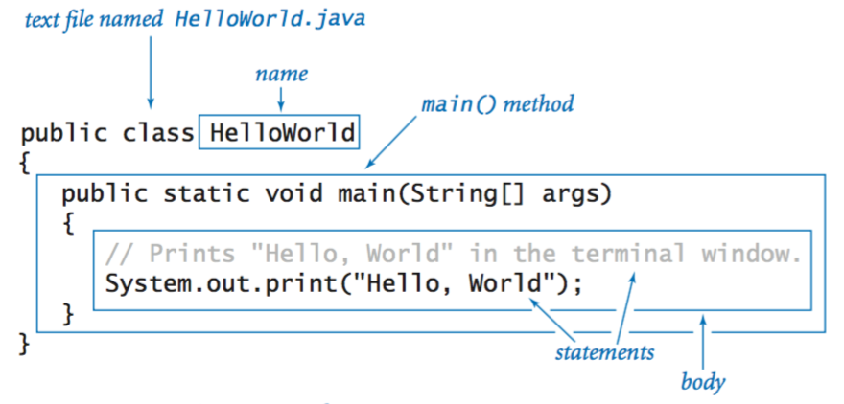

Minecraft Launcher Java Source Code
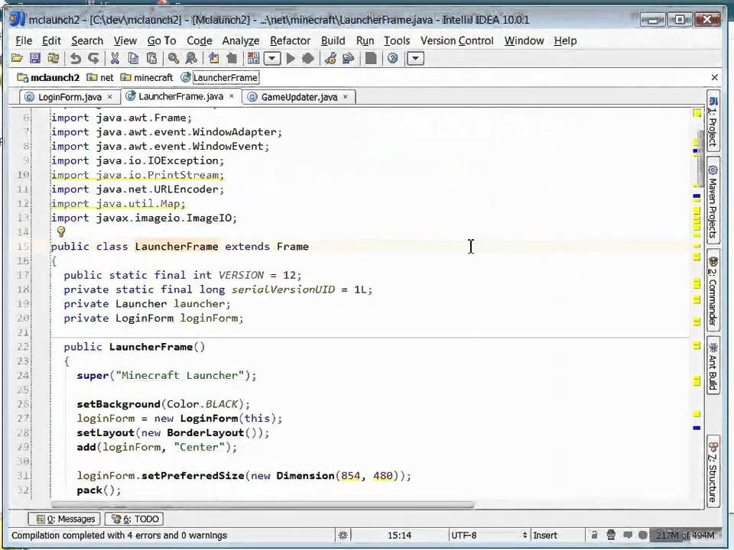

Naming Variables Example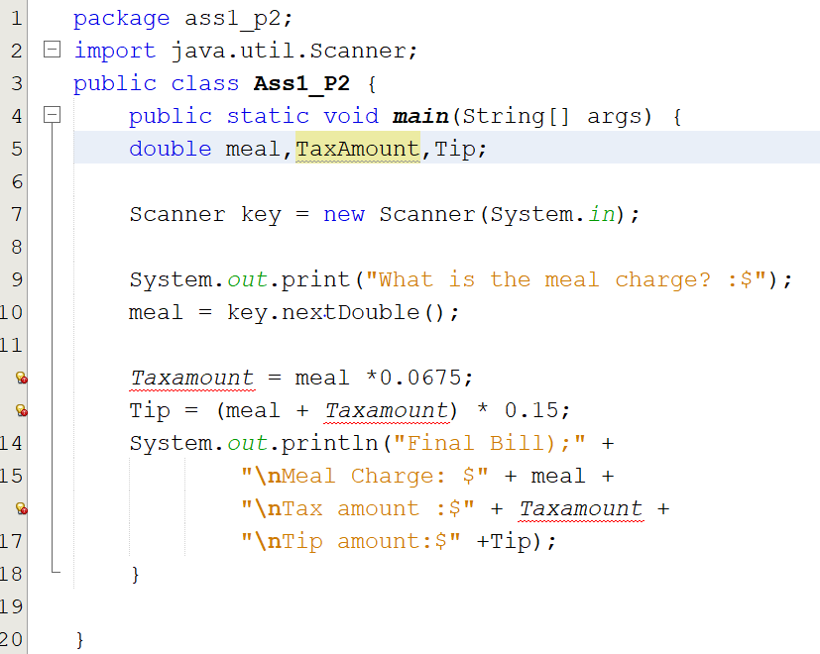

Examples of Commenting in Java Source Code
