Ludwig Liu
English 3773 – Final Project
Prof. Gold
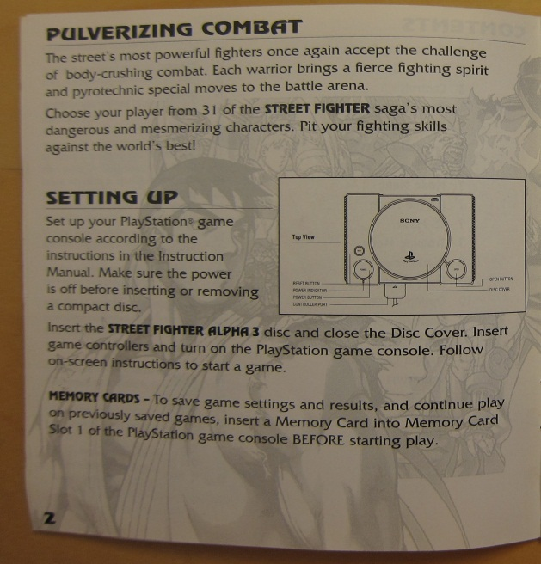
Introduction - Pulverizing Combat
The game Street Fighter Alpha 3 is a fighting game where you can choose up to 31 different characters and with these characters you battle out with your computer opponent to reach for the title of the ultimate street fighter! Your goal in the battle stage is to use your characters variety of attacks and special moves in order to deplete your opponent’s vitality bar. Although looking from the outside, the game seems very simple; attack and drain your opponent’s life bar. Street Fighter Alpha 3 is much more sophisticated than you think! There is attacking, blocking, combos (where one attack chains to another attack), baiting (where one baits their opponent to attack so you may counter attack), pressuring (where one player attack as much as possible without stopping) and footsie’s or as known as spacing (real estate on the battle area is crucial because you don’t want to get cornered). So it is vital that you must come up with your strategy to defeat your opponent!
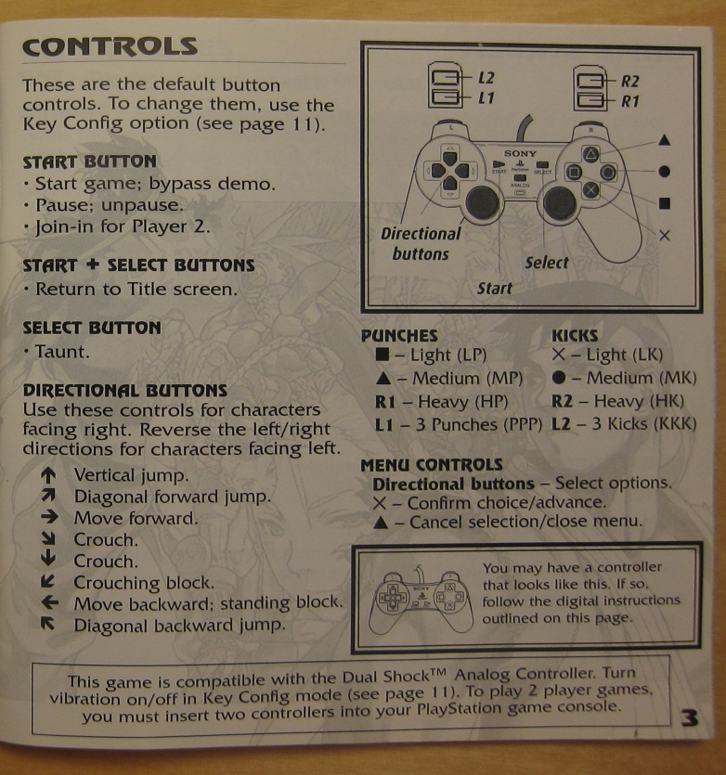
Basic Controls
Punches = Square – Light Punch, Triangle – Medium Punch, R1 – Heavy Punch
Kicks = X – Light Kick, Circle – Medium Kick, R2 – Heavy Kick
3 Punch (all) = L1
3 Kicks (all) = L2
Directional Buttons = Up, Down, Left, Right
Start = Pause
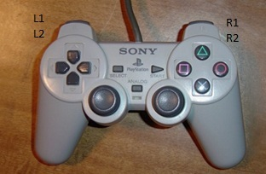
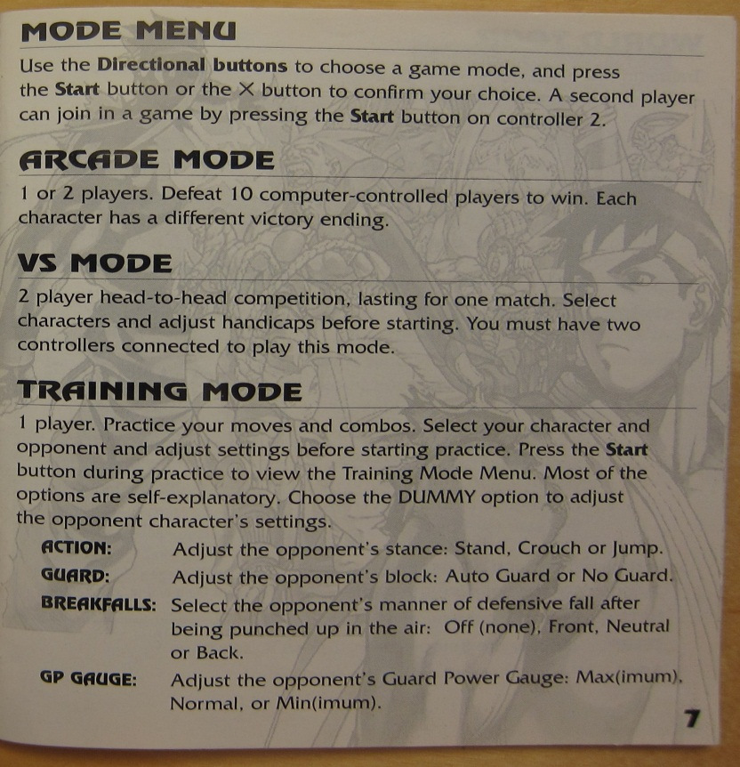
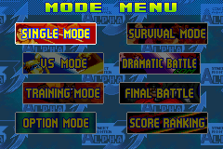
Game Modes
Arcade Mode = Player challenges against the CPU
VS (Versus) Mode = Two player mode3
Training = Payer can practice against a dummy CPU
Survival Mode = Challenge against endless CPU battle
Dramatic Mode = Two human player against CPU
Final Battle = Pits the player against the boss
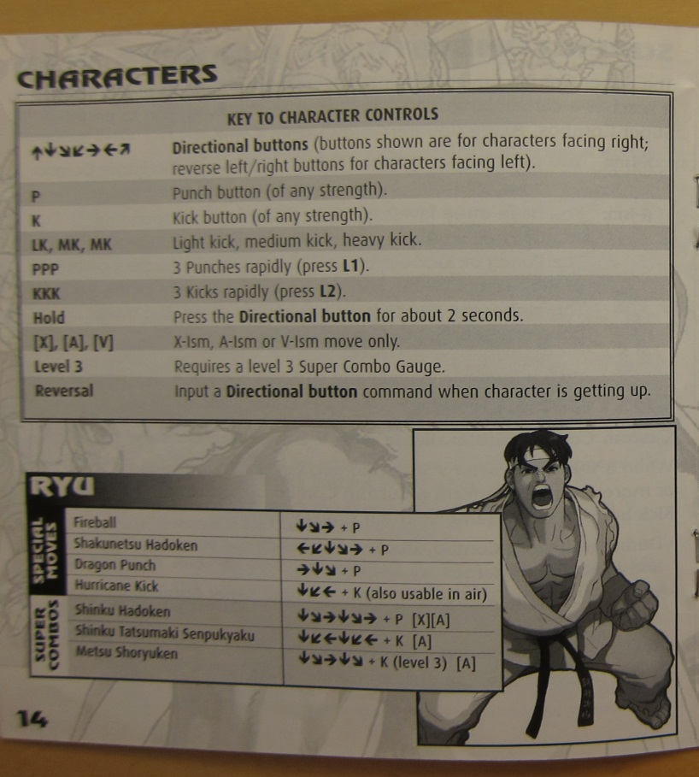
Character Controls (Ryu)
Special Moves
Fireball = Down, Down Forward, Forward + Punch
Shakunetsu Hadoken = Back, Down Back, Down, Down Forward, Forward + Punch
Dragon Punch = Forward, Down, Down Forward + Punch
Hurricane Kick = Down, Down Back, Back + Kick

Super Combo
Shinku Hadoken = Down. Down Forward, Forward, Down, Down Forward, Forward + P
Shinku Tatsumaki Sen. = Down, Down Back, Back, Down, Down Back, Back + K
Metsu Shoryuken = Down, Down Forward, Forward, Down, Down Forward + K

Awesome Tip!
You don’t need to press all the motion of the directional buttons in order for an attack to be applied. So basically by pressing Down and then Forward does essentially the same thing as with the Down, Down Forward and Forward. For example, Fireball is
Down, Down Forward, Forward + Punch changed to Down, Forward + Punch essentially the same so it’s a shortcut. Try it out!

