Hello today I am going to tell you what is a tag and how to do it. A tag is used for organizing data. Tags is a kind of metadata (metadata is data describing data). It helps to describe an item which allows it to be found in a browser or search. There is no formal way to choose a tag. In fact it can be created by the creator or even by the viewers in some cases. A tag can be in the form of words, images or even sometimes as other identifying marks. This is instructions on how to create a tag on open lab.
First log into your city tech open lab website
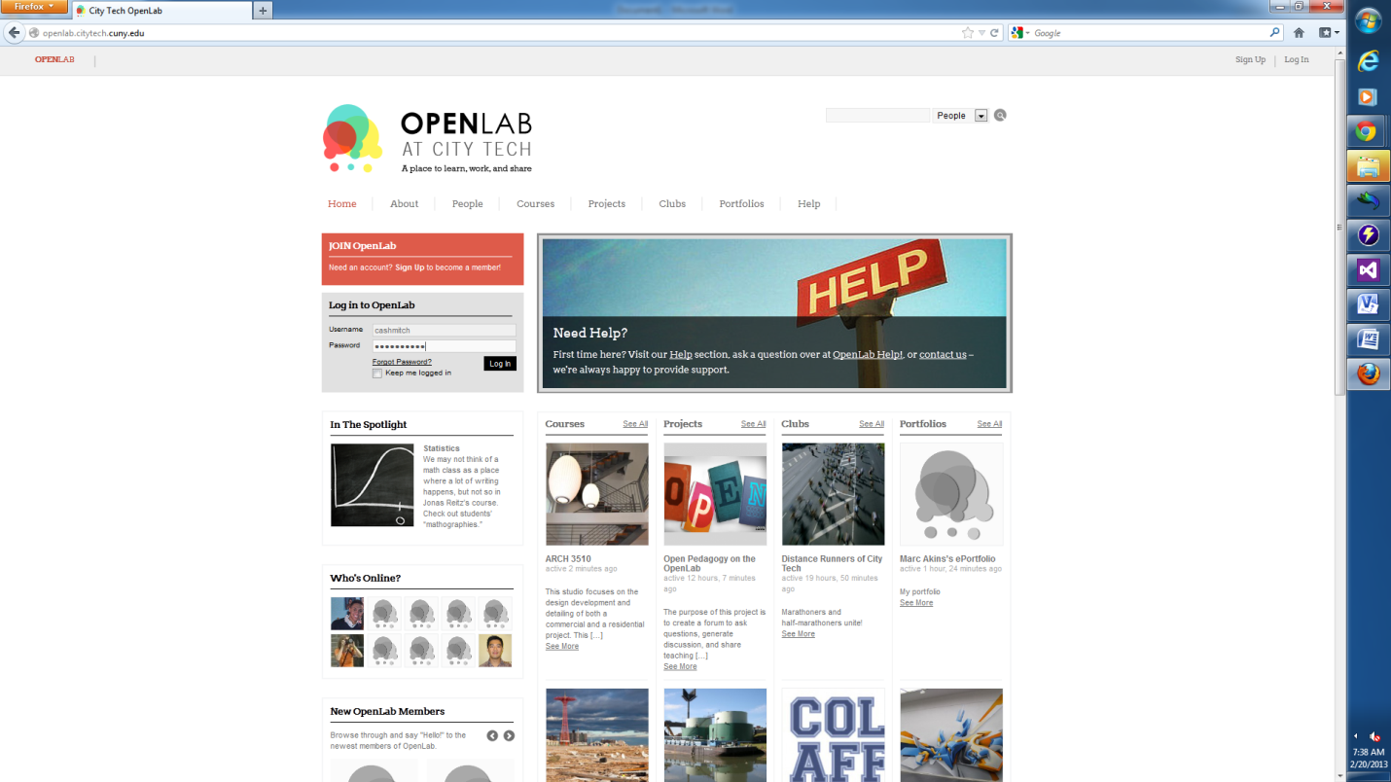

CHOOSE MY OPENLAB
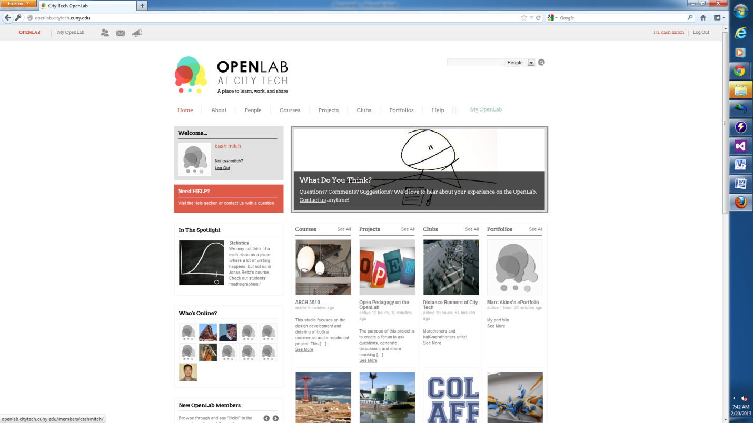

CHOOSE THE COURSE
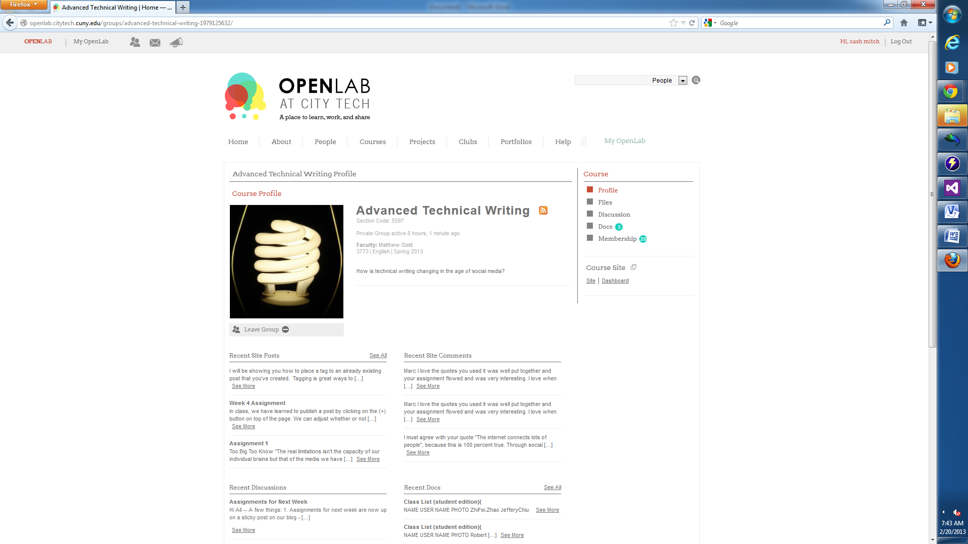
GO TO THE PLUS SIGN (+) AT THE TOP OF THE PAGE AND SELECT POST

It will take you to the NEW POST page at the bottom right of that screen you will see TAG
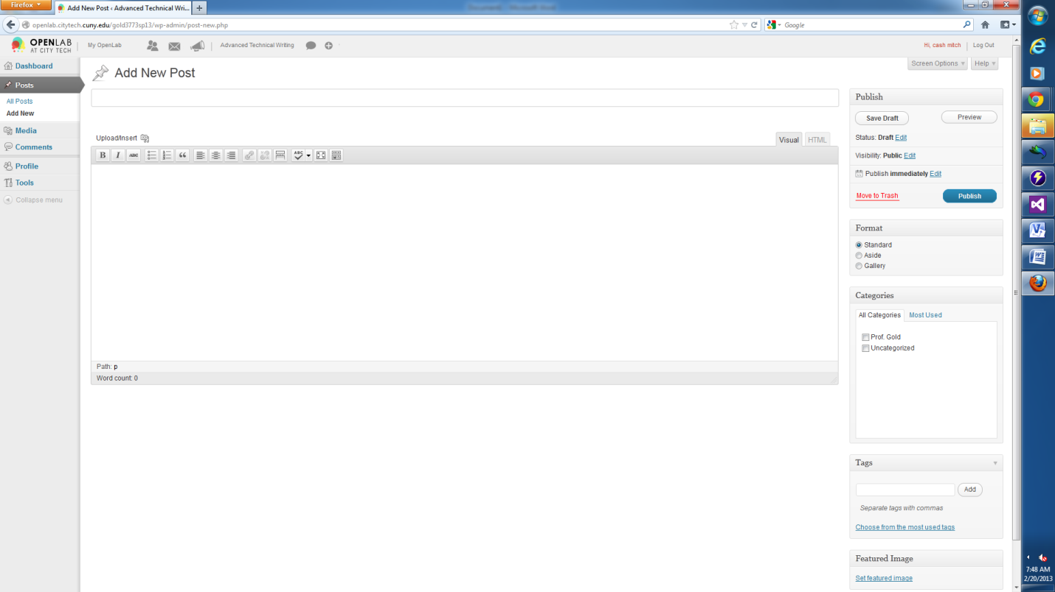ENTER YOUR TAG AND CLICK ADD. THERE YOU HAVE CREATED A TAG DON’T FORDET TO PUBLISCH YOUR WORK!!!!

