Gaethan Jean-Pierre

Professor Goetz

COMD 1111 Fall 2015

Logo History Draft

Google is a search engine that was found in the late 20th century by Larry Page and Sergey Brin. Sergey Brin and Larry Page created the original Google logo with a program called GNU Image Manipulation Program (GIMP). The First logo that they made was a sanserif font that was delivered poorly because of the words structure. The first logo of Google seemed to be floating and facing upwards so it was somewhat sorts illegible. 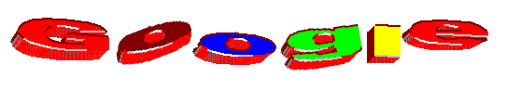

In 1998, Sergey Brin decided to remake the logo with more color and went with a more legible 2D flat logo. He used the program GIMP to remake it again. The new logo used a modern font style that was more elegant than the previous sans serif font in the original logo. The font is Baskerville Bold.



Also in 1998 Larry Page and Sergay Brin put a stick figure behind one of the O’s in the google logo. Ever since then there has been something called Google doodles. Google doodles are ideas from illustrators, animators, graphic designers, and artist. So ever since that stick figure went behind an O Google has changed for the better. There have been festive doodles for holidays and seasons. Also people do have the right to send their own ideas to Google via email for more doodles that they might use, you must email [proposals@google.com](mailto:proposals@google.com) and submit your work. 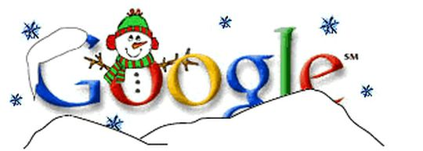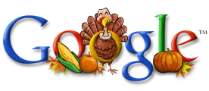

In 1999, they decided to change the color scheme of the logo again. They changed the G’s into Blue and added a blue exclamation point replicating Yahoo!’s Logo at the time. But that did not last long. They also kept the modern typeface Baskerville in the logo.

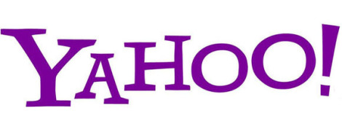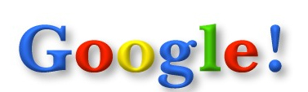

After that they decided to hire some help. They hired a designer named Ruth Kedar from KedarDesigns and he made varies of concepts until she made a design that everyone agreed on to portray as the main new logo. She changed the font into a Old style like font and made the letters very bold. The logo also has an shadow in the background mirroring the letters.

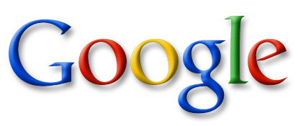

Then, in 2010, the Google logo has changed again. There was not a drastic change in the fonts or design it remained in Baskerville. In 2010 the logo changed its color scheme by a adding lighter vibrant colors. Also they changed the O into a light orange. They also took away the shadow.

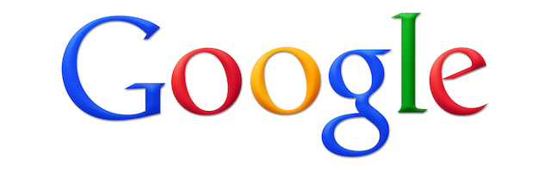

Now September 1st 2015 the logo has changed again brining back its flat 2D look to it.

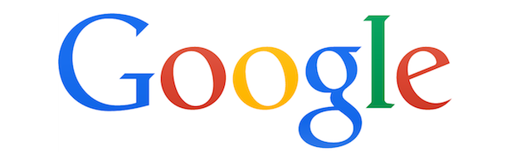

Sources : The Evolution of Google's Iconic Logo." Gizmodo. N.p., n.d. Web. 21 Sept. 2015.

"Did You Miss Something in These Logos?" Asaconsumer. N.p., 18 Oct. 2012. Web. 21 Sept. 2015.

"Penn State's Visual Identity Crisis." Lions Tales. N.p., 12 Aug. 2015. Web. 21 Sept. 2015.

About - Kedar Designs." About - Kedar Designs. N.p., n.d. Web. 21 Sept. 2015.

"Penn State's Visual Identity Crisis." Lions Tales. N.p., 12 Aug. 2015. Web. 21 Sept. 2015.