Could Climate Change Trigger Earthquakes and Tsunamis?

There has been a strong debate on whether there is a link between climate change and earthquakes with these debates being as powerful as the earthquakes that have occurred in recent times. In 2012, Bill McGuire wrote a book titled “Walking the Giant: How a Changing Climate Triggers Earthquakes, Tsunamis and Volcanoes,” in which he describes how our earth has gone through miraculous shifts and how human-caused climate change may bring about both geological and climatic changes, such as the reawakening of dormant volcanoes and earthquake faults.
At the time, people referred to this book as “science fiction.” However, a couple years prior to the release of this book, there was a report published by Chi Ching Liu and his colleagues out of the University of Taiwan. The report included evidence that there is a direct link between climate change and earthquakes. Liu and his colleagues determined that there was a sequencing pattern between typhoons and minor earthquakes. Their reasoning is that the low-pressure centers of typhoons enable earthquake faults within the crust to shift and discharge accumulated strain.
The main reasoning behind the 2011 earthquake and tsunami that occurred in Japan was a shift of plate tectonics. This natural disaster has left a big mark on Japan’s economy, the country lost substantial physical and human capital. The approximated total damage caused by the disaster ranges to be anywhere from $190 billion to as much as $300 billion. Over 25,000 people either lost their lives or have been reported to be missing. Over 200,000 houses and other structures have been destroyed or damaged. The earthquake has also caused major damage to the Fukushima nuclear power plant, triggering a nationwide crisis. Nuclear reactors sustained damage, resulting in evacuations, radioactive contamination, and shortages of electricity.
The tsunami-related events in Japan unfolded for several years after disaster. Investigators were forecasting a grim fate for Japan, saying the country’s economy would fall into a recession, unless the damage from the nuclear power plant could be contained in a timely manner. Japan and the United States’ economic ties have always been strong and mutually beneficial. The two economic powers are unified via trade of goods and services — they are significant markets of each other’s imports and exports. However, after it was discovered that the Fukushima power plant was damaged due to the earthquake, the United States began monitoring foods for radiation and even placed a ban on imports of certain vegetables and products from the vicinity of the damaged nuclear reactors. Japan plays a big role in a global supply chain, both as a supplier of products and as a producer. At this point in time, even a small disruption to the trade of goods can have a huge impact on a country’s economic health.
World Vision provided a brief timeline of events beginning from 2011 up until 2018:
2011: A cabinet-level reconstruction agency was formed. Then, the Japanese government approved a 10-year timeframe for reconstruction and amended its basic disaster management plan to better prepare for multi-hazard, high-impact events. 2012: Of the estimated 470,000 people displaced by the earthquake, tsunami, and nuclear disaster, about three-quarters — 344,000 people — were still displaced. 2015: U.N. World Conference on Disaster Risk Reduction met in Sendai and approved new international guidelines for reducing the effects of disasters from 2015 to 2030. A forum on the Japan tsunami introduced best practices of planning and community involvement. 2016: Approximately 174,000 people remained displaced from the quake, tsunami, and nuclear disaster; 60,800 people still lived in temporary housing. 2017: February: Radiation levels remained high near the wrecked nuclear power plant. Fisheries were recovering; tests of water and seafood quality were within acceptable levels. 2018: The reconstruction authority reported that 100,000 evacuees moved into permanent housing in the past two years, so only 75,000 evacuees remained in temporary housing. About 92 percent of public housing units were completed. Evacuation orders continue to be lifted as communities in Fukushima were decontaminated and radiation levels normalized. Cleanup of the Fukushima Daiichi plant continues slowly.
As another year goes by after the disaster, one question remains to the people of Japan, what is it that they can do to prepare themselves if this event to happen again? As we know, history repeats itself and unfortunately, it’s a matter of time. Since 2013, Japan has upgraded their tsunami warning system and Japan’s Climate Control Department has planted over 300 seismic stations in and around Japan. On a greater scale, the Disaster Prevention Department set up 700 stations for the establishment of the warning system. Hopefully, with the data collected from these seismic stations, the government officials can promptly inspect the data, determine the scope of the disaster, and anticipate the time of occurrence at each location and accordingly launch a warning to the people so citizens can be prepared.

Image
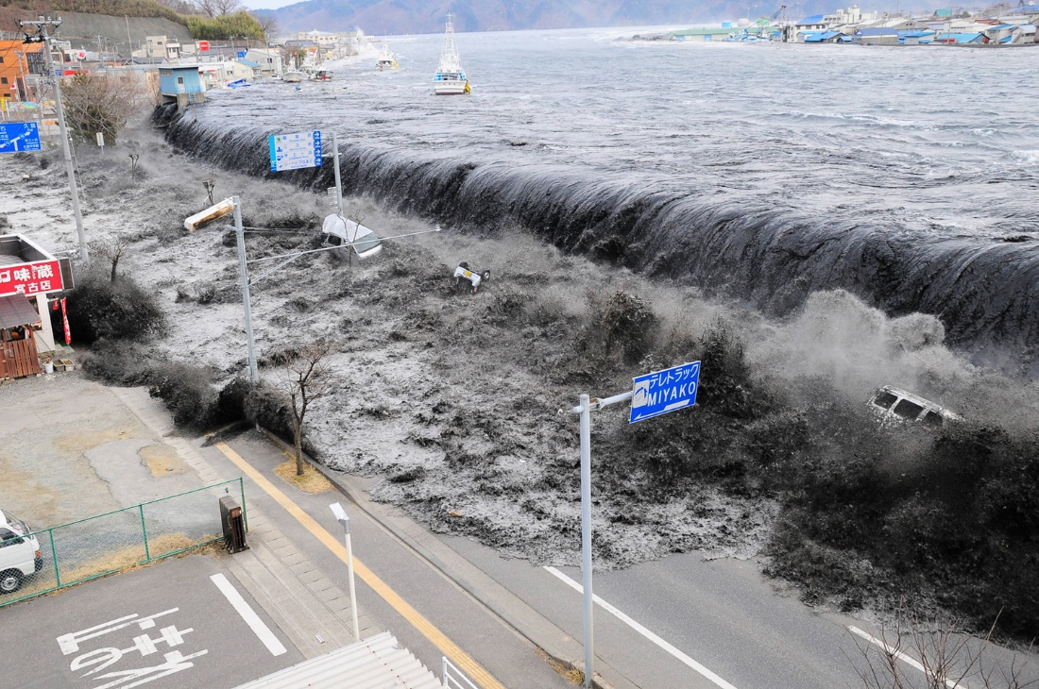
https://www.theatlantic.com/photo/2016/03/5-years-since-the-2011-great-east-japan-earthquake/473211/

Works Cited

Komatsu, Matthew
https://motherboard.vice.com/en_us/article/d3e5av/japan-tsunami-alert-system
Reid, Kathryn
https://www.worldvision.org/disaster-relief-news-stories/2011-japan-earthquake-and-tsunami-facts
Amadeo, Kimberly
https://www.thebalance.com/japan-s-2011-earthquake-tsunami-and-nuclear-disaster-3305662
McGuire, Bill
https://www.theguardian.com/world/2016/oct/16/climate-change-triggers-earthquakes-tsunamis-volcanoes

