Name: Goodman C. George

3344 Palmer Avenue
Bronx, NY 10475
# (347) - 427 -2167
goodman.george65@mail.citytech.cuny.edu
XXX-XX-1373

https://statestreet.wd1.myworkdayjobs.com/en-US/Global/job/New-York-New-York/Sr-Technical-Writer_R-589553

Objective:

To make complex information easy to understand and readily available for intended audiences

Occupation: Technical writer/Communicator

What makes you qualified

● My proficiency in writing has produced some considerable pieces of work

● Extensive research on subjects of interest relevant to assigned project

● Worked on joint-ventures collaborating with partners toward a goal

● Held presentations on research findings covering reliable sources and background

Educational status: High school graduate
Enrolled college student

Institution (s) attended: Collegiate Institute for Math and Science
New York City College of Technology (NYCCT)

Year of Enrollment: Fall 2014

Expected Graduation: Winter 2019

Level of Education

● Bachelor of Science , New York City College of Technology with Specialization in Biology 2014-2019

● Major: Professional and Technical Writing Dept.

Work Experience

Summer Youth From Jul to Aug 2018
Title: Youth Supervisor

Description: At two public schools

Summer Youth From Jul to Aug 2016
Title: Volunteer

Description: Lincoln Hospital accepts volunteers to carry out jobs reserved for the staff on standby. The department I worked in first was Human resources, then I put in the mail room downstairs.

Summer Youth From Jul to Aug 2015

Title: assistant counselor

Description: The main job placement of Summer Youth is daycare. Young employees are sent to supervise children and oi assist the on-site director.

Employment: Summer Youth From July to August 2013

Title: Day camp counselor

Relevant coursework:
Powerpoint Presentations on research findings

Discussion and seminar on technology and society

Collaboration with group members to complete joint project

Experience
Computer Skills:
Microsoft Word, Microsoft Excel, Microsoft PowerPoint, Microsoft Excel

References - Avaliable upon Request
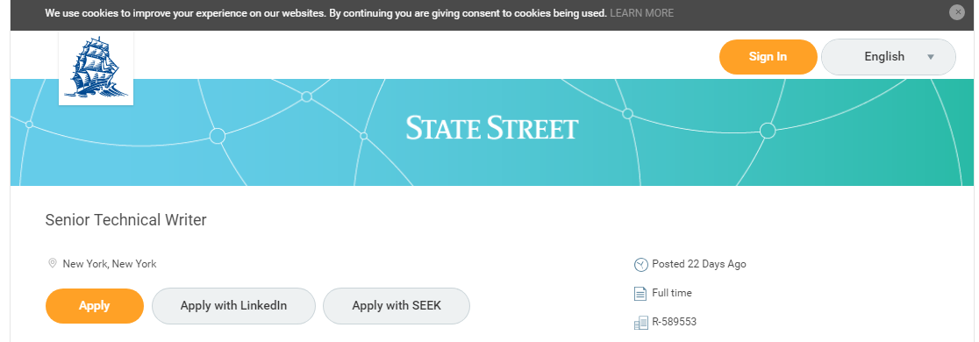

Senior Technical Writer
  - New York, New York
- Apply
- Apply with LinkedIn
- Apply with SEEK
- In January 2018, we launched one of the industry’s largest technical transformation projects, in effect building a new bank from the ground up. We’re using the same technologies that Silicon Valley giants are using: aggressive use of multiple public clouds, building our own private cloud to achieve even better performance, pushing out microservices into what will be one of the largest Kubernetes installations in the world, leveraging immutable storage to process and store hundreds of terabytes of data a day, transforming our industry through application of distributed ledger technology and cognitive computing, aggressively participating in open source communities driving our systems.
- This isn’t a traditional banking role. This is a chance to push your technical skills with people more comfortable in a technology firm than an investment bank, but solving real problems that affect anyone with any form of savings worldwide. We don’t expect you to wear a suit, we don’t expect you to not be able to tell your friends what you’re working on, and we don’t expect you to sit in meetings 5 hours a day.
- Who we are
- We are a ‘change the bank’ challenge team, working with internal and external partners to develop advanced, digitally enabled solutions that drive significant value to our clients and operating business lines.
- Core to these efforts are the engineering, build and operation of State Street's multi public cloud technology infrastructure. In short, we are assembling a team of cloud experts to provide global solutions for our internal groups as well as other financial giants.
- What you will do
- As a Senior Technical Writer on the Digital Product Engineering team, you will work closely with our technical leads and team members to document architectural components, deployment plans, functionality specs, user features and more for the global bank’s public cloud backed servicing platforms.
- You will work with architects and process specialists to shape the toolchain necessary to build an end to end No-Ops flow, enabling seamless interactions across SDLC ‘moments of truth’.
- You will define end user ‘journey maps’ through process specifications and interaction points, using ITIL processes in alignment with public cloud based capabilities.
- You will author design specifications and test cases with input from developers to aid configuration and development in a verifiable manner.
- You will help us automate key ITIL processes and monitor for infrastructure configuration drift.
- Who you are
- You have an understanding of DevOps principles (e.g., continuous integration and continuous delivery concepts) and comfort describing the latest technologies used in the development, testing and monitoring of custom applications within a cloud environment.
- You have familiarity in journey mapping concepts and developing process flows focused on addressing pain points.
- You have excellent collaboration and interpersonal skills. You will be working directly with engineers, product managers, and other stakeholders to help document (and define) new developer products and features.
- You are comfortable working in (and maybe prefer) a semi-structured writing environment with evolving processes and homegrown systems.
- You are able to clearly translate business requirements into technical requirements, analyze and document complex business processes and identify areas for improvement.
- You have a Bachelor’s degree in Computer Science, or a STEM related field, and 5 or more years of technical writing experience.

Cover Letter

Dear Joseph L. Hooley

I send this to you with the utmost intentions to be employed by your company. It is to my understanding that after the Union Bank, State Street is one of the oldest banks in the United States and the largest custodian bank in the world. Right now I’m hard at work fulfilling my ambition to become a proficient technical writer/communicator. My studies have taken me to many different areas where one is to use information provided to accomplish goals established. Often as is the case for technical communication I receive tasks imparted to follow what my clientele wishes as per contract. Once I understand that I’m to deliver the entailed object, action, or project expected of me.

The job ad I see before me states you’re looking for someone who can coordinate with a team in handling documentation, forming public clouds (services rendered over a network for public use) and specifications. In time I will learn the skills necessary to achieve these tasks and much more. The field I most inclined to enter is the scientific, but perhaps State Street will give me the experience needed to get through financial situations involving the cloud environment. On my resume you’ll see I have a Bachelor’s degree, fulfilling the education requirement.

Thank You, Goodman George

