Genesis Fernandez/COMD1112-D110

Pillsbury and America’s Doughboy

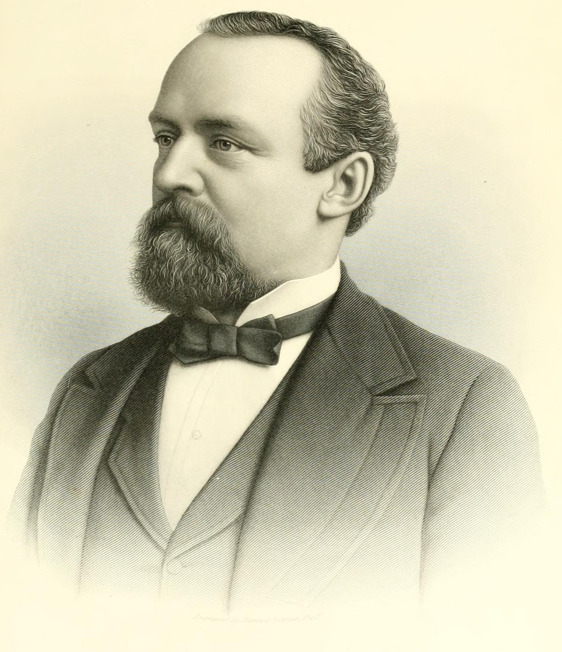
Do you know of America’s favorite Doughboy? If you go grocery shopping and walk down the dry mix and freezer isles you may have seen him. Covering a brief history of Pillsbury and its iconic character Poppin Fresh will give you an idea of why this company has remained popular over the years. Pillsbury is a company known for being one of the top selling brands in baking goods that are sold ready for the oven or require little preparation, saving you the trouble of preparing dough for cookies, pastries, cakes and icing, biscuits, pies and any other deliciously flaky delights you can think of. Aside from all the baking goods, the company was also known for its cookbooks, recipes, and annual bake off contests. But how were these delicious bake goods brought into the consumer’s world?
It all began with a man known as
Charles Alfred Pillsbury, born on December 3, 1842 in Warner, New Hampshire. Being raised in a humble way, he graduated in 1863 from Dartmouth College and paid for all educational expenses by teaching part time. Mr. Pillsbury worked several years in Montreal, Quebec in Canada at a mercantile enterprise. Through that time he met Mary Ann Stinson and got married to her in 1866. Together they had four children, two of which died in childhood and a set of twins who lived well into adulthood and got married. After seeing commercial in Montreal, processing grains from the West, he decided to move to Minneapolis and pursue business and soon established his flour business. Charles A. Pillsbury was also a member of the Minnesota State Senate, for the most part between 1878 – 1886 he was the chairman of the Finance Committee of the Senate and responsible for implementing legislation regarding the State’s Bonds. A heart issue caused his death on September 17, 1899 .
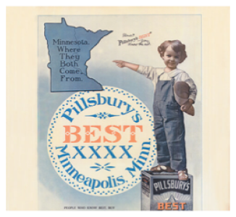
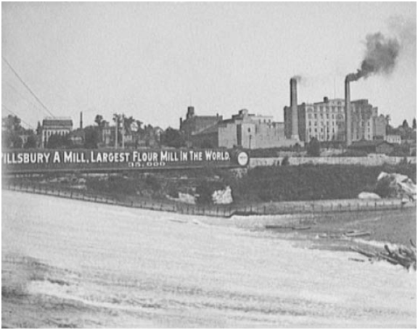
In the beginning, it was not all that it is known for today. It started in 1869 when Charles A. Pillsbury invested on one third of a flourmill on the banks of the Mississippi River in Minnesota. After convincing his father and uncle to join him in expansion in 1872, the company became recognized as C.A Pillsbury Company. It was then that Minneapolis became one of the biggest producers of grain around the world. From its first year of operation C.A Pillsbury Company was profitable and by then was producing 2,000 barrels of flour each day. Pillsbury's production skyrocketed during
the 1880s producing about 24,500 barrels of flour a day.
By 1887 it was the world's largest flour-milling operation.
The company was now advertising to trade and consumers through
magazines and newspapers. Pillsbury’s Best XXXX trademark was first registered
in 1875 , the fourth X still used today, was an indication the flour is superior to all flour. The company introduced a national baking competition, Pillsbury Bake-Off. First held as The Grand National Recipe and Baking Contest at New York’s Waldorf – Astoria Hotel. It became an annual event that was broadcasted on CBS for many years
For some time it was bought in 1889 and owned by an English Financial syndicate, the company’s name changed to Pillsbury Washburn Flour Mills Co. However, Mr. Pillsbury was the managing director of the new company. Pillsbury Washburn Flour Mills fell into financial troubles causing the company into receivership; their advertisements were limited to reassuring consumers that they were still in business. In 1923 the Pillsbury family reacquired it, then by 1935 recognized as Pillsbury Flour Mills Company . Following the years of 1950, the Pillsbury only had seven products with their name and they were ready to expand.
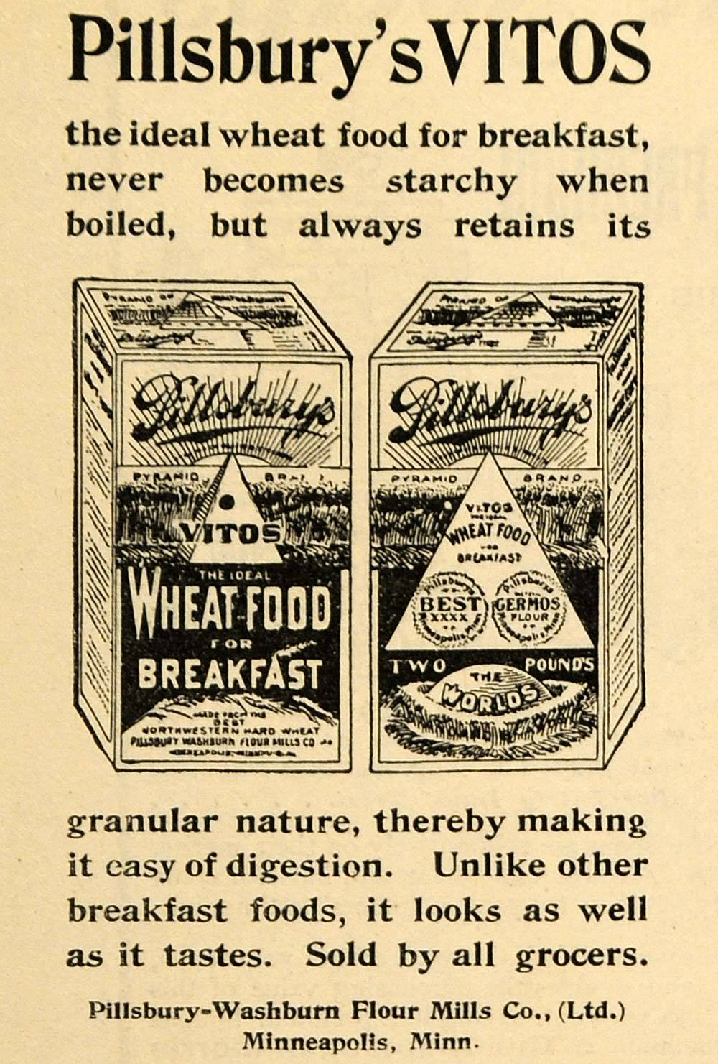
The company began introducing new products starting in the 1890s. One of the first successful products in expansion was Vitos Wheat Breakfast Food and Germos, due to advertisements in magazines like Cosmopolitan. Profit from this success lead Pillsbury to introducing a breakfast food line as well as more advertising. Other items in the early 1900s consist of health flour, flaked oat food, health bran, pancake flour, and wheat cereal. In 1929 cake flour was introduced and so did advertising their “Pillsbury’s Family of Foods” on national radio. In the 1930s the product line expanded to include yellow cake mix, pie crust mix, pancake mixes, biscuit mixes and pasta. Pillsbury even provided U.S Troops with dry soup mixes during World War II. However, if many of us know Pillsbury we know how delicious their Packaged biscuit dough can be, the production of packaged biscuit dough started in the early 1950s. Pillsbury also added products like artificial sweetener, drink mixes, chocolate flavored nuggets just to name a few.
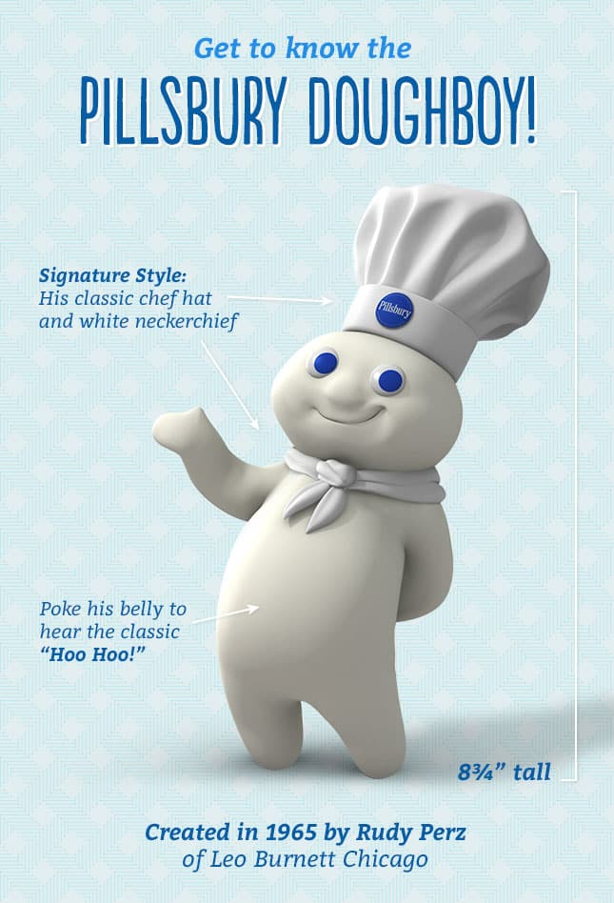
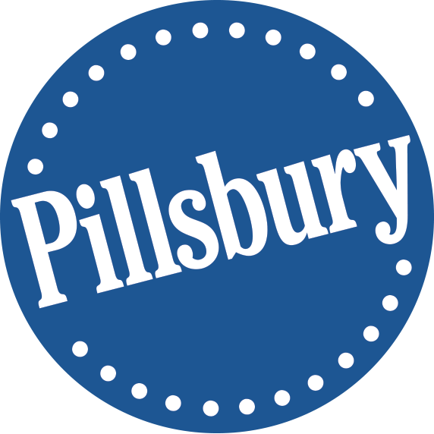
The growth of the Pillsbury Company lead to the creation of America’s Doughboy and since his début, he has become to be loved by many The Pillsbury Doughboy debuted in 1965 when the company launched their refrigerated crescent rolls. Rudy Perz created the Doughboy known also known as Poppin Fresh, with the help of Milt Schaffer who worked at the Leo Burnett advertising agency in Chicago. Popping out of a can and he introduced him self “I’m Poppin Fresh, the Pillsbury Doughboy!” This character has been used in over 600 ads for more than 50 products. He has been created into a vinyl doll and added family members. With his hat he is no taller than 8¾ inches and weighs 14 oz. In 2009 at the Macy’s Thanksgiving Parade he made his first debut as a balloon. The Pillsbury logo, aside from the doughboy is a blue circle with the companys name in white across the center in a diagonal. The font appears to be an old style font because you can see the serifs at the ends of each letter. From the very beginning you can see that the logo has remained a circle with the word Pillsbury on it, but since the company has expanded and is well known they eliminated parts such as the four Xs.
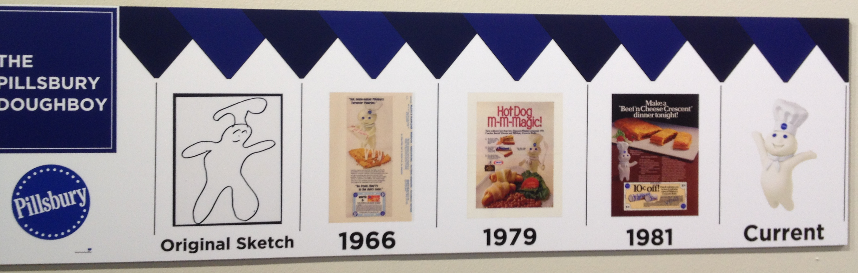
Pillsbury and the Doughboy go way back in history and yet it is still one of the best known company for recipes and easy to make baking goods. A company that started out as a small flourmill turned successful and has made the life of Americans easier by providing us with flour and our pastery needs. You can walk into the supermarkets and find a variety of premade cake mixes, cake frosting, pie dough, biscuits and so much more. Pillsbury for me is a product I always choose over any others. In many occasions I have resorted to buying Pillsbury and even searched their website recipes, whatever I choose to bake I already know the quality I am getting with Pillsbury. Besides, I share memories of my mother making Pillsbury bisquits for breakfast. When I crave a delicious treat Pillsbury is always my choice.

“Charles Alfred Pillsbury.” Wikipedia, Wikimedia Foundation, 7 Mar. 2019, en.wikipedia.org/wiki/Charles_Alfred_Pillsbury.
“Making Food People Love.” General Mills 150, history.generalmills.com/brand-pillsbury.html.
“Pillsbury Co.” Ad Age, 15 Sept. 2003, adage.com/article/adage-encyclopedia/pillsbury/98823/.
“Pillsbury Company.” Wikipedia, Wikimedia Foundation, 7 Mar. 2019, en.wikipedia.org/wiki/Pillsbury_Company.
Period Paper. “1898 Ad Pillsbury Vitos Washburn Flour Mills Wheat Food - ORIGINAL TOM3.” Period Paper, www.periodpaper.com/products/1898-ad-pillsbury-vitos-washburn-flour-mills-wheat-food-original-advertising-077241-tom3-032.
Pillsbury Kitchens. “How Well Do You Know the Pillsbury Doughboy?” Pillsbury.com, Pillsbury, 25 Mar. 2016, www.pillsbury.com/doughboy.

